

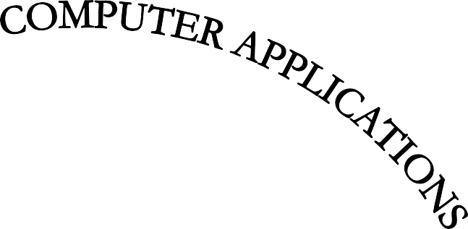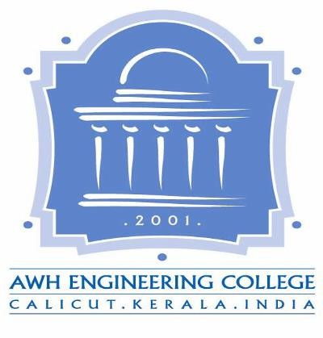

AWH ENGINEERING COLLEGE

KOZHIKODE

# CERTIFICATE

*This is to certify that this thesis entitled* ***“SMART MUKKAM””*** *submitted herewith is an authentic record of the thesis work done by* ***ADIL JASEEM.P.K. (Reg no: AWH22MCA-2001)*** *under our guidance in partial fulfillment of the requirements for the award of* ***Master of Computer Applications*** *from APJ Abdul Kalam Technological University during the academic year 2024.*

**Mrs Sruti Sudevan. Ms Ashwini M**

Assistant Professor Assistant Professor

Dept. of Computer Applications Dept. of Computer Applications

Head of the Department Project Guide

**External Examiner Internal Examiner**

# ACKNOWLEDGEMENT

I express my sincere gratitude to our beloved principal **Dr.Sabeena M V** for providing me an opportunity with the required facilities for doing this project. I express my hearty thanks to **Mrs. Sruti Sudevan**, Head of the department of Computer Application, **Ms. Ashwini M** Assistant Professor for her guidance. I am thankful to all other staff of the MCA department for their encouragement, timely guidance, valuable suggestions and inspiring ideas given throughout this project. I am grateful to my friends for the way they have cooperated, expected me to achieve success and have always stirred my ambition to do the best. Above all, I am grateful to the almighty, who has showered His blessings on me throughout my life and throughout the project.

**ADIL JASEEM.P.K.**

# ABSTRACT

Smart Mukkam is a big plan to make life easier for people living in Mukkam. It's all about using computers and phones to improve how the town works. Residents can do things like sign up for services and go shopping online. Businesses also get help with managing orders and talking to customers. Tourists visiting Mukkam can book tickets, hotels, and learn about local places to visit.

The main part of Smart Mukkam is a special computer system for the town. This system helps town officials organize appointments, approve registrations, and handle complaints. There's even a place for people to share pictures and reviews of Mukkam. This makes the town more lively and lets everyone get involved. Smart Mukkam wants to make life better for people in Mukkam by using technology. It's not just about making things digital, but also making the town a better place to live and visit.

**CONTENTS**

Page No

1. INTRODUCTION 1
2. SYSTEM ANALYSIS 3
   1. Existing System 4
   2. Proposed System 4
   3. Module Description 5
   4. Sprint 8
   5. User Story 14
3. FEASIBILITY STUDY 17
   1. Economic Feasibility 18
   2. Technical Feasibility 18
   3. Operational Feasibility 18
   4. Software Feasibility 18
   5. Hardware Feasibility 18
4. SOFTWARE ENGINEERING PARADIGM 19
   1. Agile Model 20
   2. Scrum 20
5. SYSTEM REQUIREMENT SPECIFICATIONS 21
   1. Software Requirements 22
   2. Hardware Requirements 22
6. SYSTEM DESIGN 23
   1. Database Design (MySQL) 24
   2. Tables 24
   3. UML Design 39
   4. Use Case Diagram 39
   5. Scenario 47
   6. Sequential Diagram 51
7. SYSTEM DEVELOPMENT 60
   1. Coding 61
   2. HTML/CSS 61
   3. JavaScript 61
   4. Java 62
   5. JSP 62
   6. MySQL 62
8. SYSTEM TESTING AND IMPLEMENTATION 63
   1. Types of Testing 64
9. SYSTEM MAINTENANCE 65
10. FUTURE ENHANCEMENT 67
11. CONCLUSION 69
12. Appendix 71
13. Bibliography 93