**Re: Your overdue procedure**

Following your previous procedure with me I recommended you be recalled for further surveillance. Our records indicate you have not rescheduled an appointment.

We know that many patients did not receive follow up care during and post the Covid pandemic.

As a public health initiative we are reminding you of the clinical need for further investigation.

At your convenience, please call my rooms at the Diagnostic Endoscopy Centre on 8382 6622 to organise an appointment.

If you would prefer to have a consultation to discuss this further, I would be delighted to see you in consultation prior to your procedure.

You will need a referral from your doctor.

If you have continued treatment with another gastroenterologist please let our staff know so we can remove you from our recall list.

Best regards,

Yours sincerely,

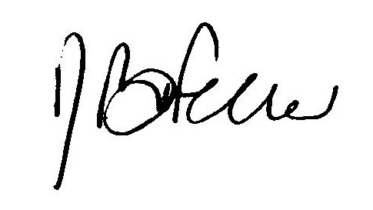

### A/Prof Robert Feller

#### MBBS PhD FRACP, FGESA