Software Engineering Lab 1
Requirements Engineering & UML Use-Case Modelling
Problem Statement #26 — Peer-to-Peer Carpooling & Expense Splitter

1. Problem Context & Overview
A commuter ridesharing portal that matches drivers and passengers with overlapping daily routes, enforces detour tolerance thresholds, and calculates automated fuel cost share splits.
Target Stakeholders / Actors: Rider Commuter, Driver Host, Payment Gateway (external system).

2. Requirements Table
Exactly five functional requirements and two nonfunctional requirements were defined. FR-001 and NFR-001 were provided in the lab handout; the remaining requirements were authored for this system.
Req ID | Type | Description | Priority | Acceptance Criteria | Rationale | Comments
FR-001 (given) | Functional | The system shall calculate route compatibility between driver and passenger commute paths, permitting matches only within a 1.5 km detour tolerance. | High | Pass: Route match confirmed and fuel cost split calculated. Fail: Detour exceeding tolerance accepted. | Core matching logic; keeps the detour worthwhile for the driver.
FR-002 | Functional | The system shall allow a Driver Host to create a trip listing specifying origin, destination, departure time, and number of available seats. | High | Pass: Trip appears in search results within 5 seconds of posting, with all details displayed correctly. Fail: Trip is missing details or is not searchable. | Supplies the inventory of rides the matching engine searches against.
FR-003 | Functional | The system shall allow a Rider Commuter to search for available trips by entering origin, destination, and preferred travel time. | High | Pass: Search returns every trip within the 1.5 km detour tolerance and time window, sorted by best route match. Fail: Search omits a valid match or returns a trip outside tolerance. | Core discovery function; riders cannot book what they cannot find.
FR-004 | Functional | The system shall automatically calculate and display each passenger's fuel cost share, split proportionally by distance traveled, at the time a ride is booked. | High | Pass: Sum of all passengers' cost shares equals 100% of trip fuel cost, each within +/-1% based on distance ridden. Fail: Split total is incorrect or not shown before booking is confirmed. | Accurate, transparent splitting is the app's core value proposition and prevents payment disputes.
FR-005 | Functional | The system shall allow both Rider Commuter and Driver Host to submit a 1-5 star rating and optional comment about each other within 48 hours of trip completion. | Medium | Pass: Rating prompt appears immediately once a trip is marked complete, and the rating saves to both profiles. Fail: Prompt does not appear or the rating fails to save. | Builds trust and accountability in a peer-to-peer marketplace.
NFR-001 (given) | Nonfunctional | User ratings, driving license verification documents, and travel histories must be stored securely with encrypted backups. | High | Pass: Benchmarking tests confirm target latency and security standards under simulated peak load. Fail: Sensitive data found unencrypted or backup fails standard. | Protects personally identifiable and safety-critical data (license, location history).
NFR-002 | Nonfunctional | The system shall return route-matching search results within 3 seconds for a search radius of up to 50 km, for 95% of queries under normal load. | High | Pass: Load testing shows 95th-percentile response time <= 3 seconds for 500 concurrent search requests. Fail: 95th-percentile response time exceeds 3 seconds. | Fast search is essential to commuter experience, especially during rush-hour peak demand.

3. UML Use-Case Diagram
Actors: Rider Commuter, Driver Host, and Payment Gateway (external system). The diagram shows seven use cases, one <<include>> relationship (Book Ride includes Calculate Fuel Cost Split), and one <<extend>> relationship (Apply Promo Code extends Make Payment).
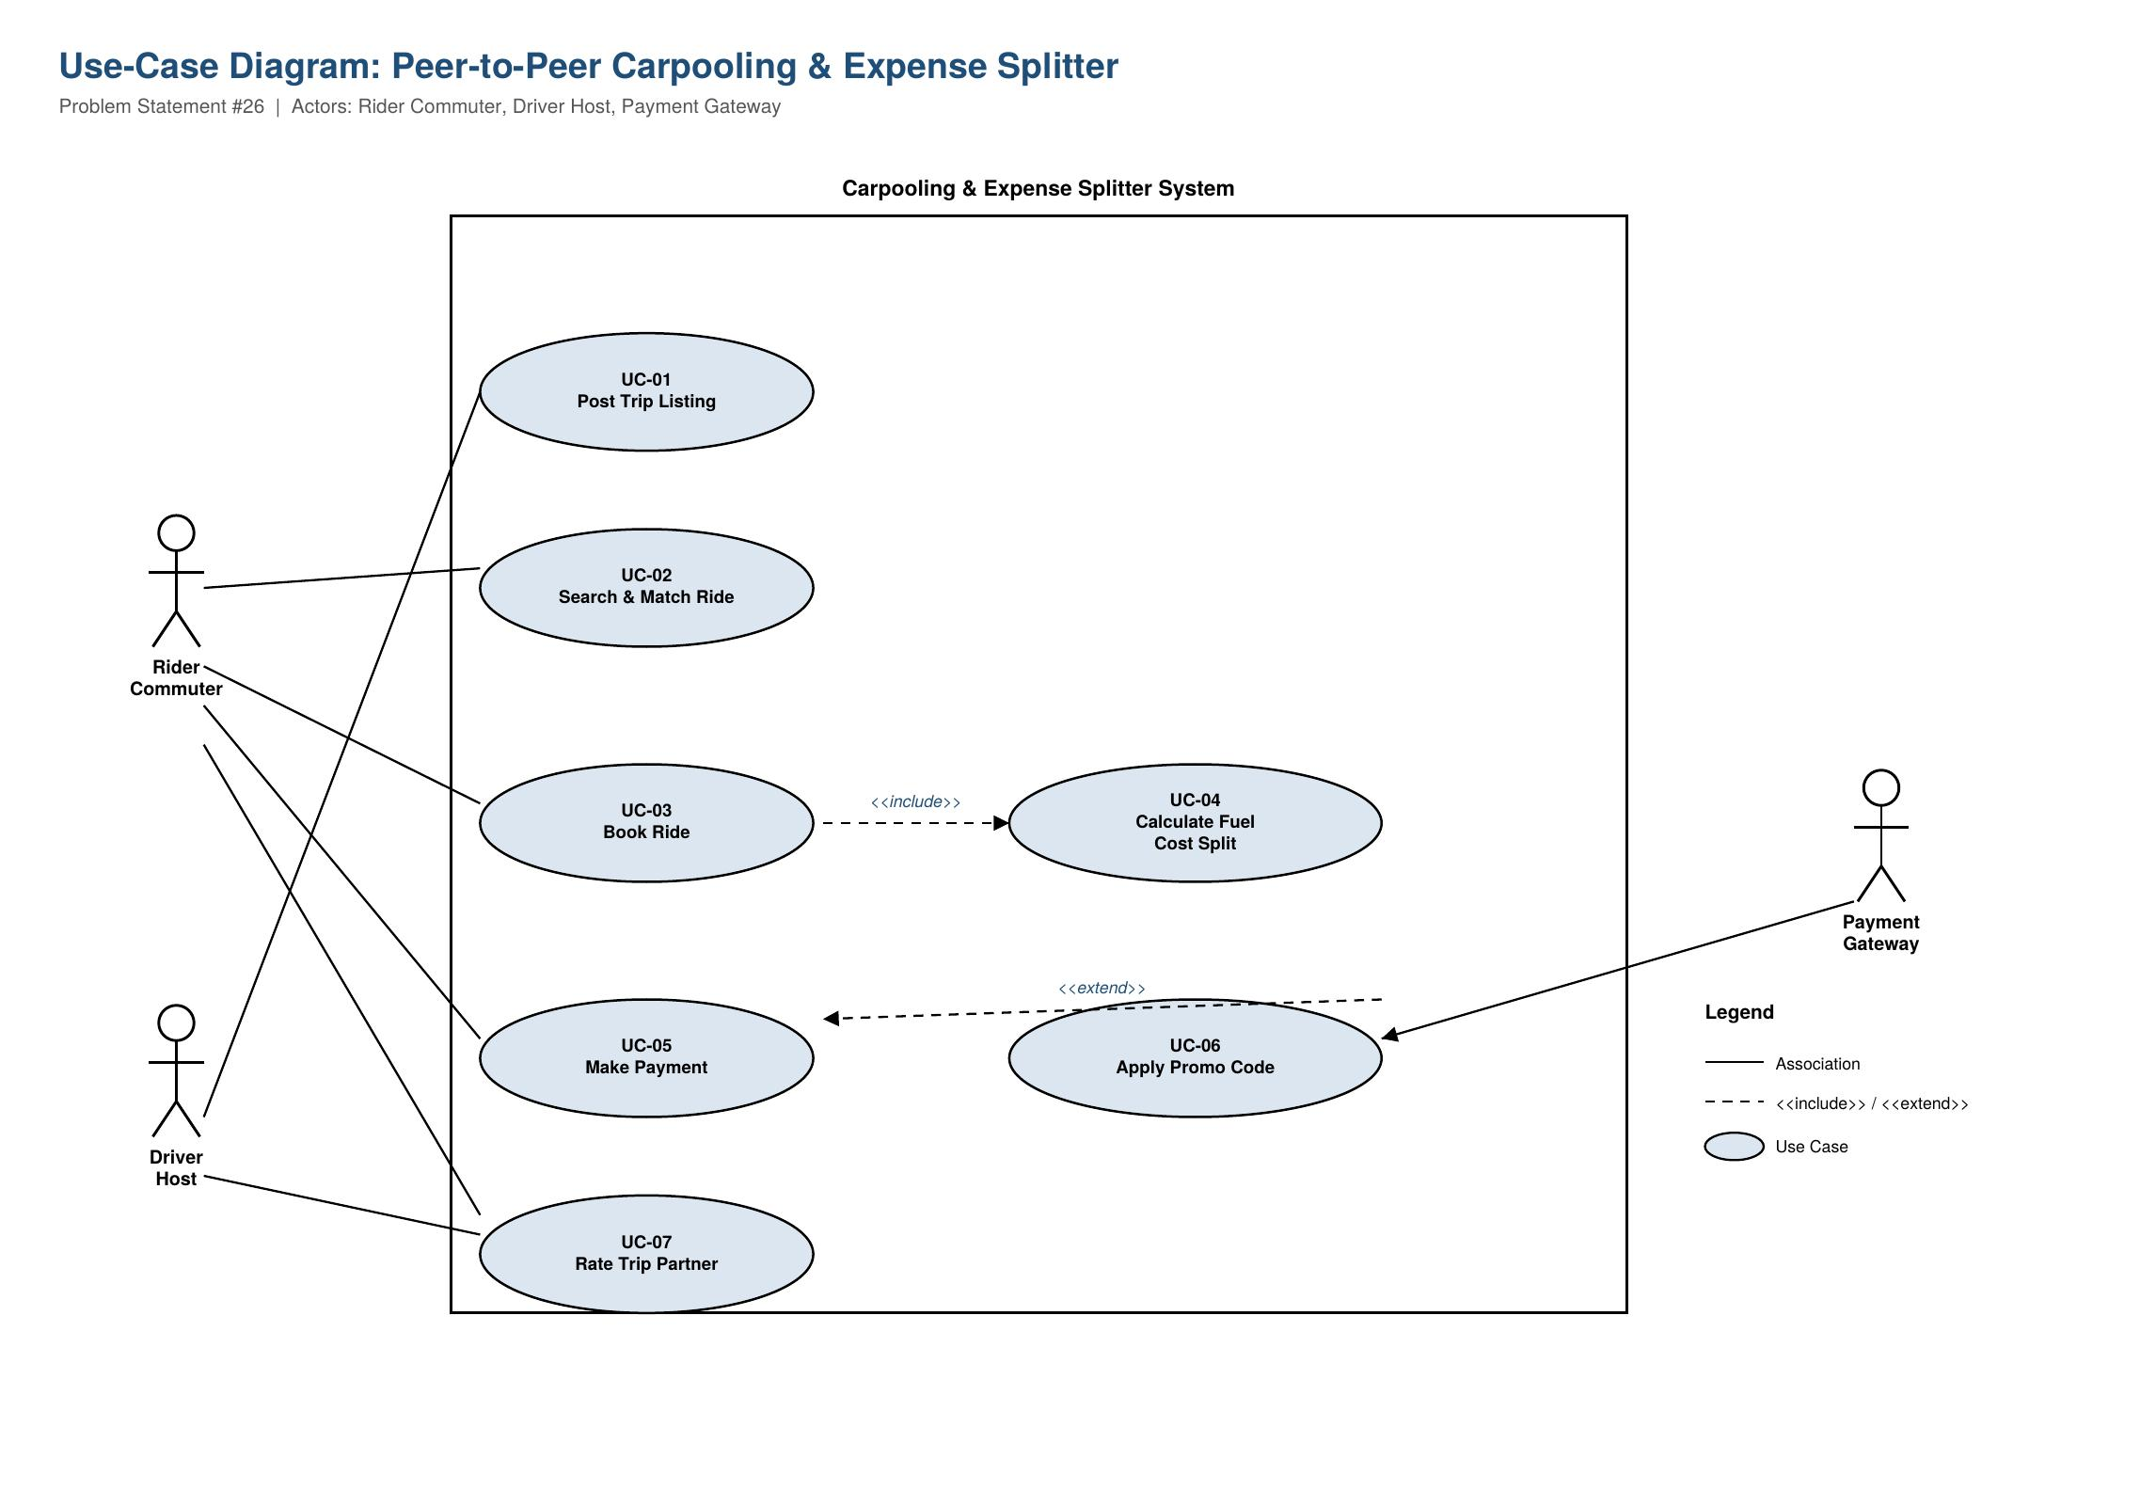

4. Use-Case Flow: Book Ride
Use Case | UC-03: Book Ride (Match & Reserve Seat)
Primary Actor | Rider Commuter
Secondary Actors | Driver Host, Payment Gateway
Preconditions | Rider Commuter is logged in; at least one Driver Host trip listing exists that satisfies the 1.5 km detour tolerance.
Postconditions | Seat is reserved, fuel cost split is finalized, and payment is confirmed for all parties.

Main Success Scenario
1. Rider Commuter logs into the app and enters origin, destination, and desired travel time.
2. System (Search & Match Ride) displays Driver Host trip listings that fall within the 1.5 km detour tolerance and time window.
3. System calculates and displays the estimated fuel cost share for each matching trip (<<include>> Calculate Fuel Cost Split).
4. Rider Commuter selects a trip and taps "Request to Book."
5. System sends a booking request notification to the Driver Host.
6. Driver Host reviews and accepts the request.
7. System confirms the seat reservation and finalizes the fuel cost split among all confirmed passengers.
8. System prompts Rider Commuter to pay; Rider Commuter authorizes payment via the Payment Gateway.
9. System sends a booking confirmation with trip details and cost breakdown to both Rider Commuter and Driver Host.
10. Use case ends successfully.

Alternate Flows
6a. Driver Host Declines the Request
- 6a1. System notifies the Rider Commuter that the request was declined.
- 6a2. System displays other matching trips within the detour tolerance.
- 6a3. If no other trips are available, Rider Commuter is prompted to widen the search radius or choose a different departure time.
8a. Payment Declined
- 8a1. System displays a "payment failed" message to the Rider Commuter.
- 8a2. Rider Commuter is prompted to try another payment method.
- 8a3. If payment fails again after 2 attempts, the booking is cancelled, the seat is released back to the Driver Host's listing, and both parties are notified.

5. Peer Critique Notes
[To be completed after swapping this requirements table with a classmate. Record clarity, testability, and relevance feedback in the Comments column of the requirements table above, then summarize any changes made below.]

