Research Report: Smart-Campus Air Quality Monitoring
Audience: college administration and student innovation teams | Simulated data only. No real devices, people or campus networks were used or tested.

1. Question and audience
How can AI help design and simulate a smart-campus IoT idea without hardware? This report picks one use case (classroom air quality), explains the IoT architecture, sensors, MQTT and the main security and privacy risks, and records which claims were verified.
- College administration: needs cost, risk, policy and a clear decision (pilot or not).
- Student innovation teams: need a buildable design, simulator, and a safe way to test ideas.
- Both: need honest limits. Everything here is simulated; real deployment needs a real pilot.

2. Why air quality (use-case choice)
Idea | Value to campus | Privacy risk | Hardware needed to prototype | Decision
Energy monitoring | High (power bills) | Low-Medium (can reveal schedules) | Current sensors on live circuits (safety risk) | Not chosen: needs electrical work
Attendance | Medium | High (identifies people; surveillance concern) | Cameras, RFID or Wi-Fi tracking | Not chosen: highest privacy risk
Air quality (CO2, PM2.5, temp, humidity) | High (comfort, health, ventilation) | Low if room-level only | Cheap sensors; fully simulable | CHOSEN

3. IoT architecture in plain language
- Sensing layer: a microcontroller (e.g. ESP32) reads sensors such as an NDIR CO2 sensor (e.g. Sensirion SCD4x family) and a laser PM2.5 sensor (e.g. Plantower PMS5003). Datasheets must be checked by the student.
- Network layer: Wi-Fi on a separate IoT VLAN; messages sent with MQTT.
- Platform layer: an MQTT broker, an ingest service that validates data, and a time-series store.
- Application layer: dashboard, alerts and a daily summary for facilities staff.
- Security cuts across all layers: identity, encryption, access control, updates, monitoring.

4. MQTT in brief
- MQTT is a lightweight publish/subscribe protocol. Clients publish to topics (e.g. campus/A/LH-101/air/co2); a broker delivers to subscribers.
- Standard versions: MQTT 3.1.1 (OASIS, October 2014) and MQTT 5.0 (OASIS Standard, 7 March 2019).
- Default ports: 1883 unencrypted, 8883 with TLS. Use 8883 only.
- Three QoS levels: 0 at most once, 1 at least once, 2 exactly once. This project uses QoS 1.
- MQTT itself does not secure a deployment; authentication, TLS and per-topic ACLs are configured on the broker.

5. Security risks (summary)
The OWASP IoT Top 10 (2018 list, still the version published on the OWASP IoT project page when checked) was used as the risk taxonomy: I1 weak or hardcoded passwords, I2 insecure network services, I3 insecure ecosystem interfaces, I4 lack of secure update mechanism, I5 insecure or outdated components, I6 insufficient privacy protection, I7 insecure data transfer and storage, I8 lack of device management, I9 insecure default settings, I10 lack of physical hardening.
NIST guidance used: IR 8228 (managing IoT cybersecurity and privacy risks; risk areas include asset management, vulnerability management, access management, data protection and incident detection) and IR 8259 (foundational activities for IoT manufacturers). Important: IR 8259 Rev. 1 was published in April 2026 and supersedes the 2020 version, so cite Rev. 1. The full 12-item risk table is in 05_Diagram_and_Risk_Table.docx.

6. Privacy and surveillance
- CO2 levels can indirectly reveal whether a room is occupied. Even a 'harmless' sensor can become a tracking tool if combined with timetables or other data.
- Design rule: room-level data only, no device or person identifiers beyond the room, short retention, role-based access, and a public data notice.
- Attendance monitoring was rejected as the first project because it directly identifies people.
- Indian data-protection law (Digital Personal Data Protection Act, 2023) may apply to any real deployment that handles personal data; students must confirm applicability with the college legal or IT office. This was not verified in this project.

7. Findings from the simulation
- Seven simulated days, four rooms, 5-minute readings (8,064 rows) with injected faults (missing packets, spikes, a stuck sensor, a dust event).
- The poorly ventilated lecture hall (LH-102, simulated at 1.2 air changes per hour) exceeded 1000 ppm CO2 for about 99% of class hours; the library stayed mostly under.
- The simple validation step caught spikes and the stuck-sensor fault before they reached the summary.
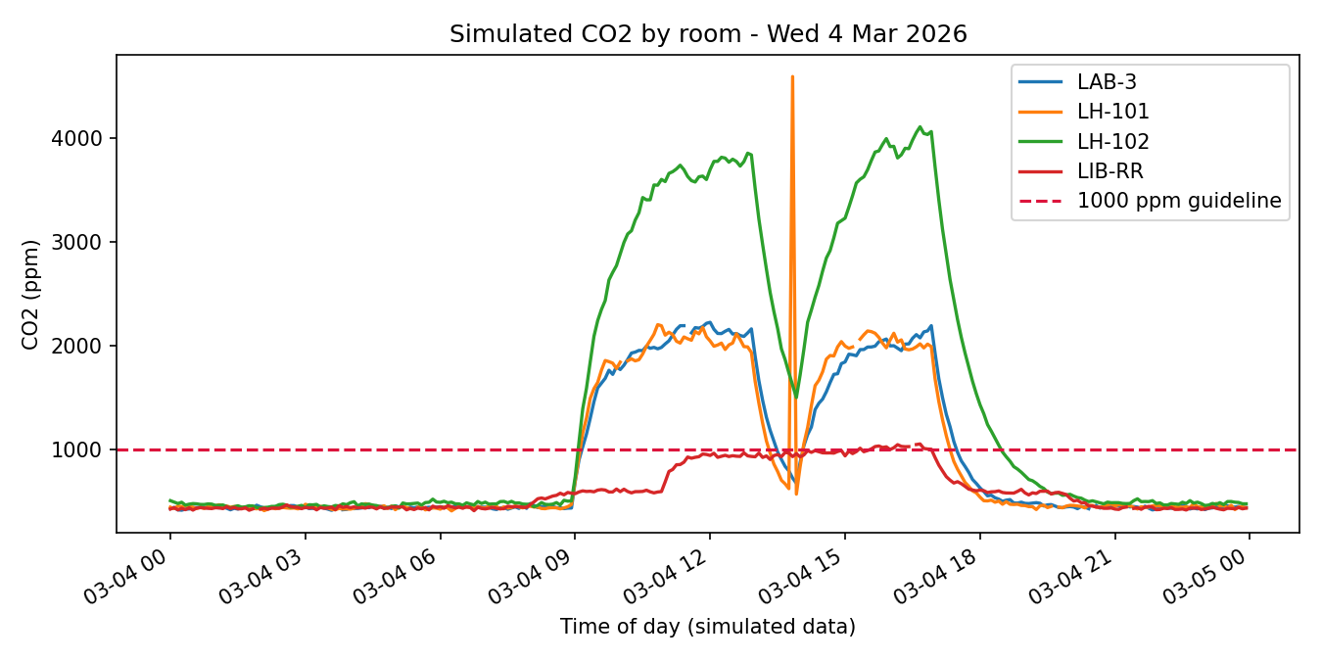
These results demonstrate the pipeline, not real room performance. The ventilation numbers were chosen by the simulation author.

8. How AI was used, and limits
- Claude (with web search) drafted the design, code, documents and verified key facts against sources listed in the Verification Report.
- The project brief asks for at least two AI research tools and four free AI tools. The prompt library lists ready-to-run prompts for Perplexity, NotebookLM, Gemini, ChatGPT and Gamma. The student must run these, capture outputs and complete the logs; this report does not claim they were run.
- Thresholds (1000 ppm CO2, 60 ug/m3 PM2.5) are screening values for a prototype, not medical or regulatory advice.

9. Sources to cite (check access date)
Source | What it supports | Link
OWASP Internet of Things Project | IoT Top 10 2018 risk categories | owasp.org/www-project-internet-of-things
NIST IR 8259 Rev. 1 (April 2026) | Manufacturer cybersecurity activities | csrc.nist.gov/pubs/ir/8259/r1/final
NIST IR 8228 | IoT cybersecurity and privacy risk considerations | csrc.nist.gov (search IR 8228)
OASIS MQTT Version 5.0 | MQTT protocol specification | docs.oasis-open.org/mqtt/mqtt/v5.0/
WHO Global Air Quality Guidelines 2021; CPCB NAAQS | PM2.5 reference values (WHO 24-h 15; India 24-h 60 ug/m3) | who.int; cpcb.nic.in

