Driver Drowsiness Detection and Alert System using CNN and Fuzzy Logic
Varnit Bansal  Roll No. 2024UCM2313  Dept. of Computer Science and Engineering  Netaji Subhas University of Technology | Prisha Yadav  Roll No. 2024UCM2367  Dept. of Computer Science and Engineering  Netaji Subhas University of Technology | Dishita Gupta  Roll No. 2024UCM2374  Dept. of Computer Science and Engineering  Netaji Subhas University of Technology | Tanishka Kumar  Roll No. 2024UCM2388  Dept. of Computer Science and Engineering  Netaji Subhas University of Technology

Abstract—Driving while sleepy is a common reason for road accidents. Many camera-based systems watch only one sign of tiredness and use one fixed threshold to decide. In this project we use two small CNNs, one for eye state (open or closed) and one for mouth state (yawning or not), and a fuzzy system that combines their outputs. Over a window of 20 frames, we calculate three simple values: PERCLOS, yawn share and eye-closure duration (ECD). A Mamdani fuzzy system with four IF–THEN rules turns these values into a drowsiness score from 0 to 100 and into one of three states: normal, warning or drowsy. Both CNNs use the same architecture with 27,777 parameters. On a 20% validation split of a public Kaggle dataset, the eye CNN reached 99.5% accuracy and the yawning CNN reached 98%. We also compared the fuzzy system with a simple crisp-threshold rule on six simulated scenarios; they gave the same state in five and differed in one. These results are preliminary because we used only still images from one dataset and no real driving video.
Index Terms—drowsiness detection, CNN, fuzzy logic, PERCLOS, yawning, soft computing

I. Introduction
Drowsy driving is a serious road-safety problem. The U.S. NHTSA estimated that about 91,000 police-reported crashes in 2017 involved drowsy drivers, with roughly 50,000 injuries and nearly 800 deaths, and it says the real numbers are probably higher [1]. Drowsiness does not come suddenly. It builds up slowly through longer eye closures and repeated yawning, so a good system should watch these signs over time instead of reacting to a single frame.
Many existing systems raise an alarm using a single threshold on a single sign, or use landmark-based rules such as the eye aspect ratio [2], which can fail with changes in face shape, lighting and eyewear [3]. Such a hard yes/no rule is not ideal here, because researchers do not even agree on the right cut-off values for indicators like PERCLOS [4]. Celecia et al. combine PERCLOS, eye-closure duration and mouth-opening time using a fuzzy system, but they get the eye and mouth states from landmark rules with fixed thresholds [4]. Zohoorian Yazdi and Soryani use a CNN for the eyes and depth data for yawning, and join them with a logical OR, reporting about 90% accuracy [5]. Our idea is to join both approaches: small CNNs read the eye and mouth state, and a fuzzy system decides how serious the situation is by looking at how these states add up over a short time.
The main points of this paper are:
- Two small CNNs with the same architecture (27,777 parameters), one for eyes and one for yawning.
- Three simple indicators over a 20-frame window and a four-rule Mamdani fuzzy system that gives a score instead of only yes/no.
- A comparison of the fuzzy system with a crisp threshold rule on six simulated scenarios, along with an honest discussion of what our experiments do not show.
Our system takes already cropped eye and mouth images as input. Face detection, live camera capture and hardware deployment are outside the scope of this work.

II. System Overview
Fig. 1 shows the complete pipeline. An eye image goes to the eye CNN and a mouth image goes to the yawning CNN. Each CNN gives a probability, which is compared with 0.5 to get a label for that frame. The labels of 20 frames are summarised into PERCLOS, yawn share and ECD. These three values go to the fuzzy system (our proposed method) and also to a crisp rule (the baseline). The final state decides which alert message is shown.
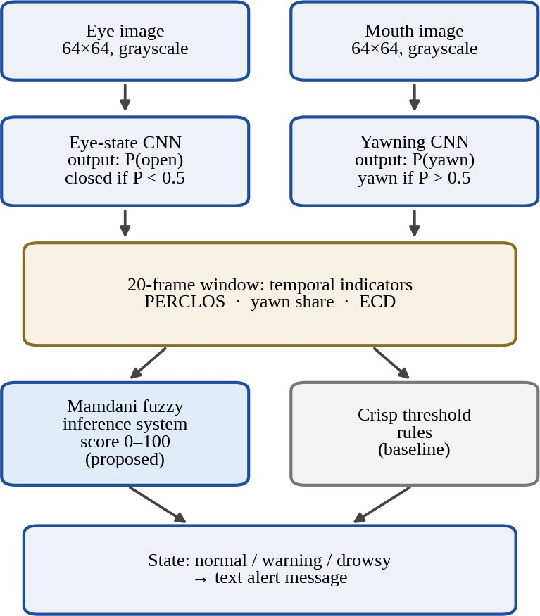
Fig. 1. Workflow of the drowsiness detection pipeline.

III. Dataset and Preprocessing
We used the public Kaggle dataset hoangtung719/drowsiness-dataset, which has four image classes: open eyes, closed eyes, yawn and no yawn. In the notebook all folders with these names were copied into an eye folder and a mouth folder. This gave 5,452 eye images and 6,114 mouth images (11,566 in total). Table I shows the class counts.
Table I
Dataset and 80/20 split
Task | Class | Total | Train | Validation
Eye state | Closed | 2,726 | 2,213 | 513
Eye state | Open | 2,726 | 2,149 | 577
Eye state | All | 5,452 | 4,362 | 1,090
Mouth state | No yawn | 3,089 | 2,484 | 605
Mouth state | Yawn | 3,025 | 2,408 | 617
Mouth state | All | 6,114 | 4,892 | 1,222
Validation class counts come from the confusion matrices in Fig. 5; training counts are total minus validation.
Every image is loaded in grayscale and resized to 64×64. Pixel values are divided by 255 inside the model. We did not use data augmentation. Each task is split 80% for training and 20% for validation with a fixed seed (42 for eyes, 123 for mouth), and the batch size is 32. Since classes are indexed alphabetically, the eye CNN outputs the probability of open and the yawning CNN outputs the probability of yawn.

IV. CNN Models

A. Architecture
Both CNNs use the same small architecture (Table II): three 3×3 convolution layers with 16, 32 and 64 filters, each followed by 2×2 max pooling, batch normalization after the third convolution, global average pooling, and a small dense head with dropout and one sigmoid output. Global average pooling is used instead of flattening so that the number of parameters stays small. We tried only this one architecture, so no comparison with other designs was done.
Table II
CNN architecture (same for both models)
Layer | Output shape | Params
Input + rescaling (1/255) | 64×64×1 | 0
Conv 3×3, 16 filters, ReLU + max pool | 31×31×16 | 160
Conv 3×3, 32 filters, ReLU + max pool | 14×14×32 | 4,640
Conv 3×3, 64 filters, same, ReLU | 14×14×64 | 18,496
Batch normalization + max pool | 7×7×64 | 256
Global average pooling + dropout (0.3) | 64 | 0
Dense 64, ReLU + dropout (0.2) | 64 | 4,160
Dense 1, sigmoid | 1 | 65
Total |  | 27,777

B. Training
Both models are trained with the Adam optimizer (learning rate 0.001) and binary cross-entropy loss:
Loss = − average of [y log(p) + (1 − y) log(1 − p)]
where y is the true label (0 or 1) and p is the predicted probability. Training runs for at most 30 epochs. We use early stopping (training stops when the validation loss does not improve for 5 epochs and the best weights are kept) and also halve the learning rate when the validation loss stops improving. The eye CNN stopped after 26 epochs and the yawning CNN after 25 epochs.
Table III summarises the training results.
Table III
Training summary
Measure | Eye CNN | Yawn CNN
Epochs run | 26 | 25
Training accuracy / loss | 0.9899 / 0.0331 | 0.9677 / 0.0976
Validation accuracy / loss | 0.995 / 0.0172 | 0.98 / 0.0801
Validation images | 1,090 | 1,222
Wrongly classified | 5 | 24

V. Fuzzy Decision Layer

A. Indicators
For each frame, the eye CNN says closed if P(open) < 0.5, and the yawning CNN says yawning if P(yawn) > 0.5. For a window of N = 20 frames we then calculate:
PERCLOS = (closed frames) / N
Yawn share = (yawning frames) / N
ECD = length of the longest run of closed frames in a row
The ECD is simply a count in frames. For example, if the closed/open pattern is 0 1 1 0 1 1 1 0, then PERCLOS counts 5 closed frames, but ECD is 3 because the longest streak is 3. This helps to tell normal blinks (short closures) from a long closure. ECD is in frames and not in seconds because the notebook does not use a frame rate. Before the fuzzy step the inputs are limited to 0.5 (PERCLOS, yawn share) and 6 frames (ECD).

B. Mamdani fuzzy system
We built a Mamdani system with the scikit-fuzzy library. Each input has three triangular membership functions (low, medium, high for PERCLOS and yawn share; short, medium, long for ECD) and the output score has three (normal, warning, drowsy). These are the evenly spaced triangles made by the library’s automatic function and are shown in Fig. 2. We use the default operators (minimum for AND, maximum for OR). The final score is the centroid, i.e. the weighted average of the output values z from 0 to 100, where the weights are the combined membership values:
Score = Σ ( z × membership(z) ) / Σ membership(z)
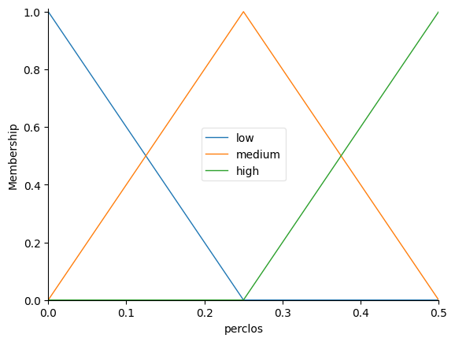 | 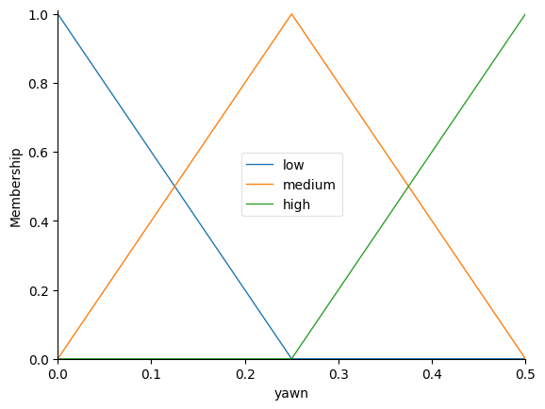
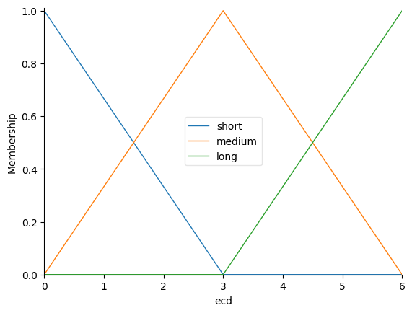 | 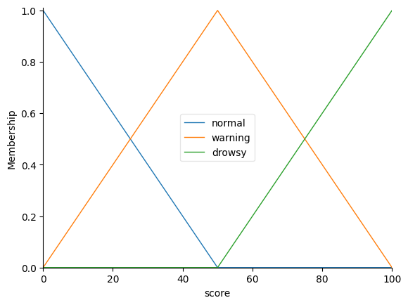
Fig. 2. Membership functions of PERCLOS, yawn share, ECD and the output drowsiness score (from the notebook).
Table IV
Fuzzy rule base
# | Rule
R1 | IF PERCLOS is high OR yawn is high OR ECD is long THEN score is drowsy
R2 | IF PERCLOS is medium OR ECD is medium THEN score is warning
R3 | IF yawn is medium AND PERCLOS is low THEN score is warning
R4 | IF PERCLOS is low AND yawn is low AND ECD is short THEN score is normal

The score is turned into a state using two cut-offs: normal if score < 45, warning from 45 to below 55, and drowsy if score ≥ 55. These cut-offs were chosen by hand and were not tuned on data. The rules use ECD to separate a few blinks from one long closure: with the same PERCLOS, many short closures mostly trigger R2, while one long closure also triggers R1.

C. Crisp baseline and alerts
As a baseline we use a simple rule on the same three values. The state is drowsy if PERCLOS ≥ 0.30 or yawn share ≥ 0.20 or ECD ≥ 3, warning if PERCLOS ≥ 0.15 or yawn share ≥ 0.10 or ECD ≥ 2, and normal otherwise. The alert part just prints a message for each state (for example “DROWSY! WAKE UP! Please rest.”). No sound, e-mail or live camera is used.

VI. Results and Discussion

A. Eye-state CNN
Fig. 3 shows the accuracy and loss of the eye CNN over 26 epochs. Training accuracy rises from 0.748 to 0.991. The validation curve is unstable at the beginning: accuracy drops to 0.529 in epoch 2 (loss 1.736) and dips again around epochs 5 and 9, but it stays above 0.97 from epoch 10 onward. We think batch normalization was still settling in the early epochs, but we did not test this. After the learning rate was reduced the curves became smoother. The final eye model reaches a validation accuracy of 0.995. Validation accuracy being slightly above training accuracy is partly because dropout is active only during training.
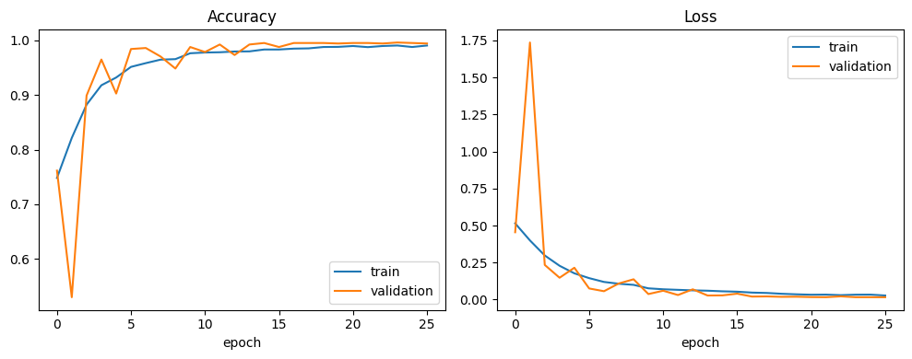
Fig. 3. Accuracy and loss of the eye-state CNN (notebook output).

B. Yawning CNN
The yawning CNN (Fig. 4) trains more smoothly. Training accuracy goes from 0.828 to 0.971 and validation accuracy from 0.847 to 0.98. The two curves stay close, so we do not see overfitting. Its final accuracy is lower than that of the eye CNN and its training loss was still falling slowly, so it may not have fully converged.
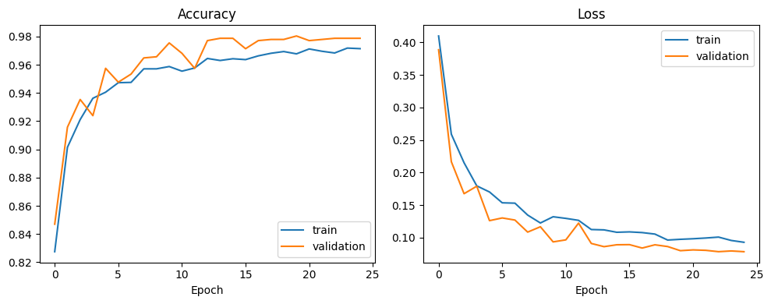
Fig. 4. Accuracy and loss of the yawning CNN (notebook output).

C. Confusion matrices
Fig. 5 shows the confusion matrices on the validation sets. The eye CNN made 5 mistakes out of 1,090 images (3 closed eyes predicted open and 2 open eyes predicted closed). The yawning CNN made 24 mistakes out of 1,222 (12 yawns missed and 12 non-yawns called yawns). For drowsiness a missed closed eye or missed yawn is the more costly mistake; these are 3 of 513 closed-eye images (0.58%) and 12 of 617 yawn images (1.94%). The classes are nearly balanced, so accuracy is a fair measure here.
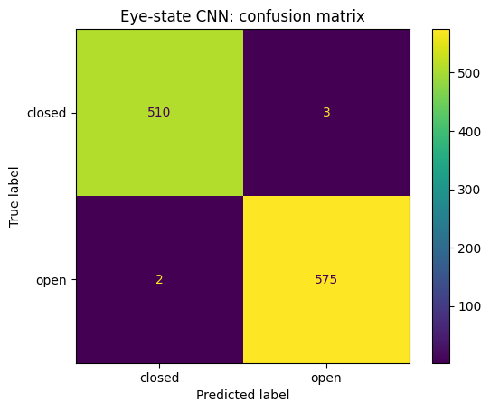 | 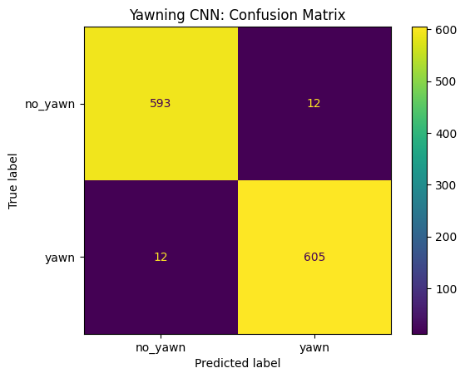
Fig. 5. Confusion matrices of (a) the eye-state CNN and (b) the yawning CNN on their validation sets (notebook output).

D. Fuzzy and crisp decisions on simulated scenarios
To test the decision layers, we made six 20-frame scenarios. For each one, a hand-written open/closed pattern picks random eye images from the dataset and a fixed number of yawn images is picked for the mouth (seed 42). The CNNs classify them and the resulting PERCLOS, yawn share and ECD go to both decision layers. In three scenarios the CNN made one small mistake (for example, in “many short closures” one closed frame was read as open, so PERCLOS is 0.25 and not 0.30). Results are in Table V and Fig. 6.
Table V
Fuzzy and crisp decisions on six simulated scenarios
Scenario | PERCLOS | Yawn share | ECD | Score | Fuzzy | Crisp
Alert driver | 0.00 | 0.00 | 0 | 16.7 | normal | normal
Normal blinks | 0.10 | 0.05 | 1 | 41.2 | normal | normal
Many short closures | 0.25 | 0.00 | 1 | 50.0 | warning | warning
One long closure | 0.25 | 0.00 | 5 | 56.7 | drowsy | drowsy
Tired and yawning | 0.20 | 0.25 | 2 | 50.0 | warning | drowsy
Very drowsy | 0.70 | 0.35 | 14 | 83.3 | drowsy | drowsy

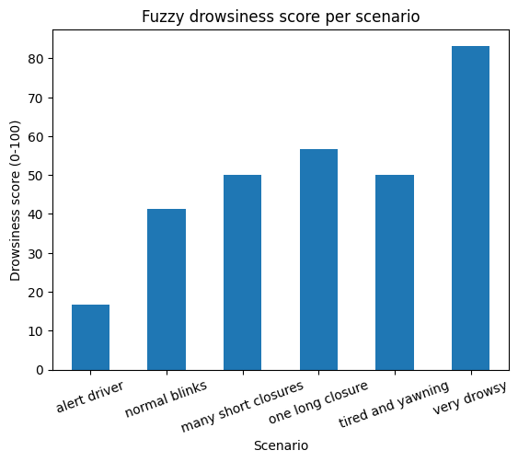
Fig. 6. Fuzzy drowsiness score for each simulated scenario.
The two layers agree in five of six scenarios. They differ only for “tired and yawning”: the crisp rule says drowsy because the yawn share (0.25) crosses its 0.20 limit, whereas the fuzzy score of 50.0 gives only a warning. The two scenarios with PERCLOS 0.25 show the effect of ECD: many short closures give 50.0 (warning) while one long closure gives 56.7 (drowsy), although this is only 1.7 points above the drowsy cut-off. The fuzzy score is also a graded value: it is 16.7 for the alert driver (not 0) and 41.2 for normal blinks, close to the warning boundary. Since these scenarios have no ground-truth labels, this does not prove that the fuzzy system is more accurate than the crisp one. It only shows that it grades the cases differently.

VII. Limitations
- Validation, not test results. The same validation split was used for early stopping, learning-rate reduction and keeping the best weights, so the accuracies are probably a little optimistic. We had no separate test set.
- Possible data leakage. The split is random at image level. If the dataset has many frames of the same person, similar images may be in both training and validation sets, which can inflate accuracy. We did not check this, so the high accuracy does not prove the model works on new drivers, lighting or eyewear.
- Single dataset and single run. We used one dataset, no augmentation, and one training run per model.
- Simulated scenarios. The six scenarios use random still images instead of real video, some images were seen during training, and six cases are too few for any statistical claim. The fuzzy parameters were not tuned and ECD is in frames, not seconds.
- Alerts and hardware. The alert module only prints text, and we did not measure speed or memory on low-cost hardware.

VIII. Conclusion and Future Work
We built a drowsiness detection pipeline in which two small CNNs read eye and mouth state and a Mamdani fuzzy system converts PERCLOS, yawn share and ECD into a score and a state. The eye CNN reached 99.5% validation accuracy and the yawning CNN 98%. On six simulated scenarios the fuzzy system agreed with a crisp baseline in five and gave a milder state in one. These results are preliminary.
In future we would like to (i) test on a separate test set split by person or video, (ii) use real driving recordings with labelled drowsiness levels, (iii) measure PERCLOS and ECD in seconds using the frame rate, (iv) tune the membership functions, rules and cut-offs, (v) add face detection, a live camera and sound alerts, and (vi) test speed and memory on low-cost hardware.

References
[1] National Highway Traffic Safety Administration, “Drowsy driving.” [Online]. Available: https://www.nhtsa.gov/risky-driving/drowsy-driving
[2] T. Soukupová and J. Čech, “Real-time eye blink detection using facial landmarks,” in Proc. 21st Computer Vision Winter Workshop (CVWW), 2016.
[3] Y. Albadawi, M. Takruri, and M. Awad, “A review of recent developments in driver drowsiness detection systems,” Sensors, vol. 22, no. 5, Art. no. 2069, 2022.
[4] A. Celecia, K. Figueiredo, M. Vellasco, and R. González, “A portable fuzzy driver drowsiness estimation system,” Sensors, vol. 20, no. 15, Art. no. 4093, 2020.
[5] M. Zohoorian Yazdi and M. Soryani, “Driver drowsiness detection by identification of yawning and eye closure,” Int. J. Automotive Engineering, vol. 9, no. 3, pp. 3033–3044, 2019.

