FULL PROJECT REPORT: MULTITHREADED WIKIPEDIA CRAWLER AND FREQUENCY ANALYSER
Course Component: Full-Stack Software Engineering Portfolio
Developer Name: Varri Yaswanth

1. PROJECT SPECIFICATIONS AND ABSTRACT
The Multithreaded Wikipedia Crawler and Frequency Analyser is an enterprise-grade Java web platform engineered on top of the Spring MVC design architecture. The primary objective of this application is to execute high-volume, concurrent web scraping tasks without inducing server-side thread locking or latency overhead.
The application implements Java's native Runnable concurrency mechanics to instantiate decoupled background workers. These workers concurrently query remote Wikipedia endpoints, extract unstructured textual descriptions, sanitize web content, and isolate absolute media file coordinates.
Additionally, the system incorporates an independent Word Frequency Analyser engine. This module processes raw data documents (such as .txt files) using a singleton configuration manager, maps unique string tokens, tracks word distribution matrices, and outputs term densities sorted by occurrence.

2. SYSTEM ARCHITECTURE AND FOLDER LAYOUT
The software application follows a standardized Maven compilation directory layout, decoupling backend controllers, database utilities, and client-facing view templates.
2.1 Project Directory Structural Map
The image below captures the absolute folder hierarchy of the application source tree inside the IntelliJ explorer view:

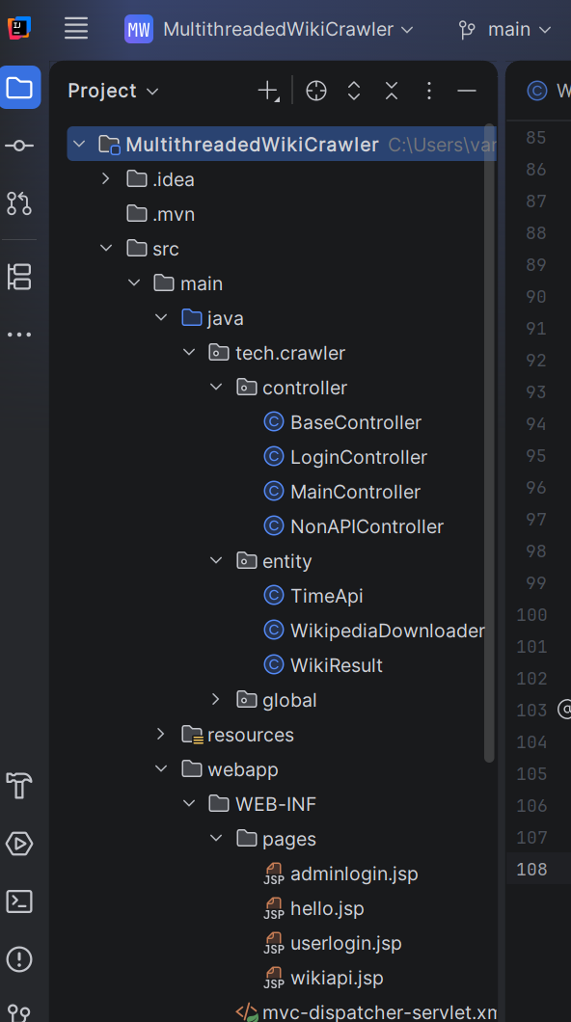
- tech.crawler.controller: Directs inbound HTTP request boundaries. Includes BaseController, LoginController, MainController, and NonAPIController to separate data-only REST endpoints from front-facing views.
- tech.crawler.entity: Houses data model representations and execution models, including TimeApi, WikiResult, and the multithreaded core component WikipediaDownloader.
- src/main/webapp/WEB-INF/pages/: Contains client view templates, including adminlogin.jsp, userlogin.jsp, hello.jsp, and wikiapi.jsp.

3. DEPENDENCY SELECTION AND BUILD PARAMETERS
The application utilizes Maven to automate software lifecycle processes and maintain external software builds. It integrates GSON for rapid object-to-JSON serialization and JSoup for parsing remote HTML DOM trees.
3.1 Maven Configuration (pom.xml)
The screenshot below confirms the baseline library specifications used to compile the application modules:
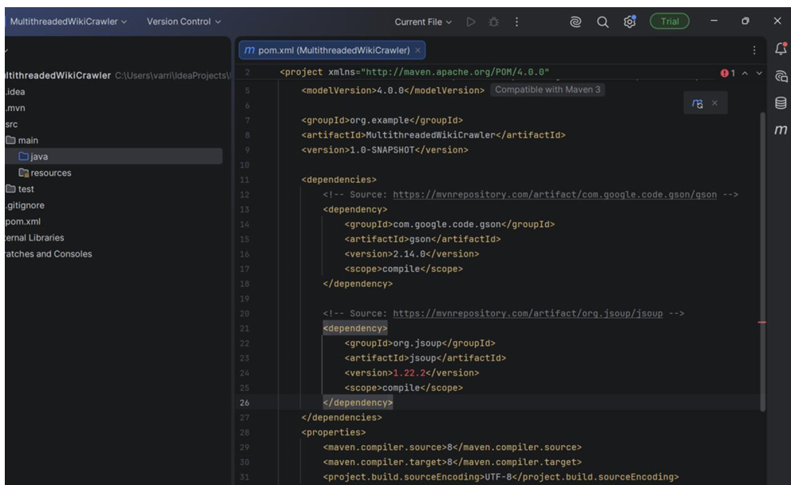

4. MULTITHREADED EXECUTION AND CORE RUNTIME OUTPUTS
4.1 Asynchronous Concurrent Crawling
By overriding the run() execution block of the Runnable library interface, the WikipediaDownloader module launches separate network threads to fetch data for distinct target terms simultaneously:
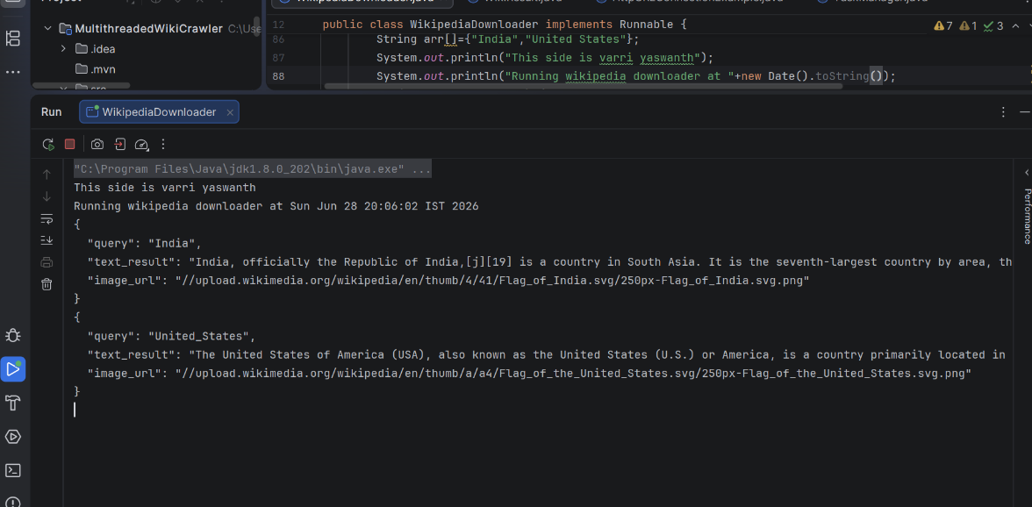

4.2 Word Frequency Density Tracking
The sub-analytical engine reads external file text structures, maps unique character strings, and sorts individual words based on density metrics:
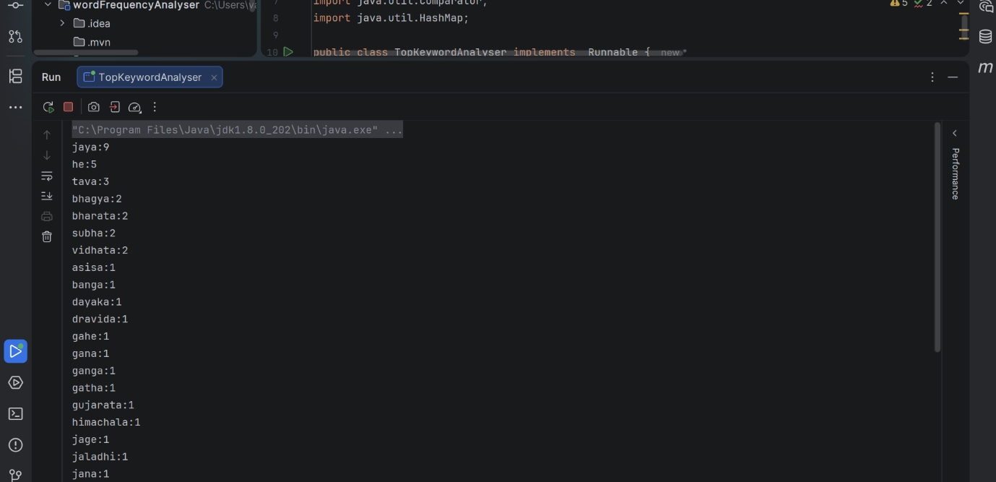

4.3 Database Persistence Node Validation
System parameters, coder log tracking tables, and data nodes are maintained inside a PostgreSQL database server context layer using explicit jOOQ query layouts:
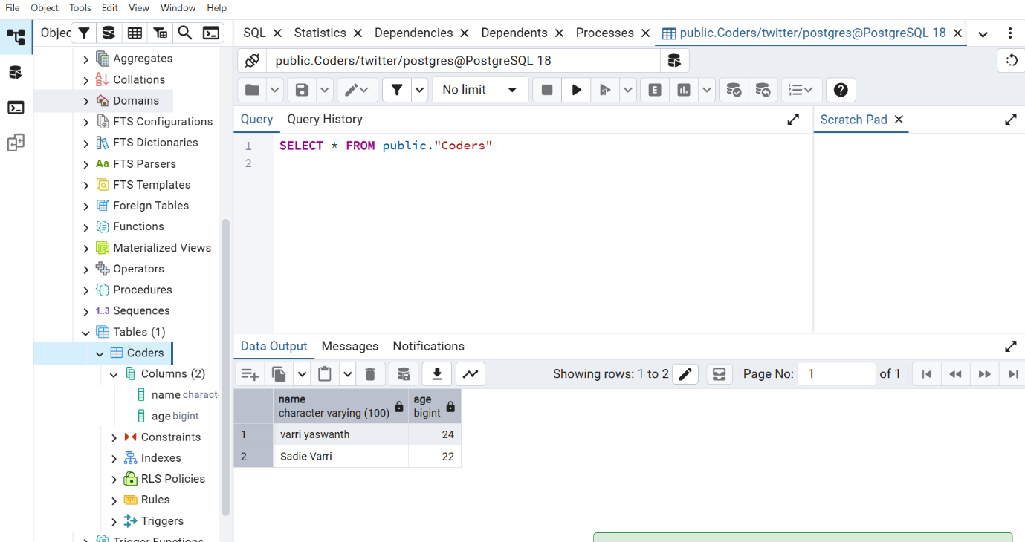

5. ENDPOINT ROUTING AND FRONTEND VIEW PROOFS
5.1 Base Gateway Validation
When launching the application context via the Jetty engine plugin, standard health routing paths verify core stability:
- Endpoint /helloworld: Confirms basic view resolver mapping.
- Endpoint /test: Confirms baseline HTTP connection loops.
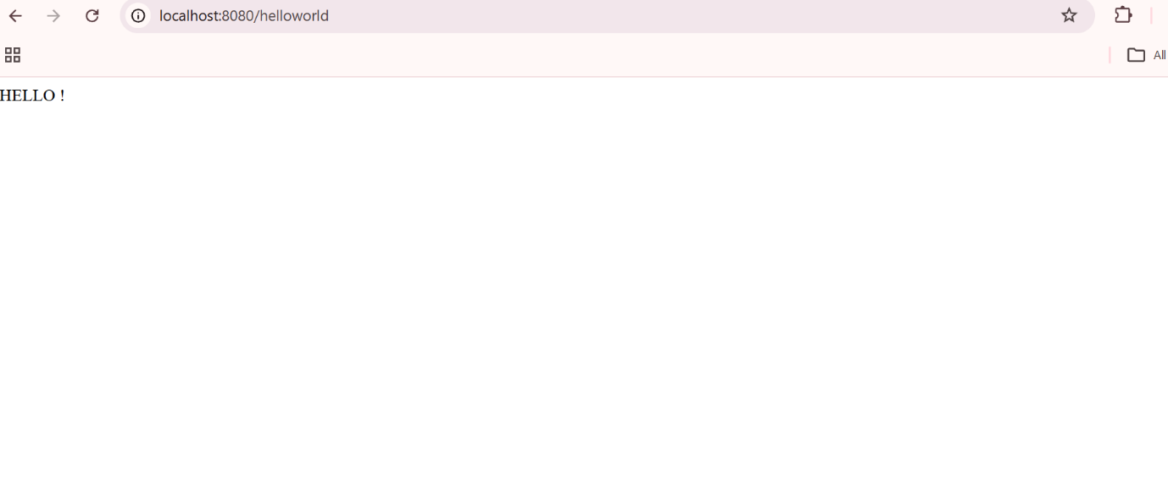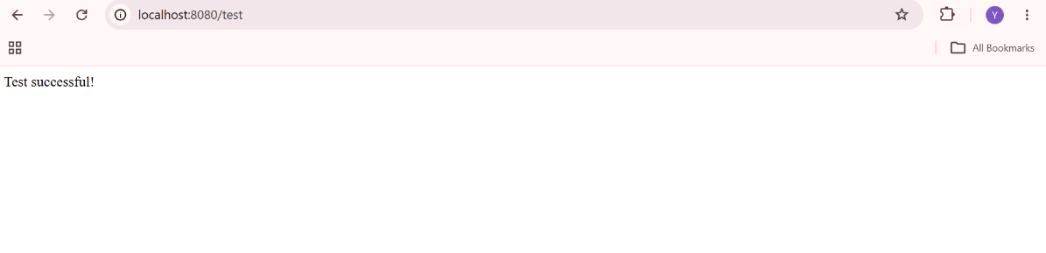

5.2 User Interface Portals
The application isolates system administration panels from consumer endpoints using standalone JSP forms:
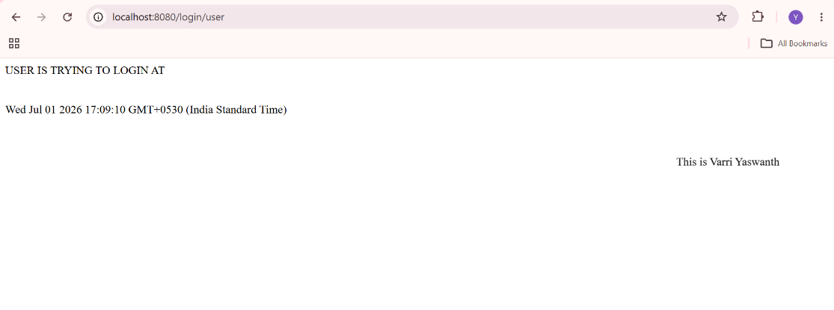

5.3 REST API JSON Payload Conversions
When external components query the REST API context path at /api/wiki?keyword=..., the application returns a raw JSON object string mapping the text summaries and absolute asset urls:
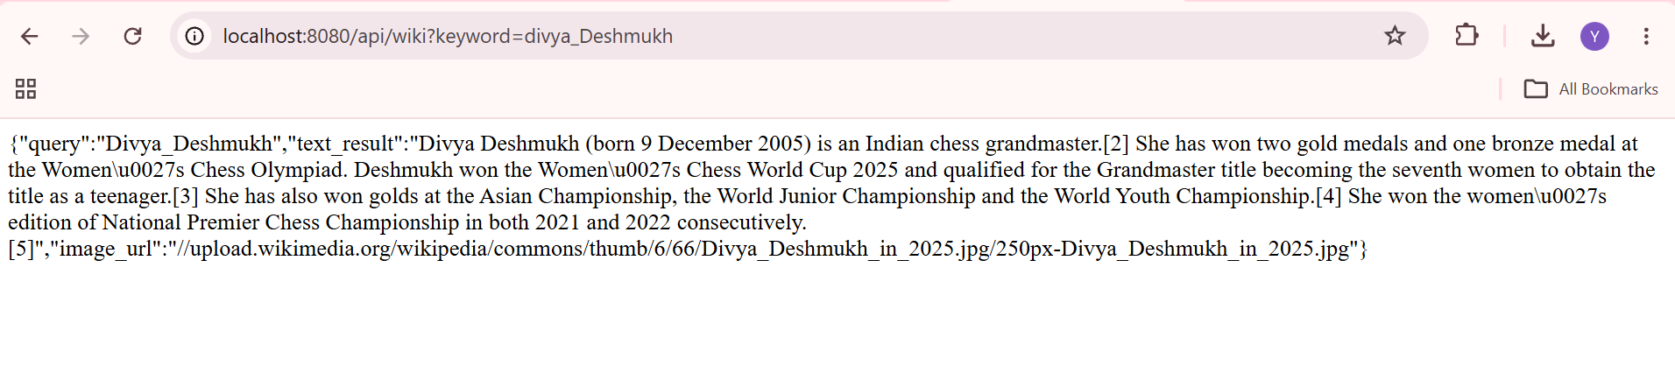
5.4 Dynamic HTML Web Presentations
When a request hits the /api/wiki/html path, the view engine injects the scraped content directly into responsive presentation layers:
(PASTE YOUR EXTRACTED SCREENSHOT HERE: The browser window rendering the final visual template for the India search request along with its flag image) 