ABSTRACT:

This project aims to explore the process of reversing a video using the OpenCV (OpenSource Computer Vision) library. Video reversal involves playing a video backward, creating a reverse chronological sequence of frames. The primary goal is to demonstrate the application of computer vision techniques in manipulating video content. This project provides an in-depth understanding of the steps involved in reversing a video and highlights the capabilities of OpenCV in video processing.

INTRODUCTION:

Video reversal is a common technique used in video editing and computer vision applications. It involves flipping the frames of a video sequence to create a backward playback effect. This project utilizes the OpenCV library, a powerful open-source computer vision and machine learning software library, to implement video reversal.

LITERATURE REVIEW:

* Video reversal is a common technique used in video editing and computer vision applications. It involves flipping the frames of a video sequence to create a backward playback effect. This project utilizes the OpenCV library, a powerful open-source computer vision and machine learning software library, to implement video reversal.
* Video processing encompasses a broad range of techniques for analyzing and altering video content. Traditional methods involve extracting individual frames, analyzing temporal patterns, and applying spatial transformations. Recent advancements have introduced deep learning approaches for more sophisticated video understanding and manipulation.
* OpenCV stands out as a popular open-source computer vision library that offers a comprehensive set of tools for image and video processing. While various studies have explored OpenCV's capabilities in tasks like object detection and tracking, there is a gap in the literature regarding its specific use for video reversal, which this project aims to address.

OBJECTIVES:

* Implement a Python script using OpenCV to reverse a video.
* Understand the fundamental concepts of video processing.
* Showcase the versatility of OpenCV in manipulating video content.

METHODOLOGY:

* Video Loading:

Use OpenCV to load the input video file.

* Frame Extraction:

Extract individual frames from the video.

* Frame Reversal:

Reverse the order of the frames to create a backward sequence.

* Video Reconstruction:

Combine the reversed frames to reconstruct the reversed video.

* Save Output:

Save the reversed video to a new file.

IMPLEMENTATION:

CODE FOR IMPLEMENTATION:

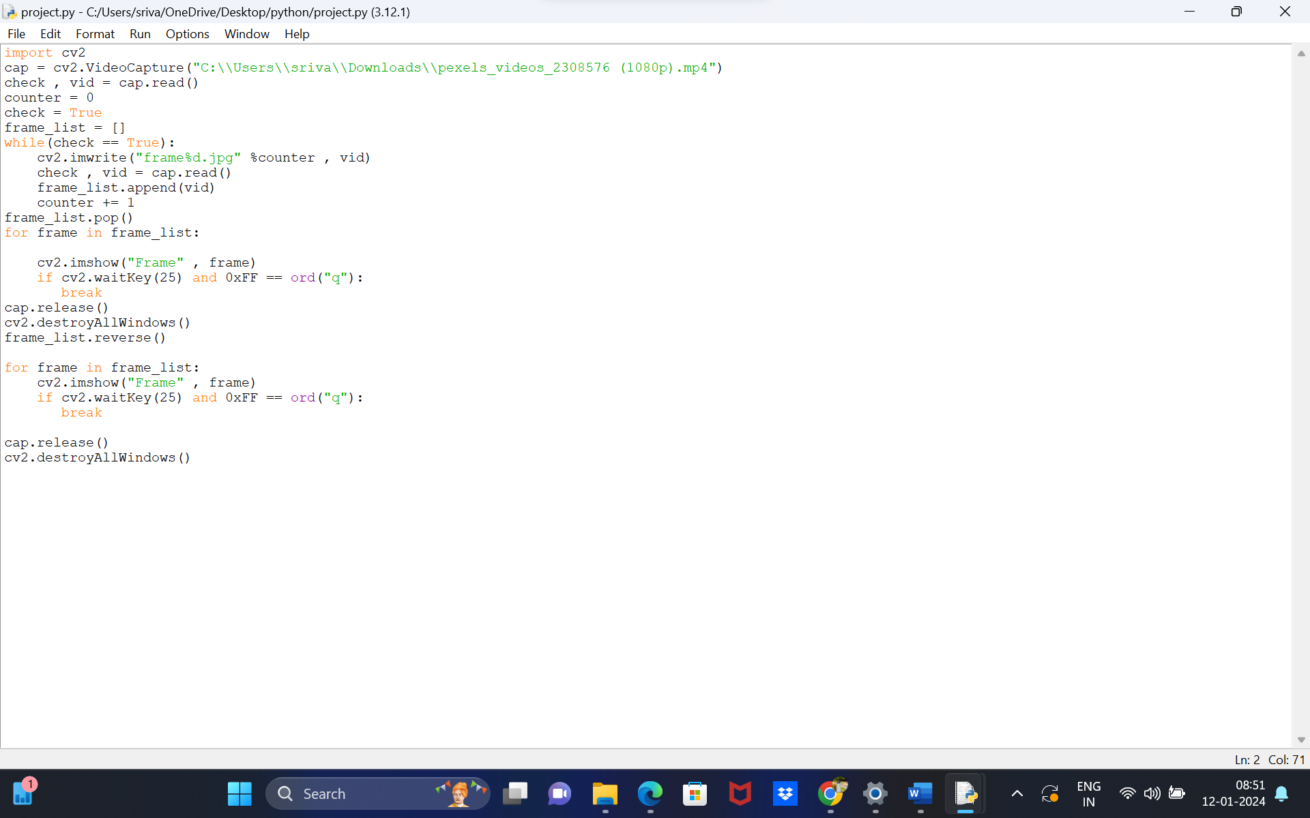

INPUT:

"C:\Users\sriva\Downloads\pexels_videos_2308576 (1080p).mp4"

APPLICATION:

Future enhancements could include exploring real-time video reversal, incorporating additional video effects, and optimizing the script for performance. Additionally, integrating the project into a graphical user interface (GUI) for user-friendly interaction could further enhance its usability.

RESULT:

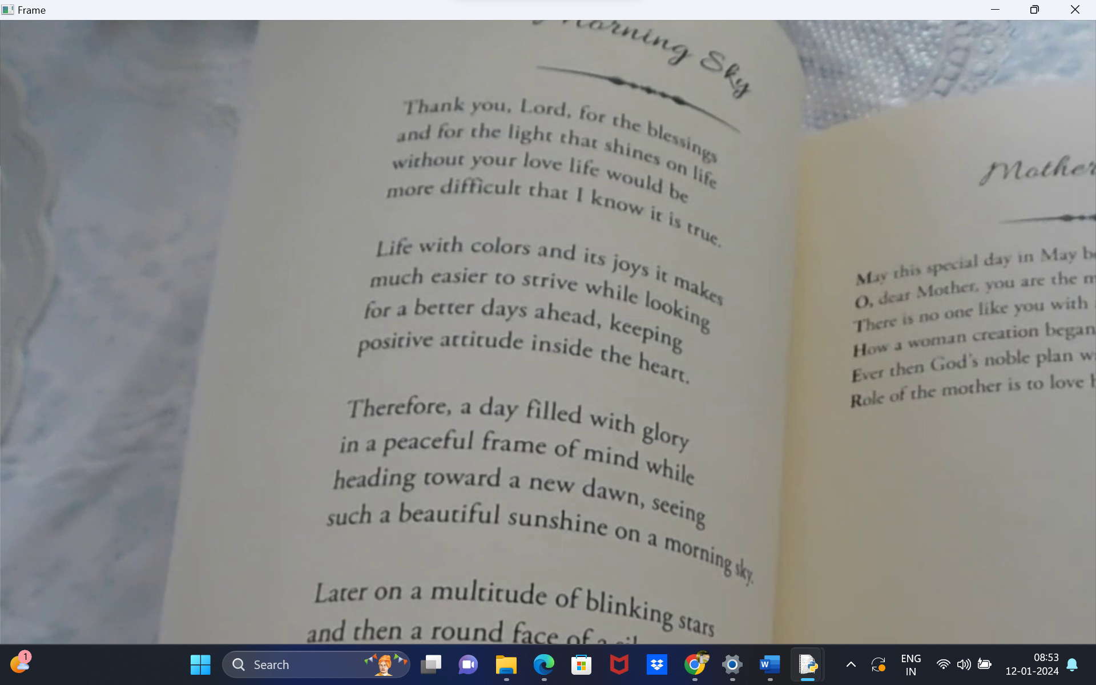

The output will be a reversed video file that can be played backward, showcasing the successful implementation of the video reversal process using OpenCV.

CONSLUSION:

This project demonstrates the practical application of OpenCV in reversing videos. Video reversal is a simple yet effective technique that finds use in various creative and analytical applications. OpenCV's capabilities make it an ideal choice for such tasks, showcasing its versatility in computer vision and video processing.