|  |  |
| --- | --- |
| 1 INTRODUCTION |  |
| 1.1 Overview |  |
| 1.2 Purpose |  |
| 2 Problem Definition & Design Thinking |  |
| 2.1 Empathy Map |  |
| 2.2 Ideation & Brainstorming Map |  |
| 3 RESULT |  |
| 4 ADVANTAGES & DISADVANTAGES |  |
| 5 APPLICATIONS |  |
| 6 CONCLUSION |  |
| 7 FUTURE SCOPE |  |
| 8 APPENDIX |  |
| A. Source Code |  |

**INTRODUCTION:**

The Tragedy of Flight: A Comprehensive crash analysis is a study that aims to analyze and understand the causes and effects of airplane crashes. The analysis involves the collection and analysis of data related to aircraft systems, operators, weather, and other factors that may have contributed to the accident. The goal of the analysis is to improve aviation safety and prevent future accidents by identifying and addressing the root causes of airplane crashes. The findings of the analysis are typically presented in a report, which may include recommendations for improving safety measures and preventing similar accidents from occurring in the future.

The aviation industry plays a critical role in modern transportation, providing a fast and efficient means of travel for people and goods across the globe. However, with the tremendous growth of air travel, the risk of accidents has also increased, making it essential to understand the causes of airplane crashes and take measures to prevent them. The Tragedy of Flight: A Comprehensive crash analysis is a detailed investigation into the causes of aviation accidents, with the ultimate goal of improving safety and preventing future accidents. This analysis involves collecting and analyzing data from various sources, including aircraft systems, operators, and other relevant factors, to identify potential causes of the accident. The results of the analysis are published in a report that includes recommendations for improving safety and preventing similar accidents in the future.

* 1. **Overview:**

The project is titled "The Tragedy of Flight: A Comprehensive Crash Analysis" and aims to provide insights and analysis into aviation accidents around the world. The project includes a detailed analysis of various factors related to aviation accidents, including the type of flight, location, operator, and number of fatalities. The analysis is presented through various visualizations and dashboards that allow users to explore and understand the data in an interactive manner. The project aims to raise awareness about aviation safety and to provide recommendations for improving safety measures and preventing future accidents.

* 1. **Purpose:**

The project is titled "The Tragedy of Flight: A Comprehensive Crash Analysis" and aims to provide insights and analysis into aviation accidents around the world. The project includes a detailed analysis of various factors related to aviation accidents, including the type of flight, location, operator, and number of fatalities. The analysis is presented through various visualizations and dashboards that allow users to explore and understand the data in an interactive manner. The project aims to raise awareness about aviation safety and to provide recommendations for improving safety measures and preventing future accidents.

**Problem Definition & Design Thinking:**

**2.1 Empathy Map:**

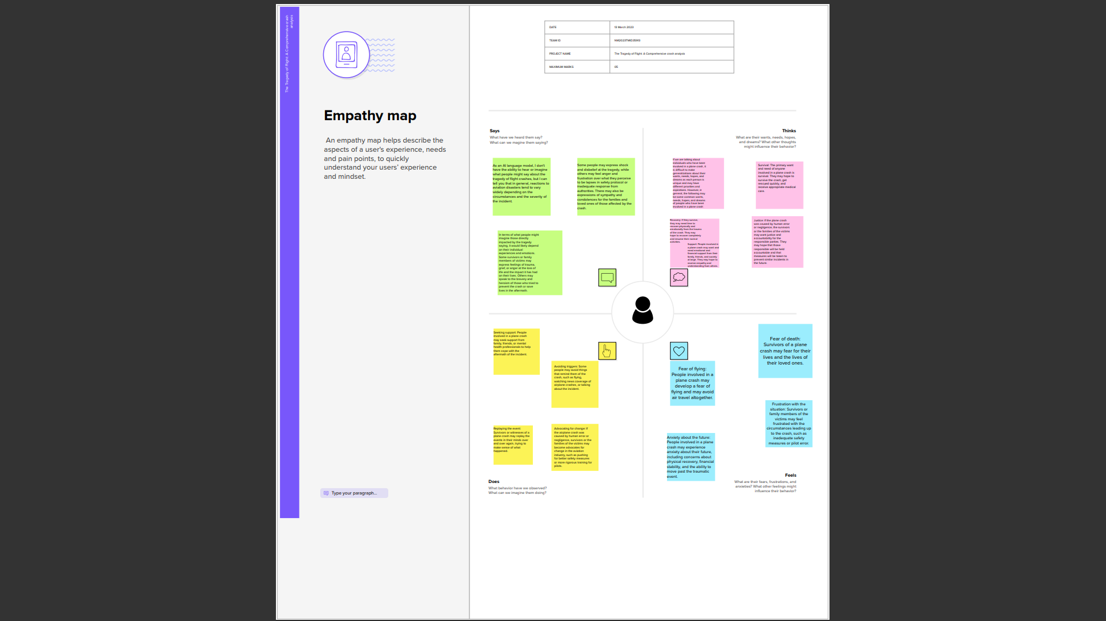

**2.2 Ideation & Brainstorming Map:**

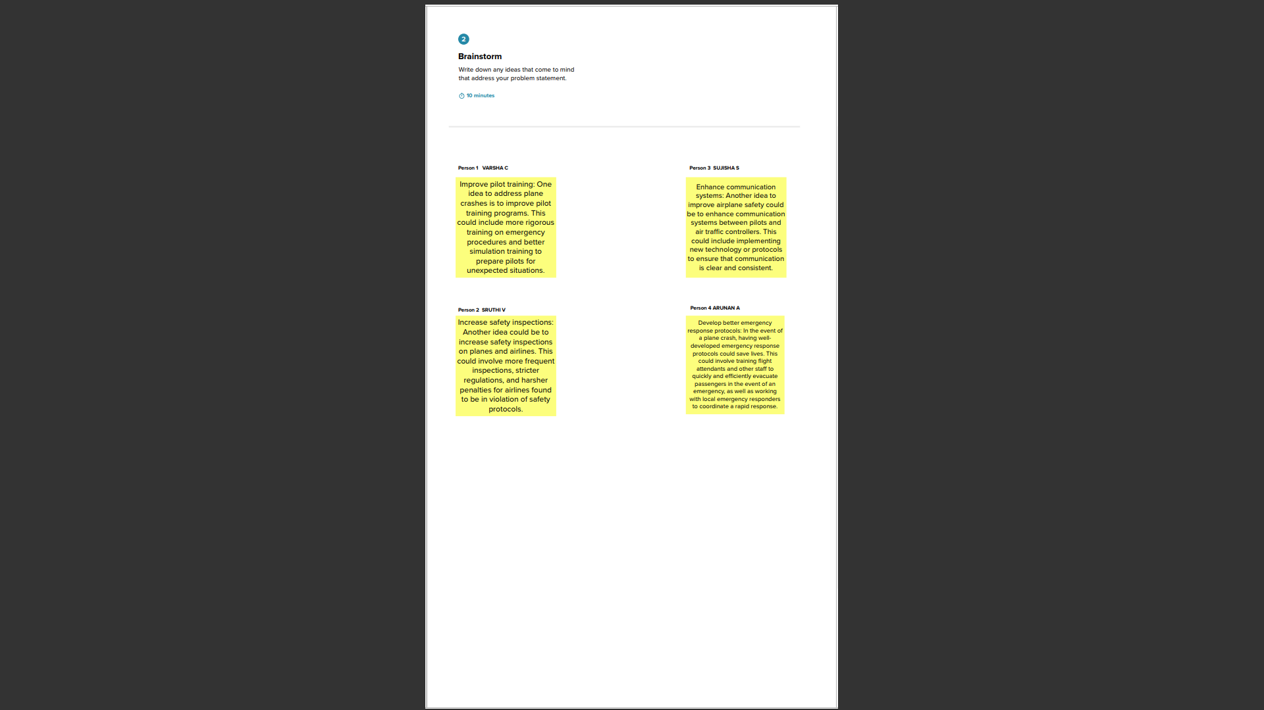

**3 RESULT**

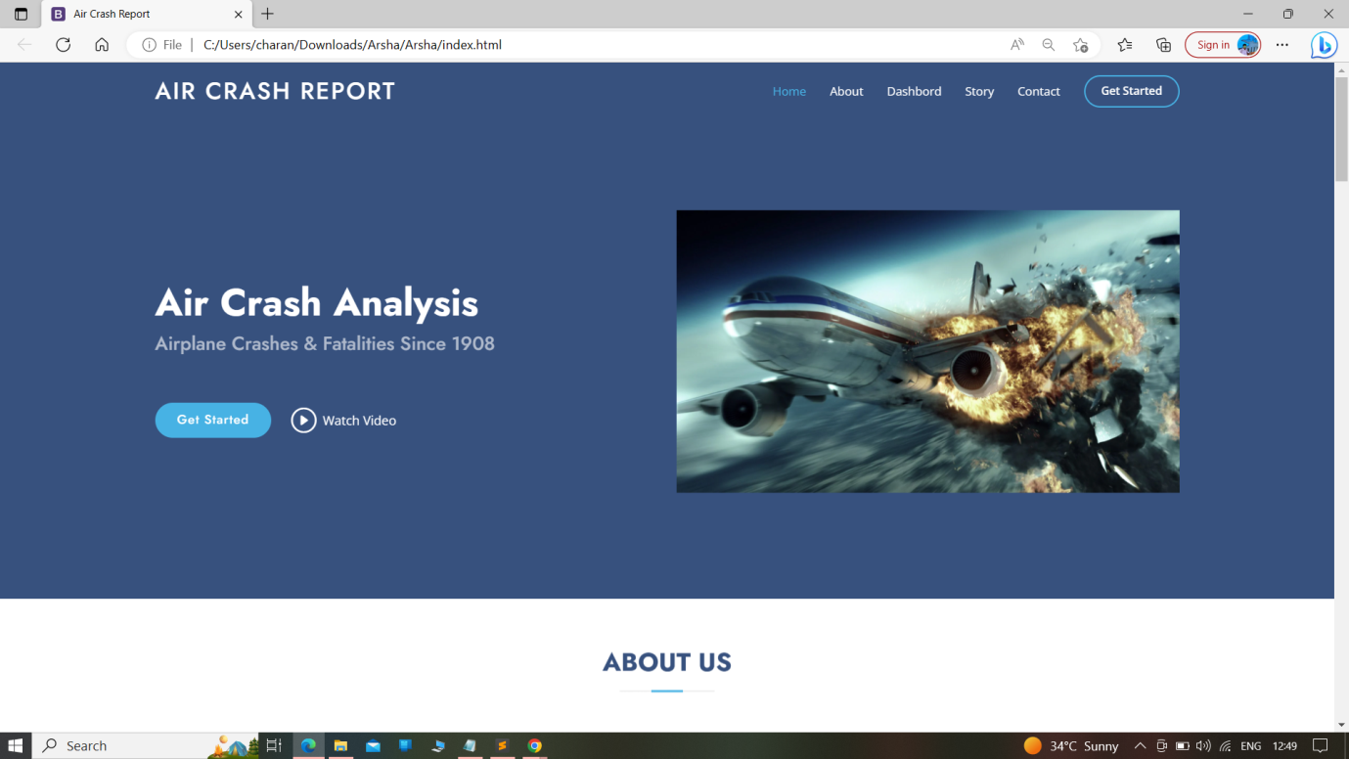

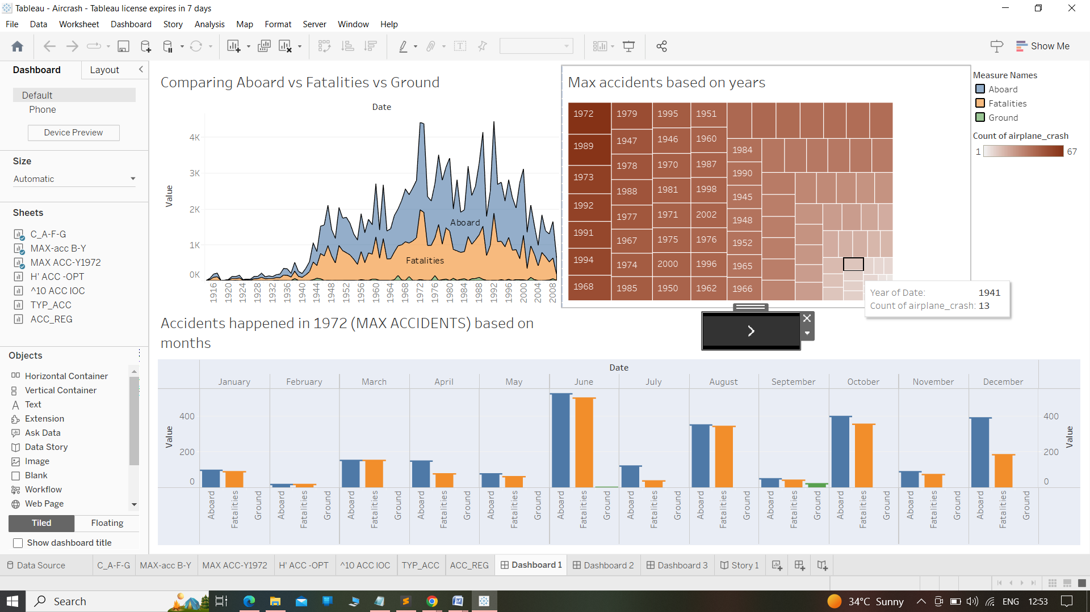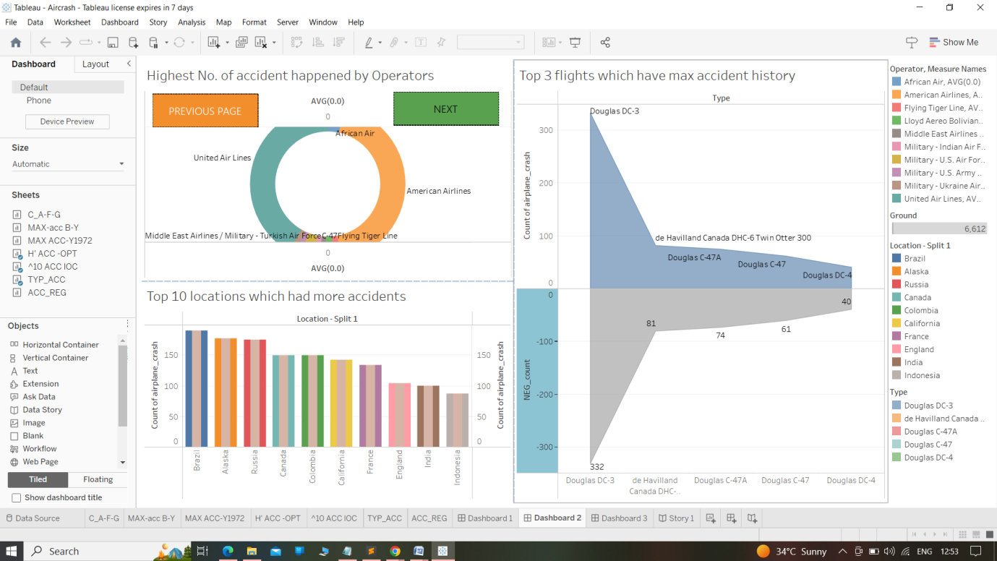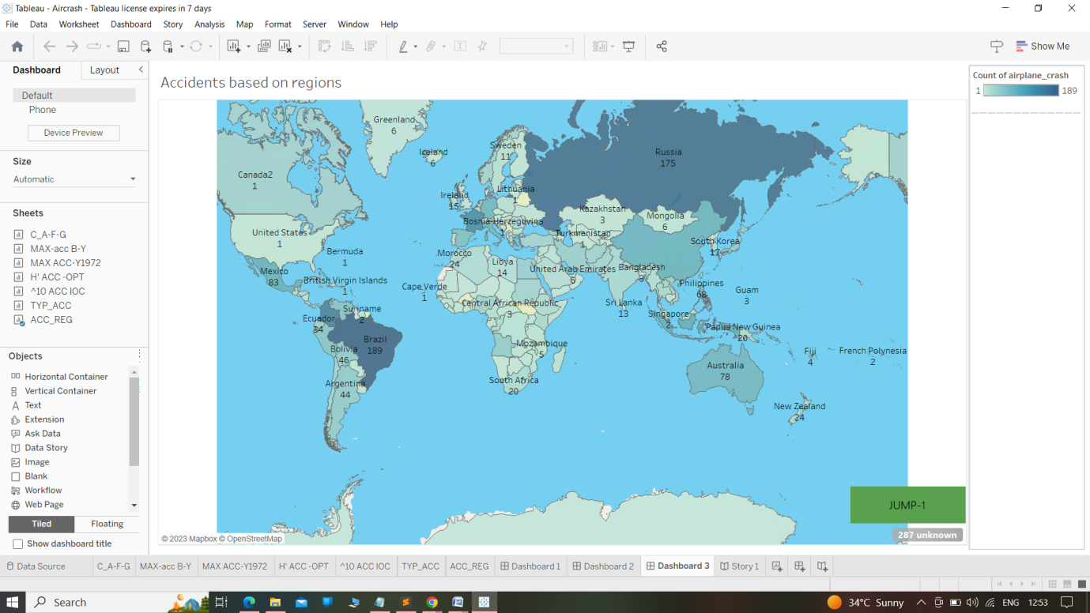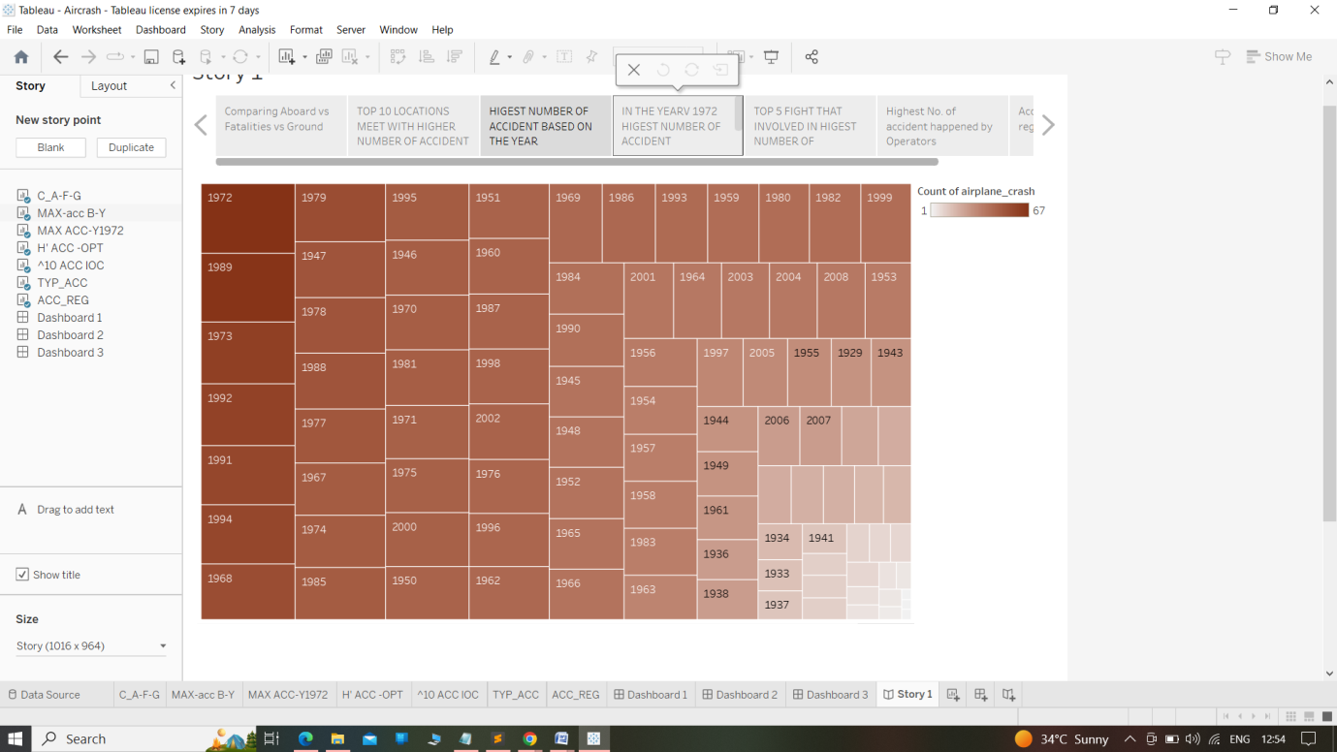

**4 ADVANTAGES & DISADVANTAGES**

**Advantages:**

* Insights and knowledge: Data analysis projects can provide valuable insights and knowledge to make informed decisions.
* Improved efficiency: Analyzing data can help identify inefficiencies in a system, allowing for improvements to be made.
* Better resource allocation: Data analysis can help in the allocation of resources, such as time, money, and manpower.
* Predictive capabilities: Analyzing data can lead to the development of predictive models, which can be used to anticipate and prevent potential problems.
* Data-driven decision making: Data analysis can help organizations make decisions based on objective data rather than subjective opinions.

**Disadvantages:**

* Data quality: Poor quality data can lead to inaccurate conclusions and decisions.
* Data privacy concerns: Analyzing sensitive data can raise concerns about privacy and security.
* Technical expertise: Data analysis requires technical expertise, which can be a challenge for organizations without in-house expertise or the resources to hire external experts.
* Time and resource-intensive: Data analysis projects can be time and resource-intensive, requiring significant investment in terms of time and money.
* Bias: Data analysis can be influenced by the biases of the analyst or the data itself, which can lead to inaccurate conclusions.

**5 APPLICATIONS:**

* Aviation Safety Improvement: The analysis of airplane crash data can help identify the root causes of accidents and provide insights for improving aviation safety measures.
* Aircraft Design and Maintenance: The insights obtained from analyzing airplane crash data can help manufacturers and maintenance engineers in identifying areas of improvement in aircraft design and maintenance.
* Insurance Industry: The analysis of airplane crash data can assist the insurance industry in setting premiums and assessing risk.
* Government and Regulatory Authorities: Government and regulatory authorities can use insights from the analysis of airplane crash data to develop regulations and policies that promote aviation safety.
* Research and Development: The analysis of airplane crash data can provide a foundation for further research and development in the field of aviation safety.
* Aviation Education: The insights gained from the analysis of airplane crash data can be used to develop case studies and examples for aviation education and training programs.

Overall, the application of airplane crash data analysis can help improve aviation safety, promote innovation and development in the aviation industry, and inform decision-making in various fields.

**6 CONCLUSION:**

In conclusion, "The Tragedy of Flight: A Comprehensive Crash Analysis" project aimed to analyze and provide insights into aviation accidents around the world. Through data analysis and visualization, we were able to identify trends, patterns, and factors that contribute to aviation accidents. The project provided information on the number and types of accidents, the operators, the location, and the fatalities.

Some of the major findings of the project were the comparison of aboard vs fatalities vs ground, maximum accidents based on years, accidents happened in 1972 based on months, highest number of accidents happened by operators, top 10 locations which had more accidents, top 3 flights which have max accident history, accidents based on regions, and others.

Overall, the project has practical applications in the aviation industry, allowing industry stakeholders to identify areas where improvements in safety and prevention can be made. The project also serves as a resource for researchers, analysts, and enthusiasts who are interested in understanding the dynamics of aviation accidents.

**7 FUTURE SCOPE:**

Some potential enhancements for the future of this project could include:

* Real-time data: Currently, the project analyzes historical data. However, incorporating real-time data would allow for more accurate and up-to-date analysis of aviation accidents.
* Predictive analysis: Implementing predictive analysis techniques can help identify potential areas of risk and enable airlines to take proactive measures to prevent accidents.
* Visualizations: Adding more interactive and visually appealing charts and graphs can help users better understand and interpret the data.
* Machine learning: Incorporating machine learning algorithms can help identify patterns and trends in the data that may not be easily recognizable through traditional analysis.
* Data from more sources: While the current project analyzes data from Kaggle, incorporating data from additional sources can provide a more comprehensive and accurate analysis of aviation accidents.
* Collaboration: Collaborating with industry experts, regulators, and airlines can help enhance the accuracy and effectiveness of the project.

**8 APPENDIX:**

**A. Source Code:**

**<!DOCTYPE html>**

**<html lang="en">**

**<head>**

**<meta charset="utf-8">**

**<meta content="width=device-width, initial-scale=1.0" name="viewport">**

**<title>Air Crash Report</title>**

**<meta content="" name="description">**

**<meta content="" name="keywords">**

**<!-- Favicons -->**

**<link href="assets/img/favicon.png" rel="icon">**

**<link href="assets/img/apple-touch-icon.png" rel="apple-touch-icon">**

**<!-- Google Fonts -->**

**<link href="https://fonts.googleapis.com/css?family=Open+Sans:300,300i,400,400i,600,600i,700,700i|Jost:300,300i,400,400i,500,500i,600,600i,700,700i|Poppins:300,300i,400,400i,500,500i,600,600i,700,700i" rel="stylesheet">**

**<!-- Vendor CSS Files -->**

**<link href="assets/vendor/aos/aos.css" rel="stylesheet">**

**<link href="assets/vendor/bootstrap/css/bootstrap.min.css" rel="stylesheet">**

**<link href="assets/vendor/bootstrap-icons/bootstrap-icons.css" rel="stylesheet">**

**<link href="assets/vendor/boxicons/css/boxicons.min.css" rel="stylesheet">**

**<link href="assets/vendor/glightbox/css/glightbox.min.css" rel="stylesheet">**

**<link href="assets/vendor/remixicon/remixicon.css" rel="stylesheet">**

**<link href="assets/vendor/swiper/swiper-bundle.min.css" rel="stylesheet">**

**<!-- Template Main CSS File -->**

**<link href="assets/css/style.css" rel="stylesheet">**

**<!-- =======================================================**

**\* Template Name: Aircarsh Report**

**\* Updated: Mar 10 2023 with Bootstrap v5.2.3**

**\* Template URL: https://bootstrapmade.com/arsha-free-bootstrap-html-template-corporate/**

**\* Author: BootstrapMade.com**

**\* License: https://bootstrapmade.com/license/**

**======================================================== -->**

**</head>**

**<body>**

**<!-- ======= Header ======= -->**

**<header id="header" class="fixed-top ">**

**<div class="container d-flex align-items-center">**

**<h1 class="logo me-auto"><a href="index.html">Air Crash Report</a></h1>**

**<!-- Uncomment below if you prefer to use an image logo -->**

**<!-- <a href="index.html" class="logo me-auto"><img src="assets/img/logo.png" alt="" class="img-fluid"></a>-->**

**<nav id="navbar" class="navbar">**

**<ul>**

**<li><a class="nav-link scrollto active" href="#hero">Home</a></li>**

**<li><a class="nav-link scrollto" href="#about">About</a></li>**

**<li><a class="nav-link scrollto" href="#services">Dashbord</a></li>**

**<li><a class="nav-link scrollto" href="#portfolio">Story</a></li>**

**<li><a class="nav-link scrollto" href="#contact">Contact</a></li>**

**<li><a class="getstarted scrollto" href="#about">Get Started</a></li>**

**</ul>**

**<i class="bi bi-list mobile-nav-toggle"></i>**

**</nav><!-- .navbar -->**

**</div>**

**</header><!-- End Header -->**

**<!-- ======= Hero Section ======= -->**

**<section id="hero" class="d-flex align-items-center">**

**<div class="container">**

**<div class="row">**

**<div class="col-lg-6 d-flex flex-column justify-content-center pt-4 pt-lg-0 order-2 order-lg-1" data-aos="fade-up" data-aos-delay="200">**

**<h1>Air Crash Analysis by Team #09</h1>**

**<h2>Airplane Crashes & Fatalities Since 1908</h2>**

**<div class="d-flex justify-content-center justify-content-lg-start">**

**<a href="#about" class="btn-get-started scrollto">Get Started</a>**

**<a href="https://www.youtube.com/watch?v=jDDaplaOz7Q" class="glightbox btn-watch-video"><i class="bi bi-play-circle"></i><span>Watch Video</span></a>**

**</div>**

**</div>**

**<div class="col-lg-6 order-1 order-lg-2 hero-img" data-aos="zoom-in" data-aos-delay="200">**

**<img src="assets/img/hero-img.png" class="img-fluid animated" alt="">**

**</div>**

**</div>**

**</div>**

**</section><!-- End Hero -->**

**<!-- ======= About Us Section ======= -->**

**<section id="about" class="about">**

**<div class="container" data-aos="fade-up">**

**<div class="section-title">**

**<h2>About Us</h2>**

**</div>**

**<div class="row content">**

**<div class="col-lg-6">**

**<p>**

**Aviation accidents are a tragic occurrence that can result in fatalities and significant damage. This project aims to comprehensively analyze aviation accidents worldwide that have resulted in fatalities, including both civil and commercial airliners, cargo, positioning, ferry, and test flights, and military transport accidents with 10 or more fatalities. The project also includes commercial and military helicopter accidents with greater than 10 fatalities, civil and military airship accidents involving fatalities, and aviation accidents involving the death of famous people. The dataset used for this analysis has been collected from reliable sources and includes detailed information about the accident, such as the location, date, aircraft type, and contributing factors. The analysis will focus on identifying any common factors that contributed to these accidents and provide recommendations for improving aviation safety in the future. The findings and recommendations of this project will be shared with relevant authorities and industry organizations to promote safer aviation practices and prevent similar accidents in the future.**

**</p>**

**<ul>**

**<li><i class="ri-check-double-line"></i> The project is a comprehensive analysis of aviation accidents worldwide, covering all types of aircraft and incidents that resulted in fatalities.</li>**

**<li><i class="ri-check-double-line"></i> Data was collected from multiple sources, including official accident reports, news articles, and other credible sources, to ensure a thorough and accurate analysis.</li>**

**<li><i class="ri-check-double-line"></i> The data was analyzed using various techniques, such as data visualization and statistical analysis, to identify patterns and trends in aviation accidents.</li>**

**</ul>**

**</div>**

**<div class="col-lg-6 pt-4 pt-lg-0">**

**<p>**

**Additionally, the data collection process for this project involved gathering information from multiple sources, including official accident reports and databases, news articles, and other credible sources. The collected data was then analyzed using various techniques, such as data visualization and statistical analysis, to identify patterns and trends in aviation accidents**

**</p>**

**<a href="#" class="btn-learn-more">Learn More</a>**

**</div>**

**</div>**

**</div>**

**</section><!-- End About Us Section -->**

**<!-- ======= Why Us Section ======= -->**

**<!-- ======= Skills Section ======= -->**

**<!-- ======= Services Section ======= -->**

**<section id="services" class="Dashbord">**

**<div class="container" data-aos="fade-up">**

**<div class="section-title">**

**<h2>Dashboard</h2>**

**<p>The dashboard provides a comprehensive analysis of air crash accidents across the world. The dashboard utilizes data collected from Kaggle and provides detailed insights into the causes and impact of air crashes.</p>**

**</div>**

**<div><div class='tableauPlaceholder' id='viz1681053551430' style='position: relative'><noscript><a href='#'><img alt='Dashboard 1 ' src='https:&#47;&#47;public.tableau.com&#47;static&#47;images&#47;Ai&#47;Aircrash_16809751240150&#47;Dashboard1&#47;1_rss.png' style='border: none' /></a></noscript><object class='tableauViz' style='display:none;'><param name='host_url' value='https%3A%2F%2Fpublic.tableau.com%2F' /> <param name='embed_code_version' value='3' /> <param name='site_root' value='' /><param name='name' value='Aircrash_16809751240150&#47;Dashboard1' /><param name='tabs' value='no' /><param name='toolbar' value='yes' /><param name='static_image' value='https:&#47;&#47;public.tableau.com&#47;static&#47;images&#47;Ai&#47;Aircrash_16809751240150&#47;Dashboard1&#47;1.png' /> <param name='animate_transition' value='yes' /><param name='display_static_image' value='yes' /><param name='display_spinner' value='yes' /><param name='display_overlay' value='yes' /><param name='display_count' value='yes' /><param name='language' value='en-US' /><param name='filter' value='publish=yes' /></object></div> <script type='text/javascript'> var divElement = document.getElementById('viz1681053551430'); var vizElement = divElement.getElementsByTagName('object')[0]; if ( divElement.offsetWidth > 800 ) { vizElement.style.width='100%';vizElement.style.height=(divElement.offsetWidth*0.75)+'px';} else if ( divElement.offsetWidth > 500 ) { vizElement.style.width='100%';vizElement.style.height=(divElement.offsetWidth*0.75)+'px';} else { vizElement.style.width='100%';vizElement.style.height='1127px';} var scriptElement = document.createElement('script'); scriptElement.src = 'https://public.tableau.com/javascripts/api/viz_v1.js'; vizElement.parentNode.insertBefore(scriptElement, vizElement); </script></div>**

**</section><!-- End Services Section -->**

**<!-- ======= Cta Section ======= -->**

**<!-- ======= Story ======= -->**

**<section id="portfolio" class="portfolio">**

**<div class="container" data-aos="fade-up">**

**<div class="section-title">**

**<h2>STORY</h2>**

**</div>**

**<div class='tableauPlaceholder' id='viz1681056057860' style='position: relative'><noscript><a href='#'><img alt='Story 1 ' src='https:&#47;&#47;public.tableau.com&#47;static&#47;images&#47;Ai&#47;AircrashStory&#47;Story1&#47;1_rss.png' style='border: none' /></a></noscript><object class='tableauViz' style='display:none;'><param name='host_url' value='https%3A%2F%2Fpublic.tableau.com%2F' /> <param name='embed_code_version' value='3' /> <param name='site_root' value='' /><param name='name' value='AircrashStory&#47;Story1' /><param name='tabs' value='no' /><param name='toolbar' value='yes' /><param name='static_image' value='https:&#47;&#47;public.tableau.com&#47;static&#47;images&#47;Ai&#47;AircrashStory&#47;Story1&#47;1.png' /> <param name='animate_transition' value='yes' /><param name='display_static_image' value='yes' /><param name='display_spinner' value='yes' /><param name='display_overlay' value='yes' /><param name='display_count' value='yes' /><param name='language' value='en-US' /><param name='filter' value='publish=yes' /></object></div> <script type='text/javascript'> var divElement = document.getElementById('viz1681056057860'); var vizElement = divElement.getElementsByTagName('object')[0]; vizElement.style.width='1016px';vizElement.style.height='991px'; var scriptElement = document.createElement('script'); scriptElement.src = 'https://public.tableau.com/javascripts/api/viz_v1.js'; vizElement.parentNode.insertBefore(scriptElement, vizElement); </script>**

**<div class="section-title">**

**</section><!-- End Portfolio Section -->**

**<!-- ======= Team Section ======= -->**

**<section id="team" class="team section-bg">**

**<div class="container" data-aos="fade-up">**

**<div class="section-title">**

**<h2>Team</h2>**

**</div>**

**<div class="row">**

**<div class="col-lg-6" data-aos="zoom-in" data-aos-delay="100">**

**<div class="member d-flex align-items-start">**

**<div class="member-info">**

**<h4>Swaminathan M</h4>**

**<span>Team Leader</span>**

**<p>A great leader is one who inspires and guides their team towards success through effective communication, motivation, and support.</p>**

**<div class="social">**

**<a href=""><i class="ri-instagram-fill"></i></a>**

**<a href=""> <i class="ri-linkedin-box-fill"></i> </a>**

**</div>**

**</div>**

**</div>**

**</div>**

**<div class="col-lg-6 mt-4 mt-lg-0" data-aos="zoom-in" data-aos-delay="200">**

**<div class="member d-flex align-items-start">**

**<div class="member-info">**

**<h4>Manoj Kumar M</h4>**

**<span>Team Member</span>**

**<p>A great team member is one who collaborates with others, takes initiative, and contributes towards achieving the team's goals</p>**

**<div class="social">**

**<a href=""><i class="ri-instagram-fill"></i></a>**

**<a href=""> <i class="ri-linkedin-box-fill"></i> </a>**

**</div>**

**</div>**

**</div>**

**</div>**

**<div class="col-lg-6 mt-4" data-aos="zoom-in" data-aos-delay="300">**

**<div class="member d-flex align-items-start">**

**<div class="member-info">**

**<h4>Raveena S</h4>**

**<span>Team Member</span>**

**<p>Effective team members communicate clearly, are open to feedback, and strive to continuously improve their skills and knowledge.</p>**

**<div class="social">**

**<a href=""><i class="ri-instagram-fill"></i></a>**

**<a href=""> <i class="ri-linkedin-box-fill"></i> </a>**

**</div>**

**</div>**

**</div>**

**</div>**

**<div class="col-lg-6 mt-4" data-aos="zoom-in" data-aos-delay="400">**

**<div class="member d-flex align-items-start">**

**<div class="member-info">**

**<h4>Shalini Priya </h4>**

**<span>Team Member</span>**

**<p>Successful team members understand the importance of collaboration, take ownership of their tasks, and are willing to support their team members when needed</p>**

**<div class="social">**

**<a href=""><i class="ri-instagram-fill"></i></a>**

**<a href=""> <i class="ri-linkedin-box-fill"></i> </a>**

**</div>**

**</div>**

**</div>**

**</div>**

**</div>**

**</div>**

**</section><!-- End Team Section -->**

**</main><!-- End #main -->**

**<!-- ======= Footer ======= -->**

**<footer id="footer">**

**<div class="footer-newsletter">**

**<div class="container">**

**<div class="row justify-content-center">**

**<div class="col-lg-6">**

**<h4>Thanks For Your Visit</h4>**

**</div>**

**</div>**

**</div>**

**</div>**

**<div class="footer-top">**

**<div class="container">**

**<div class="row">**

**<div class="col-lg-3 col-md-6 footer-contact">**

**<h3>Team#09</h3>**

**<p>**

**KG College Of Arts And Science<br>**

**Saravanampatti<br>**

**Coimbatore <br><br>**

**<strong>Email:</strong>info@kgcas.com<br>**

**</p>**

**</div>**

**<div class="col-lg-3 col-md-6 footer-links">**

**<h4>Useful Links</h4>**

**<ul>**

**<li><i class="bx bx-chevron-right"></i> <a href="#">Home</a></li>**

**<li><i class="bx bx-chevron-right"></i> <a href="#">About us</a></li>**

**<li><i class="bx bx-chevron-right"></i> <a href="#">Dashboard</a></li>**

**<li><i class="bx bx-chevron-right"></i> <a href="#">Story</a></li>**

**<li><i class="bx bx-chevron-right"></i> <a href="#">Privacy policy</a></li>**

**</ul>**

**</div>**

**<div class="container footer-bottom clearfix">**

**<div class="copyright">**

**&copy; Copyright <strong><span>Arsha</span></strong>. All Rights Reserved**

**</div>**

**<div class="credits">**

**<!-- All the links in the footer should remain intact. -->**

**<!-- You can delete the links only if you purchased the pro version. -->**

**<!-- Licensing information: https://bootstrapmade.com/license/ -->**

**<!-- Purchase the pro version with working PHP/AJAX contact form: https://bootstrapmade.com/arsha-free-bootstrap-html-template-corporate/ -->**

**Designed by <a href="https://bootstrapmade.com/">BootstrapMade</a>**

**</div>**

**</div>**

**</footer><!-- End Footer -->**

**<div id="preloader"></div>**

**<a href="#" class="back-to-top d-flex align-items-center justify-content-center"><i class="bi bi-arrow-up-short"></i></a>**

**<!-- Vendor JS Files -->**

**<script src="assets/vendor/aos/aos.js"></script>**

**<script src="assets/vendor/bootstrap/js/bootstrap.bundle.min.js"></script>**

**<script src="assets/vendor/glightbox/js/glightbox.min.js"></script>**

**<script src="assets/vendor/isotope-layout/isotope.pkgd.min.js"></script>**

**<script src="assets/vendor/swiper/swiper-bundle.min.js"></script>**

**<script src="assets/vendor/waypoints/noframework.waypoints.js"></script>**

**<script src="assets/vendor/php-email-form/validate.js"></script>**

**<!-- Template Main JS File -->**

**<script src="assets/js/main.js"></script>**

**</body>**

**</html>**

Project Report Template

Landing Page



**About Page**

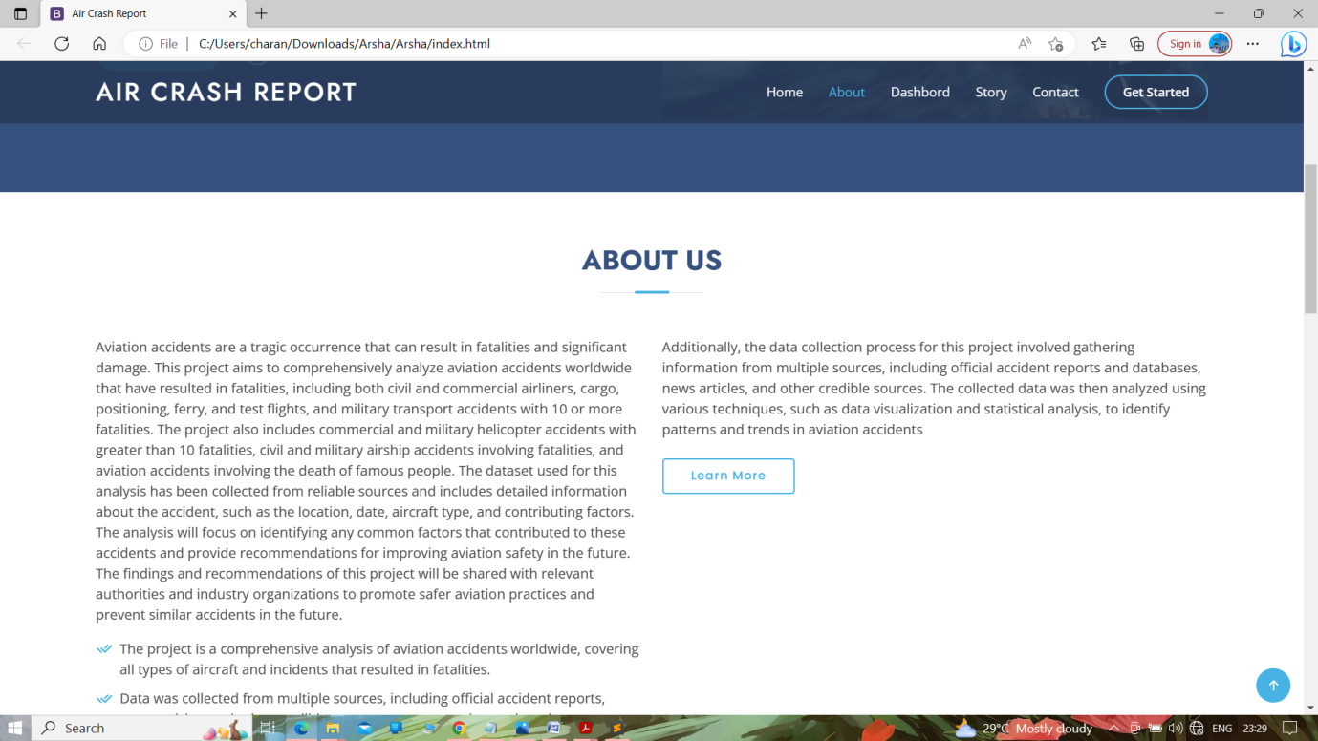

**Dashboard Page**

**Page 1**

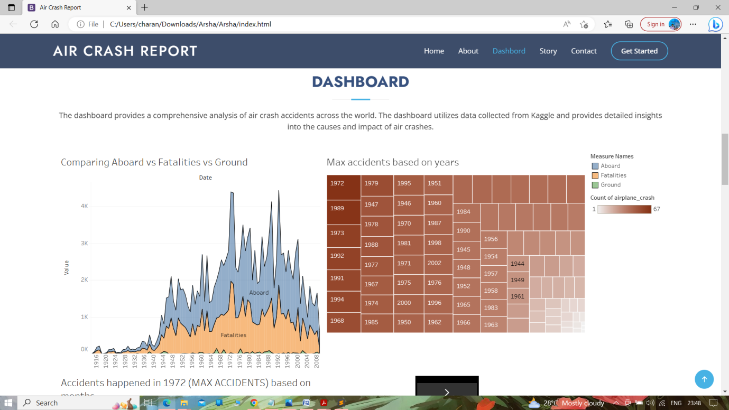

**Page 2**

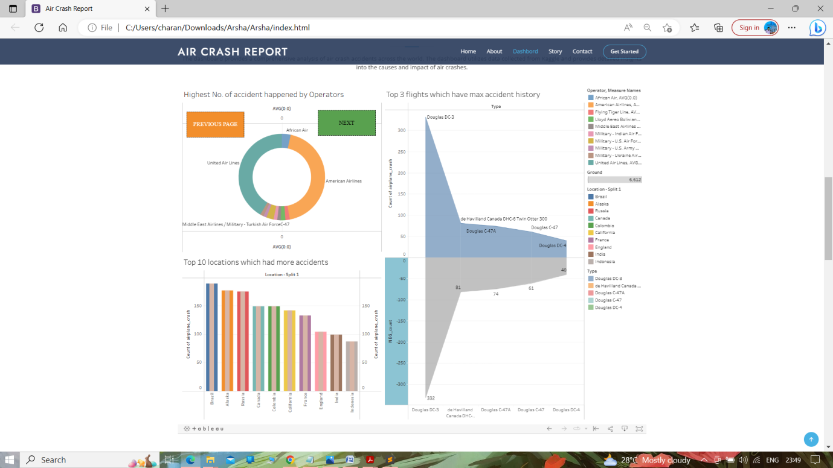

**Page 3**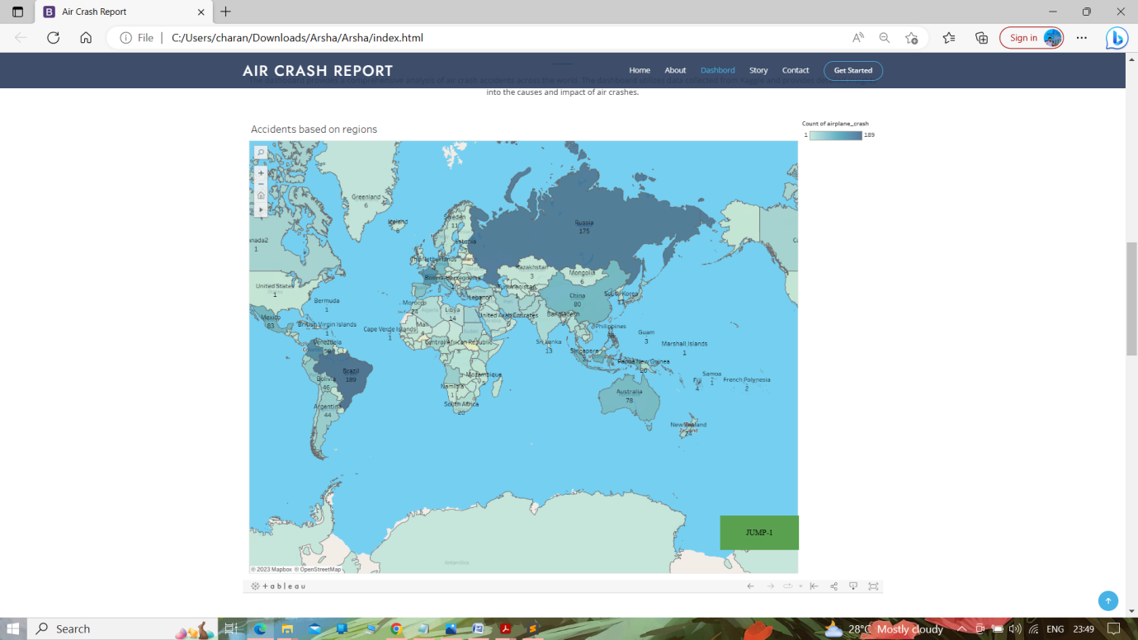

**Story page**

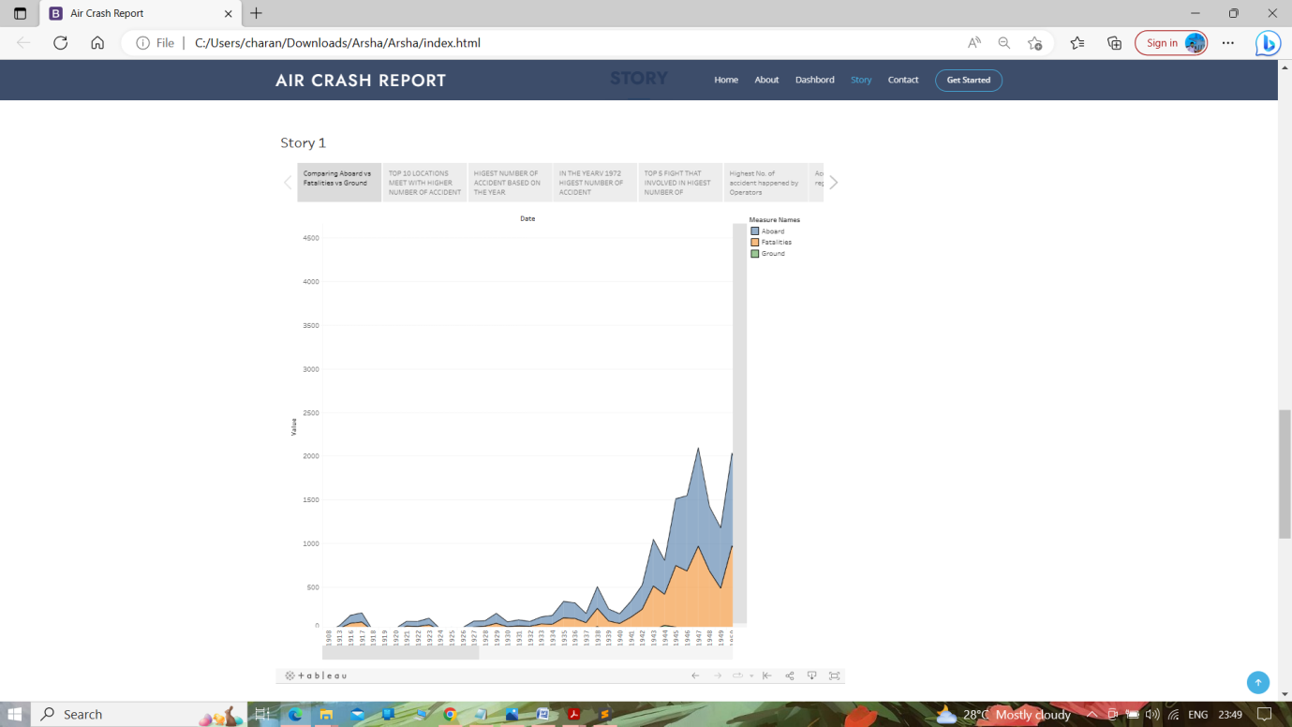

**Team Details**

