Exercise 9 – ReactJS-HOL

ListofPlayers.js
import React from 'react'; const ListofPlayers = () => { const players = [
{ name: "Virat", score: 85 },
{ name: "Rohit", score: 45 },
{ name: "Gill", score: 60 },
{ name: "Dhoni", score: 90 },
{ name: "Jadeja", score: 75 },
{ name: "Hardik", score: 40 },
{ name: "Pant", score: 55 },
{ name: "Ashwin", score: 30 },
{ name: "Bumrah", score: 88 },
{ name: "Shami", score: 67 },
{ name: "Kohli", score: 78 },
];
const lowScorers = players.filter(player => player.score < 70); return (
<div>
<h2>All Players</h2>
{players.map((p, i) => (
<p key={i}>{p.name} - {p.score}</p>
))}

<h3>Players Scoring Below 70</h3>
{lowScorers.map((p, i) => (
<p key={i}>{p.name} - {p.score}</p>
))}
</div>
);
};
export default ListofPlayers;

IndianPlayers.js
import React from 'react'; const IndianPlayers = () => {
const oddTeam = ["Virat", "Gill", "Dhoni", "Pant", "Shami"];
const evenTeam = ["Rohit", "Jadeja", "Hardik", "Ashwin", "Bumrah", "Kohli"]; const [v1, v2, v3, v4, v5] = oddTeam;
const [e1, e2, e3, e4, e5, e6] = evenTeam;
const T20Players = ["Surya", "Arshdeep", "Samson"]; const RanjiPlayers = ["Pujara", "Rahane"];
const mergedPlayers = [...T20Players, ...RanjiPlayers]; return (
<div>
<h2>Odd Team Players</h2>
<ul>
<li>{v1}</li>
<li>{v2}</li>

<li>{v3}</li>
<li>{v4}</li>
<li>{v5}</li>
</ul>
<h2>Even Team Players</h2>
<ul>
<li>{e1}</li>
<li>{e2}</li>
<li>{e3}</li>
<li>{e4}</li>
<li>{e5}</li>
<li>{e6}</li>
</ul>
<h2>Merged Players (T20 + Ranji)</h2>
{mergedPlayers.map((player, index) => (
<p key={index}>{player}</p>
))}
</div>
);
};
export default IndianPlayers;

App.js
import React from 'react'; import './App.css';
import ListofPlayers from './Components/ListofPlayers';

import IndianPlayers from './Components/IndianPlayers'; function App() {
const flag = true;

return (
<div className="App">
<h1>Cricket App</h1>
{flag ? <ListofPlayers /> : <IndianPlayers />}
</div>
);
}
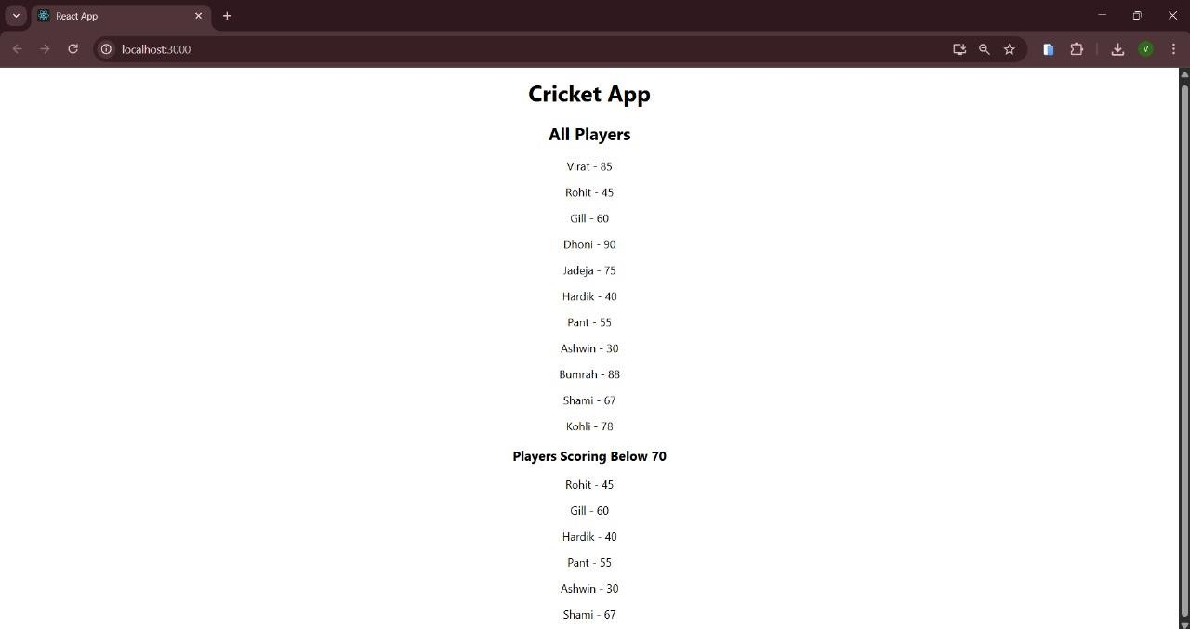
export default App;

Exercise 10 – ReactJS-HOL

App.js
import React from 'react'; import './App.css';
const officeSpaces = [
{ name: 'Elite Towers', rent: 55000, address: 'MG Road, Bangalore', image: 'office1.jpg' },
{ name: 'Skyline Hub', rent: 75000, address: 'Banjara Hills, Hyderabad', image: 'office2.jpg' },
{ name: 'Tech Heights', rent: 60000, address: 'Koregaon Park, Pune', image: 'office3.jpg' },
];
const getRentStyle = (rent) => {
return { color: rent > 60000 ? 'green' : 'red' };
};

function App() { return (
<div className="App">
<h1>Office Space Rental Listings</h1>
{officeSpaces.map((office, index) => (
<div key={index} style={{ border: '1px solid #ddd', margin: '10px', padding: '10px' }}>
<img src="office.jpg" alt={office.name} width="300" />
<h2>{office.name}</h2>
<p style={getRentStyle(office.rent)}>Rent: ₹{office.rent}</p>
<p>Address: {office.address}</p>
</div>

))}
</div>
);
}
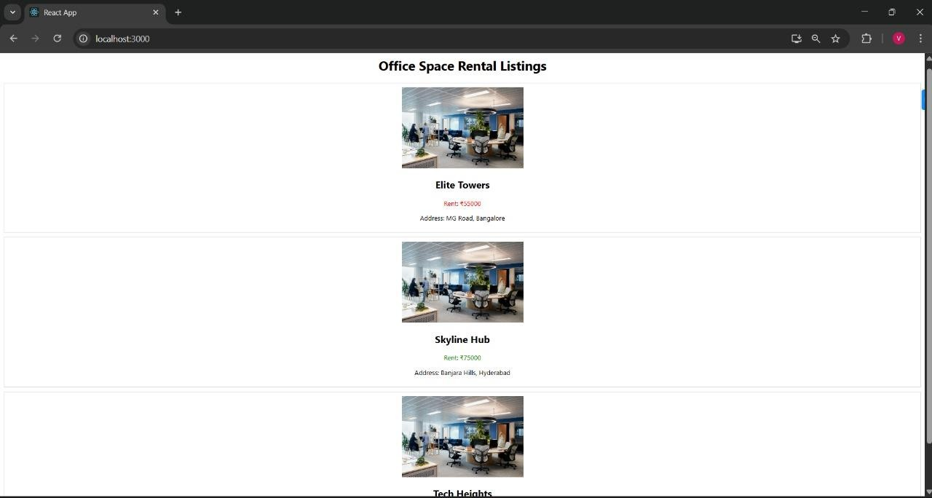
export default App;

Exercise 11 – ReactJS-HOL

App.js
import React, { useState } from 'react'; import './App.css';
function CurrencyConvertor() {
const [rupees, setRupees] = useState(''); const [euros, setEuros] = useState(null);

const handleSubmit = () => {
const euro = (parseFloat(rupees) / 90).toFixed(2); setEuros(euro);
};
return (
<div style={{ marginTop: '20px' }}>
<h2>Currency Convertor (INR to EURO)</h2>
<input type="number" placeholder="Enter amount in ₹"
value={rupees} onChange={(e) => setRupees(e.target.value)} />
<button onClick={handleSubmit}>Convert</button>
{euros CC <p>Converted: €{euros}</p>}
</div>
);
}
function App() {
const [count, setCount] = useState(0); const sayHello = () => {
console.log("Hello! This is a static message.");
};
const increment = () => { sayHello(); setCount(count + 1);
};
const decrement = () => { setCount(count - 1);
};

const sayMessage = (message) => { alert(Message: ${message});
};
const handleClick = (e) => { e.preventDefault(); alert("I was clicked");
};
return (
<div className="App">
<h1>React Event Handling Example</h1>
<p>Counter: {count}</p>
<button onClick={increment}>Increment</button>
<button onClick={decrement}>Decrement</button>
<br /><br />
<button onClick={() => sayMessage('Welcome')}>Say Welcome</button>
<br /><br />
<button onClick={handleClick}>Synthetic Event: OnPress</button>
<CurrencyConvertor />
</div>
);
}
export default App;

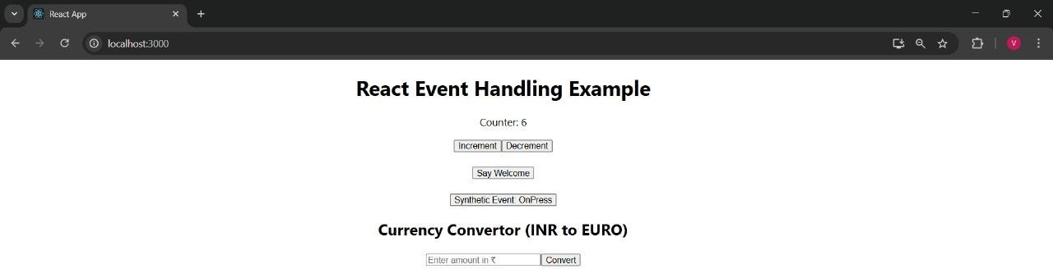
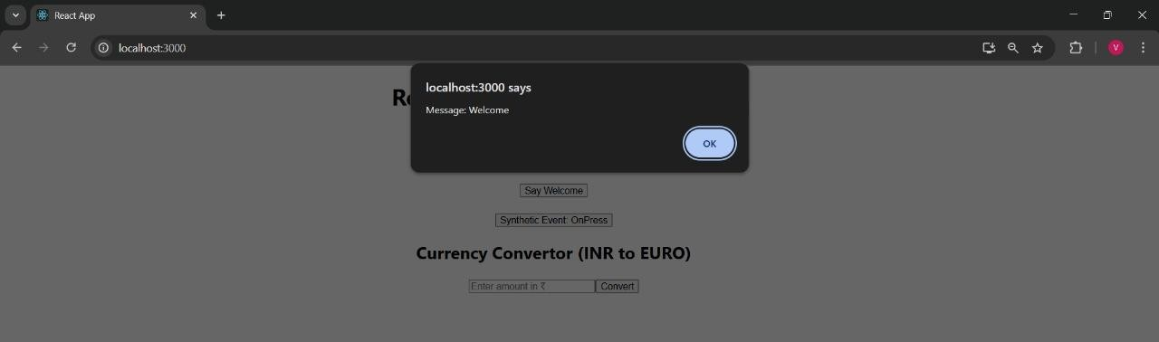
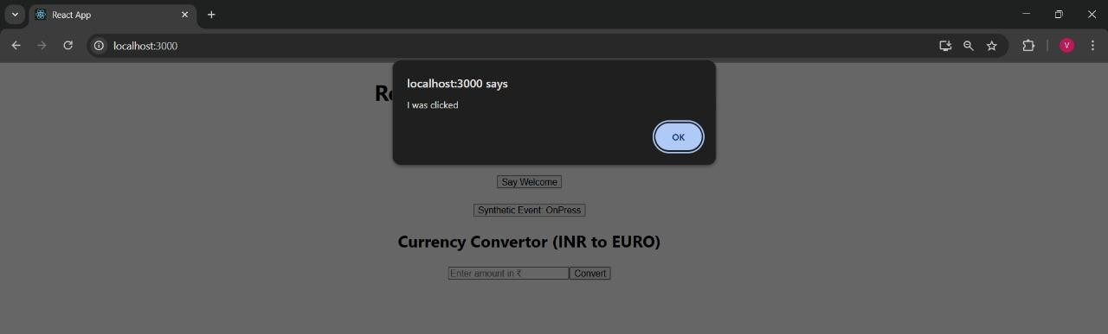
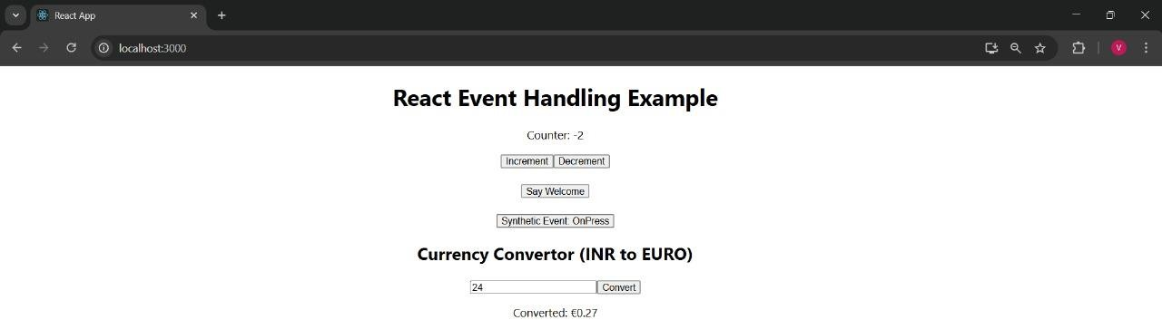

Exercise 12 – ReactJS-HOL

App.js
import React, { useState } from 'react'; import './App.css';
function GuestPage() { return (
<div>
<h2>Welcome Guest!</h2>
<p>Explore flight options. Please log in to book your ticket.</p>
</div>
);
}
function UserPage() { return (
<div>
<h2>Welcome Back!</h2>
<p>You can now book your flight tickets.</p>
</div>
);
}
function App() {
const [isLoggedIn, setIsLoggedIn] = useState(false); const handleLogin = () => setIsLoggedIn(true); const handleLogout = () => setIsLoggedIn(false);

let pageContent; if (isLoggedIn) {
pageContent = <UserPage />;
} else {
pageContent = <GuestPage />;
}
return (
<div className="App">
<h1> Ticket Booking App</h1>
{isLoggedIn ? (
<button onClick={handleLogout}>Logout</button>
) : (
<button onClick={handleLogin}>Login</button>
)}
{pageContent}
</div>
); }
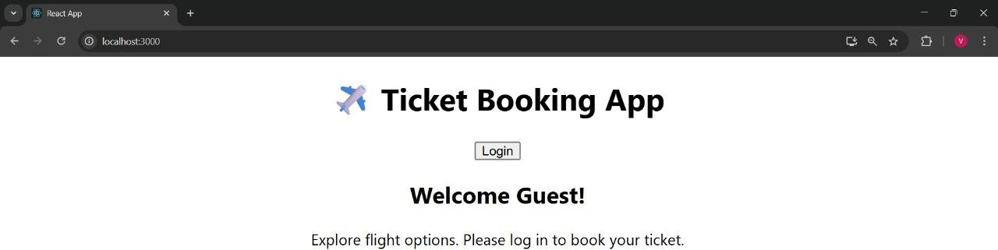
export default App;

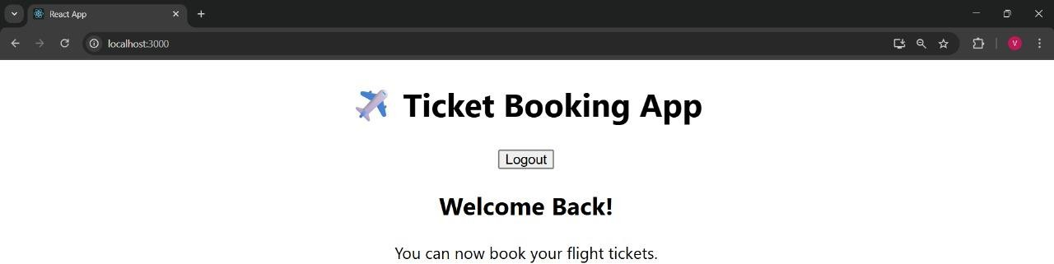

Exercise 13 – ReactJS-HOL

BookDetails.js
import React from 'react'; function BookDetails() { return ( Book Details
Title: React in Action
Author: Mark Tielens Thomas Publisher: Manning
); }
export default BookDetails;

BlogDetails.js
import React from 'react';
function BlogDetails() { const blogs = [ { id: 1, title: 'React Basics', author: 'John' }, { id: 2, title: 'Advanced React', author: 'Jane' }, { id: 3, title: 'Hooks in Depth', author: 'Sara' } ];
return ( Blog Details
{blogs.map((blog) => (

{blog.title} by {blog.author}
))}
); }
export default BlogDetails;

CourseDetails.js
import React from 'react'; function CourseDetails() { return ( Course Details
Course: React Mastery Duration: 6 Weeks Instructor: Mr. Reacto
); }
export default CourseDetails;

App.js
import React, { useState } from 'react'; import './App.css'; import BookDetails from './BookDetails'; import BlogDetails from './BlogDetails'; import CourseDetails from './CourseDetails';
function App() { const [view, setView] = useState('book');
const renderComponent = () => { if (view === 'book') return ; else if (view === 'blog') return ; else if (view === 'course') return ; else return
Please select a valid option
; };
return ( Blogger App
<button onClick={() => setView('book')}>Show Book</button>

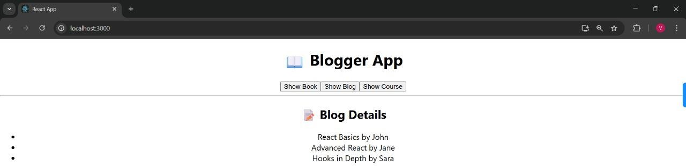
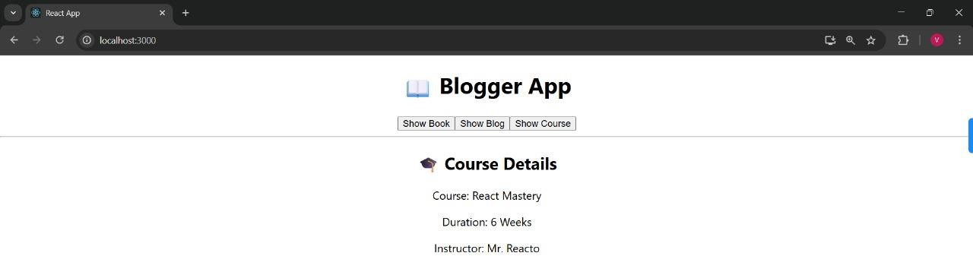
<button onClick={() => setView('blog')}>Show Blog</button>
<button onClick={() => setView('course')}>Show Course</button>
<hr />
{renderComponent()}
</div>
); }
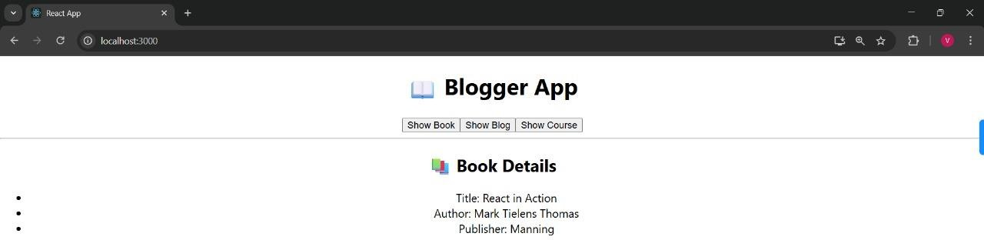
export default App;

