Microservices with API gateway

Creating Microservices for account and loan

AccountController.java
package com.cognizant.account.controller;
import org.springframework.web.bind.annotation.*; import java.util.Map;
@RestController @RequestMapping("/accounts") public class AccountController {
@GetMapping("/{number}")
public Map<String, Object> getAccount(@PathVariable String number) { return Map.of(
"number", number, "type", "savings", "balance", 234343
);
}
}

AccountApplication.java
package com.cognizant.account;
import org.springframework.boot.SpringApplication;

import org.springframework.boot.autoconfigure.SpringBootApplication;

@SpringBootApplication
public class AccountApplication { public static void main(String[] args) {
SpringApplication.run(AccountApplication.class, args);
}
}

LoanController.java
package com.cognizant.loan.controller;
import org.springframework.web.bind.annotation.*; import java.util.Map;
@RestController @RequestMapping("/loans") public class LoanController {
@GetMapping("/{number}")
public Map<String, Object> getLoan(@PathVariable String number) { return Map.of(
"number", number, "type", "car", "loan", 400000,
"emi", 3258,
"tenure", 18
);
}

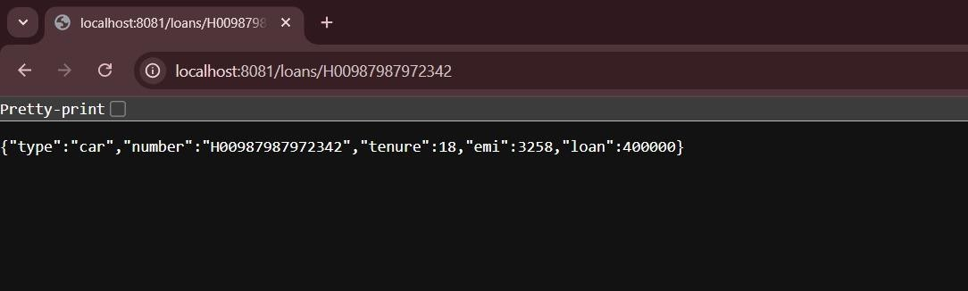
}

LoanApplication.java
package com.cognizant.loan;
import org.springframework.boot.SpringApplication;
import org.springframework.boot.autoconfigure.SpringBootApplication; @SpringBootApplication
public class LoanApplication {
public static void main(String[] args) { SpringApplication.run(LoanApplication.class, args);
}



