Spring Data JPA - Quick Example

OrmLearnApplication.java package com.cognizant.orm_learn; import java.util.List;
import org.slf4j.Logger;
import org.slf4j.LoggerFactory;
import org.springframework.boot.SpringApplication;
import org.springframework.boot.autoconfigure.SpringBootApplication; import org.springframework.context.ApplicationContext;
import com.cognizant.orm_learn.Country;
import com.cognizant.orm_learn.Service.CountryService; @SpringBootApplication
public class OrmLearnApplication {
private static final Logger LOGGER = LoggerFactory.getLogger(OrmLearnApplication.class);
private static CountryService countryService; public static void main(String[] args) {
ApplicationContext context = SpringApplication.run(OrmLearnApplication.class, args); countryService = context.getBean(CountryService.class);
testGetAllCountries();
}
private static void testGetAllCountries() { LOGGER.info("Start");
List<Country> countries = countryService.getAllCountries(); LOGGER.debug("countries={}", countries);

LOGGER.info("End");
}
}

Country.java
package com.cognizant.orm_learn; import jakarta.persistence.Column; import jakarta.persistence.Entity; import jakarta.persistence.Id; import jakarta.persistence.Table; @Entity
@Table(name = "country") public class Country {
@Id
@Column(name = "code") private String code; @Column(name = "name") private String name;
public String getCode() { return code;
}
public void setCode(String code) { this.code = code;
}
public String getName() { return name;

}

public void setName(String name) { this.name = name;
}
@Override
public String toString() {
return "Country [code=" + code + ", name=" + name + "]";
}
}

CountryRepository.java
package com.cognizant.orm_learn.Repository;
import org.springframework.data.jpa.repository.JpaRepository; import org.springframework.stereotype.Repository;
import com.cognizant.orm_learn.Country; @Repository
public interface CountryRepository extends JpaRepository<Country, String> {
}

CountryService.java
package com.cognizant.orm_learn.Service; import java.util.List;
import org.springframework.transaction.annotation.Transactional; import org.springframework.beans.factory.annotation.Autowired; import org.springframework.stereotype.Service;

import com.cognizant.orm_learn.Country;
import com.cognizant.orm_learn.Repository.CountryRepository;

@Service
public class CountryService { @Autowired
private CountryRepository countryRepository; @Transactional
public List<Country> getAllCountries() { return countryRepository.findAll();
}
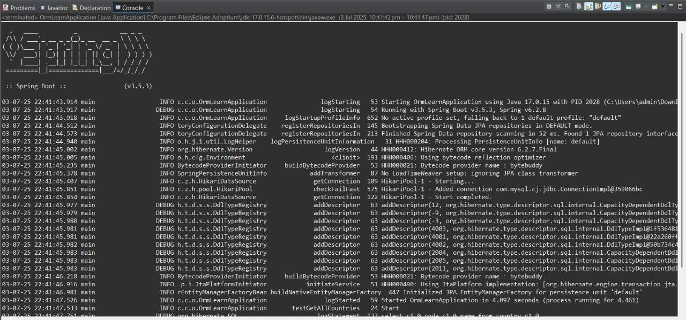
}

Difference between JPA, Hibernate and Spring Data JPA

HibernateExample.java

package com.example;

import com.example.model.Employee; import org.hibernate.*; import org.hibernate.cfg.Configuration;
public class HibernateExample { private static SessionFactory factory;

}
static {
factory = new Configuration()
.configure("hibernate.cfg.xml")
.addAnnotatedClass(Employee.class)
.buildSessionFactory();

public Integer addEmployee(Employee employee) { Session session = factory.openSession(); Transaction tx = null;
Integer employeeID = null; try {
tx = session.beginTransaction();
employeeID = (Integer) session.save(employee); tx.commit();
} catch (HibernateException e) { if (tx != null) tx.rollback(); e.printStackTrace();
} finally { session.close();
}
return employeeID;
}
public static void main(String[] args) { HibernateExample hex = new HibernateExample(); Employee emp = new Employee(); emp.setName("John Hibernate");
Integer id = hex.addEmployee(emp); System.out.println("Saved with ID: " + id);
}
}

SpringDataApp.java

package com.example;

import com.example.model.Employee; import com.example.service.EmployeeService; import org.springframework.context.ApplicationContext; import org.springframework.context.support.ClassPathXmlApplicationContext;
public class SpringDataApp { public static void main(String[] args) { ApplicationContext context = new ClassPathXmlApplicationContext("applicationContext.xml"); EmployeeService employeeService = context.getBean(EmployeeService.class);
Employee emp = new Employee(); emp.setName("John Spring Data JPA"); employeeService.addEmployee(emp); System.out.println("Employee saved.");
}
}

Employee.java

package com.example.model; import javax.persistence.*;
@Entity @Table(name = "employee") public class Employee { @Id @GeneratedValue(strategy = GenerationType.IDENTITY) private Integer id;
private String name;

public Integer getId() { return id;
}
public void setId(Integer id) { this.id = id;
}
public String getName() { return name;
}

public void setName(String name) { this.name = name;
}

}

EmployeeRepository.java

package com.example.repository;

import com.example.model.Employee; import org.springframework.data.jpa.repository.JpaRepository;
public interface EmployeeRepository extends JpaRepository<Employee, Integer> { }

EmployeeService.java

package com.example.service;

import com.example.model.Employee; import com.example.repository.EmployeeRepository; import org.springframework.beans.factory.annotation.Autowired; import org.springframework.stereotype.Service; import org.springframework.transaction.annotation.Transactional;
@Service public class EmployeeService { @Autowired private EmployeeRepository employeeRepository;
@Transactional
public void addEmployee(Employee employee) { employeeRepository.save(employee);
}
}

EmployeeService.java
package com.example.service;

import com.example.model.Employee;
import com.example.repository.EmployeeRepository;
import org.springframework.beans.factory.annotation.Autowired; import org.springframework.stereotype.Service;
import org.springframework.transaction.annotation.Transactional; @Service
public class EmployeeService { @Autowired
private EmployeeRepository employeeRepository; @Transactional
public void addEmployee(Employee employee) { employeeRepository.save(employee);
}
}

ApplicationContext.xml

<context:component-scan base-package="com.example"/>
<bean id="dataSource" class="org.springframework.jdbc.datasource.DriverManagerDataSource">
<property name="driverClassName" value="org.h2.Driver"/>
<property name="url" value="jdbc:h2:mem:testdb;DB_CLOSE_DELAY=-1"/>
<property name="username" value="sa"/>
<property name="password" value=""/>
</bean>

<bean id="entityManagerFactory" class="org.springframework.orm.jpa.LocalContainerEntityManagerFactoryBean">
<property name="dataSource" ref="dataSource"/>
<property name="packagesToScan" value="com.example.model"/>
<property name="jpaVendorAdapter">

<bean class="org.springframework.orm.jpa.vendor.HibernateJpaVendorAdapter"/>
</property>

<property name="jpaProperties">
<props>
<prop key="hibernate.hbm2ddl.auto">create</prop>
<prop key="hibernate.dialect">org.hibernate.dialect.H2Dialect</prop>
<prop key="hibernate.show_sql">true</prop>
</props>
</property>
</bean>

<bean id="transactionManager" class="org.springframework.orm.jpa.JpaTransactionManager">
<property name="entityManagerFactory" ref="entityManagerFactory"/>
</bean>

<tx:annotation-driven/>
<jpa:repositories base-package="com.example.repository"/>

Hibernate.cfg.xml
<!DOCTYPE hibernate-configuration PUBLIC
"-//Hibernate/Hibernate Configuration DTD//EN" "http://hibernate.org/dtd/hibernate-configuration-3.0.dtd">
<hibernate-configuration>
<session-factory>
<property name="hibernate.connection.driver_class">org.h2.Driver</property>
<property name="hibernate.connection.url">jdbc:h2:mem:testdb</property>
<property name="hibernate.connection.username">sa</property>
<property name="hibernate.connection.password"></property>
<property name="hibernate.dialect">org.hibernate.dialect.H2Dialect</property>
<property name="show_sql">true</property>

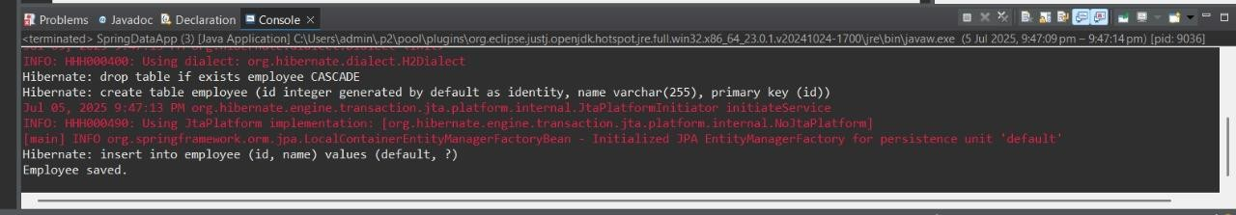
<property name="hibernate.hbm2ddl.auto">update</property>
<mapping class="com.example.model.Employee"/>
</session-factory>
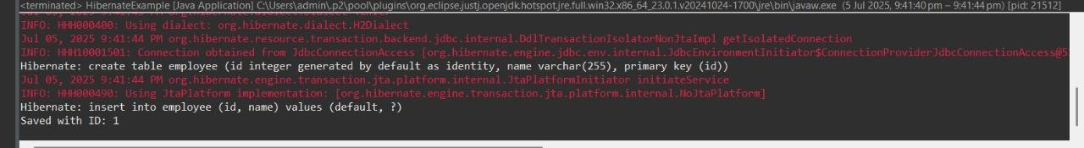
</hibernate-configuration>

