Exercise 1: Configuring a Basic Spring Application

pom.xml
<dependencies>
<dependency>
<groupId>org.springframework</groupId>
<artifactId>spring-context</artifactId>
<version>5.3.34</version>
</dependency>
</dependencies>

ApplicationContext.xml
<?xml version="1.0" encoding="UTF-8"?>
<beans xmlns="http://www.springframework.org/schema/beans" xmlns:xsi="http://www.w3.org/2001/XMLSchema-instance" xsi:schemaLocation="http://www.springframework.org/schema/beans http://www.springframework.org/schema/beans/spring-beans.xsd">
<bean id="bookRepository" class="com.library.repository.BookRepository"/>
<bean id="bookService" class="com.library.service.BookService">
<property name="bookRepository" ref="bookRepository"/>
</bean>
</beans>

BookRepository.java
package com.library.repository; public class BookRepository {

public void saveBook(String title) { System.out.println("Book saved: " + title);
}
}

BookService.java
package com.library.service;
import com.library.repository.BookRepository; public class BookService {
private BookRepository bookRepository;
public void setBookRepository(BookRepository bookRepository) { this.bookRepository = bookRepository;
}
public void addBook(String title) { System.out.println("Adding book: " + title); bookRepository.saveBook(title);
}
}

LibraryApp.java
package com.library.main;
import com.library.service.BookService;
import org.springframework.context.ApplicationContext;
import org.springframework.context.support.ClassPathXmlApplicationContext; public class LibraryApp {
public static void main(String[] args) {

ApplicationContext context =
new ClassPathXmlApplicationContext("applicationContext.xml");

BookService bookService = (BookService) context.getBean("bookService"); bookService.addBook("The Spring Handbook"); ((ClassPathXmlApplicationContext) context).close();
}
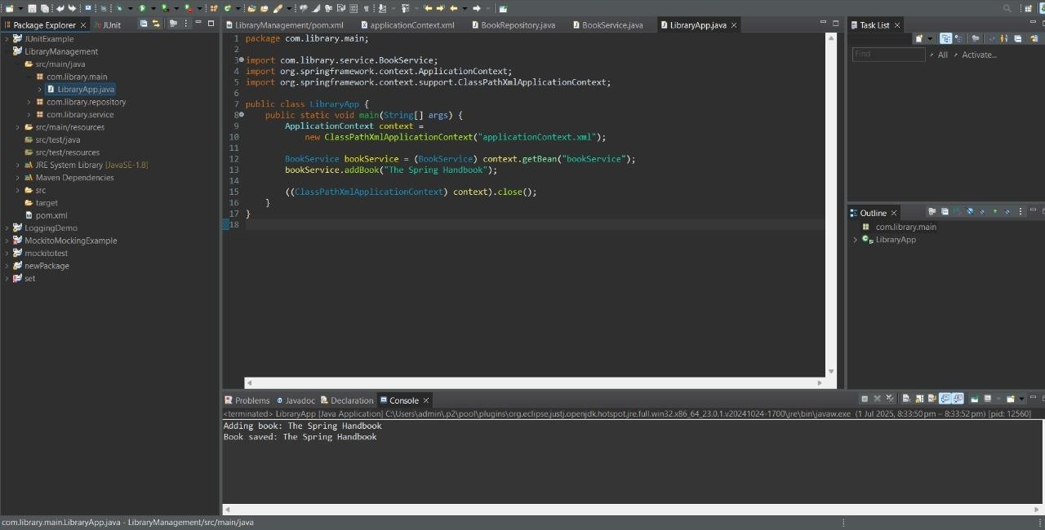
}

Exercise 2: Implementing Dependency Injection

ApplicationContext.xml
<?xml version="1.0" encoding="UTF-8"?>
<beans xmlns="http://www.springframework.org/schema/beans" xmlns:xsi="http://www.w3.org/2001/XMLSchema-instance" xsi:schemaLocation="http://www.springframework.org/schema/beans

http://www.springframework.org/schema/beans/spring-beans.xsd">
<bean id="bookRepository" class="com.library.repository.BookRepository"/>
<bean id="bookService" class="com.library.service.BookService">
<property name="bookRepository" ref="bookRepository"/>
</bean>
</beans>

BookService.java
package com.library.service;
import com.library.repository.BookRepository; public class BookService {
private BookRepository bookRepository;
//setter method for BookRepository
public void setBookRepository(BookRepository bookRepository) { this.bookRepository = bookRepository;
}
public void addBook(String title) { System.out.println("Adding book: " + title); bookRepository.saveBook(title);
}
}

LibraryApp.java
package com.library.main;
import com.library.service.BookService;
import org.springframework.context.ApplicationContext;

import org.springframework.context.support.ClassPathXmlApplicationContext; public class LibraryApp {
public static void main(String[] args) { ApplicationContext context =
new ClassPathXmlApplicationContext("applicationContext.xml"); BookService bookService = (BookService) context.getBean("bookService"); bookService.addBook("Clean Code by Robert C. Martin"); ((ClassPathXmlApplicationContext) context).close();
}
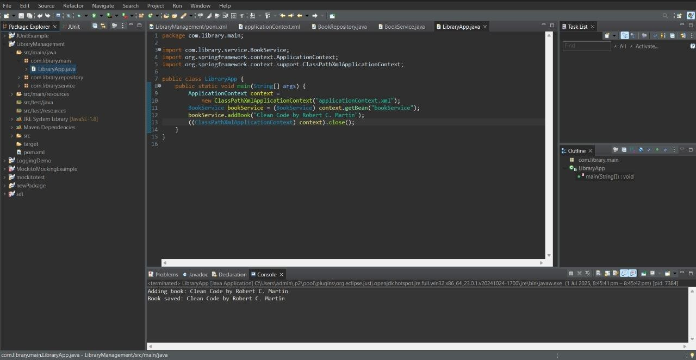
}

Exercise 4: Creating and Configuring a Maven Project

<project xmlns="http://maven.apache.org/POM/4.0.0" xmlns:xsi="http://www.w3.org/2001/XMLSchema-instance" xsi:schemaLocation="http://maven.apache.org/POM/4.0.0 https://maven.apache.org/xsd/maven-4.0.0.xsd">

<modelVersion>4.0.0</modelVersion>
<groupId>com.student</groupId>
<artifactId>StudentManagement</artifactId>
<version>0.0.1-SNAPSHOT</version>
<!--Include dependencies for Spring Context, Spring AOP, and Spring WebMVC-->
<dependencies>
<dependency>
<groupId>org.springframework</groupId>
<artifactId>spring-context</artifactId>
<version>5.3.34</version>
</dependency>
<dependency>
<groupId>org.springframework</groupId>
<artifactId>spring-aop</artifactId>
<version>5.3.34</version>
</dependency>
<dependency>
<groupId>org.springframework</groupId>
<artifactId>spring-webmvc</artifactId>
<version>5.3.34</version>
</dependency>
</dependencies>
<!--Configure the Maven Compiler Plugin for Java version 1.8 in the pom.xml file-->
<build>
<plugins>
<plugin>

<groupId>org.apache.maven.plugins</groupId>
<artifactId>maven-compiler-plugin</artifactId>
<version>3.8.1</version>
<configuration>
<source>1.8</source>
<target>1.8</target>
</configuration>
</plugin>
</plugins>
</build>
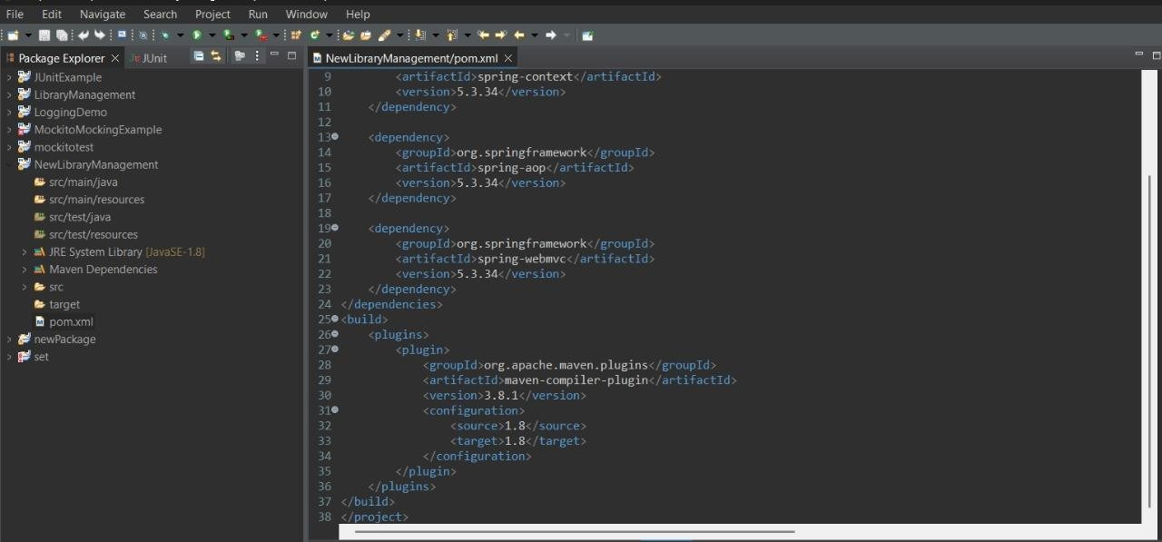
</project>

