Exercise 1: Control Structures
CREATE TABLE Customers ( CustomerID NUMBER PRIMARY KEY, Name VARCHAR2(100),
DOB DATE, Balance NUMBER, LastModified DATE );
INSERT INTO Customers (CustomerID, Name, DOB, Balance, LastModified) VALUES (1, 'John Doe', TO_DATE('1985-05-15', 'YYYY-MM-DD'), 1000, SYSDATE);
INSERT INTO Customers (CustomerID, Name, DOB, Balance, LastModified) VALUES (2, 'Jane Smith', TO_DATE('1990-07-20', 'YYYY-MM-DD'), 1500, SYSDATE);

CREATE TABLE Loans ( LoanID NUMBER PRIMARY KEY, CustomerID NUMBER,
LoanAmount NUMBER, InterestRate NUMBER, StartDate DATE, EndDate DATE, FOREIGN KEY (CustomerID) REFERENCES Customers(CustomerID) );
INSERT INTO Loans (LoanID, CustomerID, LoanAmount, InterestRate, StartDate, EndDate) VALUES (1, 1, 5000, 5, SYSDATE, ADD_MONTHS(SYSDATE, 60));
INSERT INTO Loans (LoanID, CustomerID, LoanAmount, InterestRate, StartDate, EndDate) VALUES (2, 2, 7000, 6, SYSDATE, SYSDATE + 10); COMMIT;
--Scenario 1 BEGIN
FOR cust IN (SELECT CustomerID, DOB FROM Customers)
LOOP IF MONTHS_BETWEEN(SYSDATE, cust.DOB) / 12 > 60 THEN UPDATE Loans SET
InterestRate = InterestRate - 1 WHERE CustomerID = cust.CustomerID; END IF;
END LOOP; COMMIT; END;
/

--Scenario 2

ALTER TABLE Customers ADD IsVIP VARCHAR2(5); BEGIN
FOR cust IN (SELECT CustomerID, Balance FROM Customers)
LOOP IF cust.Balance > 10000 THEN UPDATE Customers SET IsVIP = 'TRUE' WHERE CustomerID = cust.CustomerID;
END IF; END LOOP;

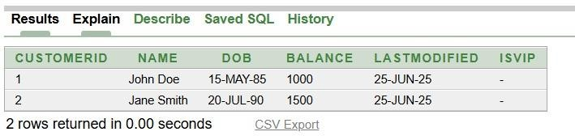
COMMIT;
END;
/
--Scenario 3 BEGIN
FOR loan_rec IN ( SELECT c.Name, l.EndDate FROM Loans l JOIN Customers c ON
l.CustomerID = c.CustomerID WHERE l.EndDate BETWEEN SYSDATE AND SYSDATE + 30 ) LOOP DBMS_OUTPUT.PUT_LINE('Reminder: Loan for ' || loan_rec.Name || ' is due on ' || TO_CHAR(loan_rec.EndDate, 'DD-MON-YYYY'));
END LOOP; END;
/

SELECT * FROM Customers; SELECT* FROM Loans;
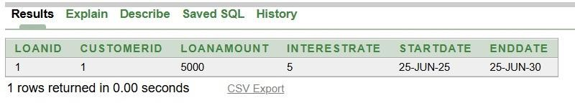
SELECT c.CustomerID, c.Name AS Customer_Name, TO_CHAR(l.EndDate, 'DD-MON- YYYY') AS Due_Date, l.LoanAmount, l.InterestRate FROM Loans l JOIN Customers c ON l.CustomerID = c.CustomerID WHERE l.EndDate BETWEEN SYSDATE AND SYSDATE + 30;

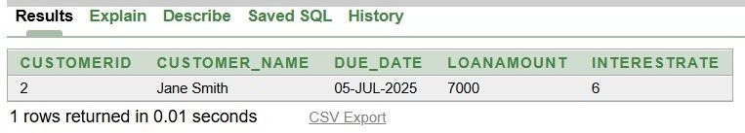
Exercise 3: Stored Procedures
CREATE TABLE Accounts (AccountID NUMBER PRIMARY KEY, CustomerID NUMBER, AccountType VARCHAR2(20), Balance NUMBER, LastModified DATE, FOREIGN KEY (CustomerID) REFERENCES Customers(CustomerID));
INSERT INTO Accounts (AccountID, CustomerID, AccountType, Balance, LastModified) VALUES (1, 1, 'Savings', 1000, SYSDATE);
INSERT INTO Accounts (AccountID, CustomerID, AccountType, Balance, LastModified) VALUES (2, 2, 'Checking', 1500, SYSDATE);

CREATE TABLE Employees (EmployeeID NUMBER PRIMARY KEY, Name VARCHAR2(100),
Position VARCHAR2(50), Salary NUMBER, Department VARCHAR2(50), HireDate DATE); INSERT INTO Employees (EmployeeID, Name, Position, Salary, Department, HireDate) VALUES (1, 'Alice Johnson', 'Manager', 70000, 'HR', TO_DATE('2015-06-15', 'YYYY-MM- DD'));
INSERT INTO Employees (EmployeeID, Name, Position, Salary, Department, HireDate) VALUES (2, 'Bob Brown', 'Developer', 60000, 'IT', TO_DATE('2017-03-20', 'YYYY-MM-DD'));

--Scenario 1

CREATE OR REPLACE PROCEDURE ProcessMonthlyInterest AS BEGIN
FOR acc IN (SELECT AccountID, Balance FROM Accounts WHERE AccountType = 'Savings') LOOP UPDATE Accounts SET Balance = Balance + (acc.Balance * 0.01), LastModified = SYSDATE WHERE AccountID = acc.AccountID;
END LOOP; COMMIT; END;
/

--Scenario 2

CREATE OR REPLACE PROCEDURE UpdateEmployeeBonus( dept_name IN VARCHAR2, bonus_percent IN NUMBER ) AS
BEGIN
UPDATE Employees SET Salary = Salary + (Salary * bonus_percent / 100) WHERE Department = dept_name;
COMMIT;
END;
/

--Scenario 3

CREATE OR REPLACE PROCEDURE TransferFunds( from_acc IN NUMBER, to_acc IN NUMBER, amount IN NUMBER ) AS from_balance NUMBER;
BEGIN
SELECT Balance INTO from_balance FROM Accounts WHERE AccountID = from_acc FOR UPDATE;
IF from_balance < amount THEN
RAISE_APPLICATION_ERROR(-20001, 'Insufficient balance.'); ELSE
UPDATE Accounts SET Balance = Balance - amount WHERE AccountID = from_acc; UPDATE Accounts SET Balance = Balance + amount WHERE AccountID = to_acc;
END IF; COMMIT;

END;
/ BEGIN
TransferFunds(1, 2, 500); END;
/

SELECT * FROM Accounts; SELECT * FROM Employees;

