GIT – Hands On Learning

git --version
git config --global user.name "Varsha"
git config --global user.email "varshabtechcse@gmail.com" git config --list
notepad++
git config --global core.editor "notepad++ -multiInst -notabbar -nosession -noPlugin" git config --global --edit
mkdir GitDemo cd GitDemo
git init
echo "Welcome to Git Hands-on Lab" > welcome.txt ls
cat welcome.txt git status
git add welcome.txt git commit
git remote add origin https://github.com/yourusername/GitDemo.git git pull origin master
git push origin master

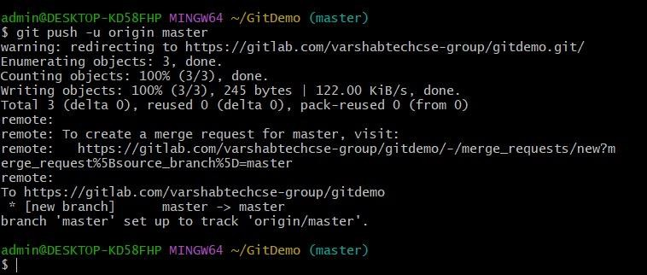

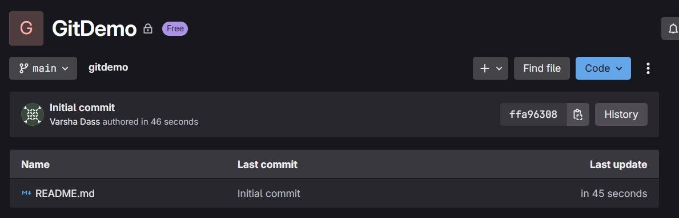
GIT – Hands On Learning

touch error.log mkdir log
touch log/server.log notepad++ .gitignore

In .gitignore file:
*.log log/

git status
git add .gitignore
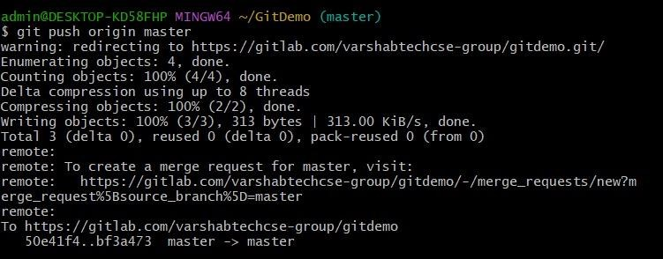
git commit -m "Add .gitignore to ignore .log files and log folder" git push origin master

GIT – Hands On Learning

git branch GitNewBranch git branch
git checkout GitNewBranch
echo "This file is created in GitNewBranch" > branchfile.txt git add branchfile.txt
git commit -m "Added branchfile.txt in GitNewBranch" git status
git checkout master
git diff master GitNewBranch

git merge GitNewBranch
git log --oneline --graph --decorate git branch -d GitNewBranch
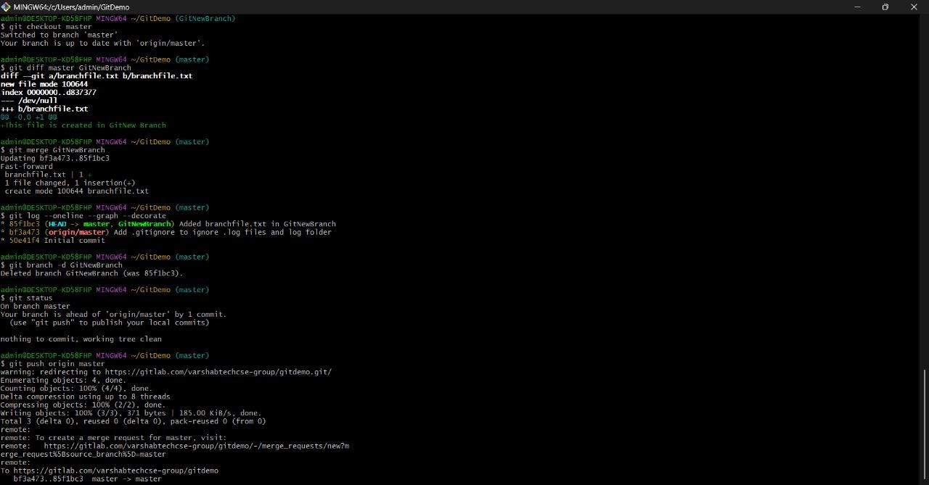
git status

GIT – Hands On Learning

git checkout master git status
git branch GitWork git checkout GitWork
echo "<greeting>Hello from GitWork branch</greeting>" > hello.xml git add hello.xml
git commit -m "Added hello.xml in GitWork with branch-specific content"

git checkout master
echo "<greeting>Hello from master branch</greeting>" > hello.xml git add hello.xml
git commit -m "Added hello.xml in master with different content" git log --oneline --graph --decorate --all
git diff master GitWork git merge GitWork

Edit hello.xml file to:
<greeting>Hello from both branches</greeting>

git add hello.xml
git commit -m "Resolved merge conflict in hello.xml" git branch
git branch -d GitWork
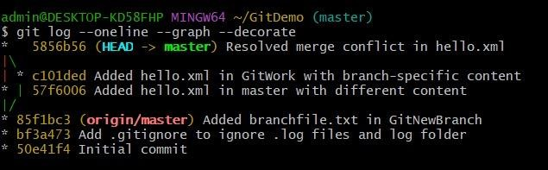
git log --oneline --graph –decorate

GIT – Hands On Learning

git checkout master git status
git branch
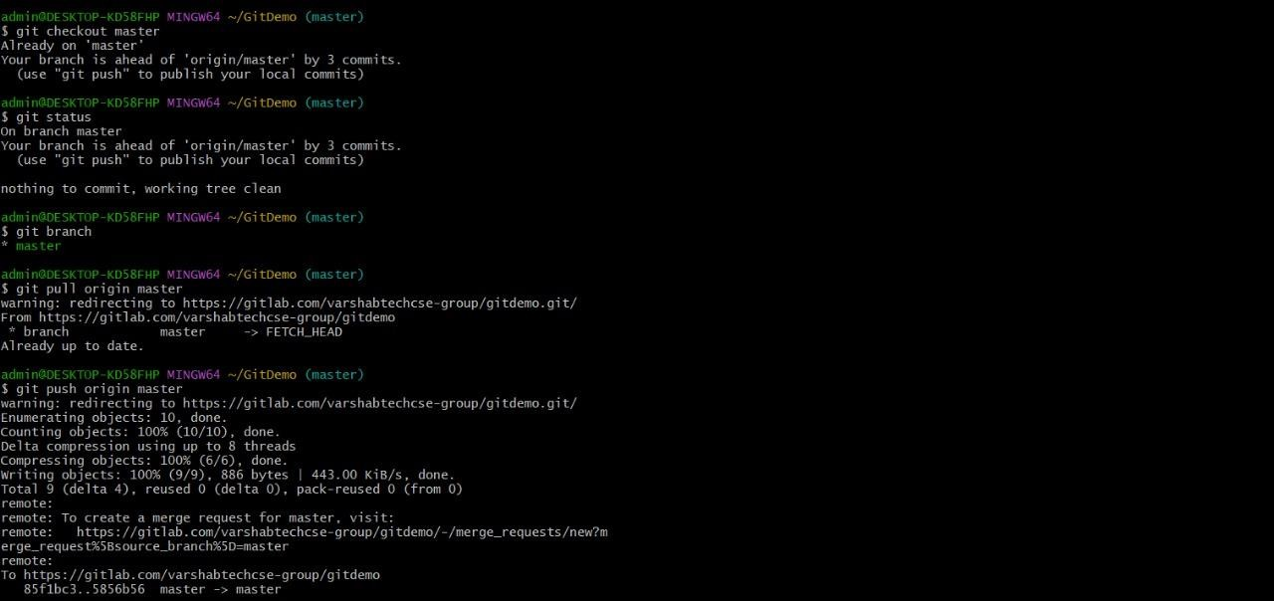
git pull origin master git push origin master

