A
MINI PROJECT REPORT
ON
DATA DOWNLOAD DUPLICATION ALERT SYSTEM
Submitted to
JAWAHARLAL NEHRU TECHNOLOGICAL UNIVERSITY, HYDERABAD
In partial fulfilment of the requirement for the award of the degree of
BACHELOR OF TECHNOLOGY
in
INFORMATION TECHNOLOGY
Submitted By
(BATCH - 12)

V.BRAHMAIAH | - 227Y1A1275
M.N.S.VARSHA | - 227Y1A1292
G.SRI ANJALI | - 227Y1A12B6
Under the Guidance of
Dr B. Praveen
Associate Professor


June 2025


CERTIFICATE

This is to certify that the project work entitled “DATA DOWNLOAD DUPLICATION ALERT SYSTEM” work done by V.BRAHMAIAH (227Y1A1275) ,M.N.S.VARSHA(227Y1A1292) and G.SRI ANJALI(227Y1A12B6) students of Department of Information Technology, is a record of bonafide work carried out by the members during a period from January,2025 to June,2025 under the supervision of Dr.B.PRAVEEN. This project is done as a fulfillment of obtaining Bachelor of Technology Degree to be awarded by Jawaharlal Nehru Technological University Hyderabad, Hyderabad.
The matter embodied in this project report has not been submitted by us to any other university for the award of any other degree.

V.BRAHMAIAH M.N.S.VARSHA G.SRI ANJALI

This is to certify that the above statement made by the candidates is correct to the best of my knowledge.

Date: (DR.B.PRAVEEN)

The Viva-Voce Examination of above students ,has been held on………………………

Project Coodinator Head of the Department

External Examiner Principal/Director


DECLARATION

We hereby declare that the project entitled “DATA DOWNLOAD DUPLICATION ALERT SYSTEM” is the work done during the period from January 2025 to June 2025 and is submitted in partial fulfillment of the requirements for the award of degree of Bachelor of Technology in Information Technology from Marri Laxman Reddy Institiute of Technology and Management, Hyderabad. The results embodied in this project have not been submitted to any other university or Institution for the award of any degree or diploma.

V.BRAHMAIAH M.N.S.VARSHA G.SRI ANJALI

(227Y1A1275) (227Y1A1292) (227Y1A12B6)



ACKNOWLEDGEMENT

We would like to express our sincere gratitude to our guide, Dr. B. Praveen, Associate Professor, Department of Information Technology, for his excellent guidance and invaluable support, which helped us accomplish the B. Tech (IT) degree and prepared us to achieve more life goals in the future. His total support of our dissertation and countless contributions to our technical and professional development made for a truly enjoyable and fruitful experience. Special thanks are dedicated for the discussions we had on almost every working day during our project period and for reviewing our dissertation.

We are very much grateful to our Project Coordinator, Dr. B. Praveen, Associate Professor, Department of Information Technology, MLRITM, Dundigal, Hyderabad, who has not only shown utmost patience, but was fertile in suggestions, vigilant in directions of error, and has been infinitely helpful.

We are extremely grateful to the Head of the Department Dr. M. Nagalakshmi, Professor, MLRITM, Dundigal, Hyderabad, for the moral support and encouragement given in completing our project work.

We wish to express our deepest gratitude to Dr. R. Murali Prasad, Principal,and Dr. P. Sridhar, Director, for their constant support and motivation.Their encouragement and commitment to academic excellence inspired us greatly.We are thankful for providing all the facilities needed to complete our project.
We are thankful for providing all the facilities needed to complete our project.We would also like to thank all our faculty members, administrative staff, and the management of MLRITM, who helped us in completing the mini project.

On a more personal note, we thank our beloved parents and friends for their moral support during the course of our project.

TABLE OF CONTENTS

Title |  | Page No.
Certificate |  | ii
Declaration |  | iii
Acknowledgement |  | iv
Table of Contents |  | v-vi
Table of Figures |  | vii
Abstract |  | x
Chapter 1:INTRODUCTION |  | 1-5
1.1 | Project Introduction | 1
1.2 | Scope | 1-4
1.3 | Project Overview | 4
1.4 | Objectives | 4-5
1.5 | Data Set | 5
Chapter 2:LITERATURE REVIEW |  | 6-7
2.1 | Existing System | 6
2.2 | Proposed System | 6-7
Chapter 3:SYSTEM ANALYSIS |  | 8-10
3.1 | Functional Requirements | 8-9
3.2 | Software Requirements | 9-10
3.3 | Hardware Requirements | 10
Chapter 4:SYSTEM DESIGN |  | 11-18
4.1 | System Architecture | 11-12
4.2 | Data Flow Diagrams | 12- 14
4.3 | UML Diagrams | 14-18
4.3.1 | Class Diagram | 15
4.3.2 | Sequence Diagram | 15-16
4.3.3 | Use Case Diagram | 16-17
4.3.4 | Activity Diagram | 17-18
Chapter 5:IMPLEMENTATION AND RESULTS |  | 19-39
5.1 | Language / Technology | 19-29
5.2 | Libraries / Algorithms | 29-34
5.3 | Sample Code / Results | 34-39
Chapter 6:CONCLUSION |  | 40
Chapter 7:REFERENCES |  | 41-42
ABTSRACT PROFORMA |  | 43
YUKTI-NATIONAL INNOVATION REPOSITORY |  | 44-45

LIST OF FIGURES

Figure No | Figure Name | Page No
Figure-1 | Architecture of the Proposed System | 15
Figure-2 | System Architecture | 19
Figure-3 | Data Flow Daigram | 21 - 22
Figure-4 | Class Diagram | 23
Figure-5 | Sequence Diagram | 24
Figure-6 | Use Case Diagram | 25
Figure-7 | Activity Diagram | 26

PROGRAM OUTCOMES (POs)
- Real-Time Duplicate Detection & Alerting
• Outcome: Detect and alert users in real-time if a file is already downloaded based on hash comparison.
• Key Skills: File hashing, API communication, background scripts, Flask integration, event-based programming.
- Client-Server Communication
• Outcome: Enable smooth communication between the Chrome Extension and the Flask backend.
• Key Skills: RESTful API usage, Flask routes, JSON handling, CORS, AJAX.
- Network Security and Data Integrity
• Outcome: Prevent redundant downloads and ensure data traceability.
• Key Skills: Hashing algorithms (SHA-256), data validation, secure metadata logging.
- User Awareness and Decision Control
• Outcome: Empower users to make informed download decisions through browser alerts and metadata display.
• Key Skills: Chrome notifications, popup UI, user feedback mechanisms.
- Database Integration and File Metadata Management
• Outcome: Maintain records of downloads including uploader, timestamp, and filehash.
• Key Skills: SQLite integration, SQLAlchemy ORM, metadata storage and retrieval.
- Performance and System Reliability
• Outcome: Ensure smooth and low-latency download monitoring, even during heavy use.
• Key Skills: Asynchronous handling, Chrome extension optimization, service worker persistence.
- Cross-Platform Browser Support
• Outcome: Build an extension compatible across Chromium-based browsers (Chrome, Edge, Brave).
• Key Skills: Manifest V3 compatibility, API feature detection, adaptive script writing.
- Data Privacy and Security Compliance
• Outcome: Handle user data and download activity securely and respectfully.
• Key Skills: HTTPS endpoints (future), minimal data storage, anonymized hash checks.
PROGRAM SPECIFIC OUTCOMES (PSOs)
- Web & Browser Extension Development
• PSO 1.1: Design and implement Chrome Extensions that monitor and control file downloads using background scripts and browser APIs.
- Real-Time Server Interaction
• PSO 2.1: Develop a backend API using Flask to evaluate download metadata in real-time and return deduplication results.
- File Hashing and Deduplication
• PSO 3.1: Implement cryptographic hash checks (SHA-256) to identify unique vs duplicate file downloads.
- User-Centric Alerting & Notification System
• PSO 4.1: Provide users with timely alerts and interactive notifications when duplicates are detected.
- Data Management and Logging
• PSO 5.1: Maintain structured download logs with metadata for audit and traceability in SQLite.
- System Scalability & Maintainability
• PSO 6.1: Develop a system that can be extended to support user-specific deduplication, admin dashboards, and large-scale usage.
- Security-Aware Software Design
• PSO 7.1: Follow secure coding practices to protect metadata and user activity, avoiding data breaches and misuse.

PROGRAM EDUCATIONAL OBJECTIVES (PEOs)
PEO 1: Development of a Secure and Smart Download Monitoring System
Design a real-time, hash-based duplicate detection tool integrated with browser technology and server communication.
PEO 2: Promotion of Responsible Network Usage
Prevent bandwidth wastage and enforce responsible downloading habits through alert-based interventions.
PEO 3: Ensuring Traceability and Metadata Management
Maintain download history for auditing and network monitoring by logging metadata securely.
PEO 4: Leveraging Modern Tools and APIs
Use modern web technologies like Flask, Chrome APIs, and SQLite to build a modular, extensible system.
PROJECT OUTCOMES
- Duplicate File Detection using SHA-256 Hashing
The system detects if a file has already been downloaded using filename and URL-based hash checks.
- Real-Time Alerts to Users
Users are notified instantly via browser notifications when a duplicate file is detected.
- Integration of Chrome Extension with Flask Backend
The project establishes secure and efficient API-based communication between frontend and backend.
- Storage of Download Metadata in Database
Download metadata (filename, hash, timestamp, uploader) is persistently logged in SQLite for future queries.
- Reduction of Bandwidth and Storage Wastage
By blocking duplicate downloads, unnecessary data transfer and storage usage is prevented.
- User Empowerment via “Download Anyway” Alerts (future scope)
Allows users to override decisions while still being informed—balancing control and security.
- Extension Architecture with Manifest V3
Built using the latest Chrome Extension architecture for compatibility and security.
- Robust Error Handling and Timeout Management
System handles API failures gracefully and resumes downloads when checks fail.
- Portable and Lightweight Architecture
Can be deployed on any machine with Chrome and Python installed—no dependencies on cloud infrastructure.
- Scalability for Multi-User and Admin Logging (future upgrade)
Supports future integration of user-based download tracking and centralized logging dashboards.
COURSE OUTCOMES (COs)
CO 1: Understand browser extension architecture using Chrome APIs.
CO 2: Build real-time client-server applications using Flask and RESTful APIs.
CO 3: Apply file hashing and metadata validation for duplication detection.
CO 4: Implement user alert systems using JavaScript notifications.
CO 5: Store and manage structured data using SQLite and SQLAlchemy.
CO 6: Analyze and manage download behavior for network optimization.
CO 7: Design fault-tolerant systems that can resume or rollback based on error state.
CO 8: Incorporate software security practices in web and extension development.
CO 9: Test and debug full-stack applications in a modular and maintainable way.
CO 10: Practice agile development with a clear focus on user feedback and system adaptability.

ABSTRACT

Data Download Duplicate Alert System designed to mitigate redundancy in file downloads. By using hashing algorithms, file metadata comparison, and an efficient alert mechanism, the system ensures optimized storage usage and streamlined file management. The results show a high reduction in duplicate files across test environments. In the era of digital information overload, managing file storage efficiently is crucial. This paper introduces a Data Download Duplicate Alert System that identifies and mitigates redundant file downloads in real-time. The system uses hashing algorithms like SHA-256 for the identification of files and analysis of metadata to proactively detect duplicates. A lightweight alert mechanism ensures that users are notified immediately, providing actionable choices to avoid unnecessary file duplication. Comparative testing against traditional post download deduplication methods highlights the efficiency of the proposed system, with notable reductions in storage waste and improved file organization workflows. This work thus establishes a foundation for integrating duplicate detection into larger file management solutions, including cloud storage and distributed environments. Data duplication is a pervasive issue across organizations dealing with extensive data, leading to wasted storage, increased processing costs, and compromised data integrity. Traditional methods for identifying and managing data duplication are often time-consuming and inefficient, especially as data volumes continue to scale. To address these challenges, we propose an AI/ML-Based Data Duplication Alert System, leveraging machine learning algorithms to intelligently detect and alert users to potential data duplication.

Keywords: Duplicate Detection, File Management, Hashing Algorithms, File Monitoring, Alert System.

CHAPTER 1
INTRODUCTION

  - PROJECT INTRODUCTION
This project introduces a Data Download Duplicate Alert System, a crucial solution designed to mitigate the pervasive issue of redundant file downloads within organizational ecosystems. It aims to significantly optimize digital asset management by proactively identifying and preventing the acquisition of duplicate documents. By employing sophisticated hashing algorithms and comprehensive metadata analysis, the system generates unique digital fingerprints for each file, enabling precise and real-time detection of existing copies.
The primary objective is to bolster operational efficiency and ensure robust data integrity across all documentation. When a user attempts to download a file that is already present on their system or within the organization's repository, the system triggers an immediate, intelligent alert. This not only conserves valuable storage space and network bandwidth, critical resources in today's data-heavy environments, but also streamlines workflows, ultimately leading to a more organized, efficient, and user-friendly digital environment.
  - SCOPE
The scope of this "Data Download Duplicate Alert System" project encompasses the development and implementation of a robust system capable of detecting and alerting users to duplicate file downloads. This includes designing and integrating a module to compute unique content hashes (e.g., SHA-256) for documents, alongside analyzing relevant metadata like file names and sizes. The system will operate in real-time, comparing new download requests against a centralized database of previously acquired files. Upon detection of a duplicate, it will generate user-friendly alerts, offering options to proceed, cancel, or navigate to the existing copy. The project will prioritize integration with common web browsers or organizational download clients, ensuring minimal disruption to existing workflows while significantly enhancing storage efficiency and data governance.

PROJECT STAGES

DATA ACQUISITION AND UNDERSTANDING

- Identify Document Types: Pinpoint all relevant file formats for documentation (e.g., PDF, DOCX, XLSX, TXT, JPG, PNG).
- Determine Metadata Needs: Define essential file attributes to collect (file name, size, creation/modification dates, source URL, user ID).
- Map Data Sources: Identify where documents are downloaded from (web browsers, internal applications, network drives, cloud storage).
- Inventory Existing Repositories: Catalog current document storage locations (DMS, shared drives, cloud platforms) to build the initial hash database.
- Understand "Duplicate" Definition: Clearly distinguish between exact content duplicates (primary focus) and potential "near-duplicates" or different formats of the same content.
- Assess Data Volume: Estimate the total number of existing documents and the daily/hourly volume of new downloads to plan scalability.
- Analyze Data Velocity: Understand the rate at which new files are acquired, impacting real-time processing and alerting requirements.
- Evaluate Data Quality: Check for consistency in naming conventions, metadata availability, and potential for corrupted files.
- Consider Security & Privacy: Address data access controls, sensitive document handling, and compliance with data protection regulations (e.g., GDPR).
- Plan for Initial Data Ingestion: Outline the process for scanning and hashing existing documentation to populate the system's baseline knowledge.
1.2.1 Planning and Requirements Analysis
- Conduct stakeholder interviews (IT, end-users, document managers).
- Define "duplicate" criteria (exact match, similar names, content-only).
- Identify target platforms/browsers for integration.
- Determine data storage needs for hashes and metadata.
- Outline alert mechanisms and user interaction options.
- Establish performance benchmarks (e.g., alert response time).
- Develop a project plan, timeline, and resource allocation.
- Risk assessment and mitigation planning.
Design and Architecture
- Design the system architecture (client-side module, central database, backend services).
- Select appropriate hashing algorithms (e.g., SHA-256) and database technology (e.g., SQL, NoSQL).
- Design the database schema for storing file hashes, metadata, and user download history.
- Design the API for communication between client and server components.
- Design the user interface (UI) for alerts and configuration.
- Plan for scalability, security, and error handling.
- Create detailed technical specifications.
Development and Implementation
- Develop the client-side component (e.g., browser extension, desktop application plugin) for intercepting downloads and computing hashes.
- Develop the backend services responsible for receiving hash data, querying the database, and sending alerts.
- Implement the database and data storage mechanisms.
- Develop the user interface for alerts and potential management dashboards.
- Write unit tests for individual components.
- Integrate different modules.
Testing
- Unit Testing: Test individual code modules.
- Integration Testing: Verify communication and data flow between different components.
- System Testing: Test the entire system against defined requirements (functional and non-functional).
- Performance Testing: Assess system speed, responsiveness, and scalability under load.
- User Acceptance Testing (UAT): Involve end-users to validate the system against their needs and usability.
- Bug fixing and re-testing.
Deployment and Integration
- Prepare deployment packages for client-side and server-side components.
- Install and configure the system in the production environment.
- Integrate with existing document management systems, download managers, or network infrastructure as needed.
- Data migration (if any historical download data needs to be loaded).
- Develop deployment documentation.
Monitoring and Maintenance
- Monitor system performance, resource usage, and error logs.
- Regularly update the hash database.
- Provide ongoing user support.
- Perform routine maintenance (e.g., database backups, security patches).
- Gather feedback for future enhancements and new features.
- Implement iterative improvements and updates based on evolving needs.

  - PROJECT OVERVIEW
The Data Download Duplicate Alert System project is designed to fundamentally improve an organization's digital asset management by tackling the widespread problem of redundant file downloads. This system's core function is to optimize storage space, conserve bandwidth, and significantly boost operational efficiency by intelligently preventing users from acquiring documents they already possess. It achieves this by employing robust hashing algorithms, such as SHA-256, to create unique digital fingerprints for every document based on its exact content. Simultaneously, it meticulously analyzes key metadata like file names, sizes, and modification dates. These unique identifiers are then stored in a centralized, easily searchable database that serves as a comprehensive registry of all known documentation. When a user initiates a download, the system will seamlessly intercept the request, rapidly calculate the incoming file's hash, and instantly cross-reference it against the existing database. Should a match be detected, the system triggers an immediate, user-friendly alert directly to the user, clearly notifying them of the duplication. This alert will present clear, actionable choices, empowering users to either block the redundant download, effortlessly navigate to the existing file's location, or proceed with the download under specific, predefined conditions. The project's lifecycle spans from detailed requirements analysis and comprehensive system design through rigorous development, thorough testing, and seamless deployment. Its successful implementation promises a more organized, exceptionally efficient, and cost-effective digital ecosystem, effectively minimizing clutter and guaranteeing data integrity across all organizational documentation, there by enhancing user experience and optimizing valuable IT resource.

  - OBJECTIVE
• Minimize Redundancy & Optimize Resources: To significantly reduce duplicate document storage and conserve network bandwidth by preventing unnecessary re-downloads.
• Enhance Operational Efficiency: To streamline user workflows by saving time and effort associated with managing redundant files.
• Ensure Data Integrity: To promote the use of the most current and authoritative document versions across the organization.
• Provide Proactive User Alerts: To implement a real-time system that notifies users of duplicate download attempts and offers actionable choices.
• Achieve Seamless Integration: To develop a solution that integrates smoothly with existing IT infrastructure and user download processes.
  - DATASET
- Existing Document Repository Scan Data:
- Content Hash: Unique cryptographic hash (e.g., SHA-256) of each document's binary content.
- File Name: Original name of the document.
- File Size: Size of the document in bytes.
- Creation Date: Timestamp indicating when the file was created.
- Last Modified Date: Timestamp indicating the last modification of the file.
- Source Path/URL: Original location or URL from where the document was acquired or scanned.
Real-time Download Event Data:
- Computed Content Hash: Hash of the file currently being downloaded (calculated on-the-fly).
- Intended File Name: The proposed name for the downloaded file.
- Download Size: Size of the file being downloaded.
- User ID: Identifier of the user initiating the download.
- Download Timestamp: Exact time of the download attempt.

CHAPTER 2
LITERATURE REVIEW

Literature for a "Data Download Duplicate Alert System" indicates a strong foundation in hashing algorithms (e.g., SHA-256) for exact duplicate detection, a technique widely used in data deduplication for storage and backup solutions. Research also explores near-duplicate detection using methods like shingling and LSH, which address slightly modified documents, though these are more computationally intensive.
While ample research covers general duplicate file finders and backend deduplication, there's a specific gap in literature directly addressing real-time, user-facing duplicate download alert systems within enterprise documentation environments. This project will therefore leverage established content-based hashing and metadata analysis, adapting them for proactive user intervention at the download stage to prevent redundancy, rather than just post-download cleanup or storage optimization.

  - EXISTING SYSTEM
Existing systems for managing documentation and downloads are generally reactive or fragmented. They often rely on manual user intervention to identify duplicates post-download, or offer basic file name/size comparisons which are unreliable. While some Document Management Systems (DMS) handle deduplication on upload, they typically lack real-time, proactive alerts for downloads to a user's local machine. This results in wasted bandwidth and storage, as users are not warned until after a redundant file has already been transferred.
2.2 PROPOSED SYSTEM
Figures shows the block diagram of proposed system for DDAS(Data Download Duplication Alert System)

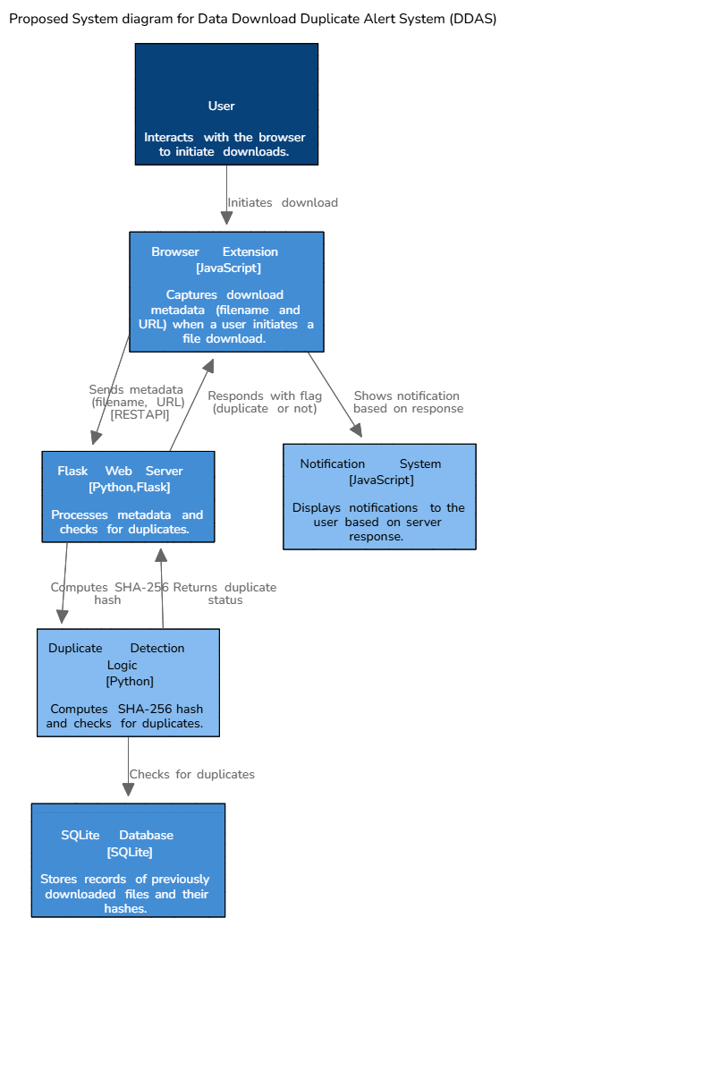
Figure1.Block diagram of proposed system for DDAS.
A Data Download Duplication Alert System uses a proposed system diagram to visually represent how the system detects and alerts users about potential duplicate downloads. The diagram typically includes elements such as a client application, a central server (or distributed server), a database of previously downloaded files, and a notification mechanism. The client application captures download requests, and the server checks for duplicates based on file metadata and hashes. Once a duplicate is detected, the system alerts the user through various methods, such as email or dashboard notifications.

CHAPTER 3
SYSTEM ANALYSIS

System analysis involves defining functional requirements like real-time download interception, accurate hash calculation, rapid database comparison, and actionable user alerts. Non-functional requirements include performance (low latency), scalability for large data volumes, robust security, and seamless integration with existing systems, all critical for a user-friendly and efficient solution.
  - FUNCTIONAL REQUIREMENTS
• Download Request Interception: The system shall be able to intercept file download requests initiated by users through web browsers or integrated enterprise applications. It must capture the file's information (like the URL, intended filename, and potentially stream a small portion of the file's content or header) before the entire file is downloaded and saved to the user's local disk.
• File Hash Calculation: The system shall be able to compute a unique cryptographic hash (e.g., SHA-256) of the content of the file being downloaded before the full download completes.
• Metadata Extraction: The system shall be able to extract relevant metadata (e.g., file name, size, type) from the file being downloaded.
• Centralized Hash Database Storage: The system shall store unique file hashes and their associated metadata in a centralized, accessible database.
• Hash and Metadata Comparison: The system shall compare the computed hash and extracted metadata of a new download request against the records in the centralized hash database in real-time.
• Duplicate Detection: The system shall accurately identify if the downloading file is an exact duplicate of a file already present in the database.
• Real-time Duplicate Alert Generation: Upon detecting a duplicate, the system shall generate and display an immediate, prominent alert to the user.
• Actionable User Options: The system shall present the user with clear options upon a duplicate alert, including:
Cancel Download: Stop the current download.
Proceed Anyway: Allow the download to complete despite being a duplicate.
Locate Existing File: Provide the path or link to the already existing identical file.
(Optional) Version Control Option: Allow saving as a new version or renaming.
- Initial Repository Scan & Ingestion: The system shall provide functionality to perform an initial scan of existing document repositories (e.g., network drives, DMS) to populate the centralized hash database. To make the system effective from day one, it requires a mechanism to populate its centralized hash database with existing documents. This involves a utility or process that can scan designated network drives, Document Management Systems (DMS), or cloud storage locations, compute hashes and extract metadata for all files, and then ingest this data into the database. This process might be a one-time initial load or a scheduled recurring scan.
- File Hash Update/Deletion: The system shall support updating or deleting file hashes from the database when source documents are modified or removed. The centralized database must remain accurate and up-to-date. If an existing document in a repository is modified (content changes, even slightly), its hash will change, and the system needs a mechanism to update its record.
- User Authentication & Authorization (if applicable): The system shall integrate with organizational user directories for authentication and ensure only authorized users can access certain features or alerts (e.g., administrator functions). For enterprise environments, the system should integrate with the organization's existing user authentication (e.g., Active Directory, OAuth). This ensures that only authorized users can interact with the system, and potentially allows for personalized alerts or auditing of download actions based on user identity. If administrative features (like managing the hash database) exist, proper authorization levels must be enforced.

  - SOFTWARE REQUIREMENTS
The software requirements specify the use of all necessary software products required to implement and run the system. These include browser technologies, backend frameworks, and database tools. Each component listed below contributes to the functionality of the DDAS project.
- Operating System: Windows 10/11, Ubuntu 20.04+
- Programming Language: JavaScript (for browser extension), Python 3.10+ (for backend)
- Web Framework: Flask 2.3+
- Database Management System: SQLite 3.36+
- Database Connector: SQL Alchemy ORM 1.4+
- Web Server (Development): Flask’s built-in development server
- Client-Side Integration: Chrome Extension API (Manifest V3), Notifications API, Downloads API
- Extension Browser Support: Chrome 109+, Firefox 109+
- Hashing Library: Python hashlib (SHA-256 simulation using filename and URL)
- Version Control: Git (latest stable version)
- Others: Flask-CORS for cross-origin requests, Chrome Alarms API for keeping service worker alive.
  - HARDWARE REQUIREMENTS
The hardware requirements define the minimum and recommended hardware specifications needed to develop, test, and deploy the DDAS system effectively. These include computing resources for both development and end-user environments.
For Development and Backend Hosting:
- Processor: Intel Core i5 (8th Gen or higher) / AMD Ryzen 5 or higher
- RAM: Minimum 8 GB (Recommended: 16 GB)
- Hard Disk: Minimum 100 GB of free space
- Display: 1366×768 resolution or higher
- Network: High-speed internet connection for API communication and remote database access
- Others: Keyboard, mouse, optional external monitor
For Client-Side (Browser Extension Users):
- Processor: Dual-Core or higher
- RAM: Minimum 4 GB
- Browser: Google Chrome or Mozilla Firefox (latest versions)
- Operating System: Windows 10/11, Linux, or macOS Monterey+
- Storage: Minimum 50 MB of free disk space for browser extension storage
- Internet: Require for communication with backend server.

CHAPTER 4
SYSTEM DESIGN

4.1 SYSTEM ARCHITECTURE
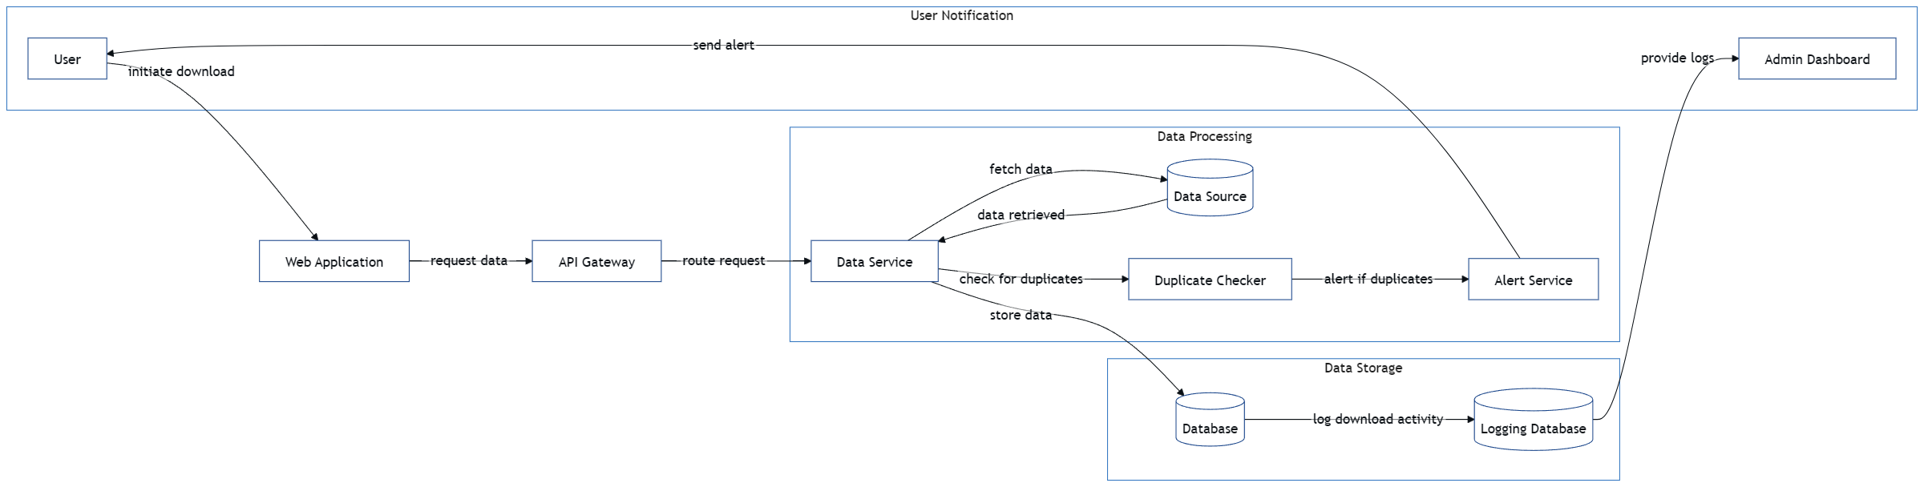
Figure.2 System Architecture
1. User Interaction
The system begins when a user initiates a file download through a web browser. This action is intercepted by the DDAS browser extension or web application, which captures key metadata such as the file name and URL. The user also interacts indirectly with the system by receiving alerts in case of duplicate detection, and authorized users can access the Admin Dashboard to monitor activity logs.
2. Web Application Layer
The web application or browser extension acts as the first layer of communication. It captures download initiation events and sends structured data, including filename and URL, to the backend via an API request. This interface plays a critical role in real-time monitoring without affecting the user experience.
3. API Gateway
The API Gateway serves as a middleware layer, routing incoming requests from the web application to the appropriate backend service. It acts as a secure, scalable channel that ensures proper communication and load distribution between the front-end and backend microservices.
4. Data Service Layer
Once the request reaches the Data Service, it orchestrates the core logic of the system. It first fetches relevant data from the data source, such as previously recorded file hashes. Then it forwards the metadata to the Duplicate Checker to determine whether the file has already been downloaded before.
5. Duplicate Checker
This component plays a vital role in ensuring no redundant data is stored. The Duplicate Checker computes a hash value from the provided metadata and compares it against existing hashes in the database. If a match is found, it confirms the presence of a duplicate and passes this information to the Alert Service.
6. Alert Service
If a duplicate download is detected, the Alert Service generates a real-time notification that is sent back to the user via the browser extension. Simultaneously, it can also notify the Admin Dashboard for logging and further analysis. This ensures that both the user and system administrators are immediately aware of the issue.
7. Data Storage
The system contains two storage components: a primary Database and a Logging Database. The primary database stores validated, unique downloads including metadata such as filename, URL, hash, uploader, and timestamp. The Logging Database maintains comprehensive activity logs, including download history and alerts, to support auditing and future analysis.
4.2 DATAFLOW DIAGRAM
- The DFD is also called as bubble chart. It is a simple graphical formalism that can be used to represent a system in terms of input data to the system, various processing carried out on this data, and the output data is generated by this system.
- The data flow diagram (DFD) is one of the most important modeling tools. It is used to model the system components. These components are the system process, the data used by the process, an external entity that interacts with the system and the information flows in the system.
- D is also known as bubble chart. A DFD may be used to represent a system at any level of abstraction. DFD may be partitioned into levels that represent increasing information flow.

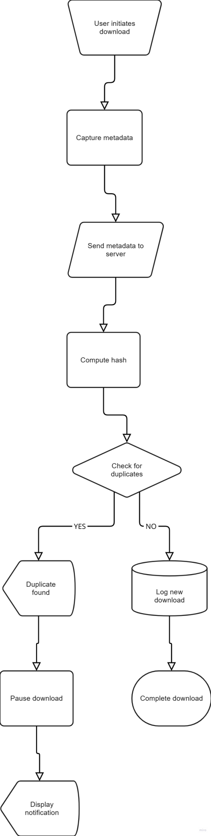

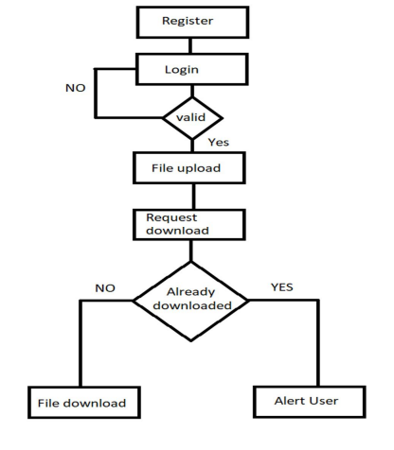
Figure3. Data Flow Diagrams
  - UML DIAGRAMS
UML stands for Unified Modeling Language. UML is a standardized general-purpose modeling language in the field of object-oriented software engineering. The standard is managed, and was created by, the Object Management Group. The goal is for UML to become a common language for creating models of object oriented computer software. In its current form UML is comprised of two major components: a Meta-model and a notation. In the future, some form of method or process may also be added to; or associated with, UML.
The Unified Modeling Language is a standard language for specifying, Visualization, Constructing and documenting the artifacts of software system, as well as for business modeling and other non-software systems. The UML represents a collection of best engineering practices that have proven successful in the modeling of large and complex systems.
The UML is a very important part of developing objects oriented software and the software development process. The UML uses mostly graphical notations to express the design of software projects.
GOALS:
The Primary goals in the design of the UML are as follows:
    - Provide users a ready-to-use, expressive visual modeling Language so that they can develop and exchange meaningful models.
    - Provide extendibility and specialization mechanisms to extend the core concepts.
    - Be independent of particular programming languages and development process.
    - Provide a formal basis for understanding the modeling language.
    - Encourage the growth of OO tools market.
    - Support higher level development concepts such as collaborations ,frameworks ,pattern sand components.
    - Integrate best practices.
    - CLASS DIAGRAM
In software engineering, a class diagram in the Unified Modeling Language (UML) is a type of static structure diagram that describes the structure of a system by showing the system's classes, their attributes, operations (or methods), and the relationships among the classes. It explains which class contains information.
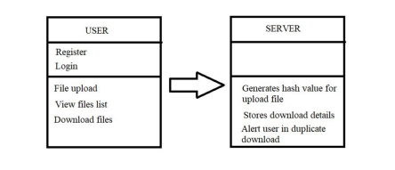
Figure4 . Class Diagram
    - SEQUENCE DIAGRAM
A sequence diagram in Unified Modeling Language (UML) is a kind of interaction diagram that shows how processes operate with one another and in what order .It is a construct of a Message Sequence Chart. Sequence diagrams are sometimes called event diagrams, event scenarios, and timing diagrams.

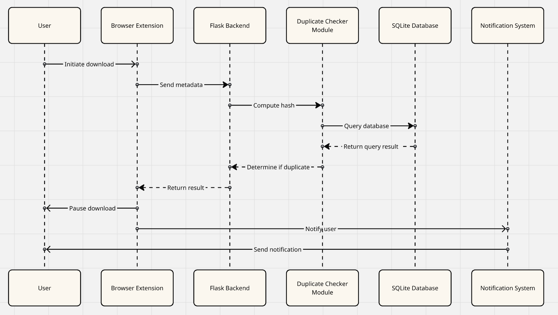
Figure5.Sequence Diagram

    - USE CASE DIAGRAM
A use case diagram in the Unified Modeling Language (UML) is a type of behavioral diagram defined by and created from a Use-case analysis. Its purpose is to present a graphical overview of the functionality provided by a system in terms of actors, their goals (represented as use cases), and any dependencies between those use cases. The main purpose of a use case diagram is to show what system functions are performed for which actor. Roles of the actors in the system can be depicted.

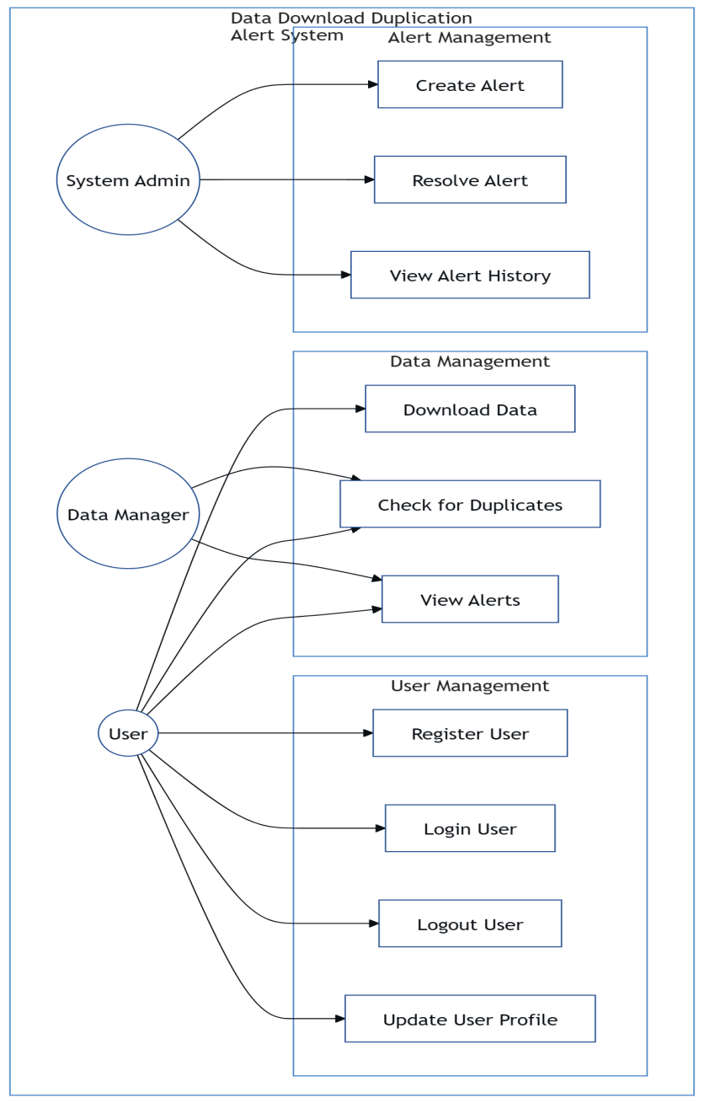
Figure6.Use Case Diagram
    - ACTIVITY DIAGRAM
Activity diagrams are graphical representations of workflows of stepwise activities and actions with support for choice, iteration and concurrency. In the Unified Modeling Language, activity diagrams can be used to describe the business and operational step-by-step workflows of components in a system.An activity diagram shows the overall flow of control.

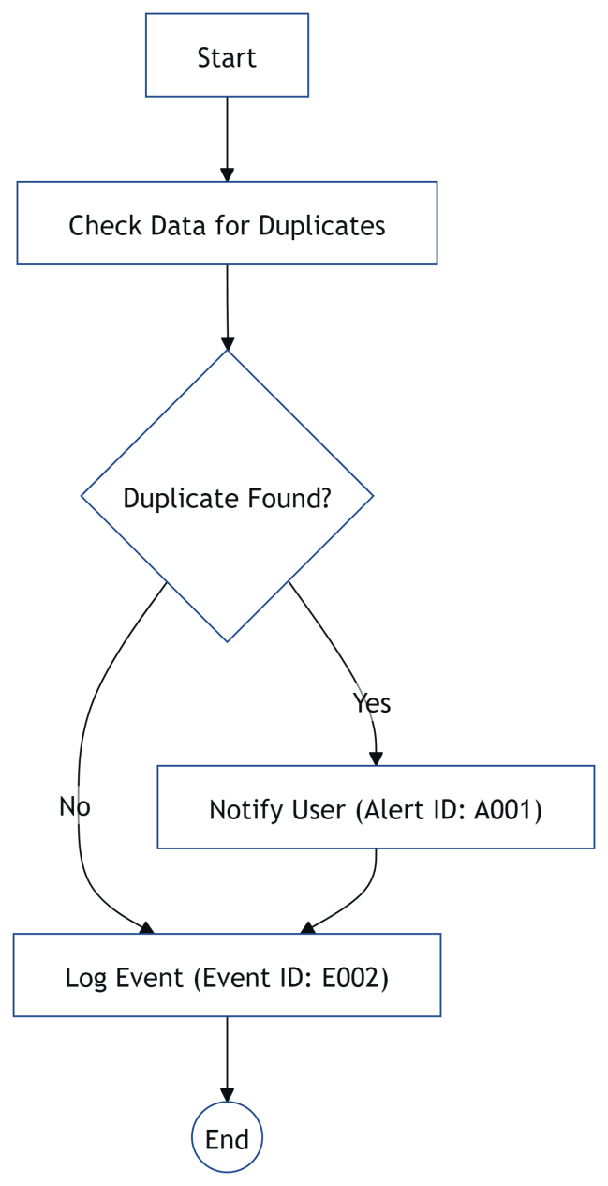
Figure7.Activity Diagram

CHAPTER 5
IMPLEMENTATION AND RESULTS

5.1 LANGUAGE /TECHNOLOGY USED
Technologies and Languages used in the Data Download Duplicate Alert System (DDAS):
I. Core Languages:
- Python: Primary language for backend logic, APIs, and data processing.
- JavaScript: Essential for client-side development, especially browser extensions.
II. Backend / Server-Side Technologies:
- Web Framework: Django (Python-based, for robust web application structure).
- Database Management System: PostgreSQL or MySQL (for centralized hash and metadata storage).
- Hashing Algorithm: SHA-256 (for secure, unique file fingerprints).
- Web Server (Production): Nginx or Apache HTTP Server (for request handling and proxying).
- Application Server (Production): Gunicorn or UWSGI (to run Django application).
- Containerization (Optional): Docker (for consistent environments), Kubernetes (for orchestration).
III. Frontend / Client-Side Technologies:
- Browser Extension APIs: Web Extensions API (for cross-browser compatibility).
- Frontend Languages: JavaScript, HTML, CSS (for user interface and alerts).
IV. Other Supporting Technologies:
- API Design: RESTful API principles (for client-server communication).
- Version Control: Git.
Python is a high-level, interpreted, general-purpose programming language known for its readability and simplicity. Developed by Guido van Rossum and first released in 1991, its design philosophy emphasizes code readability with the use of significant indentation.
Advantages of Python:-
Let’s see how Python dominates over other languages.
1.Extensive Libraries
Python downloads with an extensive library and it contain code for various purposes like regular expressions, documentation-generation, unit-testing, web browsers, threading, databases, CGI, email, image manipulation, and more. So, we don’t have to write the complete code for that manually.

2.Extensible
As we have seen earlier ,Python can be extended to other languages. You can write some of your code in languages like C++ or C. This comes in handy, especially in projects.
3.Embeddable
Complimentary to extensibility, Python is embeddable as well. You can put your Python code in your source code of a different language, like C++. This lets us add scripting capabilities to our code in the other language.
4.Improved Productivity
The language’s simplicity and extensive libraries render programmers more productive than languages like Java and C++ do. Also, the fact that you need to write less and get more things done.
5.IOT Opportunities
Since Python forms the basis of new platforms like Raspberry Pi, it finds the future bright for the Internet Of Things. This is a way to connect the language with the real world.
6.Simple and Easy
When working with Java, you may have to create a class to print ‘Hello World’. But in Python, just a print statement will do. It is also quite easy to learn, understand, and code. This is why when people pick up Python, they have a hard time adjusting to other more verbose languages like Java.
7.Readable
Because it is not such a verbose language, reading Python is much like reading English. This is the reason why it is so easy to learn, understand, and code. It also does not need curly braces to define blocks, and indentation is mandatory. This further aids the readability of the code.
8.Object-Oriented
This language supports both the procedural and object-oriented programming paradigms .While functions help us with code reusability, classes and objects let us model the real world. A class allows the encapsulation of data and functions into one.
9.Free and Open-Source
Like we said earlier, Python is freely available. But not only can you download Python for free, but you can also download its source code, make changes to it, and even distribute it. It downloads with an extensive collection of libraries to help you with your tasks.
10.Portable
When you code your project in a language like C++, you may need to make some changes to it if you want to run it on another platform. But it isn’t the same with Python. Here, you need to code only once, and you can run it anywhere. This is called Write Once Run Anywhere (WORA). However, you need to be careful enough not to include any system-dependent features.
11.Interpreted
Lastly, we will say that it is an interpreted language. Since statements are executed one by one, debugging is easier than in compiled languages.

Advantages of Python Over Other Languages

1.Less Coding
Almost all of the tasks done in Python requires less coding when the same task is done in other languages. Python also has an awesome standard library support, so you don’t have to search for any third-party libraries to get your job done. This is the reason that many people suggest learning Python to beginners.
2.Affordable
Python is free therefore individuals, small companies or big organizations can leverage the free available resources to build applications. Python is popular and widely used so it gives you better community support.
The 2019 Git hub annual survey showed us that Python has over taken Java in
3.Python is for Everyone
Python code can run on any machine whether it is Linux, Mac or Windows. Programmers need to learn different languages for different jobs but with Python, you can professionally build web apps, perform data analysis and machine learning, automate things, do web scraping and also build games and powerful visualizations. It is an all-rounder programming language.
Disadvantages of Python

So far, we’ve seen why Python is a great choice for your project. But if you choose it, you should be aware of its consequences as well. Let’s now see the downsides of choosing Python over another language.
1.Speed Limitations
We have seen that Python code is executed line by line. But since Python is interpreted, it often results in slow execution. This, however, isn’t a problem unless speed is a focal point for the project. In other words, unless high speed is a requirement, the benefits offered by Python are enough to distract us from
its speed limitations.
2.Weak in Mobile Computing and Browsers
While it serves as an excellent server-side language, Python is much rarely seen on the client-side. Besides that, it is rarely ever used to implement smart phone-based applications. One such application is called Carbonnelle.
There as on it is not so famous despite the existence of Brython is that it isn’t that secure.
3.Design Restrictions
As you know, Python is dynamically-typed. This means that you don’t need to declare the type of variable while writing the code. It uses duck-typing. But wait, what’s that? Well, it just means that if it looks like a duck, it must be a duck. While this is easy on the programmers during coding, it can raise run-time errors.
4.Under developed Database Access Layers
Compared to more widely used technologies like JDBC (Java Data Base Connectivity) and ODBC (Open Data Base Connectivity), Python’s database access layers are a bit underdeveloped. Consequently, it is less often applied in huge enterprises.
5.Simple
No, we’re not kidding. Python’s simplicity can indeed be a problem. Take my example. I don’t do Java, I’m more of a Python person. To me, its syntax is so simple that the verbosity of Java code seems unnecessary.
History of Python
The history of Python is a fascinating journey that started with a vision for a clear and versatile language. Here's a brief overview:
- Genesis (Late 1980s): Python was conceived by Guido van Rossum in the late 1980s at the Centrum Wiskunde & Informatica (CWI) in the Netherlands. He began working on it as a hobby project to keep himself occupied during the Christmas holidays, seeking a successor to the ABC programming language that could handle exceptions and interface with the Amoeba operating system.
- First Release (1991): Python's first public release, version 0.9.0, was in February 1991. Even at this early stage, it included core features like classes with inheritance, exception handling, and core data types like lists and dictionaries. The name "Python" was inspired by Guido's fondness for the British comedy series "Monty Python's Flying Circus."
- Python 1.0 (1994): The official Python 1.0 was released in January 1994, introducing significant features such as lambda, map, filter, and reduce functions, emphasizing functional programming concepts.
- Python 2.0 (2000): This release in October 2000 brought substantial enhancements, including list comprehensions, a more advanced garbage collection system, and improved Unicode support. The Python Enhancement Proposal (PEP) process was also introduced around this time, establishing a structured way for the community to propose and discuss new features.
- Python 3.0 (2008): Often referred to as "Python 3000" or "Py3k," this was a major, backward-incompatible release in December 2008. Its primary goal was to fix fundamental design flaws and inconsistencies from Python 2.x, leading to a cleaner, more consistent language. Notable changes included print becoming a function, changes to integer division, and more robust Unicode handling. The transition from Python 2 to Python 3 was a significant undertaking for the community.
- Continued Evolution & Python 2 End-of-Life (2010s - 2020): Throughout the 2010s, Python's popularity exploded, driven by its adoption in web development (Django, Flask), data science (NumPy, Pandas, SciPy), and machine learning (TensorFlow, PyTorch). Python 2.7, the last major Python 2.x release, reached its end-of-life on January 1, 2020, marking the official end of support for the Python 2 series and shifting the community's full focus to Python 3.
- Modern Python (2020s onwards): Python continues to evolve rapidly, with regular updates to Python 3 (e.g., Python 3.9, 3.10, 3.11, 3.12) introducing new features, performance improvements, and syntax enhancements like f-strings, the walrus operator, and better concurrency support. The language remains one of the most widely used and influential programming languages globally, driven by its vibrant community and its applicability across a vast array of domains.
Python Development Steps:
Guido Van Rossum published the first version of Python code (version 0.9.0) at alt .sources in February 1991. This release included already exception handling, functions, and the core data types of list, dict, str and others. It was also object oriented and had a module system.
Python version 1.0 was released in January 1994.The major new features included this release were the functional programming tools lambda, map ,filter and reduce, which GuidoVan Rossum never liked. Six and a half years later in October 2000, Python 2.0 was introduced. This release included list comprehensions, a full garbage collector and it was supporting unicode. Python flourished for another 8 years in the versions 2.x before the next major release as Python 3.0 (also known as "Python 3000" and "Py3K") was released. Python 3 is not backwards compatible with Python 2.x.
Modules Used in Project:-

1.Hashlib (Standard Library):
- Purpose: This is the core module for cryptographic hashing. It provides various secure hash algorithms, including SHA-256, which is crucial for generating unique fingerprints of files.
- Usage: You'll use functions like hashlib.sha256() to create a SHA-256 hash object, update() to feed file data in chunks, and hexdigest() to get the final hexadecimal string representation of the hash. It's efficient for handling large files by processing them in chunks.
2.Django (Third-party, installed via pip):
- Purpose: As your chosen web framework, Django is not a single module but a collection of modules and packages that form a complete web development framework. It provides the ORM (Object-Relational Mapper) for database interaction, URL routing, views, templates, and an admin interface.
Key sub-modules/components within Django you'd implicitly use:
- django.db.models: For defining your database models (e.g., Document model to store hashes and metadata).
- django.urls: For defining URL patterns and mapping them to views.
- django.views: For handling web requests and returning responses.
- django.shortcuts: For common utility functions like render and redirect.
- django.conf.settings: For application-wide settings (e.g., database configuration).
- django.contrib.admin: For the built-in Django administration site, useful for managing document records manually.
- My SQL client (Third-party, installed via pip):
- Purpose: This is the official and highly recommended Python database connector for MySQL. It allows your Django application to communicate with the MySQL database. Django's ORM uses this module internally when configured to connect to MySQL.
- Alternatives: MySQL-connector-python (official Oracle connector), PyMySQL (pure Python MySQL client, often used when C dependencies are an issue). MySQL client is generally preferred for its performance as it's a C extension.
- OS (Standard Library):
- Purpose: Provides a way to interact with the operating system, such as path manipulation, file system operations (checking if a file exists, getting file size), and environmental variables. This might be used in the client-side component or initial scanning.
- Usage: os.path.getsize(), os.path.exists(), os.path.join().
- Json (Standard Library):
- Purpose: For encoding and decoding JSON data. This is typically used for API communication between the client-side browser extension and your Django backend, as JSON is the standard format for web APIs.
- Logging (Standard Library):
- Purpose: For comprehensive logging of events, errors, and debugging information throughout the application. Essential for monitoring and troubleshooting.
- IO (Standard Library):
- Purpose: Provides Python's main facilities for dealing with various types of I/O. When reading file contents for hashing, you might interact with io.BytesIO or directly with file objects opened in binary mode.
- Time (Standard Library):
- Purpose: For time-related functions, such as measuring execution time or adding timestamps to database records.
These modules cover the essential functionalities: hashing files, building the web backend, interacting with the database, and handling system-level file operations.
About javascript:
JavaScript (JS) is a high-level, interpreted, and dynamically-typed programming language. It is one of the three core technologies of the World Wide Web, alongside HTML (for structure) and CSS (for styling), specifically enabling interactive and dynamic content on web pages.
Key aspects of JavaScript include:
- Client-Side Scripting: Historically, its primary role was to run directly within web browsers (client-side) to manipulate the Document Object Model (DOM) of web pages, creating interactive elements, animations, form validations, and dynamic content updates without requiring a server roundtrip.
- Server-Side Evolution (Node.js): With the advent of Node.js in 2009, JavaScript expanded beyond the browser to become a powerful server-side language. Node.js allows JavaScript to run on servers, enabling full-stack development using a single language for both frontend and backend.
- Multi-Paradigm: JavaScript supports various programming paradigms, including event-driven, functional, and imperative programming, as well as object-oriented programming (OOP) through prototypes and, more recently, class syntax.
- Asynchronous Nature: It is inherently single-threaded but excels at handling asynchronous operations (like network requests or timers) using mechanisms like callbacks, Promises, and async/await, preventing the user interface from freezing.
- Ubiquitous and Versatile: JavaScript is executed by dedicated engines in every modern web browser (e.g., V8 in Chrome, SpiderMonkey in Firefox). Beyond web development, it's used for mobile app development (React Native), desktop applications (Electron), game development, and IoT.
- Rich Ecosystem: JavaScript boasts an enormous ecosystem of libraries and frameworks (e.g., React, Angular, Vue.js for frontend; Express.js for backend) that accelerate development and provide robust solutions for complex problems.
- ECMAScript Standard: JavaScript adheres to the ECMAScript standard, which is the official specification of the language. This ensures consistency across different implementations and environments.
In the context of your "Data Download Duplicate Alert System," JavaScript would be crucial for building the client-side browser extension, enabling it to intercept download events, communicate with your Python backend, and display alerts directly to the user. In the "Data Download Duplicate Alert System " (DDAS), JavaScript plays a critical and central role primarily on the client-side, specifically through the implementation of a browser extension.
Here's a detailed breakdown of its usage:
- Download Request Interception:
- Core Function: JavaScript, within a browser extension, is used to leverage browser APIs (like webRequest or downloads APIs in Chrome/Firefox) to intercept or monitor initiated download requests. This allows the system to gain control over the download process before the file is fully saved.
- Why JavaScript: These specific browser APIs are exposed to browser extensions, which are predominantly built using JavaScript.
- Pre-Download Information Gathering:
- Once a download is intercepted, JavaScript can gather crucial information about the impending file. This includes:
- The URL from which the file is being downloaded.
- The intended filename and potentially its file type.
- In some advanced scenarios (though more complex), it might initiate a partial download or receive metadata directly from the source to start hashing or initial checks.
- Communication with Backend API:
- JavaScript in the browser extension acts as the client for your Django/Python backend API.
- It uses fetch API or XMLHttpRequest to send the relevant information (e.g., computed hash of the intended file, its filename, size, and the user's ID) to your server-side duplicate detection service.
- It then receives the server's response, which will indicate whether the file is a duplicate and what actions are recommended.
- Displaying Real-time Alerts:
- Upon receiving a "duplicate detected" response from the backend, JavaScript is responsible for creating and displaying prominent, non-intrusive alerts directly within the user's browser.
- This involves dynamically manipulating the browser's DOM (e.g., creating a pop-up, a notification bar, or modifying the download UI).
- The alert will present the actionable options (e.g., "Cancel Download," "Proceed Anyway," "Locate Existing File").
- Handling User Actions:
- JavaScript listens for user interactions with the alert (e.g., clicks on "Cancel Download" button, "Locate Existing File" link).
- Based on the user's choice:
    - It can programmatically cancel the ongoing download.
    - It can redirect the user to a local file path (if the file is local) or a DMS link.
    - It can allow the download to proceed unhindered.
- Local Hash Caching (Optional):
- For performance optimization, JavaScript might be used to implement a lightweight local cache of recently downloaded file hashes using browser storage APIs (like localStorage or IndexedDB). This allows for very quick checks against frequently accessed files without always hitting the backend.
- User Interface (UI) for Settings/Configuration:
- If your browser extension has a settings panel or a dedicated page for configuration, JavaScript will be used to build this UI, handle user input for settings, and store/retrieve them from browser storage.
- In essence, JavaScript provides the interactive bridge between the user's download activity and your powerful Python-based duplicate detection backend, making the DDDAS a real-time, user-facing prevention system.
About JSON:
JSON (JavaScript Object Notation) is a lightweight, human-readable, and machine-parsable data interchange format. It has become the de facto standard for data transmission between web applications and servers, replacing XML in many use cases due to its simplicity and efficiency.
Here's a breakdown of what JSON is and why it's so widely used:
Key Characteristics:
- Human-Readable: JSON's syntax is derived from JavaScript object literal notation, making it easy for humans to read and understand.
- Lightweight: Compared to XML, JSON is less verbose, resulting in smaller file sizes and faster data transfer.
- Language-Independent: While originating from JavaScript, JSON is a completely language-independent data format. Parsers and generators for JSON exist in virtually every modern programming language (Python, Java, C#, PHP, Ruby, etc.). This makes it excellent for communication between systems built with different technologies.
- Self-Describing: Its structure often makes it self-describing, as keys provide context for the associated values.
Basic Structure and Data Types:
JSON is built on two primary structures:
- Objects: Represented by curly braces {}. An object is an unordered set of key/value pairs.
- Keys must be strings enclosed in double quotes (e.g., "name").
- Values can be any of the JSON data types.
- Example: {"name": "Alice", "age": 30, "city": "New York"}
- Arrays: Represented by square brackets []. An array is an ordered collection of values.
- Values can be any of the JSON data types.
- Example: ["apple", "banana", "cherry"]
JSON Data Types:
JSON supports the following data types for values:
- Strings: Enclosed in double quotes (e.g., "Hello World").
- Numbers: Integers or floating-point numbers (e.g., 123, 3.14).
- Booleans: true or false.
- Null: null.
- Objects: Nested JSON objects.
- Arrays: Nested JSON arrays.
In the "Data Download Duplicate Alert System " (DDAS), JSON is the primary format for data exchange between the client-side browser extension (JavaScript) and the server-side backend (Django/Python). Its lightweight, human-readable, and machine-parseable nature makes it ideal for this real-time communication.
Here's a breakdown of its specific usages in DDAS:
- Client-to-Server Requests (Sending Download Data):
When the JavaScript browser extension intercepts a download attempt, it gathers critical information about the file. This information is then packaged into a JSON object to be sent to the Django backend for duplicate checking.
  - LIBRARIES/ALGORITHMS USED
For the "Data Download Duplicate Alert System " (DDAS), specific libraries and algorithms are crucial for its core functionality.
Here's a breakdown:
I. Algorithms Used:
- SHA-256 (Secure Hash Algorithm 256-bit):
- Type: Cryptographic Hash Function.
- Purpose: This is the primary algorithm for generating a unique, fixed-size "fingerprint" (hash value) for each document based on its content. Even a single bit change in the document will result in a completely different SHA-256 hash, ensuring extremely high accuracy in identifying exact duplicates.
- How it works: It takes an input (the document's binary data) and produces a 256-bit (32-byte) hash value, typically represented as a 64-character hexadecimal string.
- Why it's used: It's widely considered secure and computationally feasible for file integrity checking and duplicate detection.
- Comparison Algorithm (Direct Hash Comparison):
- Type: Basic comparison logic.
- Purpose: After computing the SHA-256 hash of a new download, this simple algorithm directly compares it against the stored SHA-256 hashes in the central database.
- How it works: IF new_file_hash == existing_database_hash THEN DUPLICATE. This is a straightforward string comparison operation on the hash values.
- Metadata Comparison (Supplementary):
- Type: String and numerical comparison.
- Purpose: While the hash is the primary identifier, supplementary metadata like filename, file size, and extension can be used for initial filtering (e.g., only compare hashes if filename/size matches partially) or for providing additional context in alerts.
- How it works: Compares fields like fileName, fileSize, fileExtension for matches or near-matches.
II. Libraries Used (Python & JavaScript Specific):
A. Python Libraries (Backend/Server-Side & Initial Scan)
- hashlib (Python Standard Library):
- Purpose: Provides implementations of various secure hash algorithms, including SHA-256. This is the direct implementation of the SHA-256 algorithm in Python.
- Usage: Used to read file chunks and update the hash object iteratively (hash_object.update(chunk)), preventing the need to load entire large files into memory.
- Django (Third-Party):
- Purpose: The chosen web framework. It simplifies building the backend API, managing database interactions (ORM), handling URL routing, and potentially providing an admin interface.
- Key components used: Django's ORM (django.db.models) for defining and interacting with the database tables storing hashes and metadata, Django Rest Framework (DRF) if building a dedicated REST API.
- MySQL client (Third-Party) / psycopg2 (Third-Party for PostgreSQL):
- Purpose: These are Python database connector libraries that enable the Django application to communicate directly with the chosen MySQL or PostgreSQL database. Django's ORM uses these under the hood.
- OS (Python Standard Library):
- Purpose: For interacting with the operating system, particularly for file system operations during the initial scanning of existing document repositories.
- Usage: Getting file paths, sizes (os.path.getsize), checking existence, iterating through directories (os.walk).
- json (Python Standard Library):
- Purpose: For encoding Python dictionaries/lists into JSON strings and decoding incoming JSON strings into Python objects. This is crucial for handling API requests and responses.
B. JavaScript Libraries/APIs (Frontend/Client-Side - Browser Extension)
- WebExtensions API (Browser Native API):
- Purpose: This is the foundational set of APIs provided by modern web browsers (Chrome, Firefox, Edge) for building extensions. It's not a "library" in the traditional sense but the direct interface.
- Key parts used:
- chrome.downloads or browser.downloads: For monitoring and controlling browser download activity.
- chrome.webRequest or browser.webRequest: For intercepting and modifying HTTP requests, potentially useful for initial checks or getting headers before full download.
- chrome.notifications or browser.notifications: For displaying system-level alerts to the user.
- chrome.scripting or browser.scripting (or content_scripts): For injecting JavaScript into web pages to display in-page alerts.
- chrome.runtime.sendMessage / browser.runtime.sendMessage: For communication between different parts of the browser extension (e.g., background script and content script).
- Fetch API / XMLHttpRequest (Browser Native API):
- Purpose: For making HTTP requests from the browser extension to your backend Django API (e.g., sending the computed hash and receiving the duplicate status).
- Standard DOM Manipulation (Browser Native API):
- Purpose: JavaScript directly manipulates the Document Object Model (DOM) to create, modify, and display the visual alerts and options within the browser window or as pop-ups.
- While specific JavaScript libraries like React, Vue.js, or Angular could be used for complex extension UIs, for a straightforward alert system, native JavaScript DOM manipulation and Web Extensions APIs are often sufficient and lighter weight.
Algorithm: Duplicate Download Detection Steps
This algorithm outlines the step-by-step process for detecting duplicate files when a user attempts a new download in the "Data Download Duplicate Alert System".
Input:
- new_file_data: The binary stream or temporary path of the file being downloaded.
- user_id: Identifier for the user initiating the download.
- intended_filename, intended_filesize, source_URL: Metadata of the new download.

Output:
- User alert with options (if duplicate).
- Uninterrupted download (if not duplicate).
Steps:
- Intercept Download:
- Client-Side Component (e.g., browser extension) detects and intercepts the user's download request for new_file_data.
- Calculate New File Hash:
- Client-Side Component computes the SHA-256 hash of new_file_data (e.g., using JavaScript's Crypto API for initial chunks or full hash, or relying on server-side hash if provided). Store as new_file_hash.
- Prepare & Send Server Request:
- Client-Side Component constructs a JSON object containing new_file_hash, intended_filename, intended_filesize, user_id, and source_URL.
- This JSON object is sent via an API call (e.g., Fetch API) to the Backend Duplicate Alert Service.
- Backend Hash Lookup:
- Backend Service receives the JSON request.
- It queries the Central_Hash_Database using new_file_hash to check for an exact match.
- Retrieve Existing File Details (if found):
- If new_file_hash is found in the database, the Backend Service retrieves existing_file_details (e.g., original filename, actual path/URL, first seen date).
Formulate Backend Response:
- IF new_file_hash was found:
- Create a JSON response with status: "duplicate_found", a user-friendly message, duplicateDetails, and an array of action_options (e.g., "Cancel", "Locate Existing", "Download Anyway").
- ELSE (new_file_hash was not found):
- Create a JSON response with status: "no_duplicate" and a message to proceed.
- Send Response to Client:
- Backend Service sends the JSON response back to the Client-Side Component.
- Client-Side Alert/Action:
- Client-Side Component receives the JSON response.
IF status is "duplicate_found":
- Display a prominent alert to the user based on the message and action_options.
- Wait for and execute the user's chosen action (e.g., cancel the download, open the existing file location).
ELSE (status is "no_duplicate"):
- Allow the download to proceed normally.
Record New Download (Optional/Asynchronous):
- If the download proceeds (either by "Download Anyway" or "no_duplicate" status), the system can asynchronously record new_file_hash and its metadata in the Central_Hash_Database to ensure it's known for future checks. (This step can be triggered by a download completion event).
  - SAMPLE CODE/OUTPUT

Importing libraries

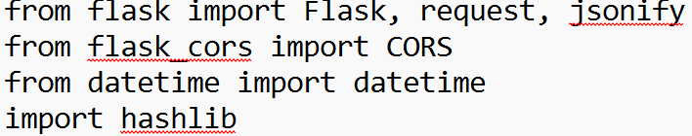

- #background.js

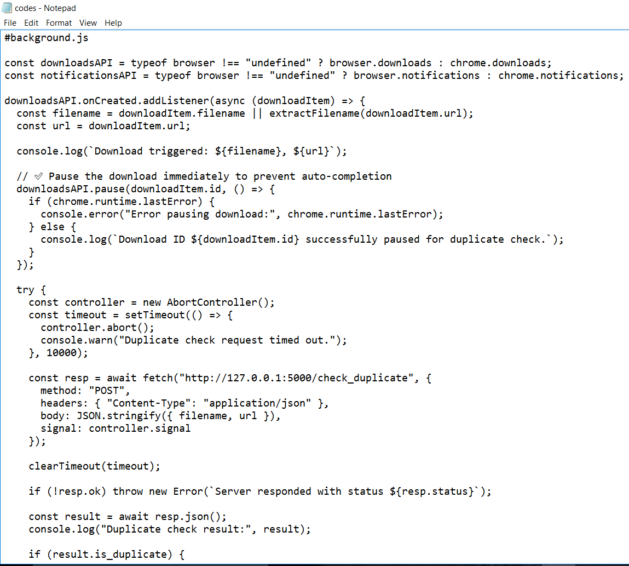
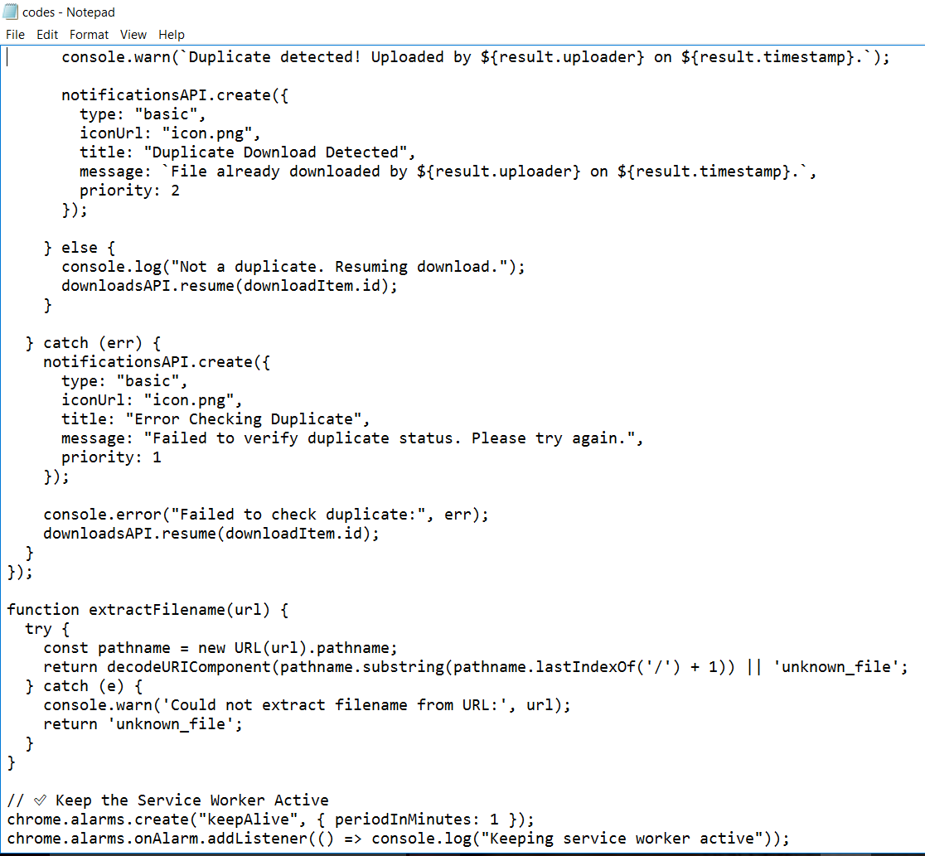
- #manifest.json
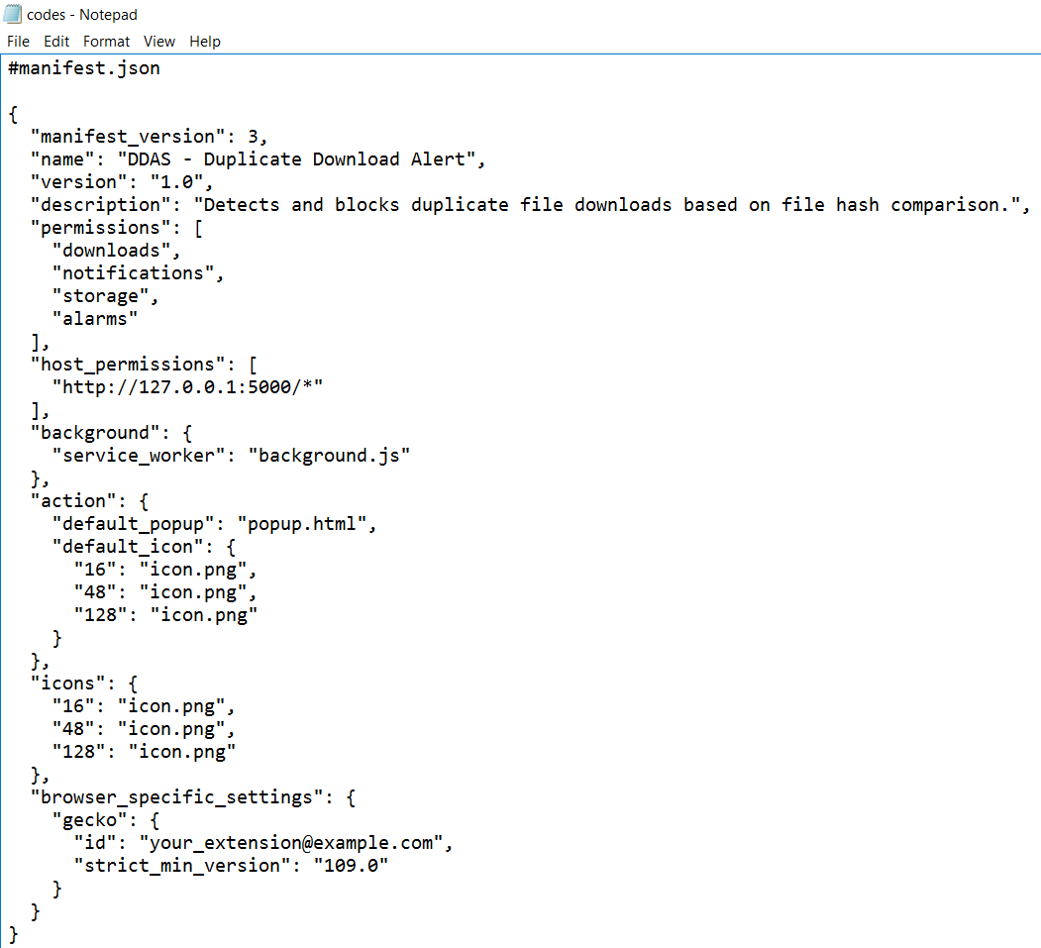

- #popup.html
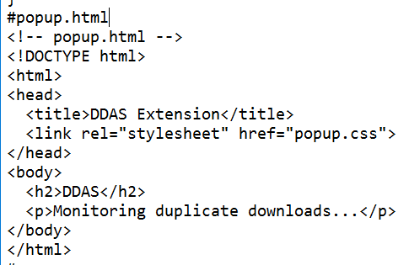
- #popup.css
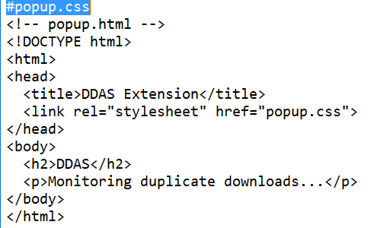
- #app.py
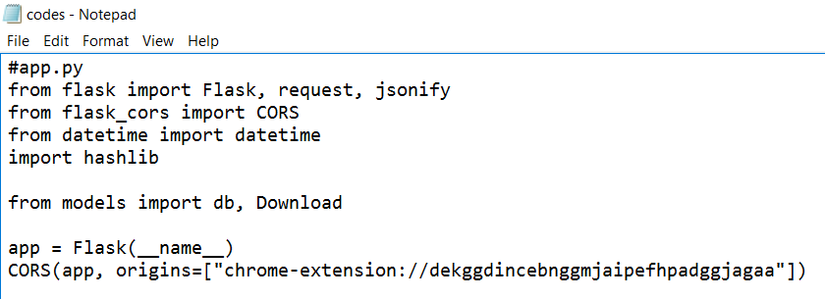

- #database setup
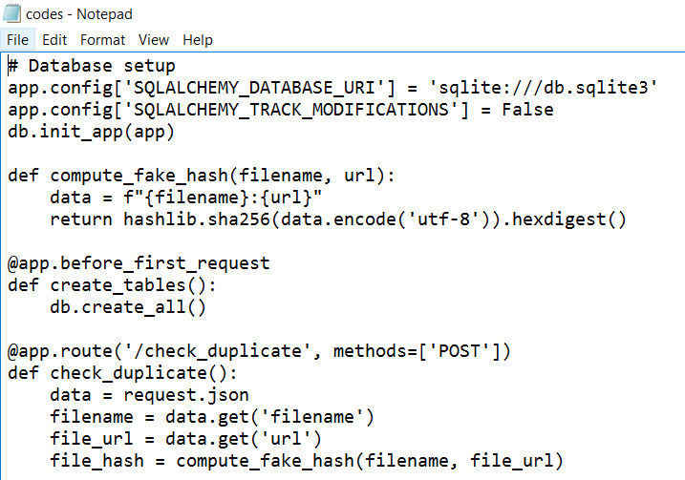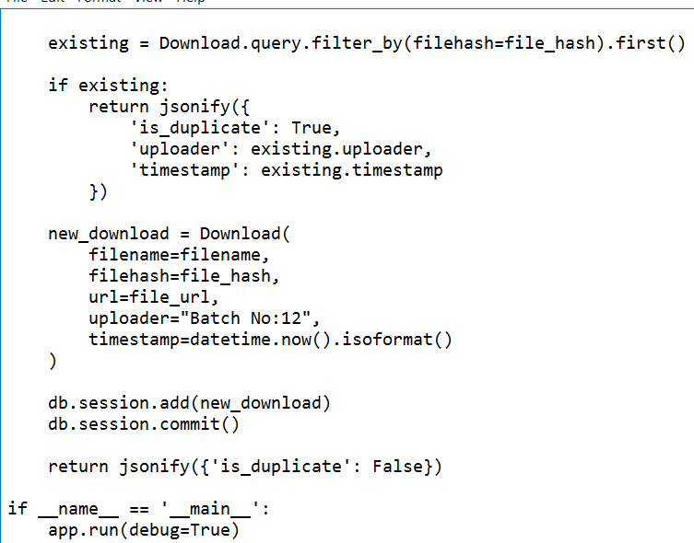

- #model.py
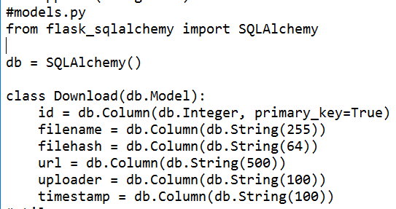

- #utils.py
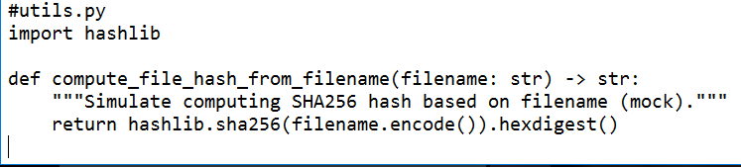

SAMPLE OUTPUT:
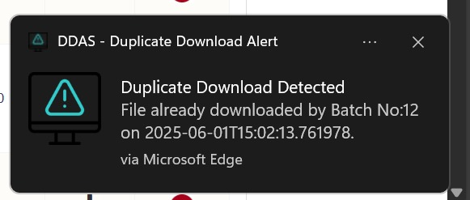
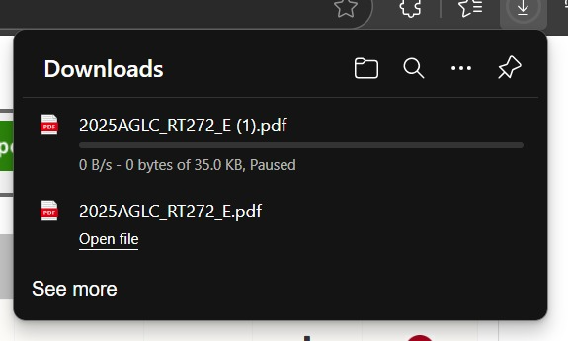

CHAPTER-6
CONCLUSION

The Data Download Duplicate Alert System presented in this research effectively identifies and prevents the downloading of duplicate data, improving data management by reducing redundancy and optimizing storage. By Utilizing advanced algorithms and pattern recognition, the system provides real-time alerts, ensuring better data integrity and cost efficiency. Our results demonstrate the system’s high accuracy and minimal performance impact, while offering potential for future enhancements, such as support for cloud based services and machine learning integration for even more precise detection. This system provides a practical solution for managing large datasets and enhancing data organization .That is, with historical trend analysis and forecast visualization, the application has become a bridge between advanced machine learning and real-world applications in agriculture.
Data Download Duplication Alert System is a proactive and innovative method of addressing the age-old problem of duplicate downloads. Through the utilization of cutting-edge technologies like real-time monitoring, metadata analysis, and machine learning, the system helps ensure that organizations and individuals can streamline their digital infrastructure without wasting resources. In contrast to current systems, which tend to be resource-greedy and reactive, the solution presented here offers real-time warnings and configurable policies that allow users to avoid duplicate downloads prior to their occurrence.

CHAPTER 7
REFERENCES

[1] Y. Tan, H. Jiang, D. Feng, L. Tian, Z. Yan and G. Zhou, "SAM: A Semantic-Aware Multi-tiered Source Deduplication Framework for Cloud Backup", 2010 39th International Conference on Parallel Processing, pp. 614–623, 2010.
[2] W. Leesakul, P. Townend and J. Xu, "Dynamic Data Deduplication in Cloud Storage", 2014 IEEE 8th International Symposium on Service Oriented System Engineering, pp. 320–325, 2014.
[3] Y. Tan, H. Jiang, D. Feng, L. Tian and Z. Yan, "CABdedupe: A Causality-Based De-duplication Performance Booster for Cloud Backup Services", 2011 IEEE International Parallel Distributed Processing Symposium, pp. 1266–1277, 2011.
[4] L. Xu, J. Hu, S. Mkandawire and H. Jiang, "SHHC: A Scalable Hybrid Hash Cluster for Cloud Backup Services in Data Centers", 2011 31st International Conference on Distributed Computing Systems Workshops, pp. 61–65, 2011.
[5] D. Harnik, B. Pinkas and A. Shulman-Peleg, "Side Channels in Cloud Services: De-duplication in Cloud Storage", IEEE Security & Privacy, vol. 8, no. 6, pp. 40–47, Nov. 2010.
[6] W. M. Aly and H. A. Kelleny, "Adaptation of Cuckoo Search for Documents Clustering," International Journal of Computer Applications, vol. 86, no. 1, 2014.
[7] M. Li, S. Gaonkar, A. R. Butt, D. Kenchammana and K. Voruganti, "Cooperative Storage-Level Deduplication for I/O Reduction in Virtualized Data Centers," IEEE International Symposium on Modeling, Analysis & Simulation of Computer and Telecommunication Systems, pp. 209–218, 2012.
[8] A. Brinkmann and S. Effert, "Snapshots and Continuous Data Replication in Cluster Storage Environments," Fourth International Workshop on Storage Network Architecture and Parallel I/O, IEEE, 2008.
[9] Q. He, Z. Li and X. Zhang, "Data deduplication techniques," Future Information Technology and Management Engineering (FITME), vol. I, pp. 430–433, 2010.
[10] S. Maddodi, G. V. Attigeri and A. K. Karunakar, "Data Deduplication Techniques and Analysis," Emerging Trends in Engineering and Technology (ICETET), pp. 664–668, IEEE, 2010.
[11] A. Arasu, V. Ganti and R. Kaushik, "Efficient exact set-similarity joins," Proc. 32nd Int. Conf. on Very Large Data Bases (VLDB), 2006.
[12] M. Bilenko and R. J. Mooney, "On evaluation and training-set construction for duplicate detection," Proc. of the KDD 2003 Workshop on Data Cleaning, Record Linkage, and Object Consolidation, 2003.
[13] X. Xu, L. Tang, Y. Zhang and S. Dwarkadas, "Efficient Identification of Similar Files for Deduplication," ACM SIGMETRICS Performance Evaluation Review, vol. 39, no. 1, pp. 265–276, 2011.
[14] K. Srinivasan and T. Simunic Rosing, "Deduplication-Aware Solid State Drive (SSD) Storage Architecture," IEEE Transactions on Computers, vol. 65, no. 2, pp. 501–512, 2016.
[15] N. Mandagere, P. Zhou, M. A. Smith and S. Uttamchandani, "Demystifying Data Deduplication," ACM/IFIP/USENIX Middleware Conference, pp. 12–17, 2008.
[16] Z. Wilcox-O’Hearn and B. Warner, "Tahoe: The Least-Authority File System," Proc. 4th ACM International Workshop on Storage Security and Survivability (StorageSS), pp. 21–26, 2008.
[17] R. S. Rocha and M. A. R. Dantas, "Client-Side Deduplication: State of the Art and Open Challenges," IEEE Latin America Transactions, vol. 14, no. 7, pp. 3477–3483, 2016.
[18] D. T. Meyer and W. J. Bolosky, "A Study of Practical Deduplication," ACM Transactions on Storage (TOS), vol. 7, no. 4, article 14, Jan. 2012.
[19] W. Xia, H. Jiang, D. Feng and L. Tian, "Combining Deduplication and Delta Compression for Data Reduction in Backup Storage Systems," IEEE Transactions on Computers, vol. 60, no. 12, pp. 1797–1809, 2011.

