HR Product Feature Priorotization

1. Project Overview
The HR Product Feature Prioritization Project aims to analyze employee workforce data to identify key workplace challenges and prioritize HR technology features that can improve employee engagement, productivity, and retention.
The project leverages data analytics and visualization tools such as Microsoft Power BI to identify patterns in employee engagement, training, and manager effectiveness.
The final outcome of the project is to recommend high‑impact HR product features that address employee needs and improve organizational performance.

2. Current System (AS-IS)
Most organizations currently rely on annual employee engagement surveys and static HR reports. These traditional approaches have several limitations:
• HR teams lack real‑time visibility into employee sentiment.
• Managers cannot identify engagement issues early.
• HR technology investments are often prioritized without clear data insights.

3. Future State (TO-BE)
The proposed solution will implement a data-driven HR analytics framework supported by a Pulse Survey platform and an HR analytics dashboard.
The new system will:
• Collect employee feedback frequently through pulse surveys
• Provide real‑time insights through dashboards
• Enable HR leaders to prioritize HR product features based on impact
• Support proactive workforce decision‑making

4. Business Problem
Organizations face multiple workforce challenges including:

• Low employee engagement
• Lack of continuous employee feedback
• Limited visibility into workforce sentiment
• Ineffective prioritization of HR technology features
Without continuous insights, HR leaders cannot identify engagement risks early or invest in the most impact HR technology features.

5. Business Objectives
The objectives of this project are:
• Identify HR challenges affecting employee satisfaction
• Prioritize HR product features using a scoring framework
• Provide actionable insights through interactive dashboards
• Recommend a high-priority HR technology feature for implementation

6. Stakeholders
HR Leaders – Strategic workforce planning
HR Analytics Team – Data analysis and reporting
People Managers – Improve team engagement
Employees – Provide feedback and engagement data
Product Managers – Implement prioritized HR technology features

7. Project Scope
In Scope
• Employee engagement analysis
• Manager effectiveness analysis
• Training impact analysis
• HR feature prioritization framework
• HR analytics dashboard development
Out of Scope
• Payroll systems
• Recruitment system implementation
• Performance management redesign

8. Data Sources
The project uses an employee workforce dataset with the following fields:
Employee ID – Unique identifier
Department – Employee department
Manager Rating – Performance rating of manager
Engagement Score – Employee engagement level
Training Hours – Training received
Feature Name – HR feature being evaluated
Priority Score – Calculated feature priority

9. Analytical Approach
Step 1 – Data Analysis
Analyze workforce data to identify trends in engagement, manager effectiveness, and training impact.

Step 2 – Dashboard Development
Create an interactive HR analytics dashboard using Microsoft Power BI.

Dashboard Pages:
• Workforce Overview
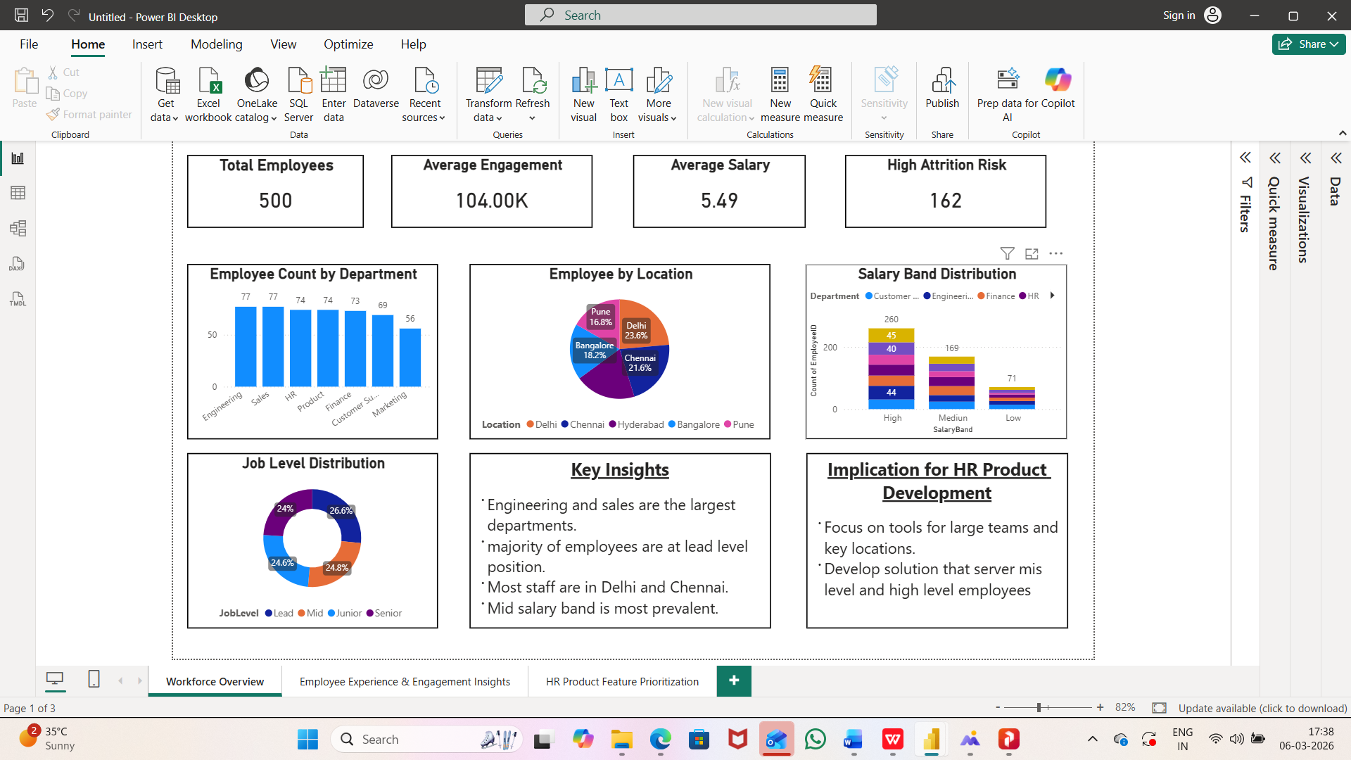
• Employee Experience Insights
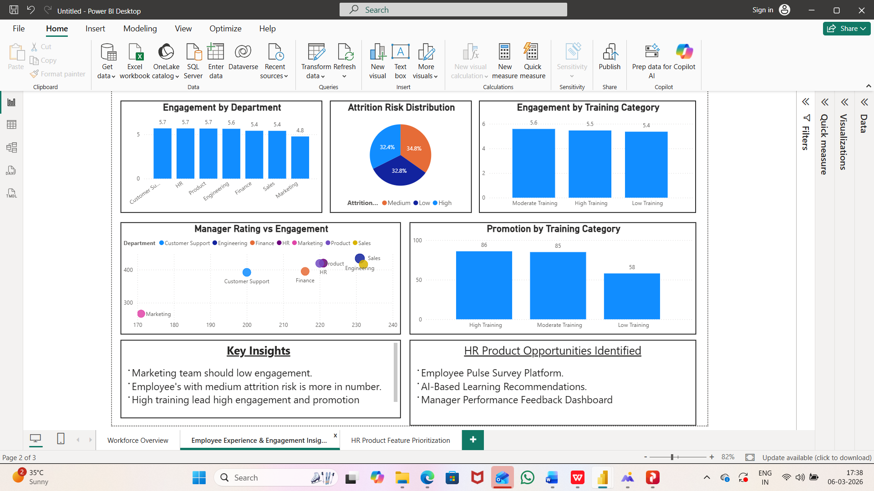

• HR Product Feature Prioritization
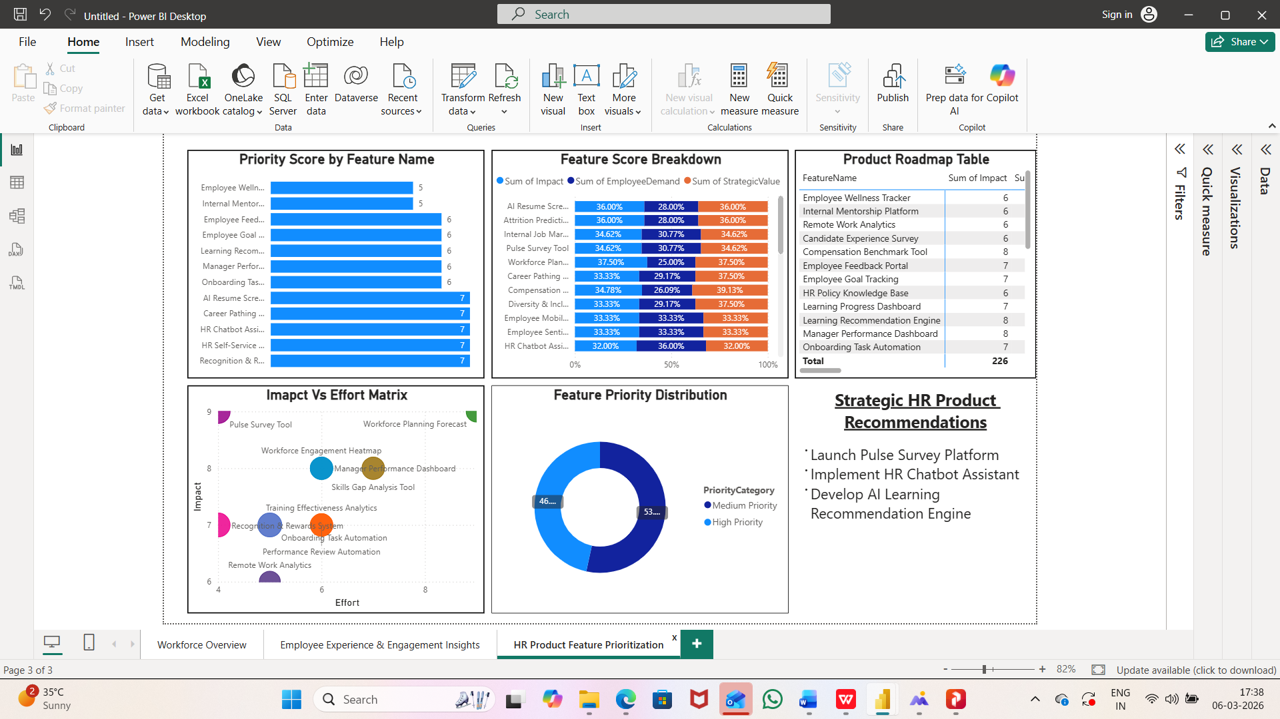

Step 3 – Feature Scoring
Each HR feature is evaluated using:
• Impact
• Employee demand
• Implementation effort

10. Feature Prioritization Framework
Features are evaluated using a Priority Score model.
Example:
Pulse Survey Tool – Impact: High | Effort: Medium | Demand: High
AI Learning Recommendations – Impact: Medium | Effort: High | Demand: Medium
Recognition Platform – Impact: Medium | Effort: Medium | Demand: Medium
Career Pathing Tool – Impact: High | Effort: High | Demand: Medium
The Pulse Survey Tool receives the highest score and is recommended for implementation.

11. Key Business Insights
• Employees with higher manager ratings show higher engagement.
• Training hours moderately improve engagement.
• Employees prefer frequent feedback rather than annual surveys.
These insights highlight the need for continuous employee feedback.

12. Recommended Feature
Pulse Survey Platform
The Pulse Survey platform allows organizations to collect frequent employee feedback through short surveys.
Benefits:
• Real-time engagement tracking
• Early detection of workplace issues
• Improved manager accountability
• Data-driven HR decision making

