HR On-boarding & Early Attrition Analysis

1. Project Overview
This project analyzes employee on-boarding processes and early attrition patterns within an organization. The objective is to identify key on-boarding and organizational factors that contribute to employees leaving within the first year of employment. By leveraging HR analytic’ s and interactive dashboards in Power BI, the project provides actionable insights that can help HR teams improve retention strategies and enhance the on-boarding experience.

2. Business Problem
Employee attrition, especially within the first year of joining, is a major challenge for many organizations. Early attrition increases recruitment costs, disrupts team productivity, and affects employee morale. Many of these exits are linked to on-boarding experience, role clarity, manager support, or compensation issues. This project aims to analyze these factors using HR data and identify patterns that lead to early employee exits.

3. Project Objectives
The primary objectives of this project are:
- Analyze overall employee attrition trends
- Identify on-boarding factors affecting early attrition
- Evaluate attrition patterns across departments and work modes
- Understand the major reasons employees resign
- Provide data-driven recommendations to improve employee retention.

4. Data-set Description
The data-set used for this project contains 1000 employee records representing on-boarding details, organizational information, and attrition outcomes. The dataset was designed to simulate a real-world HR analytic scenario.
Variables included in the data-set:
- Employee_ID
- Gender
- Age
- Department
- Role_Level
- Location
- Education
- Work_Mode
- Hire_Date
- Laptop_Day1
- Buddy_Assigned
- Role_Clarity_Score
- Training_Hours_First_Month
- Salary_Gap
- Manager_Experience
- Tenure_Months
- Employment_Status
- Exit_Category
- Exit_Reason
- Early_Attrition

5. Data Cleaning & Preparation
- Imported dataset into Power BI
- Verified data types for all columns
- Created a Date Table to enable time-based analysis
- Established relationship between Hire_Date and Date Table
- Handled missing values in exit-related fields
- Created calculated columns and measures for attrition analysis

6. Data Model
A simple star schema model was used for the analysis. The main HR data-set was connected to a Date Table through the Hire_Date column. This relationship allows time-based analysis such as attrition trends over time and hiring patterns.

7. Dashboard Overview

Page 1 – Executive Overview
This page provides a high-level overview of workforce statistics including total employees, attrition rate, early attrition rate, and average on-boarding score. The page also includes employment status distribution and attrition trends based on hire dates.
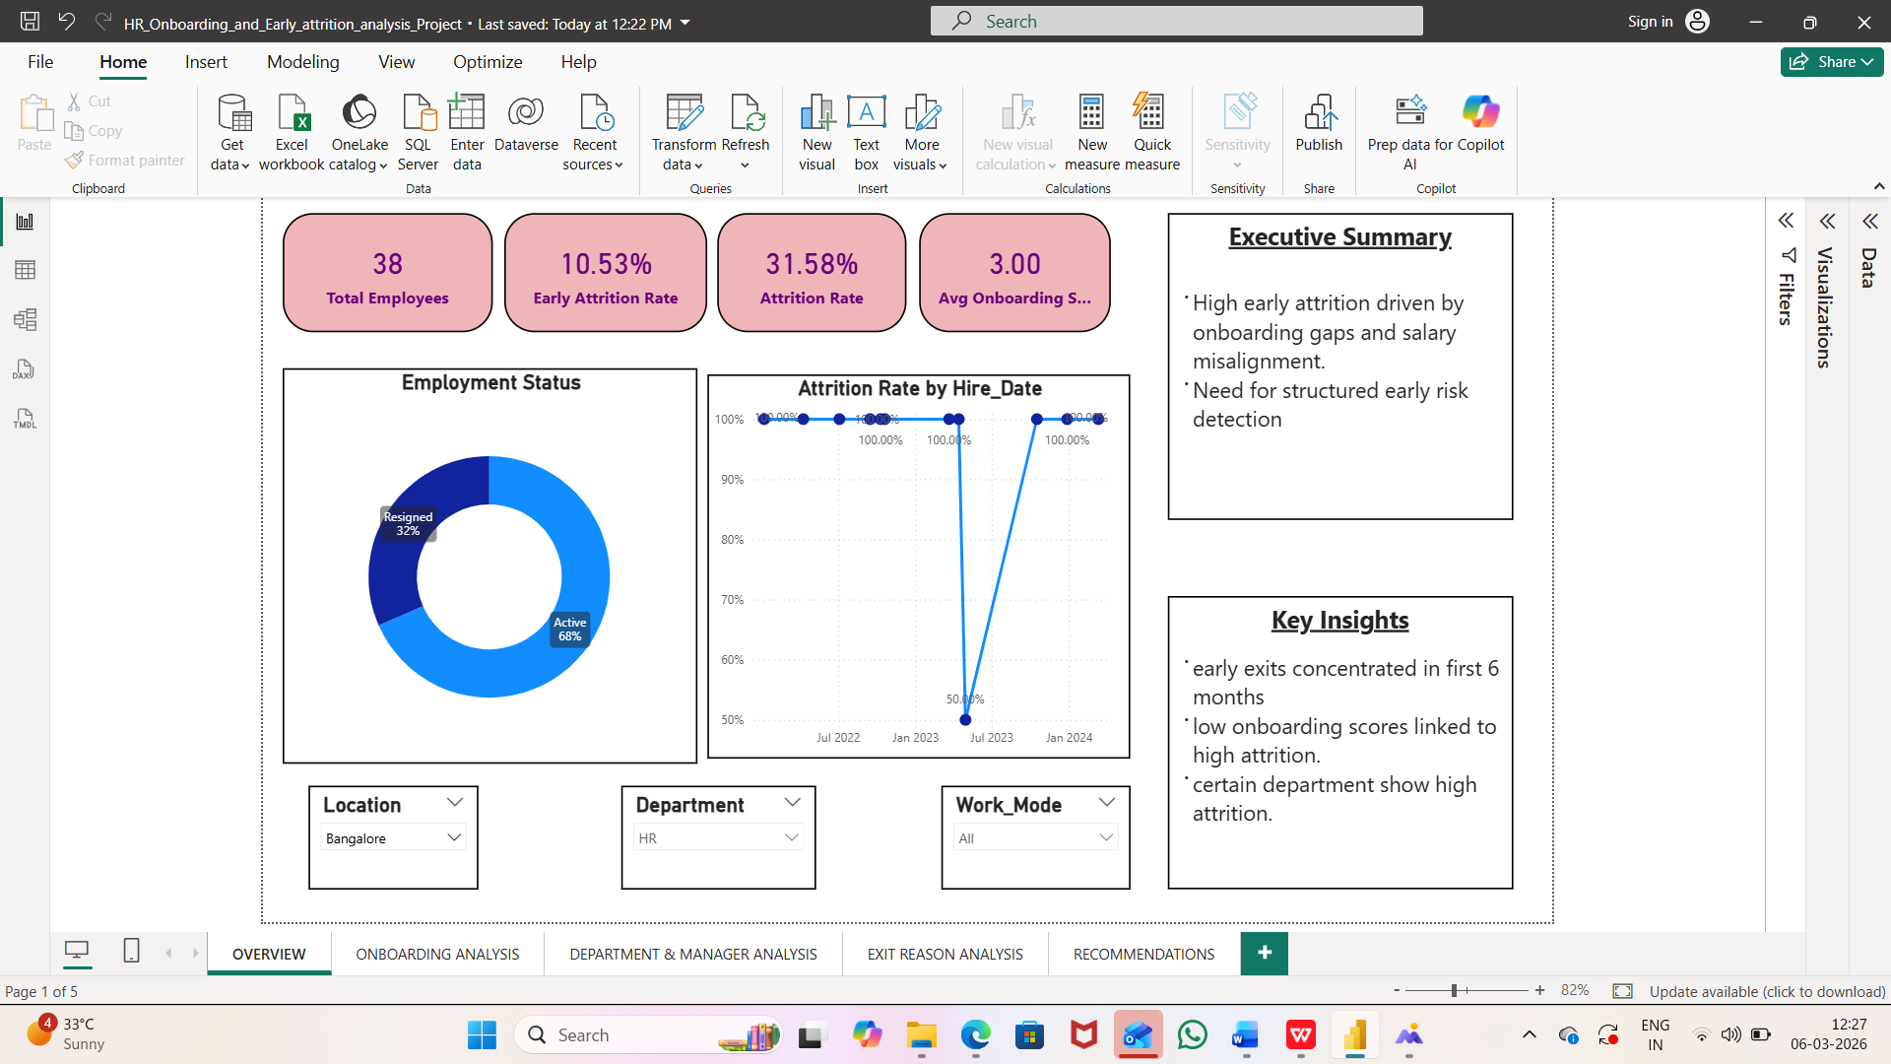

Page 2 – On-boarding Analysis
This page analyzes on-boarding factors such as laptop availability on the first day, buddy assignment, role clarity scores, and training hours. These factors help determine how on-boarding experience impacts early employee attrition.
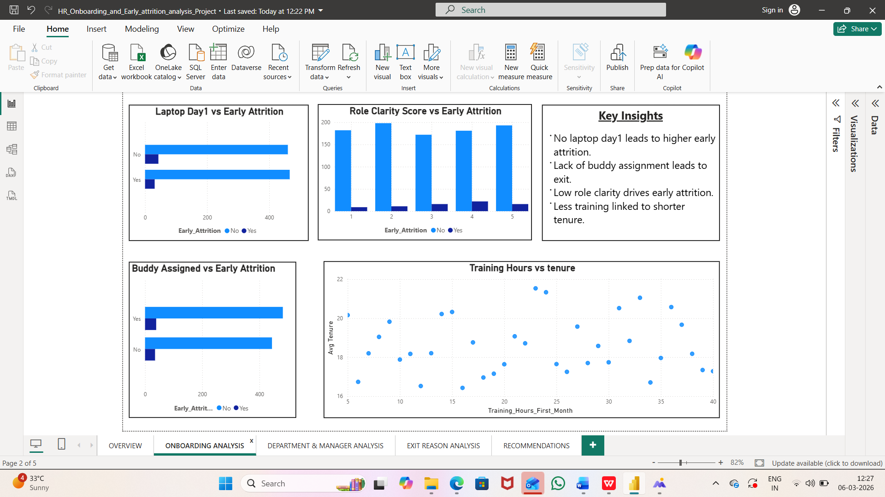

Page 3 – Department & Manager Analysis
This page evaluates attrition patterns across departments, work modes, salary gaps, and manager experience. It helps identify structural organizational factors contributing to employee turnover.

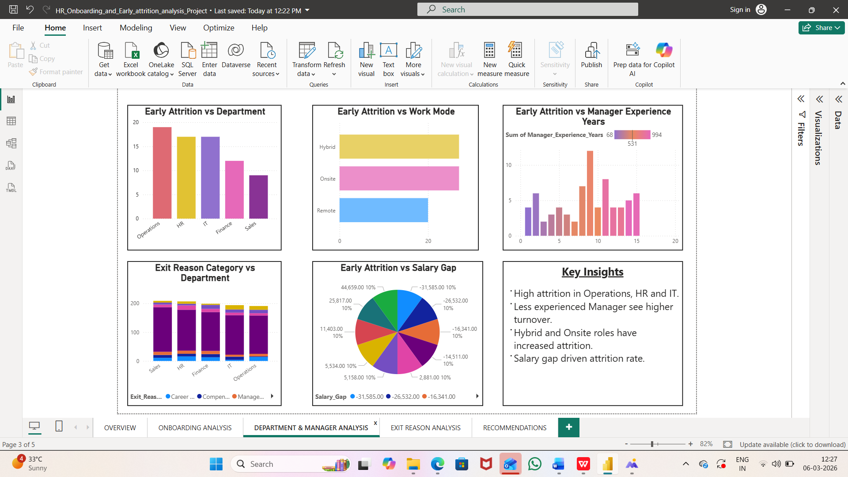

Page 4 – Exit Reason Analysis
This page focuses on the main reasons employees leave the organization. Exit reasons are categorized into compensation, career growth, management issues, work-life balance, and personal reasons.

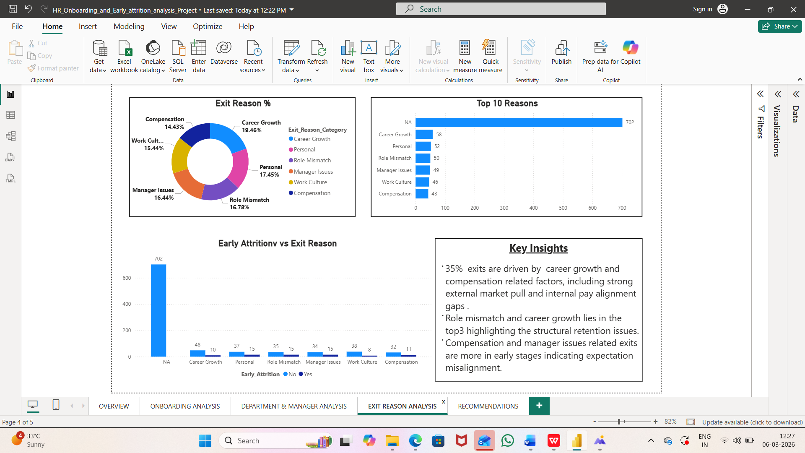

8. Key Insights
- Employees who did not receive laptops on their first day showed higher early attrition rates.
- Employees without assigned on-boarding buddies had a higher probability of leaving early.
- Lower role clarity scores strongly correlated with early attrition.
- Compensation and career growth opportunities were the most common exit categories.
- Some departments showed significantly higher attrition rates compared to others.

9. Business Recommendations
- Ensure all employees receive required work equipment on their first day.
- Implement a structured buddy or mentor-ship program for new hires.
- Improve role clarity through structured on-boarding and manager discussions.
- Increase training hours during the first month to support skill development.
- Conduct regular salary bench-marking to remain competitive in the market.

10. Conclusion
This project demonstrates how HR analytic and data visualization tools like Power BI can help organizations identify patterns in employee attrition. By focusing on on-boarding improvements, manager support, and compensation strategies, organizations can reduce early attrition and improve overall workforce stability.

