Bank Loan Database

* select Count(id) as Total_laon_application from Bank_loan_data  
  
* select COUNT(id) As MTD_Total_loan_Application from Bank_loan_data  
  where MONTH(issue_date) = 12 and year(issue_date) = 2021  
  
* select SUM(loan_amount) as MTD_Total_funded_amount from Bank_loan_data  
  where MONTH(issue_date) = 12 and YEAR(issue_date)= 2021



* select SUM(total_Payment) as MTD_Total_Amount_Received from Bank_loan_data

where MONTH(issue_date) = 12 and YEAR(issue_date) = 2021



* select round(AVG(int_rate), 4) * 100 as Interest_rate From Bank_loan_data



* select Round(AVG(DTI), 4) * 100 as avr_dti from Bank_loan_data



* select (COUNT(case when loan_status = 'fully Paid' or loan_status = 'current' then id end)* 100) / count(id) as good_loan_percentage from Bank_loan_data  
  
* select COUNT(id) as good_loan_Funded_Amount from Bank_loan_data

where loan_status = 'fully paid' or loan_status ='current'  


* select SUM(loan_amount) as good_loan_Funded_Amount from Bank_loan_data

where loan_status = 'fully paid' or loan_status ='current'



* select SUM(Total_payment) as good_loan_Funded_Amount from Bank_loan_data

where loan_status = 'fully paid' or loan_status ='current'  


* select count(id) as Bad_Loan_Application from Bank_loan_data where loan_status = 'charged off'  
  
* select SUM(loan_amount) as Bad_Loan_funded_amount from Bank_loan_data where loan_status = 'charged off'  
  
* select SUM(total_payment) as Bad_Loan_amount_received from Bank_loan_data where loan_status = 'charged off'



* select

loan_status, count(id) as Total_loan_application,

sum(total_payment) as total_amount_received,

sum(loan_amount) as total_funded_amount,

avg(int_rate*100) as Interest_rate,

avg(dti*100) as dTI

from bank_Loan_data

group by loan_status

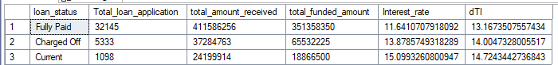

* select

loan_status,

sum(total_payment) as total_amount_received,

sum(loan_amount) as total_funded_amount

from bank_Loan_data

where month(issue_date) = 12

group by loan_status

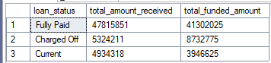

* select

month(issue_date) as month_number,

datename(month, issue_date) as month_name,

count(id) as total_loan_Application,

SUM(loan_amount) as total_funded_Application,

SUM(total_payment) as total_received_amount

from Bank_loan_data

group by month(issue_date), DATENAME(month, issue_date)

order by month(issue_date)

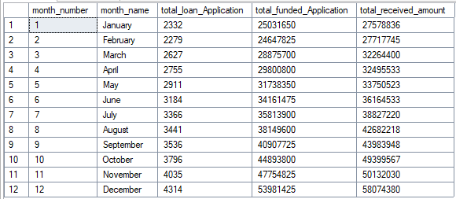

* select

address_state,

count(id) as total_loan_Application,

SUM(loan_amount) as total_funded_Application,

SUM(total_payment) as total_received_amount

from Bank_loan_data

group by address_state

order by COUNT(id) desc

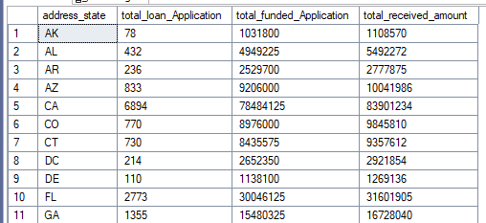

* select

term,

count(id) as total_loan_Application,

SUM(loan_amount) as total_funded_Application,

SUM(total_payment) as total_received_amount

from Bank_loan_data

group by term

order by term



* select

emp_length,

count(id) as Total_loan_application,

SUM(loan_amount) as total_funded_application,

SUM(total_payment) as total_recceived_amount

from Bank_loan_data

group by emp_length

order by emp_length

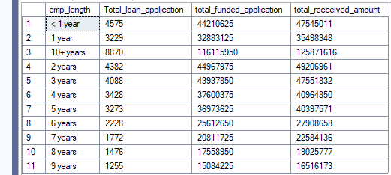

* select

purpose,

count(id) as Total_loan_application,

SUM(loan_amount) as total_funded_application,

SUM(total_payment) as total_recceived_amount

from Bank_loan_data

group by purpose

order by COUNT(id) desc

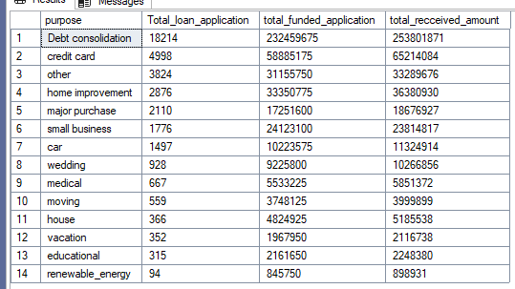

* select

home_ownership,

count(id) as Total_loan_application,

SUM(loan_amount) as total_funded_application,

SUM(total_payment) as total_recceived_amount

from Bank_loan_data

group by home_ownership

order by COUNT(id) desc

