Part (a) Pedestrian Tracking Without Kalman Filter
1. Data and objective
We used a series of accelerometer data recordings from the instructor’s dataset: CST05_left (100 Hz, accelerometer in g, gyroscope in °/s, 171 s) . All processing was done in MATLAB. We tracked the foot with a basic integration based estimation and identified the walking scenario for the same.
2. Method
- Approach (accelerometer): a constant gravity offset, estimated from an initial still window, was removed, then the acceleration data was integrated twice using matlab’s inbuilt mathematics tools.
3. Results
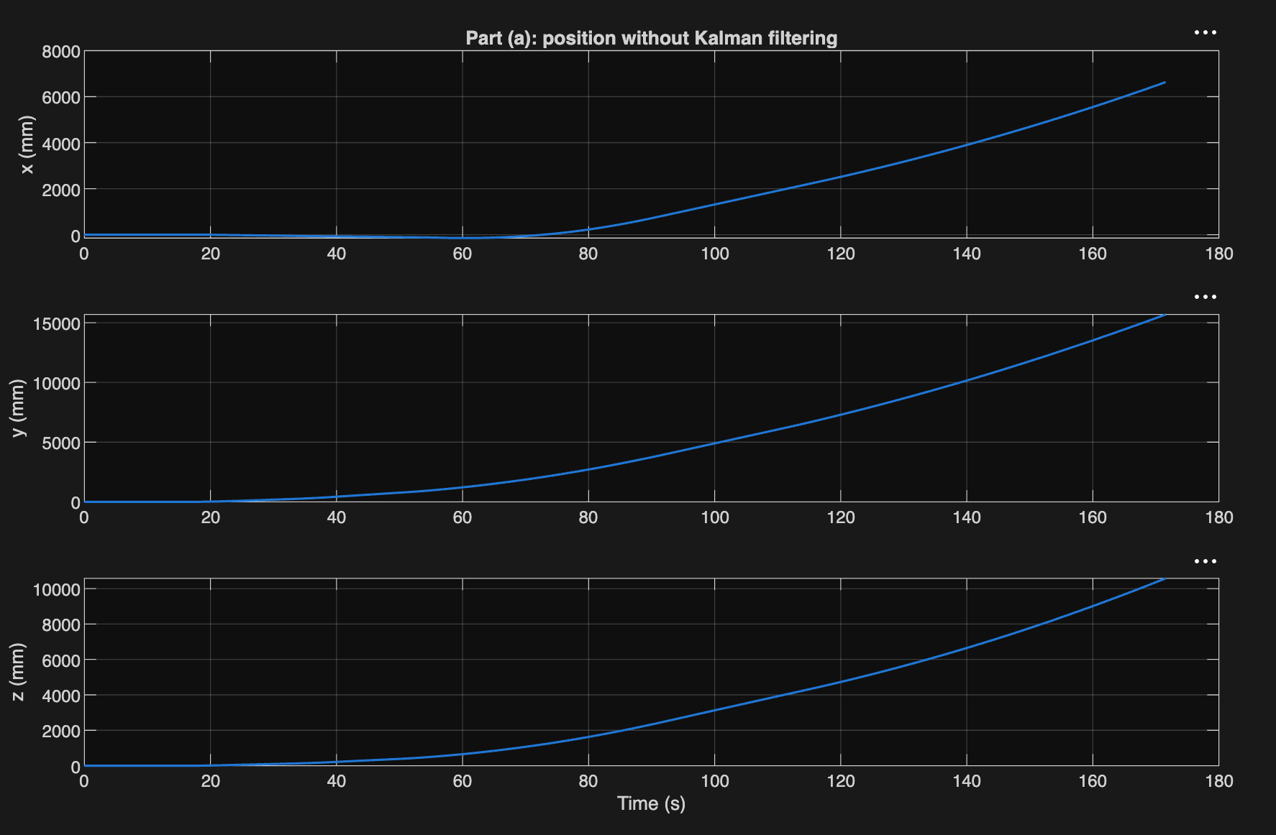

The plotted data clearly indicates a heavy drift introduced in the data without filters. The obvious sources for this induced drift error is the gravity leakage from foot rotation that may alter the gravity reception for different sensors and register it in an unbalanced way. Besides, the double integration magnifies smaller errors to a higher scale and produces larger deflections.

Part (b) Pedestrian Tracking With Kalman Filter
1. Data and objective
We used a series of accelerometer data recordings from the instructor’s dataset: CST05_left (100 Hz, accelerometer in g, gyroscope in °/s, 171 s) . All processing was done in MATLAB. We tracked the foot with a basic integration based estimation and identified the walking scenario for the same.
2. Method
- Approach (accelerometer): a constant gravity offset, estimated from an initial still window, was removed, then the acceleration data was used to apply a basic kalman filter and obtain a smoother movement tracking and estimation pipeline.
3. Results
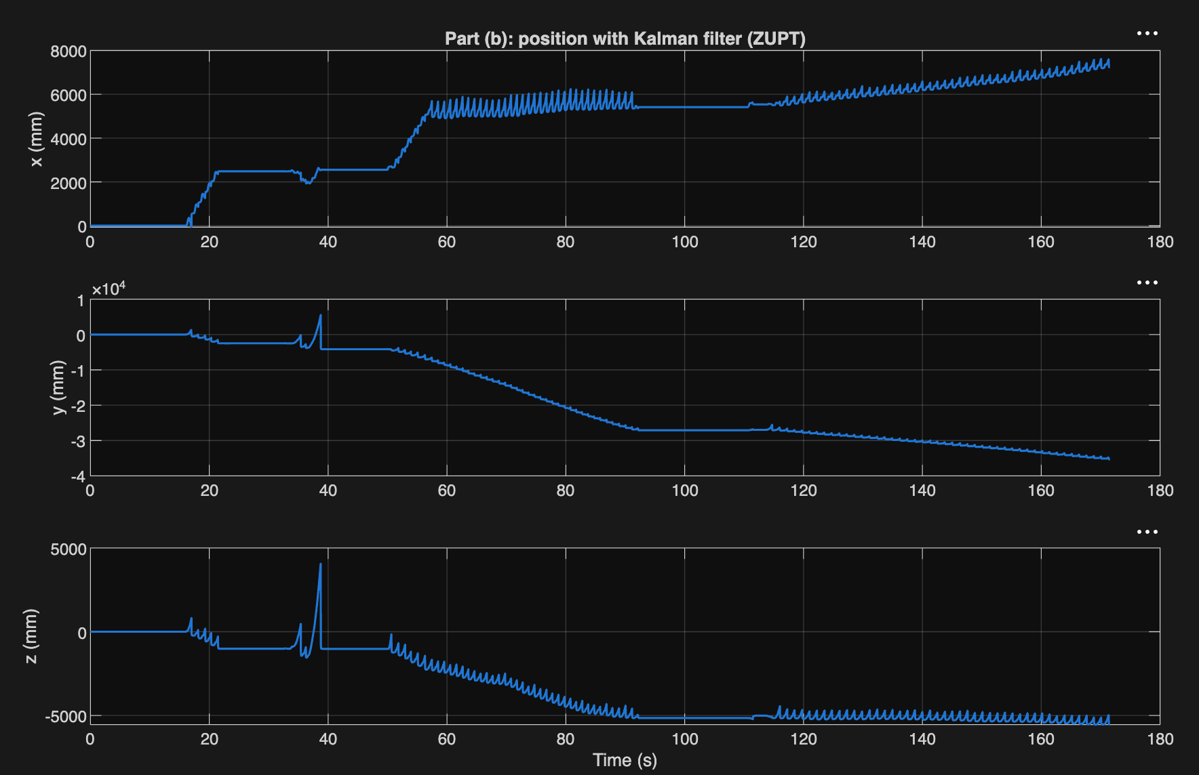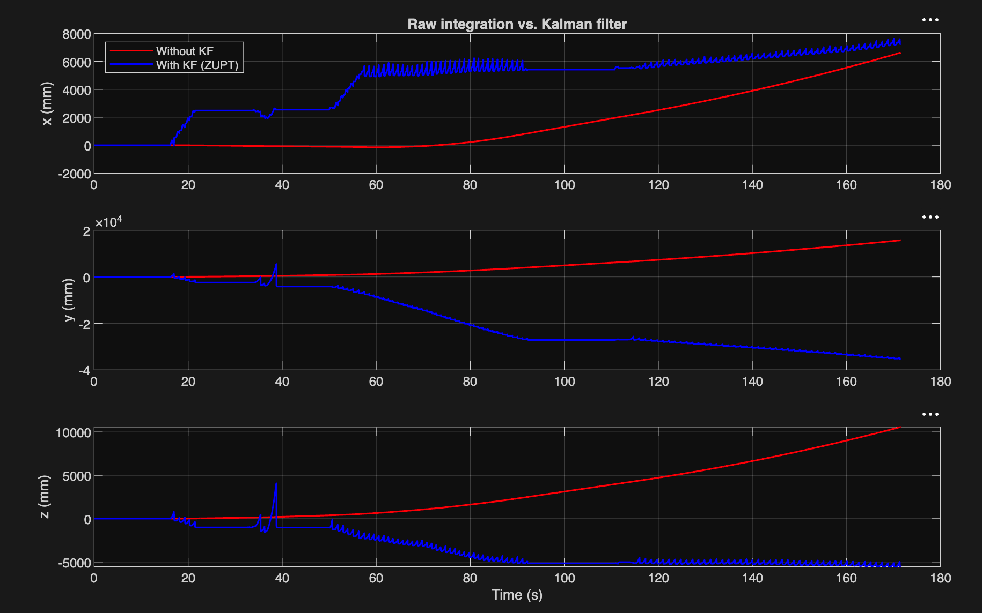

The plotted data clearly indicates a more accurate, less biased series of movements. The model predicts credible periodic motion for extended lengths when compared to the filterless predictions. Some errors still creep through, presumably due to the gravity leakage but the filter handles the errors much better, instead of magnifying them to higher scales.

Part (c): Pedestrian Tracking Through Sensor Fusion
Datasets: CST03_left, WIPAD12
1. Data and objective
We used two IMU recordings from the instructor’s dataset: CST03_left (100 Hz, accelerometer in g, gyroscope in °/s, 171 s) and WIPAD12 (about 500 Hz with irregular sampling, resampled to 200 Hz, 100 s). WIPAD timestamps wrap every 20 s, so the blocks were stitched back together. All processing was done in MATLAB. We tracked the foot with two approaches and identified the walking scenario in each recording.
2. Methods
- Approach 1 (accelerometer only): a constant gravity offset, estimated from an initial still window, was removed, then a Kalman filter with zero-velocity updates (ZUPT) estimated position and velocity. As a baseline we also integrated the acceleration twice with no filtering.
- Approach 2 (accelerometer + gyroscope): the gyroscope was integrated for orientation, acceleration was rotated into a world frame with gravity subtracted, and an error-state Kalman filter with ZUPT estimated the motion. Each ZUPT corrects velocity and also tilt through the filter’s cross-covariance. Gyro bias was averaged over all standing periods.
- Stance detection: a SHOE-style detector flags when the foot is still and triggers the ZUPTs. We tuned its threshold ourselves to give about one stance period per stride.
- Validation: on a synthetic walk with known truth (31.2 m), naive integration drifted to about 1520 m, while fusion recovered 31.3 m.
3. Results
Metric | CST03 | WIPAD12
Naive double integration, max distance [m] | 21,069 | 2,986
Approach 1 (KF + ZUPT), max distance [m] | 18.6 | 14.4
Approach 1, velocity drift per stride [m/s] | 2.26 | 1.04
Approach 2 (fusion), velocity drift per stride [m/s] | 0.42 | 0.20
Fusion max |z| [m] | 3.26 | 0.79
Fusion mean |dz| per stride [m] | 0.067 | 0.013
Stride length, mean ± std [m] | 0.86 ± 0.27 | 0.33 ± 0.06
Number of strides | 99 | 77
Fusion path length [m] | 86.4 | 25.2
Fusion end-to-start distance [m] | 37.2 (open path) | 0.72

Fusion cut velocity drift per stride by about 5× in both files (2.26 to 0.42 m/s and 1.04 to 0.20 m/s). ZUPT alone bounded the naive drift from thousands of metres to under 20 m. For WIPAD12, the accelerometer-only track runs in a nearly straight line about 14 m from the start (Fig. 3, left panel). The fused track stays within about 5 m and ends 0.72 m from the start, which is 2.8% of the 25.2 m path.
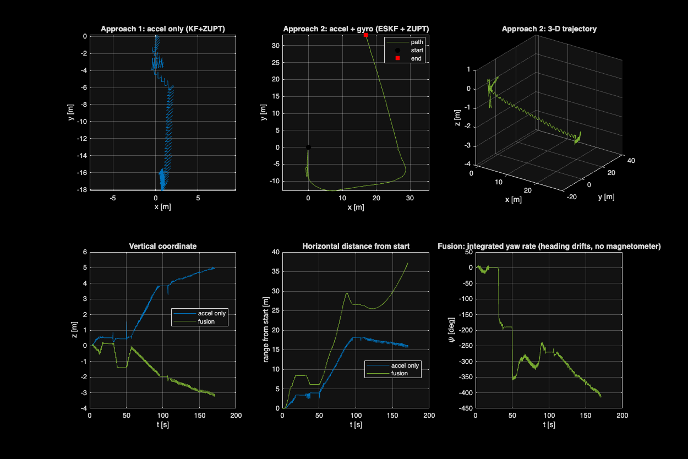
Fig. 1: CST03 – Approach 1 (accelerometer only) versus Approach 2 (accelerometer + gyroscope).
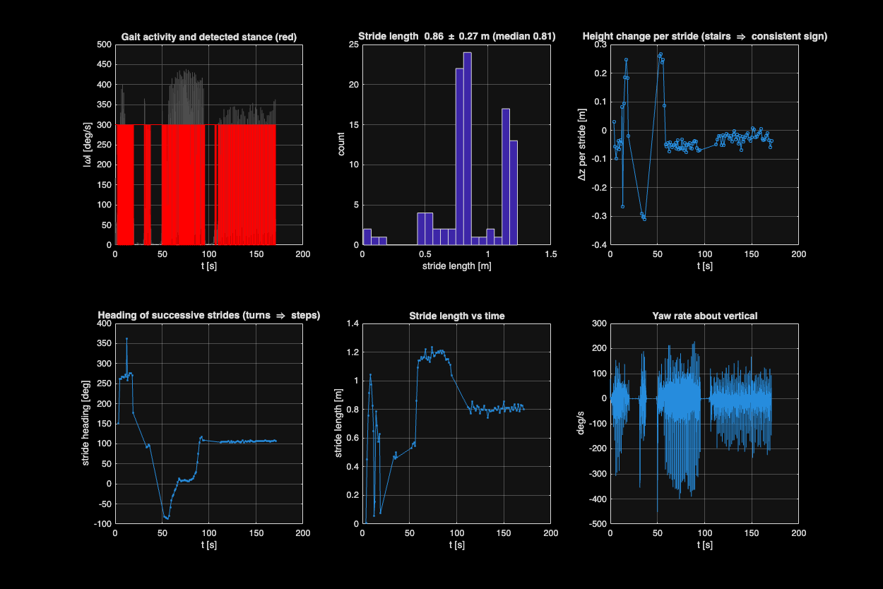
Fig. 2: CST03 – scenario identification (stance, stride length, height change, stride heading, yaw rate).
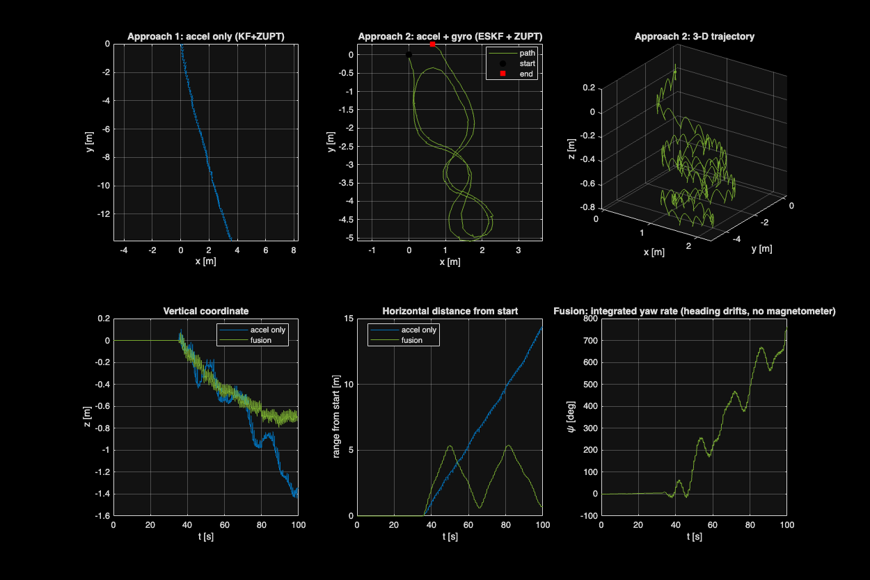
Fig. 3: WIPAD12 – Approach 1 versus Approach 2.
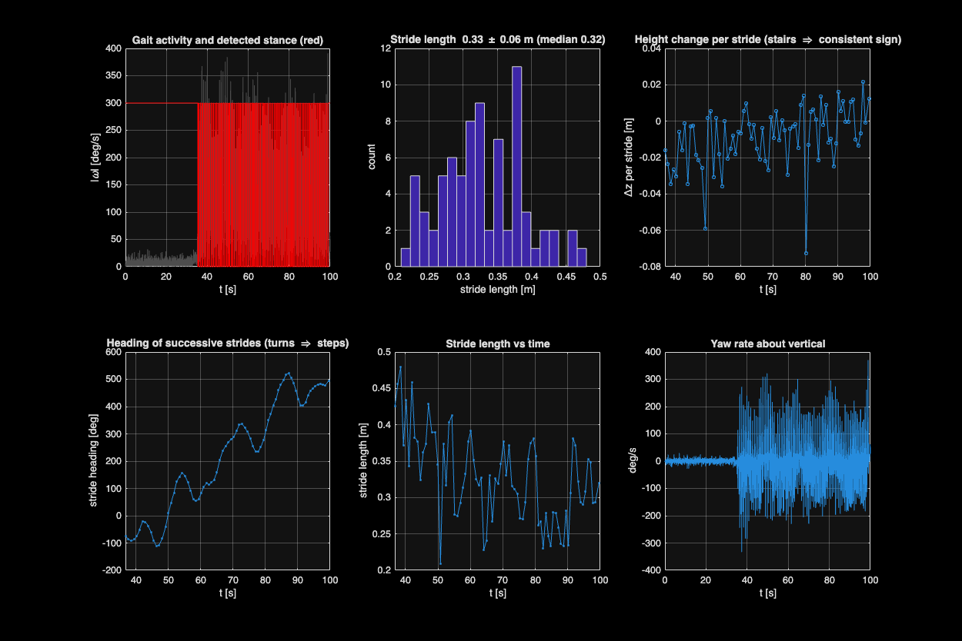
Fig. 4: WIPAD12 – scenario identification.
4. Scenario identification
WIPAD12. The subject stands still for about 36 s, then walks for about 64 s. The fused path (Fig. 3) is a closed curve about 2.5 m × 5 m, drawn as two nearly overlapping laps with a self-crossing near its centre. Distance from the start peaks twice, near 50 s and 81 s, and falls back to under 1 m between and after the peaks. The integrated yaw grows to about +750° (two full turns), and the stride heading climbs by about 600° with no reversal (Fig. 4). Strides are short and fairly uniform (0.33 ± 0.06 m), and height change per stride stays within about ±0.02 m. We conclude this is level, slow walking along a closed curved path covered twice, with repeated turning in one direction. The x–y path resembles a figure-eight, but the steadily rising heading would not occur in a true figure-eight, so the exact intended path cannot be confirmed from the IMU data alone.
CST03. The recording contains several walking blocks separated by standing rests (Fig. 2): short bursts early on, then longer blocks at about 50–95 s and 108–170 s. Stride length steps between blocks: about 1.2 m at 58–95 s, then a very steady 0.8 m at 110–170 s, with the highest gyro peaks (about 430°/s) in the faster middle block. Stride heading holds near 105° for the whole last block, which indicates straight-line walking. The integrated yaw shows jumps of roughly 180° during the rests (Fig. 1), which we read as turn-arounds. We conclude this is straight-line walking in several segments at different paces, with turn-arounds between them. The first 20 s contain short, irregular bursts with stride lengths between 0 and 1 m and are not reliable. Between about 35 and 55 s the strides are steadier at about 0.5 m. The path is not a closed loop, so the 37 m end-to-start distance is not an error measure.
5. Effect of sensor fusion on accuracy and reliability
Accuracy. The accelerometer axes rotate with the foot, so without orientation gravity leaks into the horizontal and vertical estimates, and ZUPT can only reset the resulting velocity error. The gyroscope supplies orientation, so acceleration can be rotated into a fixed frame before integrating, and the filter corrects tilt at every stance. The result is roughly five-fold lower velocity drift, a trajectory with the right shape, and, for WIPAD12, a loop that closes to within 3%.
Reliability. Fusion is more consistent, but it is not drift-free:
- Heading: with no magnetometer, absolute heading is unobservable. In CST03 the integrated yaw trace declines steadily in the last block while the stride headings stay constant near 105°, so we treat the integrated yaw as unreliable there and use stride heading from the fused path instead. For WIPAD12 the yaw and stride heading both rise steadily, so some of that growth may be heading drift.
- Height: vertical position still drifts, by 3.26 m over 171 s in CST03 and 0.79 m over 100 s in WIPAD12. The steady −0.02 to −0.06 m per stride in CST03 is far smaller than a real stair step, so we read it as drift and not stairs.
- Stance model: in CST03 the gyro never drops near zero during stance because the foot keeps rolling, so the ZUPT assumption holds only approximately. Results depend on the stance threshold.
- Clipping: the WIPAD accelerometer clips at ±4 g on heel strikes.
- Ground truth: there is none, so our evidence is drift, stride consistency and loop closure.

