Assignment-2

Submitted To,
Mr. Murugadoss Natarajan

Submitted By,
Varsha Shaji
varshamariyashaji2002@gmail.com
GitHub Repository: https://github.com/varsha-shaji/ustglob-python
List
- How do you add an element at the end of a list in Python?
Program
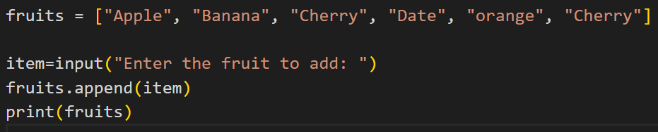
Output
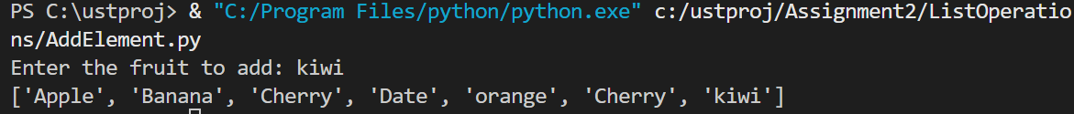
- How can you remove an element from a list by its index?
Program
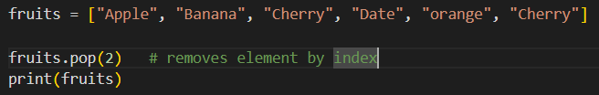 Output
- What will be the output of the following code snippet?
lst = [1, 2, 3, 4, 5]
lst[1:3] = [10, 20]
print(lst)
Output

- How can you check if an element exists in a list in Python?
Program
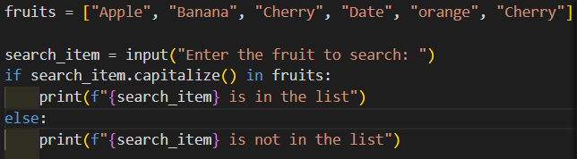
Output
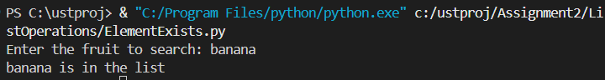
- Write a Python function that removes duplicates from a list without using the set() function.
Program
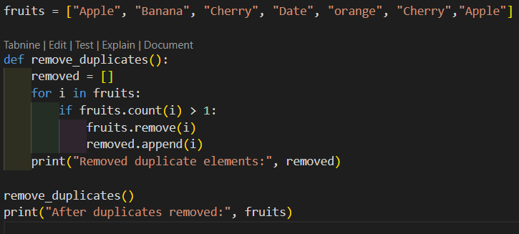
Output

Tuple
- Can you modify the elements of a tuple after it has been created? Why or why not?
- No, you cannot modify a tuple after it has been created.
- A tuple in Python is immutable, meaning its elements cannot be changed, added, or removed.
- Any attempt to modify a tuple element (e.g., t[1] = 50) will raise a TypeError.
- Tuples are used when data should remain fixed and unchanged.
- This immutability makes tuples faster and more memory-efficient than lists.
- How would you access the second-to-last element in a tuple?
- Python supports negative indexing for sequences.
- Index -2 accesses the second-to-last element.
Program
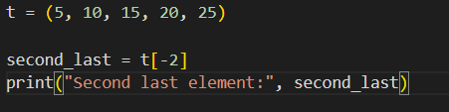
Output

- What is the difference between a list and a tuple in Python?
No. | List | Tuple
1 | Mutable (can be changed) | Immutable (cannot be changed)
2 | Uses [ ] brackets | Uses ( ) brackets
3 | Slower than tuple | Faster than list
4 | More memory usage | Less memory usage
5 | Supports methods like append(), remove() | Limited methods like count(), index()
6 | Used for dynamic data | Used for fixed data
7 | Can be modified after creation | Cannot be modified after creation
8 | Not hashable | Hashable (if elements are immutable)
Program
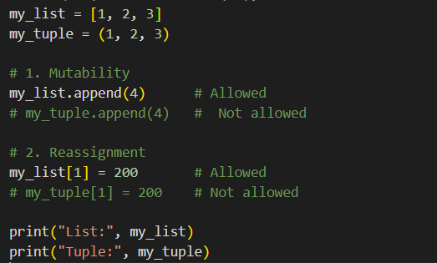
Output
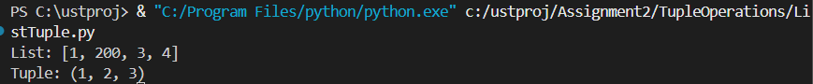
- Given the tuple t = (1, 2, 3, 4), how can you change the value 3 to 100?
Program
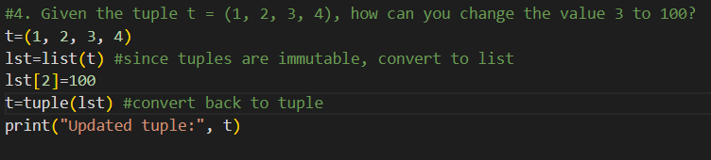
Output
- Write a Python function that takes a tuple of numbers and returns the sum of all its elements.
Program
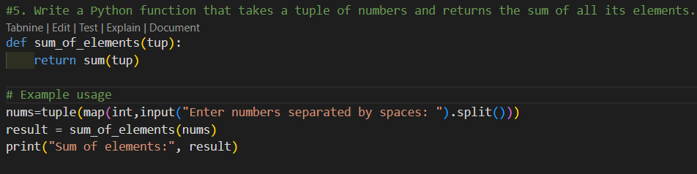
Output

Set
- How do you remove all elements from a set in Python?
- The clear() method removes all elements from the set.
- After calling clear(), the set becomes empty.
Program
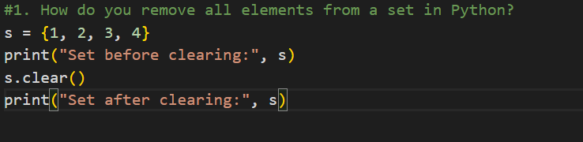 Output
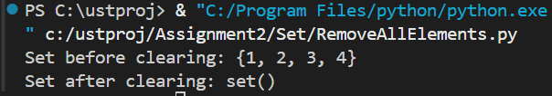

- What is the output of the following code snippet?
a = {1, 2, 3, 4}
b = {3, 4, 5, 6}
print(a - b)
Output
- How do you check if an element is present in a set?
Program
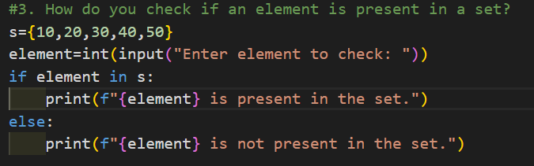
Output
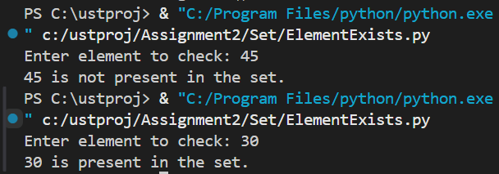
- Write a Python program to find the intersection of two sets.
Program
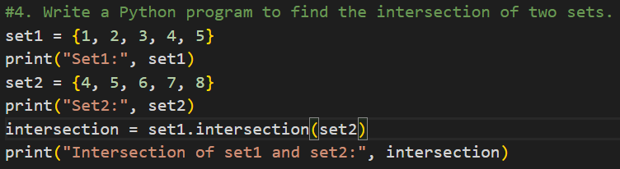
Output
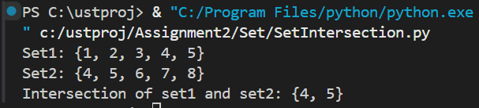
- How does a set handle duplicate values when adding them?
- Sets do not allow duplicate values.
- If a duplicate is added, it is ignored automatically.
Program
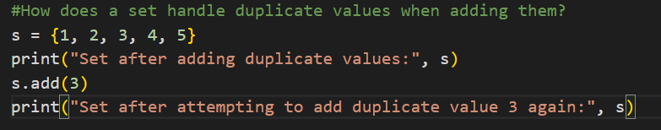
Output
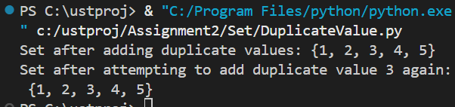

Dictionary
- How can you add a new key-value pair to an existing dictionary in Python?
- A new key-value pair can be added using dictionary[key] = value.
- If the key does not exist, Python creates it automatically.
Program
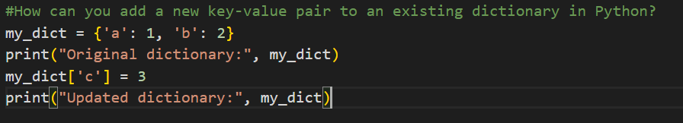
Output
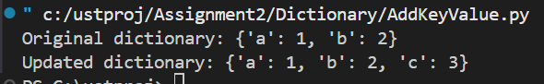
- What happens if you try to access a key that does not exist in a dictionary?
- Accessing a non-existent key using [] raises a KeyError.
- Using get() returns None (or a default value) instead of an error.
Program
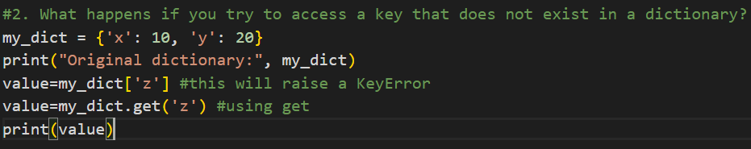
Output
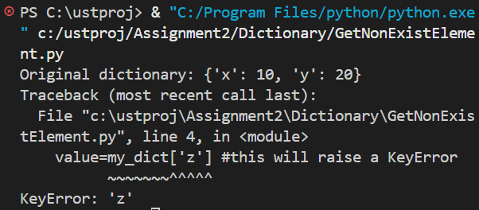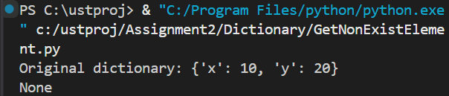

- Write a Python function that takes a dictionary and returns a list of keys that have values greater than 50.
Program
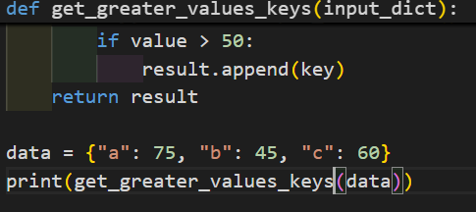
Output
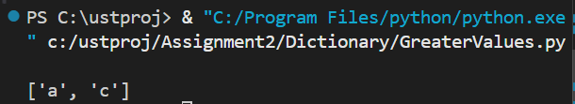
- How would you iterate over both keys and values of a dictionary in Python?
- The items() method returns both keys and values together.
- A for loop is used to access them one by one.
Program
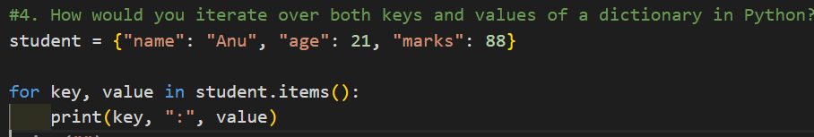
Output
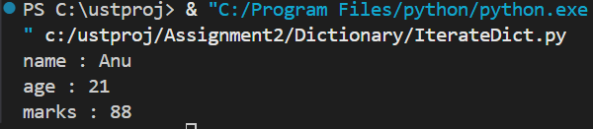
- Write a Python function that merges two dictionaries.
- The ** operator unpacks and merges dictionaries.
- If keys are the same, values from the second dictionary overwrite the first.
Program
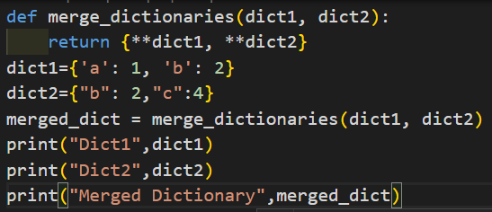
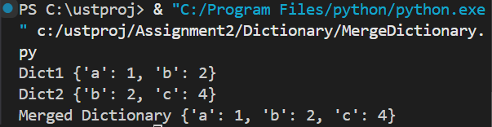

Map and Reduce

- How does the map() function work in Python? Give an example where you square each number in a list.
- map() applies a given function to each element of an iterable.
- It returns a map object, which can be converted to a list.
Program
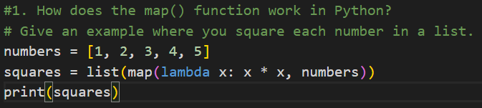
Output
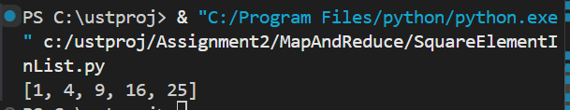
- What is the output of the following code?
from functools import reduce
result = reduce(lambda x, y: x * y, [1, 2, 3, 4])
print(result)
Output
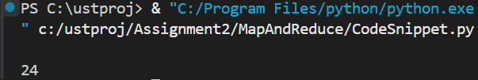
- How would you use the map() function to convert all string elements of a list to uppercase?
Program
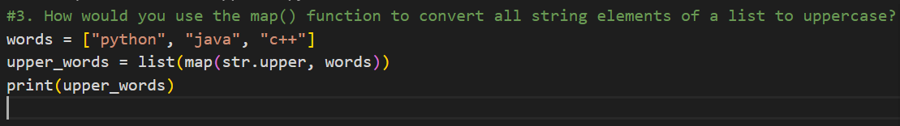
Output
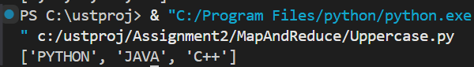

- Write a Python program that uses reduce() to find the greatest common divisor (GCD) of a list of numbers.
Program
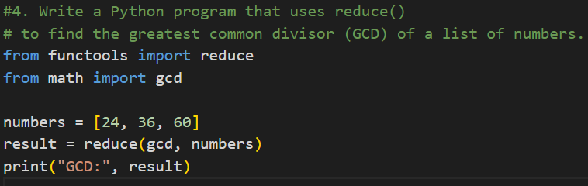
Output
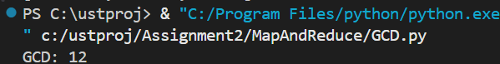
- Compare and contrast the map() and filter() functions in Python.
- map() modifies each element, while filter() selects elements based on a condition.
- map() returns all results, whereas filter() returns only True-condition elements.
Program
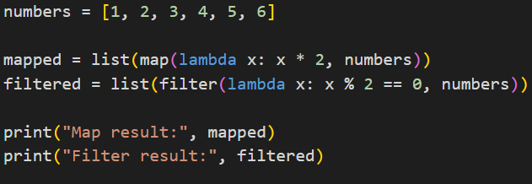
Output
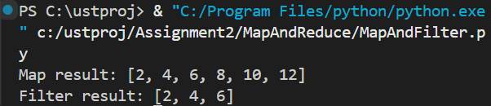

List Comprehension
- Write a list comprehension that returns all even numbers from 0 to 20.
Program
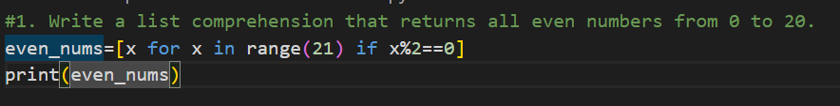
Output
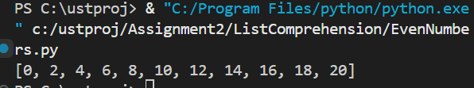
- How would you create a new list of squares from an existing list of numbers using list comprehension?
Program
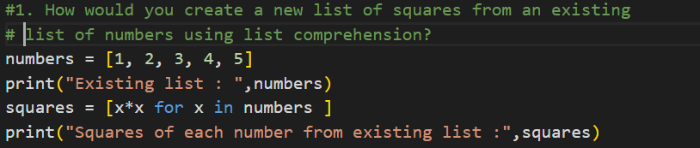
Output
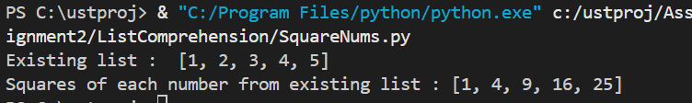
- Write a list comprehension to extract all words that are longer than 4 characters from a sentence.
Program
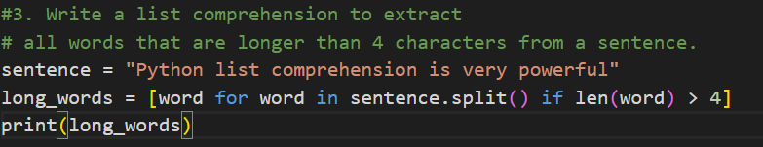
Output
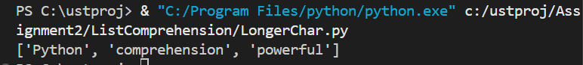
- How can you use list comprehension to generate a list of the first 10 Fibonacci numbers?
Program
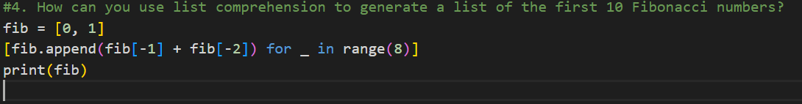
Output
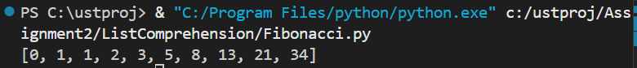
- Can you use an if condition inside a list comprehension? Provide an example where only odd numbers are selected from a list.
- List comprehensions support conditional filtering using if.
- The condition selects only odd numbers.
Program
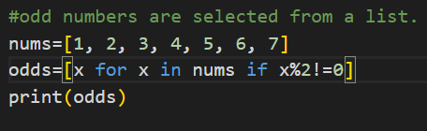
Output
