Assignment

Linux Scripting

Submitted To
Instructor Name: Murgadoss Natarajan

Submitted By
Name: Varsha Shaji
Email: varshamariyashaji2002@gmail.com

- Number Classification (if + function)
Write a shell script that uses a function to check whether a number is positive, negative, or zero using if.
Program:
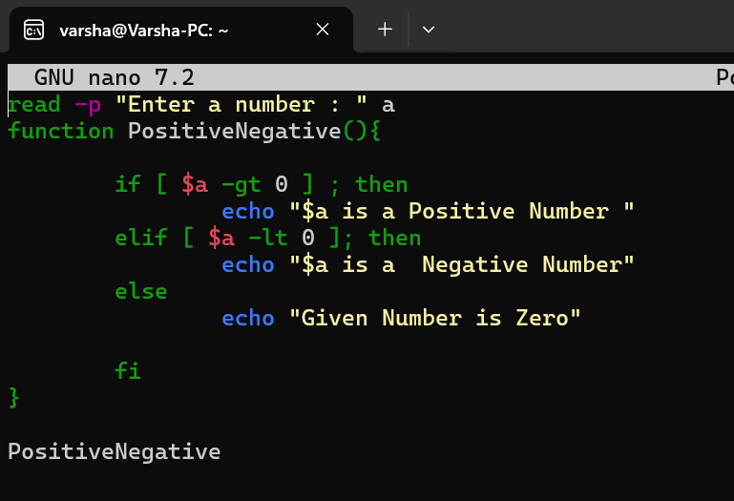
Output:
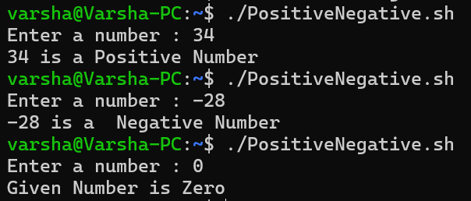

- Factorial of a Number (while + function)
Write a shell script to calculate the factorial of a number using a while loop inside a function.
Program:
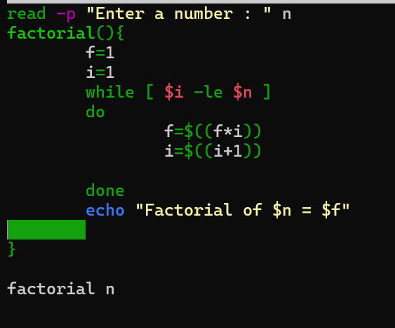
Output:
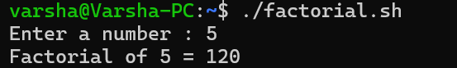
- Sum of N Numbers (for + function)
Write a shell script to calculate the sum of numbers from 1 to N using a for loop inside a function.
Program:
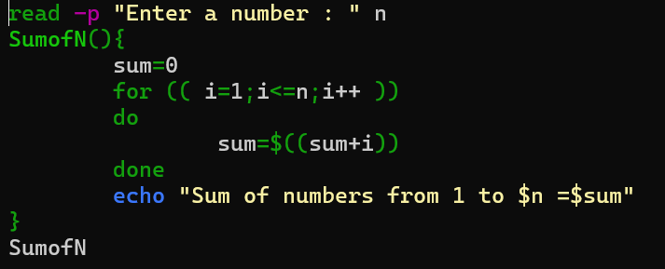
Output:

- Prime Number Check (if + for + function)
Write a shell script that uses a function to check whether a given number is prime using if and for.
Program:
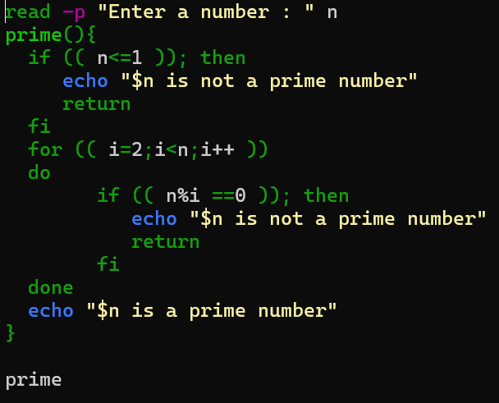
Output:
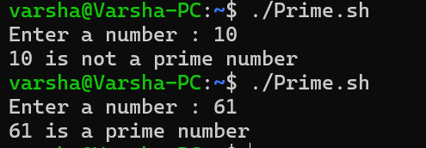

- Reverse a Number (while + if)
Write a shell script to reverse a number using a while loop and if conditions where required.
Program:
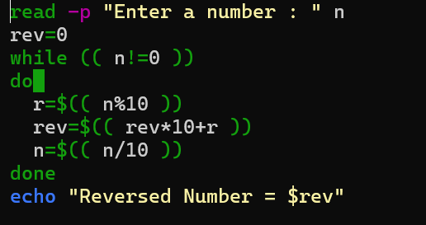
Output:
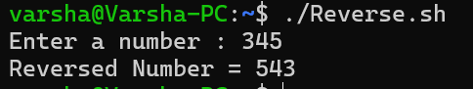

- File Existence & Permission Check (if + function)
Write a shell script that uses a function to check if a file exists and whether it has read, write, and execute permissions.
Program:
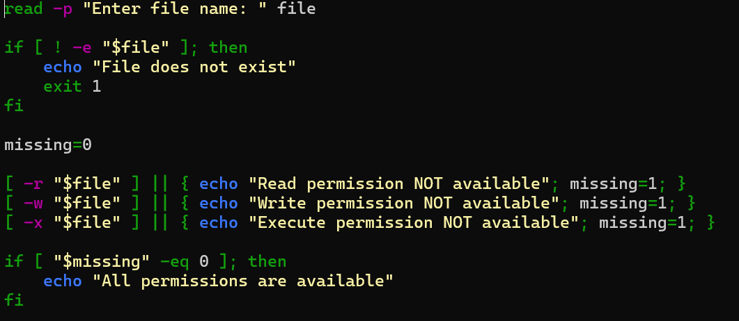

Output:
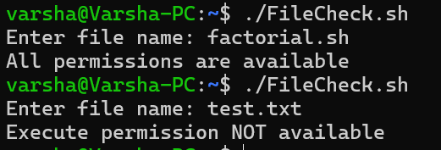

- Menu-Driven Calculator (while + case + function)
Write a shell script that shows a menu in a while loop and performs add, subtract, multiply, divide using functions.
Program:
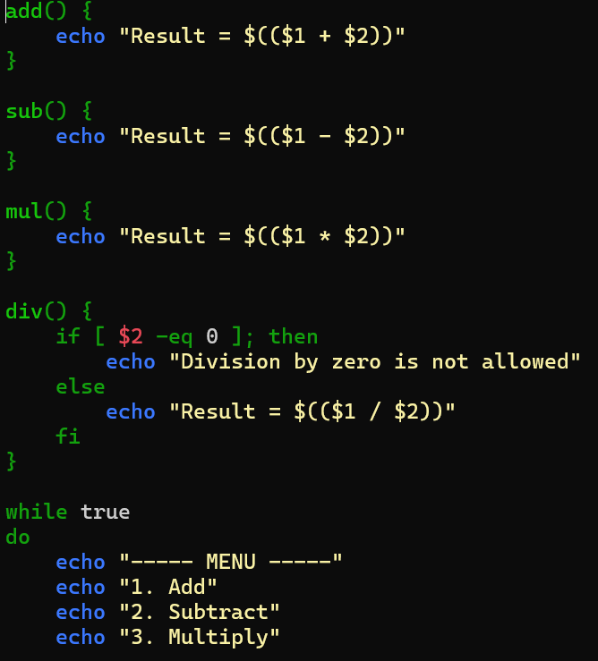
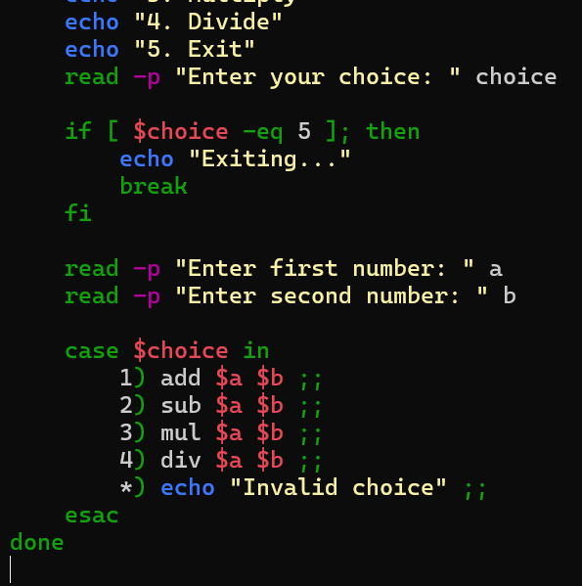
Output:

