Assignment-3

Submitted To,
Mr. Murugadoss Natarajan

Submitted By,
Varsha Shaji
varshamariyashaji2002@gmail.com
GitHub Repository: https://github.com/varsha-shaji/ustglob-python
Map

- Write a Python program using map() to convert a list of integers into their squares.
Program
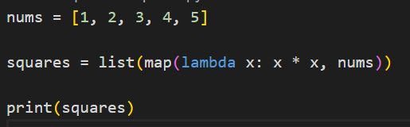
Output
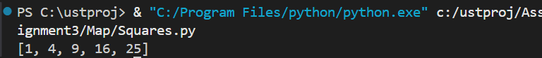

- Write a program using map() to convert all strings in a list to uppercase.
Program
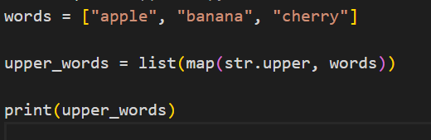
Output
- Given a list of temperatures in Celsius, use map() to convert them to Fahrenheit.
Program
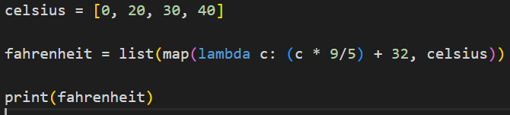
Output
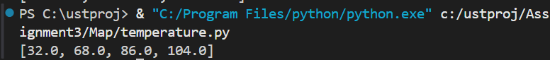

- Write a program using map() to calculate the length of each word in a list of strings.
Program
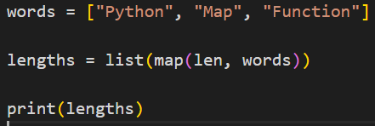
Output
- Use map() to add 10 to each element of a given list of numbers.
Program
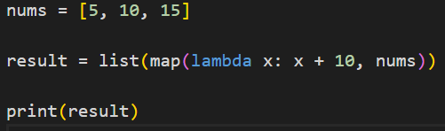
Output
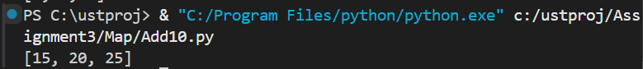

Filter

- Write a Python program using filter() to extract all even numbers from a list.
Program
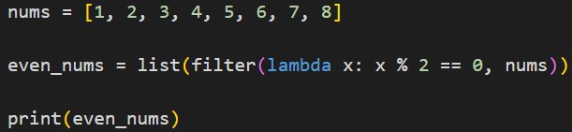
Output

- Write a program using filter() to select all words from a list that start with a vowel.
Program
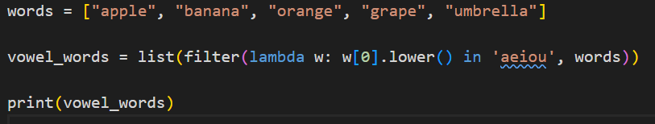
Output

- Given a list of integers, use filter() to remove all negative numbers.

Program
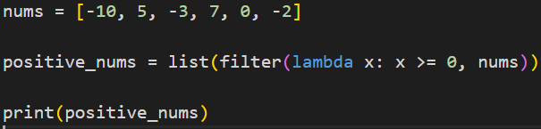
Output

- Write a program using filter() to find numbers greater than 50 from a list.
Program
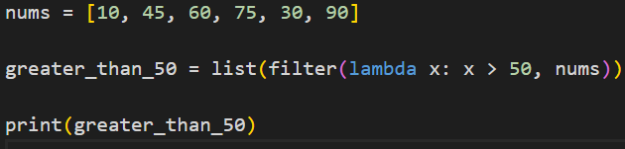
Output
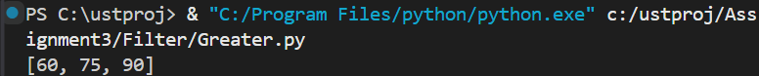

- Use filter() to extract all palindromic strings from a list.
Program
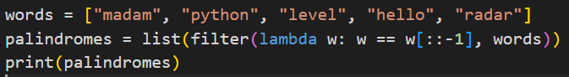
Output
