Assignment-4

Submitted To,
Mr. Murugadoss Natarajan

Submitted By,
Varsha Shaji
varshamariyashaji2002@gmail.com
GitHub Repository: https://github.com/varsha-shaji/ustglob-python
Exception Handling
- Write a Python program to handle a ZeroDivisionError.
Program
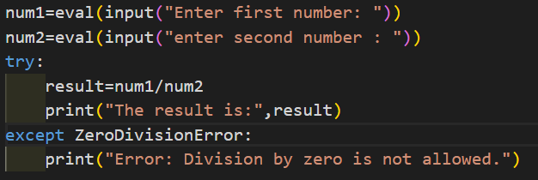
Output
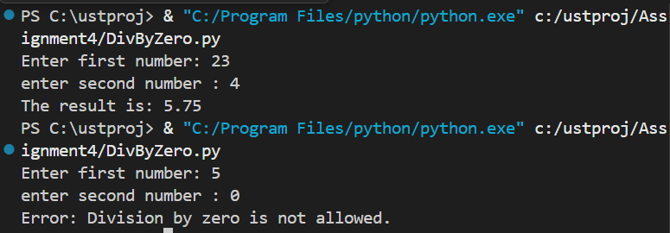

- Write a program that accepts user input and handles a ValueError if the input is not an integer..
Program
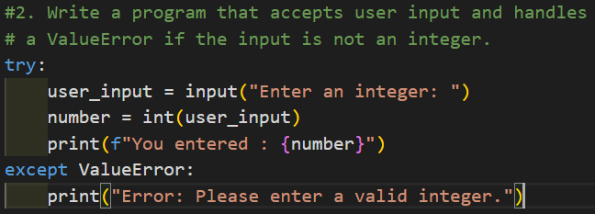
Output
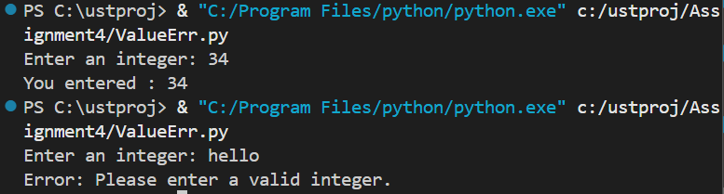

- Write a program to open a file and handle a FileNotFoundError.
Program
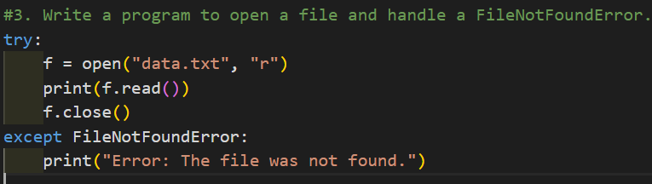
Output
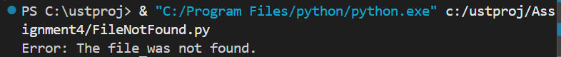

- Write a Python program that uses try, except, else, and finally blocks.
Program
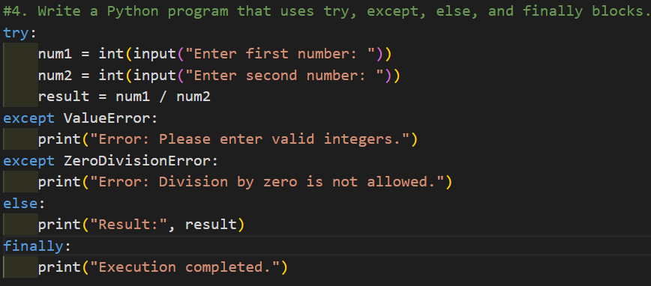
Output
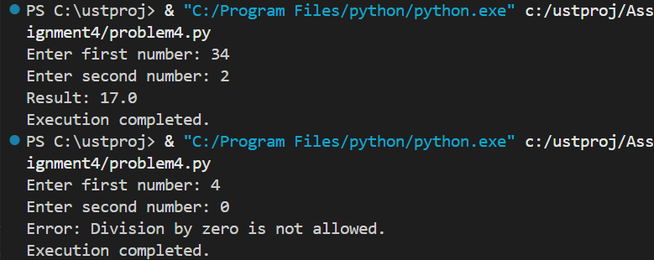

- Write a program to handle multiple exceptions in a single try block.
Program
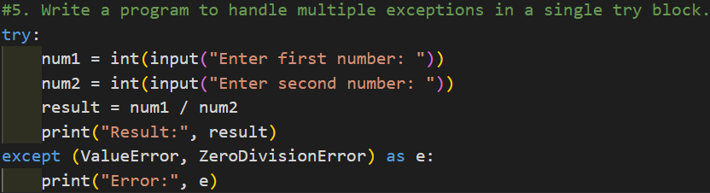
Output
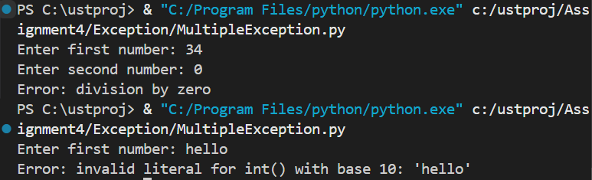

Text Files

- Write a Python program to create a text file and write multiple lines into it.
Program
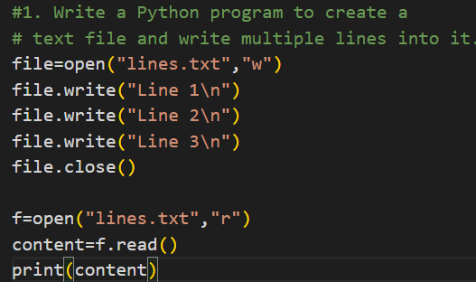
Output
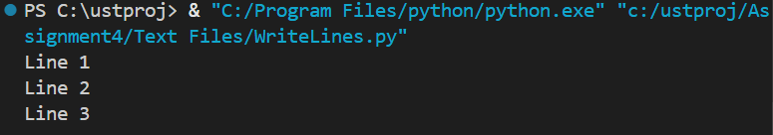

- Write a program to read the contents of a text file line by line.
Program
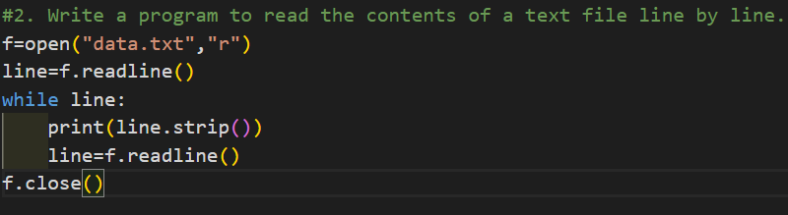

Output
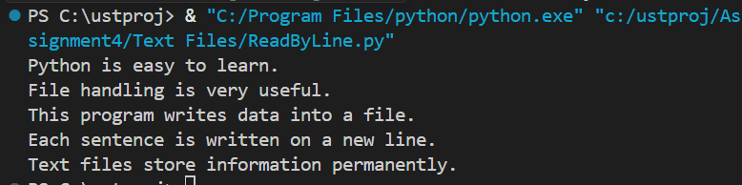

- Write a Python program to count the number of lines, words, and characters in a text file.

Program
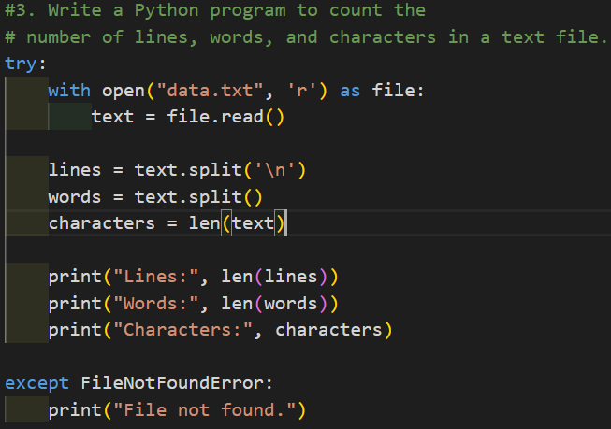
Output
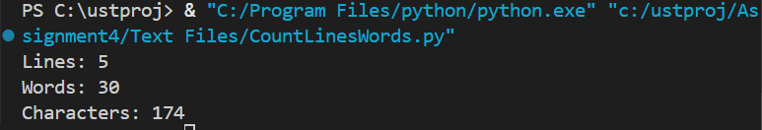

- Write a program to copy the contents of one text file into another file.
Program
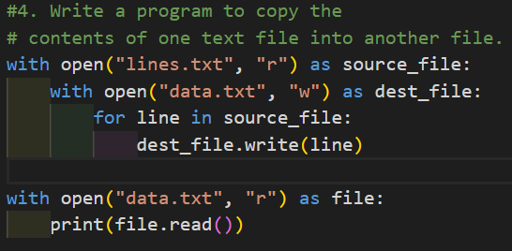
Output
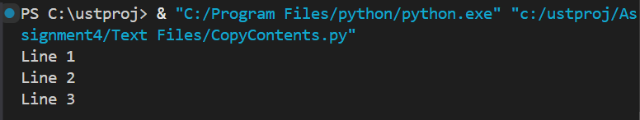

- Write a Python program to search for a specific word in a text file and display the line numbers where it appears..
Program
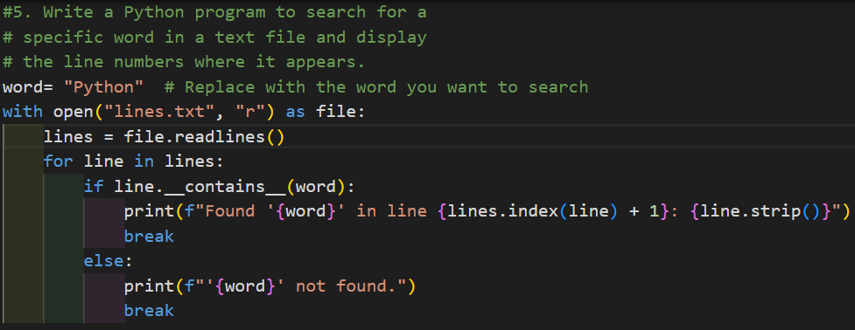
Output
