Assignment-5

Submitted To,
Mr. Murugadoss Natarajan

Submitted By,
Varsha Shaji
varshamariyashaji2002@gmail.com
GitHub Repository: https://github.com/varsha-shaji/ustglob-python
SQL
- Write an SQL query to display the second highest salary from an Employees table.
Query
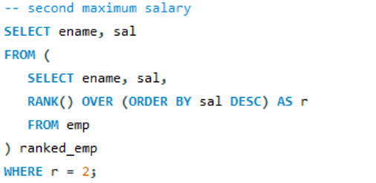
Output
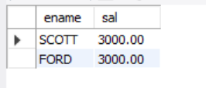

- Given a table Orders(order_id, customer_id, order_date, amount), write a query to find the total order amount per customer, but display only customers whose total exceeds 50,000.
Query
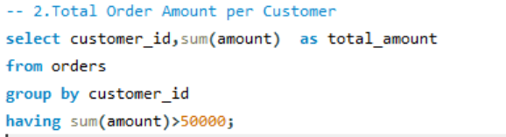
Output
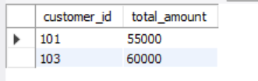
- Write an SQL query to find the number of employees in each department, excluding departments with fewer than 3 employees.
Query
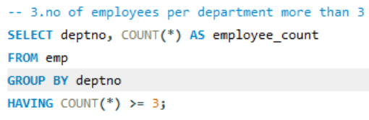
Output
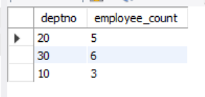

- Given tables Students(student_id, name) and Marks(student_id, subject, marks), write a query to find students who have scored more than 80 in at least two subjects.
Query
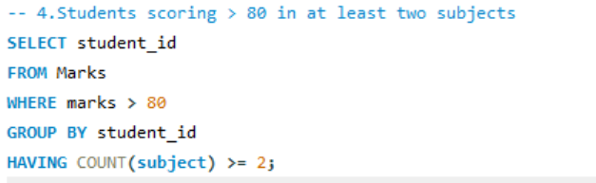
Output
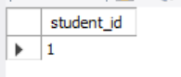

- Write an SQL query to retrieve the names of employees who earn more than the average salary of their department.
Query
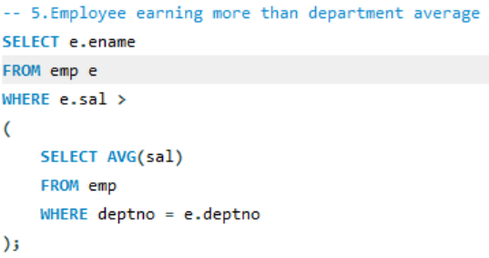
Output
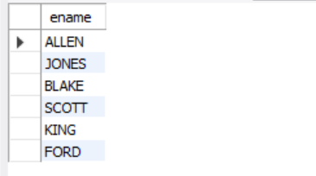

- Given a table Sales(sale_id, product_id, sale_date, quantity), write a query to find the total quantity sold for each product in the year 2024.
Query
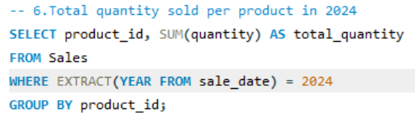
Output


- Write an SQL query to display the top 3 highest-paid employees from each department.
Query
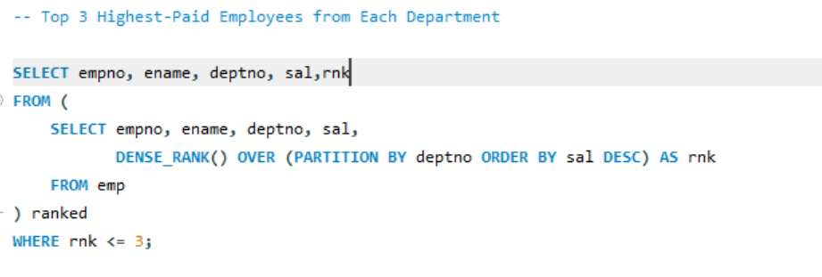
Output
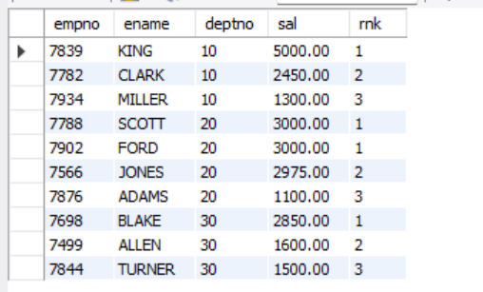

- Given a table Customers(customer_id, customer_name, city), write a query to find cities that have more than 5 customers.

Query
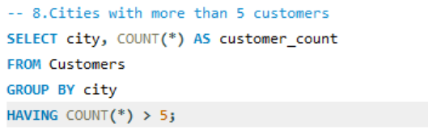
Output


- Write an SQL query to find employees who do not have any records in the Attendance table.
Query
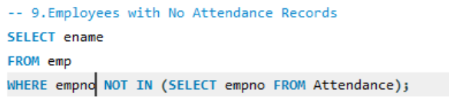
Output
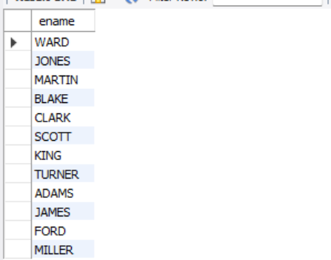

- Given a table Employees(employee_id, name, manager_id), write an SQL query to display each employee’s name along with their manager’s name.
Query
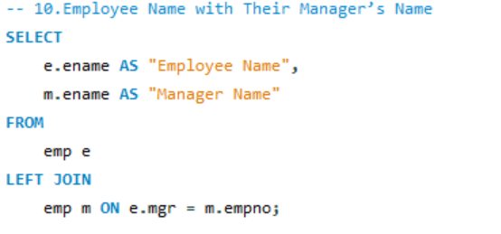
Output
