Project 1: Stroop Test

Table of Contents

Glimpse of the data 2

Independent variable and dependent variable 2

Hypothesis 2

Descriptive Statistics 3

Statistical Test 4

# Glimpse of the data

Congruent Incongruent

0 12.079 19.278

1 16.791 18.741

2 9.564 21.214

3 8.630 15.687

4 14.669 22.803

5 12.238 20.878

## Independent variable and dependent variable

Independent variable is the individuals undertaking the Stroop test, while the dependent variable is the time needed for each of them to complete the congruent and incongruent tests of the Stroop test.

# Hypothesis

What is an **appropriate set of hypotheses for this task**? **What kind of statistical test do you expect to perform? Justify your choices.**

Ho (Null Hypothesis): The population means of the two tasks (congruent and incongruent) are equal.

Ho: μ congruent = μ incongruent

Ha (Alternate Hypothesis): The population means of the two tasks (congruent and incongruent) are NOT equal.

Ha: μ congruent  ≠ μ incongruent

Although I anticipate the incongruent task’s mean to be greater than the congruent task’s mean, I find it safer to use a two-tailed Dependent Samples t-test (also known as paired t-test) here. As the sample size is less than 30, a t-test is recommended in this case.

Also as the same individual is measured for the Congruent as well as the Incongruent task, a Dependent Samples t-test is appropriate for this hypothesis.

## Descriptive Statistics

As per the descriptive statistics below we see that mean for Incongruent task is higher than that of the Congruent task as expected.

**Congruent** **Incongruent**

count 24.000000 24.000000

mean 14.051125 22.015917

std 3.559358 4.797057

min 8.630000 15.687000

25% 11.895250 18.716750

50% 14.356500 21.017500

75% 16.200750 24.051500

max 22.328000 35.255000

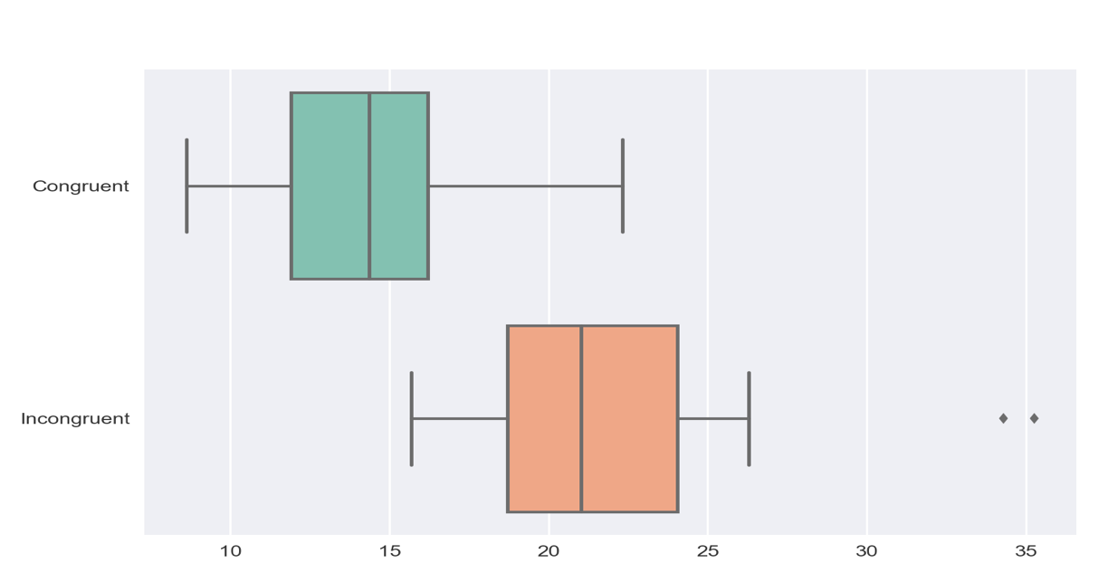

* As seen in the boxplot above 50% of the individuals need around 12 to 16 seconds approx. for the Congruent task versus 18.5 to 24 seconds approx. for the Incongruent task.
* IQR for the Congruent task is 4.3 seconds approx. and IQR for Incongruent task is 5.3 approx.
* The standard deviation is 3.5 seconds for Congruent task versus 4.8 seconds for the Incongruent task.

**Observation**

From the above plot we can see that times needed for completing Incongruent task in general is higher than that needed for completing Congruent task.

There are also two outliers seen while doing the congruent task indicating that two of the participants likely needed much higher time (around 35 seconds) to complete the Incongruent task versus the group mean of 22 seconds.

## Statistical Test

**Ho (Null Hypothesis): The mean difference between the two tasks (congruent and incongruent) is zero.**

**Ha (Alternate Hypothesis): The mean difference between the two tasks is not zero.**

Although as seen in the boxplot the incongruent task in general requires more time than that needed for the congruent task, I find it safer to use a two-tailed Dependent Samples t-test (also known as paired t-test) here instead of one-tailed t-test. As the sample size is less than 30, a t-test is recommended in this case.

Also as the same individual is measured for the Congruent as well as the Incongruent task, a Dependent Samples t-test is appropriate for testing this hypothesis.

Performing paired t-test in Python ( **print** stats.ttest_rel(df['Congruent'],df['Incongruent'],)) yields:

**statistic=-8.020706944109957, pvalue=4.1030005857111781e-08 for a 95% confidence interval.**

**As the p-value < 0.05, the result is statistically significant. Thus we reject the Ho (Null Hypothesis) and accept that the difference in the means of the two tasks is different.**

As the t statistic is negative we can conclude the directionality, meaning the time needed has increased significantly for completing the Incongruent task versus completing the Congruent task.

The increase in time needed to complete the Incongruent task can be attributed to the mismatch in the text ink color and the text color spelling. Our brain is preconditioned to read the text than reading the color of the ink. When they are the same the task becomes more easy but in cases of mismatch the brain has to do extra work to ignore the text and focus only on the ink color.