Exercise

Submitted by: Varsha Deora

Employee ID: 3270

Topic:Introduction to HTML/CSS

1. How are inline and block elements different from each other?

**Ans:** Inline elements get displayed without a line break. They do not start from a new line. They only take up the amount of width required. Some examples of inline elements are: <a> , <img>

Block level elements start from a new line and take up the maximum width. No other element can be in the same line as one block element.

Some examples of block elements are: <h1> , <div> ,<p>

2. Explain the difference between visibility:hidden and display:none

**Ans: visibility:hidden** hides the particular element from the web page but leaves a space where that element is located.

**display:none** hides the element from the web page but doesn’t leave a space where the element is located.

3. Explain the clear and float properties.

Ans: The **float** property is used for positioning and formatting content e.g. let an image float left to the text in a container. It can have the following values:

* left - The element floats to the left of its container
* right- The element floats to the right of its container
* none - The element does not float (will be displayed just where it occurs in the text). This is default
* inherit - The element inherits the float value of its parent

The clear property specifies what elements can float beside the cleared element and on which side. It can have the following values:

* none - Allows floating elements on both sides. This is default
* left - No floating elements allowed on the left side
* right- No floating elements allowed on the right side
* both - No floating elements allowed on either the left or the right side
* inherit - The element inherits the clear value of its parent

4. Explain difference between absolute, relative,fixed and static.

**Ans:**

* **Absolute**

An element with position: absolute; is positioned relative to the nearest positioned element ancestor.

* **Relative**

An element with position: relative; is positioned relative to its normal position. Setting the top, right, bottom, and left properties of a relatively-positioned element will cause it to be adjusted away from its normal position. Other content will not be adjusted to fit into any gap left by the element.

* **Fixed**

An element with position: fixed means it always stays in the same place even if the page is scrolled. The top, right, bottom, and left properties are used to position the element.

* **Static**

An element with position: static is not positioned in any special way. It is always positioned according to the normal flow of the page. Static positioned elements are not affected by the top, bottom, left, and right properties.

5. Write the HTML code to create a table in which there are 4 columns( ID , Employee Name, Designation, Department) and at least 6 rows. Also do some styling to it.

**htmltable1.html CODE:**

<!DOCTYPE html>

<head>

<title>Table Styling</title>

<link rel="stylesheet" type="text/css" href="table1.css">

</head>

<body>

<table>

<tr>

<th>ID</th>

<th>Employee Name</th>

<th>Designation</th>

<th>Department</th>

</tr>

<tr>

<td>01</td>

<td>Samantha</td>

<td>Front End Engineer</td>

<td>FEEN</td>

</tr>

<tr>

<td>02</td>

<td>John</td>

<td>DevOps Engineer</td>

<td>DevOps</td>

</tr>

<tr>

<td>03</td>

<td>David</td>

<td>Quality Engineer</td>

<td>QE</td>

</tr>

<tr>

<td>04</td>

<td>Justin</td>

<td>Front End Engineer</td>

<td>FEEN</td>

</tr>

<tr>

<td>05</td>

<td>Sarah</td>

<td>DevOps Engineer</td>

<td>DevOps</td>

</tr>

<tr>

<td>06</td>

<td>Emma</td>

<td>Quality Engineer</td>

<td>QE</td>

</tr>

</table>

</body>

</html>

**Table1.css CODE:**

table{

border: 5px rgb(206, 223, 240) solid;

width: 50%;

}

tr{

background-color: rgb(206, 223, 240);

text-align: center;

font-family: sans-serif;

}

th {

background-color: rgb(36, 90, 121);

color: white;

}

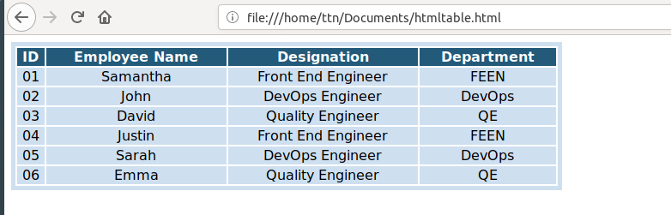

6. Why do we use meta tags?

**Ans:**

The <meta> tag provides metadata about the HTML document. They are typically used to specify page description, keywords, author of the document, last modified, and other metadata. The metadata can be used by browsers (how to display content or reload page), search engines (keywords), or other web services.

<head>

<meta name=”description” content=”This is where you add your meta description.”>

</head>

7. Explain box model.

**Ans:**

All HTML elements can be considered as boxes. In CSS, the term "box model" is used when talking about design and layout.

The CSS box model is essentially a box that wraps around every HTML element. It consists of: margins, borders, padding, and the actual content.

* **Content** - The content of the box, where text and images appear
* **Padding** - Clears an area around the content. The padding is transparent
* **Border** - A border that goes around the padding and content
* **Margin** - Clears an area outside the border. The margin is transparent.

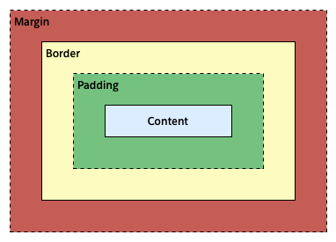

8. What are the different types of CSS Selectors?

**Ans:** CSS selectors are used to select the content you want to style.

They are of different types:

* **CSS Element Selector:**

The element selector selects the HTML element by name.

* **CSS Id Selector:**

The id selector selects the id attribute of an HTML element to select a specific element. An id is always unique within the page so it is chosen to select a single, unique element.

It is written with the hash character (#), followed by the id of the element.

* **CSS Class Selector:**

The class selector selects HTML elements with a specific class attribute. It is used with a period character . (full stop symbol) followed by the class name.

* **CSS Universal Selector:**

The universal selector is used as a wildcard character. It selects all the elements on the pages. It is used with a * character.

* **CSS Group Selector:**

The grouping selector is used to select all the elements with the same style definitions. Grouping selector is used to minimize the code. Commas are used to separate each selector in grouping.

9. Define Doctype.

**Ans:** The <!DOCTYPE> declaration is not an HTML tag It is an instruction to the web browser about what version of HTML the page is written in.

10. Explain 5 HTML5 semantic tags.

**Ans:** Some of the HTML semantic tags are:

* **<table>**

An HTML table is defined with the <table> tag. Each table row is defined with the <tr> tag. A table header is defined with the <th> tag. A table data/cell is defined with the <td> tag.

* **<form>**

The HTML <form> element defines a form that is used to collect user input. Form elements are different types of input elements, like text fields, checkboxes, radio buttons, submit buttons, and more.

* **<section>**

The <section> element defines a section in a document. A home page could normally be split into sections for introduction, content, and contact information.

* **<header>**

The <header> element specifies a header for a document or section.

It should be used as a container for introductory content.

* **<figure>**

In HTML5, an image and a caption can be grouped together in a <figure> element using <figcaption>.

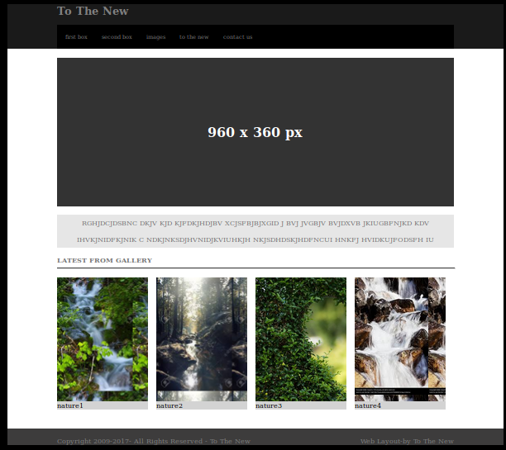11. Create HTML for web-page.jpg

12. Create HTML for form.png

