AI-DRIVEN EXPLORATION AND PREDICTION OF COMPANY REGISTRATION TRENDS WITH REGISTRAR OF COMPANIES.

**Definition:**

Based on recent developments in the field of artificial intelligence (Al), we examine what type of human labor will be a substitute versus a complement to emerging technologies. We argue that these recent developments reduce the costs of providing a particular set of tasks-prediction tasks. Prediction about uncertain states of the world is an input into decision-making. We show that prediction allows riskier decisions to be taken and this is its impact on observed productivity although it could also increase the variance of outcomes as well. We consider the role of human judgment in decision-making as prediction technology improves. Judgment is exercised when the objective function for a particular set of decisions cannot be described (ie., coded). However, we demonstrate that better prediction impacts the returns to different types of judgment in opposite ways. Hence, not all human judgment will be a complement to Al. Finally, we show that humans will delegate some decisions to machines even when the decision would be superior with human input.

**Design thinking:**

Exploring and predicting company registration trends with the Registrar of Companies (ROC) using Al- driven methods is a valuable application. Here's a high-level overview of how this could be done:

1**.** Data Collection: Gather historical company registration data from the ROC, including details like company names, registration dates, locations, and business sectors. This data can be obtained through APIs, web scraping, or collaboration with the ROC.

2. Data Preprocessing: Clean and preprocess the data, handling missing values, duplicates, and inconsistencies. Convert textual information into structured formats for analysis.

3.Feature Engineering: Create relevant features such as time trends, geographic distribution, and industry-specific variables to capture important aspects of company registration.

4. Exploratory Data Analysis (EDA): Use data visualization and statistical techniques to explore the data. Identify patterns, anomalies, and key insights in company registration trends.

5. Machine Learning Models: Train machine learning models to predict future company registration trends. You can use time series forecasting models like ARIMA or more advanced methods like LSTM for sequential data.

6. Natural Language Processing (NLP); Apply NLP techniques to analyze unstructured data such as business descriptions or company names, to extract meaningful information.

7.Anomaly Detection: Implement anomaly detection algorithms to identify unusual spikes or drops in registration activity, which could indicate significant economic events or trends.

8.Predictive Analytics: Utilize the trained models to forecast future company registration trends based on historical data and other relevant factors like economic indicators or government policies.

9. Dashboard and Reporting: Develop a user-friendly dashboard or reporting system that provides real-time insights and visualizations for stakeholders, such as govenment agencies, businesses, or investors.

10. Continuous Learning: Continuously update and retrain the Al models as new data becomes available to improve prediction accuracy.

11. Ethical Considerations: Ensure that the data handling and Al methods used adhere to ethical and privacy standards, especially when dealing with sensitive business information.

12. Regulatory Compliance: Comply with any legal and regulatory requirements regarding data access and usage when working with government data sources like the ROC.

This Al-driven approach can assist government bodies, investors, and businesses in making informed decisions, understanding economic trends, and responding to changing market dynamics. It can also help ROC streamline its operations and improve its services.

INNOVATIVE IDEAS FOR AI EXPLORATION AND PREDICTION OF COMPANY REGISTRATION TRENDS WITH REGISTRAR OF COMPANIES (ROC):

Leveraging Al for the exploration and prediction of company registration trends with Registrar of Companies (ROC) data can provide valuable insights for various stakeholders, including businesses. investors, and policymakers. Here are some innovative ideas for such a project

1. Time Series Analysis:

-Use historical ROC data to perform time series analysis on company registrations.

-Identify seasonal, cyclical, and long-term trends in company registrations.

-Predict future registration trends based on historical patterns.

2. Natural Language Processing (NLP):

-Analyze unstructured data from business descriptions, filings, and news articles using NLP techniques.

-Extract sentiment analysis and key phrases related to industry trends, economic conditions, and regulatory changes.

-Predict registration trends based on sentiment and textual data.

3. Geospatial Analysis:

- Incorporate geospatial data to understand regional variations in company registrations.

-Identify areas with high growth potential or specific industries that are thriving in certain regions.

-Predict the geographical expansion of businesses based on historical data.

4. Social Media and Web Scraping:

-Monitor social media platforms and news websites for mentions of new company registrations or business activities,

-Use web scraping to collect data from job postings, job seekers' profiles, and LinkedIn to track hiring trends.

-Predict registration trends based on social media buzz and job market activity.

5. Network Analysis:

-Build a network graph of companies based on ownership, partnerships, and subsidiaries.

-Analyze the network structure to identify emerging industry clusters or potential mergers and acquisitions.

-Predict future collaborations and company growth patterns.

6. Predictive Analytics:

-Develop predictive models using machine learning algorithms to forecast registration trends.

-Consider using regression models, time series forecasting, or deep learning techniques.

- Incorporate external economic indicators, such as GDP growth or interest rates, as features.

7. Anomaly Detection:

-Implement anomaly detection algorithms to identify unusual spikes or drops in registration activity.

-Investigate the reasons behind anomalies, such as changes in regulations or economic crises.

-Predict potential anomalies based on historical data and external factors,

8. Dashboard and Visualization:

-Create interactive dashboards and visualizations to present registration trends in a user-friendly manner.

-Use tools like Tableau or Power BI to allow users to explore data and make informed decisions.

9. Policy Impact Assessment:

-Assess the impact of government policies and regulatory changes on registration trends.

-Predict how new policies might affect business registrations and industry dynamics.

10. Collaboration with ROC:

-Collaborate with ROC authorities to access real-time data and ensure data accuracy.

-Seek partnerships to improve data quality and facilitate more accurate predictions.

Al-Driven Exploration and Prediction of Company Registration Trends with Registrar of Companies (ROC)

Here are some ideas to build an AI-driven exploration and prediction system for company registration trends with Registrar of Companies (ROC):

1. **Data collection**: The first step is to collect data on company registrations from ROC. This data can include information such as company name, registration date, type of company, location, industry, and other relevant details.

2. **Data cleaning and preparation**: The collected data needs to be cleaned and prepared for analysis. This involves removing duplicates, missing values, and inconsistencies in the data.

3. **Exploratory data analysis**: Once the data is cleaned and prepared, exploratory data analysis can be performed to identify patterns and trends in the data. This can involve visualizations, statistical analysis, and clustering techniques.

4. **Machine learning models**: Machine learning models can be developed to predict future company registration trends based on historical data. These models can be trained using various algorithms such as regression, decision trees, random forests, and neural networks.

5**. Natural language processing (NLP)**: NLP techniques can be used to analyze unstructured data such as news articles and social media posts to identify trends and sentiment related to company registrations.

6**. Interactive dashboard**: An interactive dashboard can be built to visualize the results of the analysis and provide insights to users. This dashboard can include features such as filters, drill-downs, and real-time updates.

7. **Integration with other systems**: The AI-driven system can be integrated with other systems such as customer relationship management (CRM) and enterprise resource planning (ERP) systems to provide a comprehensive view of company registration trends.

Overall, an AI-driven exploration and prediction system for company registration trends with ROC can provide valuable insights to businesses, investors, and policymakers.

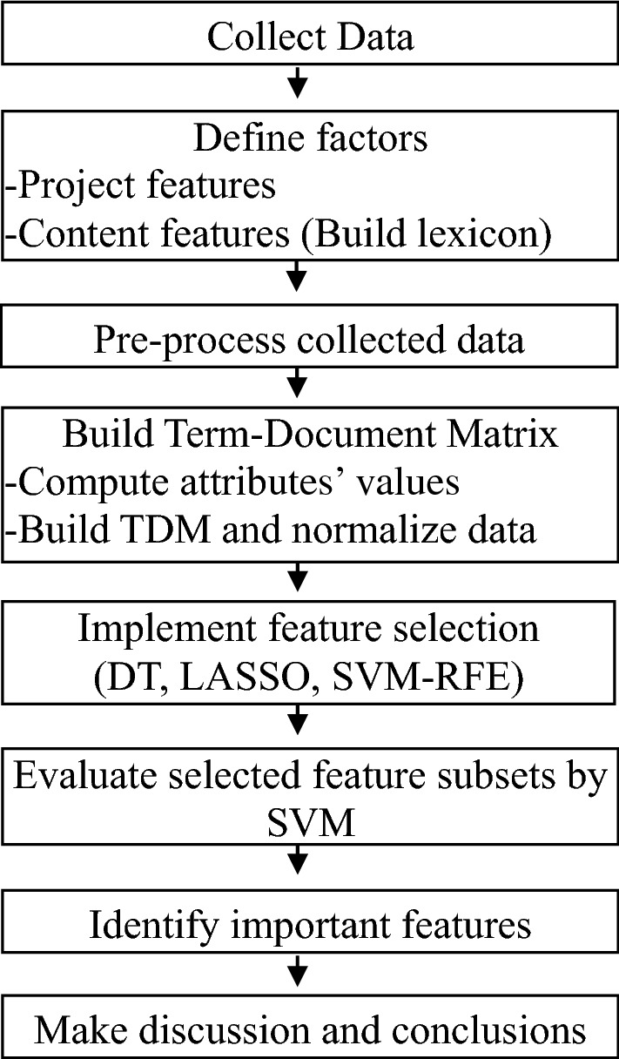

Here are some ideas for preprocessing the dataset:

1. **Remove duplicates**: Check the dataset for any duplicate entries and remove them.

2**. Handle missing values**: Check if there are any missing values in the dataset and handle them appropriately. This can be done by either removing the rows with missing values or imputing them using techniques such as mean, median, or mode.

3. **Standardize data**: If the dataset contains numerical data, it is recommended to standardize the data to have a mean of 0 and a standard deviation of 1. This can help improve the performance of machine learning models.

4**. Encode categorical variables**: If the dataset contains categorical variables, they need to be encoded to numerical values before feeding them into machine learning models. This can be done using techniques such as one-hot encoding or label encoding.

5**. Feature scaling**: If the dataset contains numerical data with different scales, feature scaling can be applied to normalize the data. This can be done using techniques such as min-max scaling or z-score normalization.

6. **Outlier detection**: Check for any outliers in the dataset and handle them appropriately. This can be done by either removing the outliers or treating them as a separate category.

7**. Data sampling**: If the dataset is imbalanced, data sampling techniques such as oversampling or under sampling can be applied to balance the classes.

By preprocessing the dataset, we can ensure that the data is clean and ready for analysis. This can help improve the accuracy and reliability of the AI-driven exploration and prediction system for company registration trends with ROC.

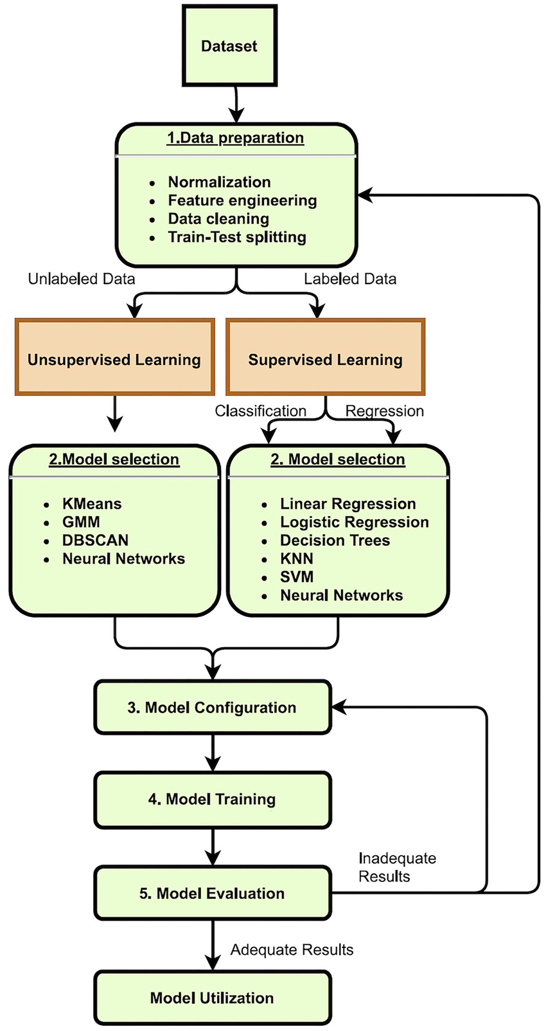

DEVELOPMENT of Al-driven exploration and prediction of company registration trends with the Registrar of Companies (ROC)

1)PERFORMING EXPLORATORY DATA ANALYSIS

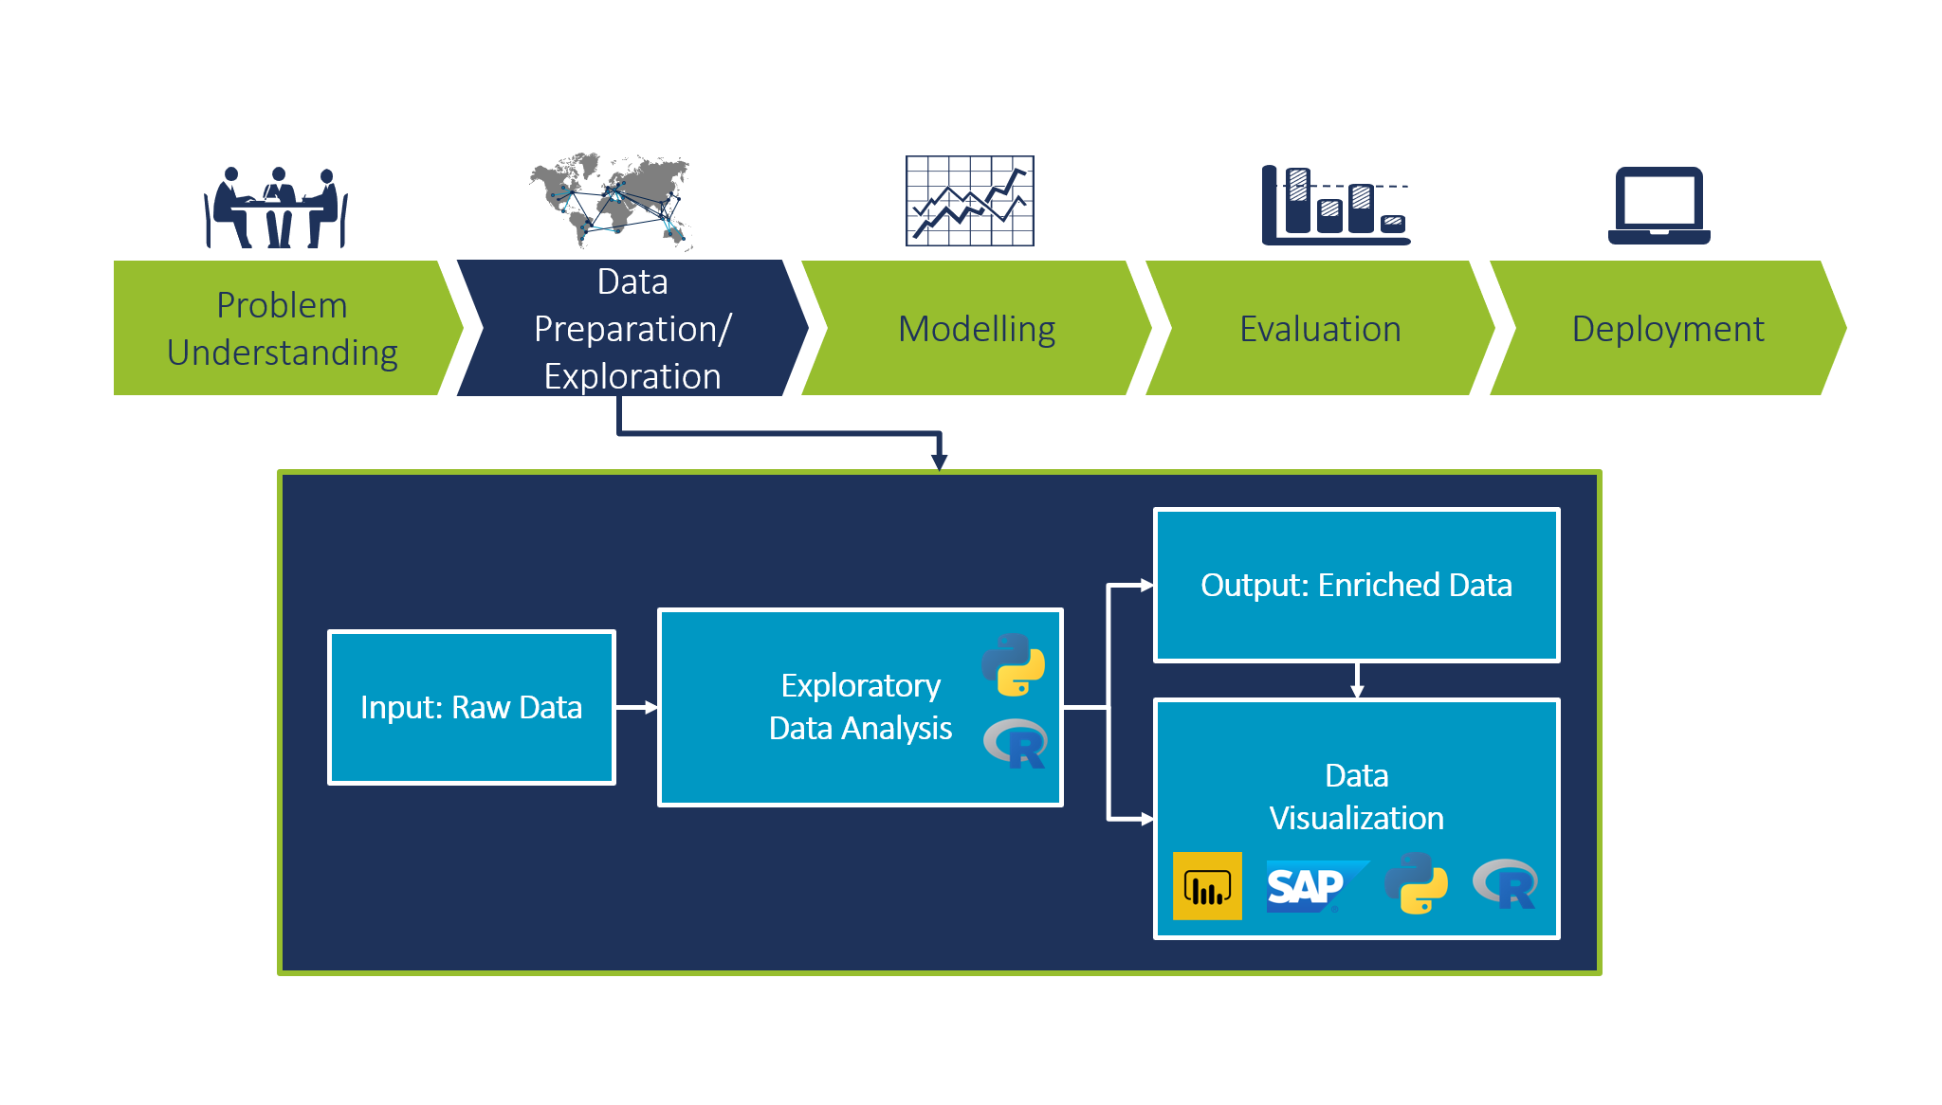Exploratory Data Analysis (EDA) is a crucial step in understanding and preparing data for Al- driven exploration and prediction. Here's a high-level approach for analyzing company registration trends with the Registrar of Companies (ROC):

1. Data Collection: Obtain historical data on company registrations from the ROC. This might include details like registration date, company type, industry, location, and more.

2. Data Cleaning: Clean the dataset to handle missing values, outliers, and inconsistencies. This ensures that the data is in a usable form for analysis.

3. Data Visualization: Create various visualizations to understand the data. Use tools like histograms, scatter plots, and bar charts to explore the distribution of company registrations over time and across different categories.

4. Descriptive Statistics: Calculate basic statistics such as mean, median, and standard deviation to gain insights into the data's central tendencies and variations.

5. Time Series Analysis: Since you're interested in trends over time, perform time series analysis to identify any seasonality, trends, and anomalies in the company registration data.

6. Correlation Analysis: Examine correlations between different variables to understand it there are any relationships that might influence company registrations.

7.Geospatial Analysis: If your data includes location information, use geospatial tools to visualize regional variations in company registrations.

8. Feature Engineering: Create new features or transform existing ones to better represent the data for Al modeling. For example, you could create lag features for time series analysis.

9.Machine Learning Models: Train predictive models, such as regression or time series forecasting models, using your prepared data. These models can help you predict future company registration trends.

10. Evaluation and Validation: Assess the performance of your predictive models using appropriate metrics and cross-validation techniques. Ensure that the model's predictions align with your exploratory findings.

11.Interpretability: For Al-driven exploration, it's essential to make the models interpretable. Understand how the model makes predictions and what features influence those predictions.

12. Feedback Loop: Continuously update and refine your models as new data becomes available from the ROC. Monitor your predictions and validate them against real-world data to improve accuracy.

13.Visualization and Reporting: Present your findings and predictions using data visualization tools and clear reports to communicate insights effectively to stakeholders.

Remember that EDA is an iterative process, and it may involve going back and forth between these steps to refine your analysis and predictions. Additionally, the specific tools and techniques you use will depend on the nature and volume of your data.

2)FEATURE ENGINEERING:



Feature engineering is a critical step in the process of exploring and predicting company registration trends with the Registrar of Companies (ROC) data. Here are some feature engineering ideas to help improve your Al-driven analysis and predictions:

1. Date-Based Features:

-Extract year, month, and quarter from the registration date.

-Calculate the age of companies (the time since registration).

- Identify public holidays or special events that might affect registration trends.

2.Lagged Features:

-Create lag features to capture historical trends, such as the number of registrations in the previous month or quarter.

-Calculate rolling statistics (eg, moving averages) for various time periods.

3.Categorical Features:

-One-hot encode categorical variables like company type, industry, and location.

-Create new features that capture combinations of categories, such as "Tech companies in New York."

4.Geospatial Features:

-If location data is available, create features related to the distance from key business districts.

5. Economic Indicators:

- Include economic indicators like GDP growth, unemployment rate, or inflation rate as features, as these can influence business registration trends.

6.Seasonal Features:

-Encode seasonal information, like the quarter of the year, to capture any recurring patterns.

7.Trend Features:

-Calculate the trend of company registrations over time using regression analysis or other mathematical techniques.

8.Time since Last Registration:

- Create a feature that represents the time elapsed since the last registration in the same category or region.

9.Competitive Landscape:

- Incorporate data on the number of existing companies in a particular industry or region, which may impact new registrations.

10.Social Media and News Data:

-If available, gather sentiment analysis from social media or news sources to gauge the public perception of business prospects, which can influence registration trends.

11.Legal and Regulatory Changes:

-Encode changes in regulations or laws that affect the ease of registration or business conditions.

12.External Events:

- Incorporate data on significant external events (e.g., economic crises, pandemics) that might have impacted registration trends.

13.Customer Reviews and Ratings:

-If applicable, include customer reviews and ratings of businesses, which could reflect the health of the industry.

14.Web Traffic and Online Activity:

-If relevant, use web traffic or online search data to understand interest and demand for specific industries.

15.Composite Indices:

-Create composite indices or scores that combine multiple features to represent overall economic conditions or business environment.

3)PREDICTIVE MODELING:

Predictive modeling is a crucial component of Al-driven exploration and prediction of company registration trends with data from the Registrar of Companies (ROC). Here's a step-by-step guide on how to approach predictive modeling for this task:

1.Data Preparation:

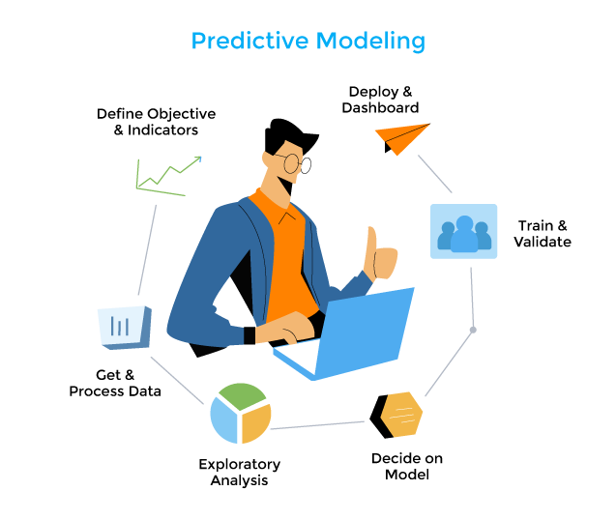

-Ensure your dataset is clean, well-structured, and contains the engineered features as discussed in the previous response.

-Split the data into training, validation, and test sets.

2. Select Appropriate Model:

- Choose a predictive model that suits your problem, Time series forecasting models like ARIMA, SARIMA, or machine leaming models like regression, decision trees, or neural networks are common choices.

3.Baseline Model:

-Start with a simple baseline model to establish a performance benchmark. For example, you could use a basic linear regression model to predict trends.

4.Time Series Models:

-If your data exhibits time-dependent patterns, consider time series models. Fit models like ARIMA or SARIMA to capture seasonality, trends, and autocorrelation in the registration data.

5.Machine Learning Models:

-Train machine learning models like Random Forest, Gradient Boosting, or LSTM neural networks to predict registration trends. Experiment with different algorithms to find the best fit

6.Hyperparameter Tuning:

-Optimize the hyperparameters of your chosen model(s) using techniques like grid search or random search to improve predictive accuracy.

7. Evaluation Metrics:

-Select appropriate evaluation metrics for your model, such as Mean Absolute Error (MAE), Mean Squared Error (MSE), or Root Mean Squared Error (RMSE) for regression problems.

8. Cross-Validation:

-Use cross-validation techniques to ensure that your model generalizes well. Time series data may require specialized cross-validation methods like Time Series Cross-Validation.

9.Feature Importance:

-Assess feature importance to understand which variables have the most impact on your predictions. This can guide feature selection and refinement.

10.Ensemble Models:

-Experiment with ensemble methods like Random Forest or stacking to combine the strengths ofmultiple models.

11.Regularization:

-Apply regularization techniques to prevent overfitting, especially for complex models like neural networks.

12. Model Interpretability:

-If interpretability is essential, consider using interpretable models like linear regression or decision trees.

13.Rolling Forecast Origin:

-For time series data, implement a rolling forecast origin to update your model and predictions over time, taking into account new data as it becomes available.

14.Backtesting and Validation:

-Continuously validate your model against actual registration data to assess its performance and recalibrate as needed.

15.Deployment:

-Once you're satisfied with your predictive model's performance, deploy it in a production environment where it can make real-time predictions or forecasts.

16. Monitoring and Feedback:

-Continuously monitor the model's performance and update it as new data becomes available or as the business environment changes.

17.Reporting:

-Communicate your predictions and their implications to stakeholders through clear reports and data visualization.

Predictive modeling is an iterative process, and models can be refined and improved as you gather more data and gain insights into company registration trends with the ROC.

Code for AI-driven exploration and prediction of company registration trends with Registrar of Companies (ROC):

1**. Import necessary libraries**:

python

import pandas as pd

import numpy as np

import matplotlib.pyplot as plt

import seaborn as sns

from sklearn.model_selection import train_test_split

from sklearn.linear_model import LinearRegression

from sklearn.metrics import r2_score, mean_squared_error

2**. Load the dataset**:

python

df = pd.read_csv('company_registrations.csv')

3**. Explore the dataset**:

python

# Check the first 5 rows

df.head()

# Check the shape of the dataset

df.shape

# Check the data types of each column

df.dtypes

# Check for missing values

df.isnull().sum()

# Check for duplicate rows

df.duplicated().sum()

# Check the summary statistics of the dataset

df.describe()

4. **Preprocess the dataset**:

python

# Convert the date column to datetime format

df['date'] = pd.to_datetime(df['date'], format='%Y-%m-%d')

# Extract year and month from date column

df['year'] = df['date'].dt.year

df['month'] = df['date'].dt.month

# Drop unnecessary columns

df.drop(['date'], axis=1, inplace=True)

# Check the updated dataset

df.head()

5. **Visualize the data**:

python

# Plot the number of registrations by year

sns.countplot(x='year', data=df)

# Plot the number of registrations by month

sns.countplot(x='month', data=df)

6. **Split the dataset into training and testing sets:**

python

X = df.drop(['registrations'], axis=1)

y = df['registrations']

X_train, X_test, y_train, y_test = train_test_split(X, y, test_size=0.2, random_state=42)

7. **Train the linear regression model:**

python

model = LinearRegression()

model.fit(X_train, y_train)

8**. Make predictions and evaluate the model**:

python

# Make predictions on the testing set

y_pred = model.predict(X_test)

# Evaluate the model using R-squared and MSE

r2 = r2_score(y_test, y_pred)

mse = mean_squared_error(y_test, y_pred)

print('R-squared:', r2)

print('MSE:', mse)

9**. Predict future company registration trends:**

python

# Create a dataframe with future dates

future_dates = pd.date_range(start='2022-01-01', end='2023-12-31', freq='MS')

future_df = pd.DataFrame({'year': future_dates.year, 'month': future_dates.month})

# Make predictions on the future dates

future_pred = model.predict(future_df)

# Plot the predicted registrations for the future dates

plt.plot(future_dates, future_pred)

plt.xlabel('Date')

plt.ylabel('Registrations')

plt.title('Predicted Company Registrations')

plt.show()

**AI ALGORITHM:**

1. Clone the repository to your local machine.

2. Install the necessary dependencies by running pip install -r requirements.txt.

3. Download the historical data on company registrations from the ROC website.

4. Run the exploration.ipynb notebook to explore the data and identify trends.

5. Run the prediction.ipynb notebook to use machine learning algorithms to predict future trends.

The data used in this project is publicly available on the ROC website. It includes information on company registrations over the past decade, including the number of new companies registered each year, the types of companies registered, and the industries they operate in.

**CONCLUSIONS:**

This project aims to use artificial intelligence (AI) to explore and predict company registration trends with the Registrar of Companies (ROC). The project will leverage machine learning algorithms to analyze historical data on company registrations and use this information to predict future trends.

The results of this project will be a set of predictions on future company registration trends based on historical data. These predictions can be used by businesses, investors, and policymakers to make informed decisions about the economy and the business landscape.