**SHOPNEST E-COMMERCE REPORT**

**QUESTION STATEMENT-**

1. Identify the rating distribution in the Shop_Nest dataset, showcasing ratings categorized as Excellent, Very Good, Good, Bad, and Very Bad along with the corresponding orders.

**VISUALIZATION-**

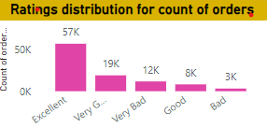

**EXPLANATION-**

* The visual used is a stacked column chart with X-axis representing ratings and Y-axis representing number of orders.
* The ratings are given in such a way that 5 corresponds to excellent, 4 to very good, 3 to good, 2 to bad and 1 to very bad respectively.
* As we can see that majority of orders have excellent ratings and very few have very bad ratings.
* This indicates that the customers are highly satisfied with the e-commerce platform delivering all types of products across various regions.
* It also gives us a deep understanding of how ratings are directly affected by the type of product being delivered, speed of delivery, quality of product, customer services, delivery across various regions, multiple sellers etc.
* However, there is always scope for improvement. The store can work on certain logistical issues to deliver products on time which will affect the ratings positively.

**QUESTION STATEMENT-**

1. What are the top 10 and bottom 18 most popular product categories in the Shop_Nest dataset? Please list them based on the number of orders.

**VISUALIZATION-**

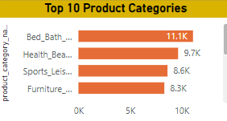 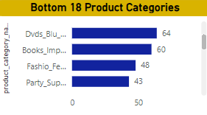

**EXPLANATION-**

* The visual used is a stacked bar chart with X-axis representing number of orders and Y-axis representing product categories.
* The top 10 categories in terms of orders are bed_bath_table, health_beauty, sports_leisure, furniture_decor, computer_accessories, housewares, watches_gifts, telephony, garden_toos, auto.
* The bottom 18 categories in terms of orders include not so popular categories like clothing, dvds, music, small appliances, security and services etc.
* This shows that majority of sales happens in furniture or bathroom fixtures etc similar to Ikea.
* This provides us insights that people trust the variety and quality that Shop_Nest offers to people and hence they are willing to purchase more.
* The bottom categories have lesser sales probably because they lack variety, lack more local support through the production of these items, higher costs or below par quality items.
* If the store also concentrates on expanding in these categories their sales may increase.

**QUESTION STATEMENT-**

1. List the total number of active sellers by yearly and monthly.

**VISUALIZATION-**

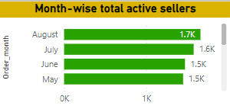 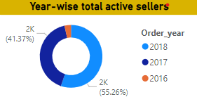

**EXPLANATION-**

* The charts used are clustered bar chart where X-axis represents total active sellers and Y-axis represents order month whereas donut chart represents active sellers throughout the years.
* As seen sellers are high in number in the months of May, June, July and August and low in the months of September, October and December.
* These fluctuations can be caused due to various factors such as seasonal trends, promotions and marketing, economic factors, supply chain cycles, platform policies and features etc.
* Year wise there is an increase in the number of sellers. This can be also due to increase in affiliate marketing.
* The company can give attractive offers to sellers so that more sales can happen and hance more revenue.

**QUESTION STATEMENT-**

1. Which payment methods are most commonly used by ShopNest customers.

**VISUALIZATION-**

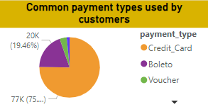

**EXPLANATION-**

* The visual used is a pie chart with distributions of various payment methods.
* Most common payment method chosen by customers is credit cards, followed by boleto, vouchers, debit cards.
* Credit cards are easily available across all regions and credit card providers give a good limit to spend which can be paid within a few days. This method is most convenient as you can spend money and pay it later. Several banks provide discounts on credit cards as well. So along with rewards one can also avail discounts.
* Boleto is a common payment method which is primarily used in countries like Brazil or Portugal where a payment slip is generated and can later be paid by customers through banks or certain stores. This type of payment takes little time to process.
* Vouchers or gift cards are used as well. These vouchers can be bought using credit card rewards and hence there is an increase in usage of credit cards.
* Debit cards are less preferred as there is direct deduction of money.

**QUESTION STATEMENT-**

1. Identify the product category wise profit margin using the formula.

(Payment_value-Price+Freight_value)/(Payment_value) *100

**VISUALIZATION-**

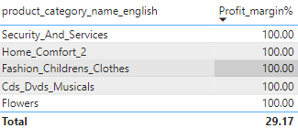

**EXPLANATION-**

* The visual used is a table with two columns i.e. product categories and their respective profit percentage.
* Here it can be observed that top product categories have lesser profit margin as compared to certain bottom product categories.
* This can be possible due to various factors such as
  + 1. High sales volume with lower margins
    2. Discounts and promotions
    3. High competition
    4. Higher Cost of Goods sold
    5. Low pricing power
    6. Increased marketing and operational costs.
* Overall profit margin is 29.17% indicates a healthy financial performance with good cost management and pricing strategy, efficient operations and good pricing power.

**QUESTION STATEMENT-**

1. Determine the monthly payments made by customers using credit cards.

**VISUALIZATION-**

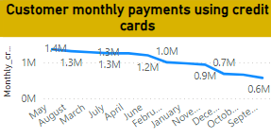

**EXPLANATION-**

* We have used a line chart which which gives us the month on month trends of customer behaviour for usage of credit cards.
* It can be observed that although there is a significant decline in credit card users throughout the months, the margins are still higher compared to other forms of payments.
* It can be seen that the months of September, October, November and December have a decline. This can be due to many factors like

1. Economic conditions
2. Holiday spending behaviour
3. End of promotional periods
4. Increased use of other payment methods
5. High interest rates on credit cards

**QUESTION STATEMENT-**

1. Identify sellers categorized by city, excluding cities starting with the letters S and B.

**VISUALIZATION-**

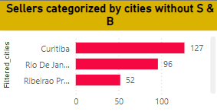

**EXPLANATION-**

* The visual used is a stacked bar chart with X-axis representing count of sellers and Y-axis representing filtered cities.
* Since most regions that are popular in Brazil start from letters S and B, it is obvious that most sellers belong to cities from these regions.
* In cities that were not starting with the letters S and B, Curitiba has the highest number of sellers with 127 indicating that this city is well developed and well populated and has access to well developed network of transportation and urban planning.
* Xaxim has the least number of sellers with just 1. This could be possible due to certain reasons-

1. Small population
2. Not an economic hub
3. Not well developed
4. Small consumer base
5. Poor logistics and accessibility

**QUESTION STATEMENT-**

1. Create a dynamic visual that compares the number of delayed orders to the number of orders received earlier for each month.

**VISUALIZATION-**

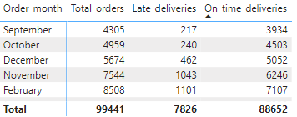

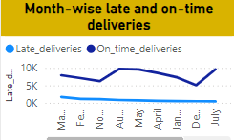

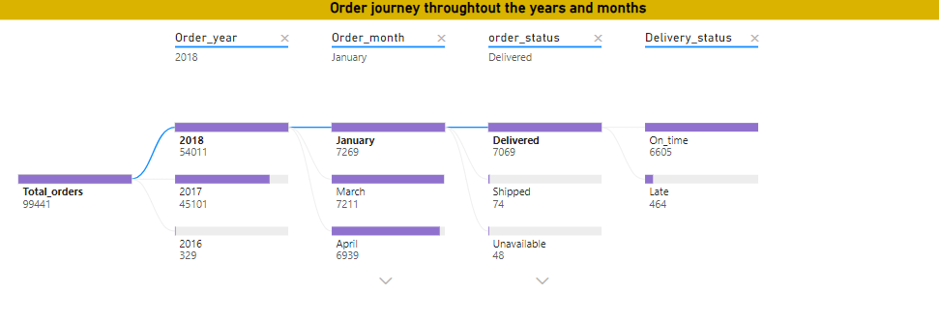

**EXPLANATION-**

* In the visuals we can see that there are almost 99k orders out of which 89k are delivered on time i.e. delivered within estimated time. That means that almost 89.9% deliveries are successes indicating the platform is managing logistics very efficiently for most orders.
* Late delivery rate is just 7.88% which is not a bad figure however there is always scope for improvement. Since late deliveries could affect customer satisfaction and later reduce customer retention, this issue can be tackled with certain improvements in logistics.
* There is a very less percentage of orders which are shipped but not delivered, cancelled, still in processing etc. However, even a small percentage of failed orders can negatively impact customer experience and profitability.
* Hence minor logistics issues can be carefully monitored and resolved for better customer satisfaction.
* Certain late deliveries can be possible for reasons such as –

1. Logistical or transportation issues
2. Operational problems
3. External factors
4. Supply chain challenges
5. Technical issues
6. Customer- related issues
7. Delivery capacity constraints

**CONCLUSION-**

* Overall, the platform is performing well with nearly 90% of deliveries on time.
* However, relatively high late delivery percentage and cancellations suggests scope for operational improvements.
* A profit margin of 27% also indicates a healthy financial condition of the store.
* Customer ratings are also steady with extremely good ratings which provide insights on customer satisfaction.
* The product categories are well thought of and cover almost all sections necessary in day to day life.
* There is also a huge list of sellers that indicates how well developed or urban planning is in Brazil.

**SCOPE FOR IMPROVEMENT-**

* **Addressing late deliveries-** analysing the reasons for late deliveries would help in improvement of logistics. This could be optimizing routes, reducing warehouse handling times, partnering with efficient delivery services.
* **Minimising cancellations-** Understanding and addressing why orders are cancelled, whether it is because of stock availability, payment issues, shipping delays etc.
* **Enhancing communication-** Improving customer communication about order status, especially if orders are going to get delayed.
* **Order fulfilment and inventory management-** Improving stock management and implementing quality checks to reduce errors.
* **Customer service-** Offer open communication to customers and reliable customer services. Offer multiple channels for customer support like email, chat, phone, messages etc.
* **User experience-** Enhance user experience by making the website user-friendly, easy navigation, easy checkout process etc.
* **Pricing and discounts-** Regularly update prices according to dynamic market changes to remain profitable.
* **Payment processing-** Provide a variety of payment options to accommodate different customer behaviour.
* **Marketing and engagement-** Develop eye catching marketing campaigns to keep the audience invested and implement loyalty programs to attract repeat customers.