Decision tree – Attrition Dataset

Dependent variable – Attrition

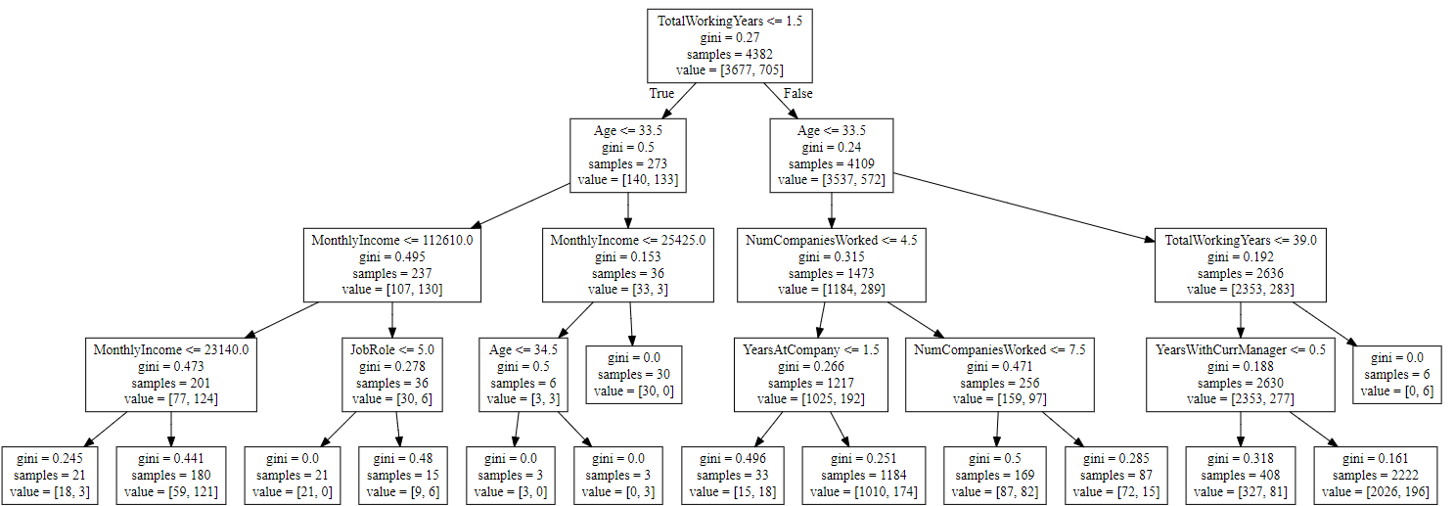Independent variable - 'Age', 'DistancefromHome', 'JobRole', 'MonthlyIncome', 'NumCompaniesWorked', 'PercentSalaryHike', ' TotalworkingYears', 'YearsAtCompany', 'YearsWithCurrManager'

Decision rules –

1. TotalworkingYears <= 1.5 and Age <= 33.5 and MonthlyIncome < = 112610 => 124 Attrition
2. TotalworkingYears <= 1.5 and Age <= 33.5 and MonthlyIncome > 112610 and JobRole> 5.0 => 6 Attrition
3. TotalworkingYears <= 1.5 and Age <= 33.5 and MonthlyIncome<=25425and Age<=34.5 => 3 Attrition
4. TotalworkingYears > 1.5 and Age <= 33.5 and NumCompaniesWorked <= 4.5 and YearsAtCompany <= 1.5 => 192Attrition
5. TotalworkingYears > 1.5 and Age >33.5 and TotalworkingYears<=39 and YearwithCurrManager <= 0.5 => 277 Attrition