Decision tree

Dependent variable- Personal Loan

Independent variable - Age, Experience, Income, Family , CCAvg, Education, Mortgage, Securities Account, CD Account, Online, Credit Card

Score = 0.99(99%)

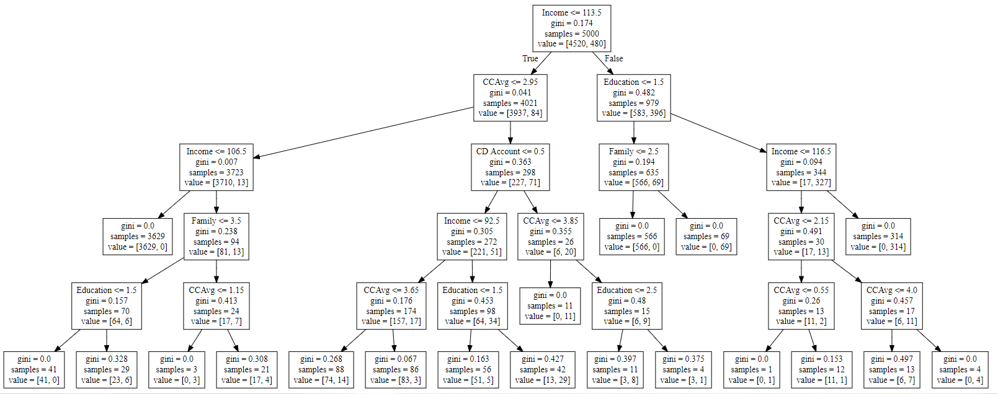

After Random Forest Classifier

Dependent variable = Personal Loan

Independent variable = Income, Family, CCAvg, Education, CD Account

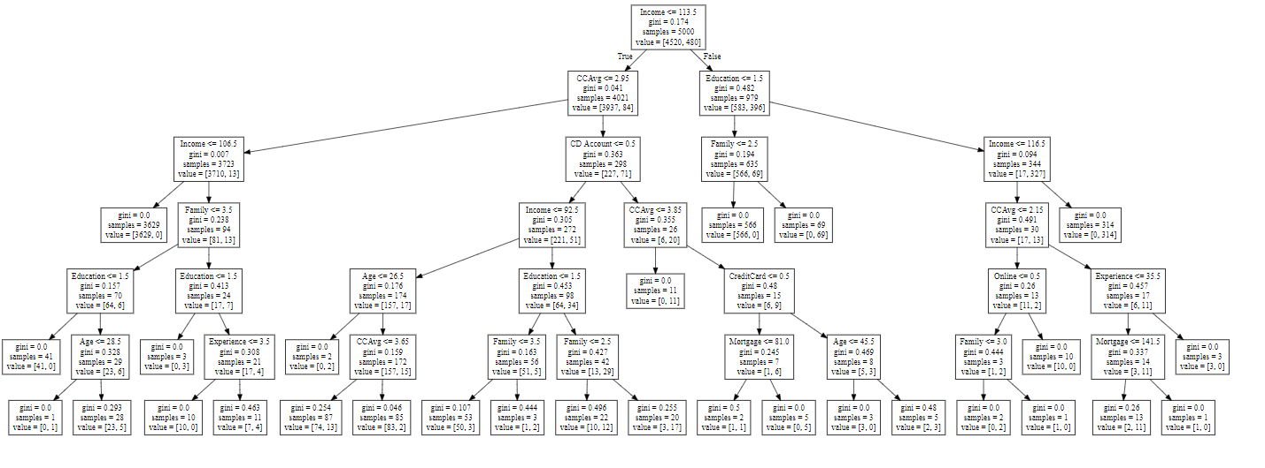

True = 0 No loan will get

False = 1 Loan will pass

Decision Rules-

1. Income<=113.5 and CCAvg <= 2.95 and Income <= 106.5 => no loan
2. Income >=113.5 and Education <= 1.5 and Family < = 2.5 => no loan pass
3. Income >=113.5 and Education <= 1.5 and Family > = 2.5 => loan pass
4. Income >=113.5 and Education <= 1.5 and Income<=116.5 and CCAvg <= 2.15 and family<=3.0 => loan pass

