Decision Tree - Titanic Dataset

Dependent variable – Survived

Independent variable - 'Sex'

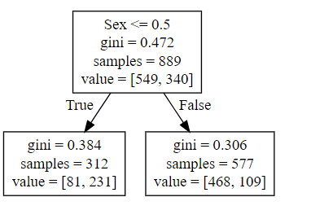Score = 0.786

Decision rule total survived = 340

1. If sex< =0.5 survived = 231
2. If sex> 0.5 survived = 109

Dependent variable = Survived

Independent variable = Sex , Pclass , Age ,Fare

Score = 0.89

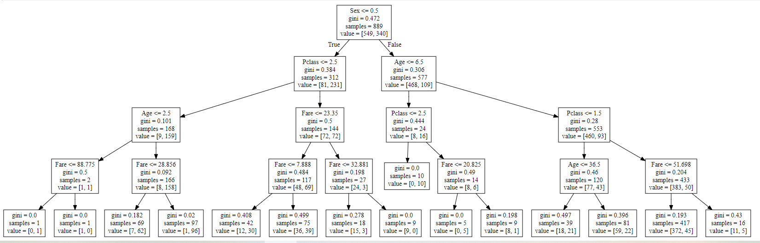

Decision tree with 6 independent variables:

Dependent variable = Survived

Independent variable = Sex , Pclass , Age ,Fare, Embarked, SibSp

Score = 0.90

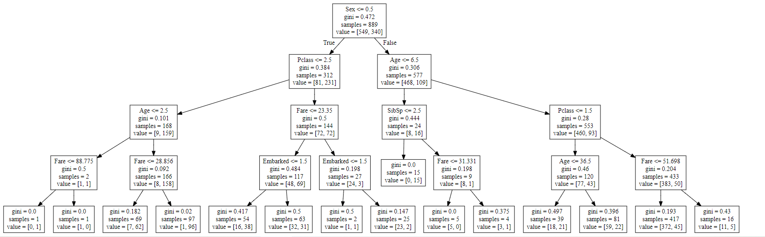

Decision tree with3 independent variables: After apply random forest classifier

Dependent variable = Survived

Independent variable = Sex , Age ,Fare

Score = 0.9763

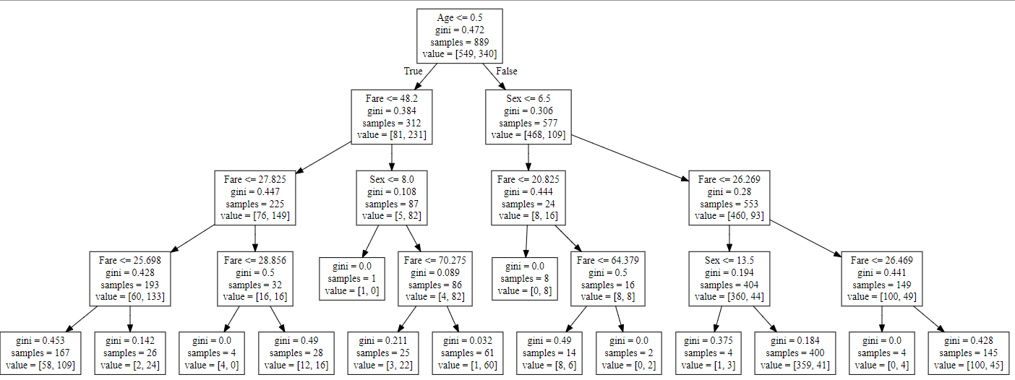

Decision rule:

1. Age<=0.5 and fare <=48.2 and sex < = 8.0 => 82 survived

2. Age<=0.5 and fare <=48.2 and fare < = 27.8 => 133 survived

3. Age<=0.5 and fare <=48.2 and fare >= 27.8 => 16 survived

4. Age<=0.5 and sex <=6.5 and fare < =20.8 => 8 survived

5. Age<=0.5 and sex <=6.5 and fare >= 20.8 and fare <=64.379 = 8 survived