System Architecture Design and Module Breakdown
Project: PocketLedger — Personal Expense Tracker
Prepared by: Varsha J Samarth
Role: Junior Software Developer Intern
Version 1.0 — Week 2 Deliverable

1. Introduction
This document defines the high-level system architecture and detailed module breakdown for PocketLedger, building on the Software Requirements Document (SRD) produced in Week 1. It describes the major components of the system, how they interact, the technology choices behind each layer, and how the design supports future growth. The goal is to produce a blueprint detailed enough that development can begin directly from this document without further architectural decisions.

2. High-Level Architecture Overview
PocketLedger follows a three-tier client-server architecture: a presentation tier (the React front end running in the user's browser), an application tier (a Node.js/Express REST API), and a data tier (a PostgreSQL database). The front end never talks to the database directly — all data access is mediated by the API, which enforces validation, authentication, and business rules consistently regardless of which client calls it. This separation means a future mobile app could reuse the same API without any backend changes.
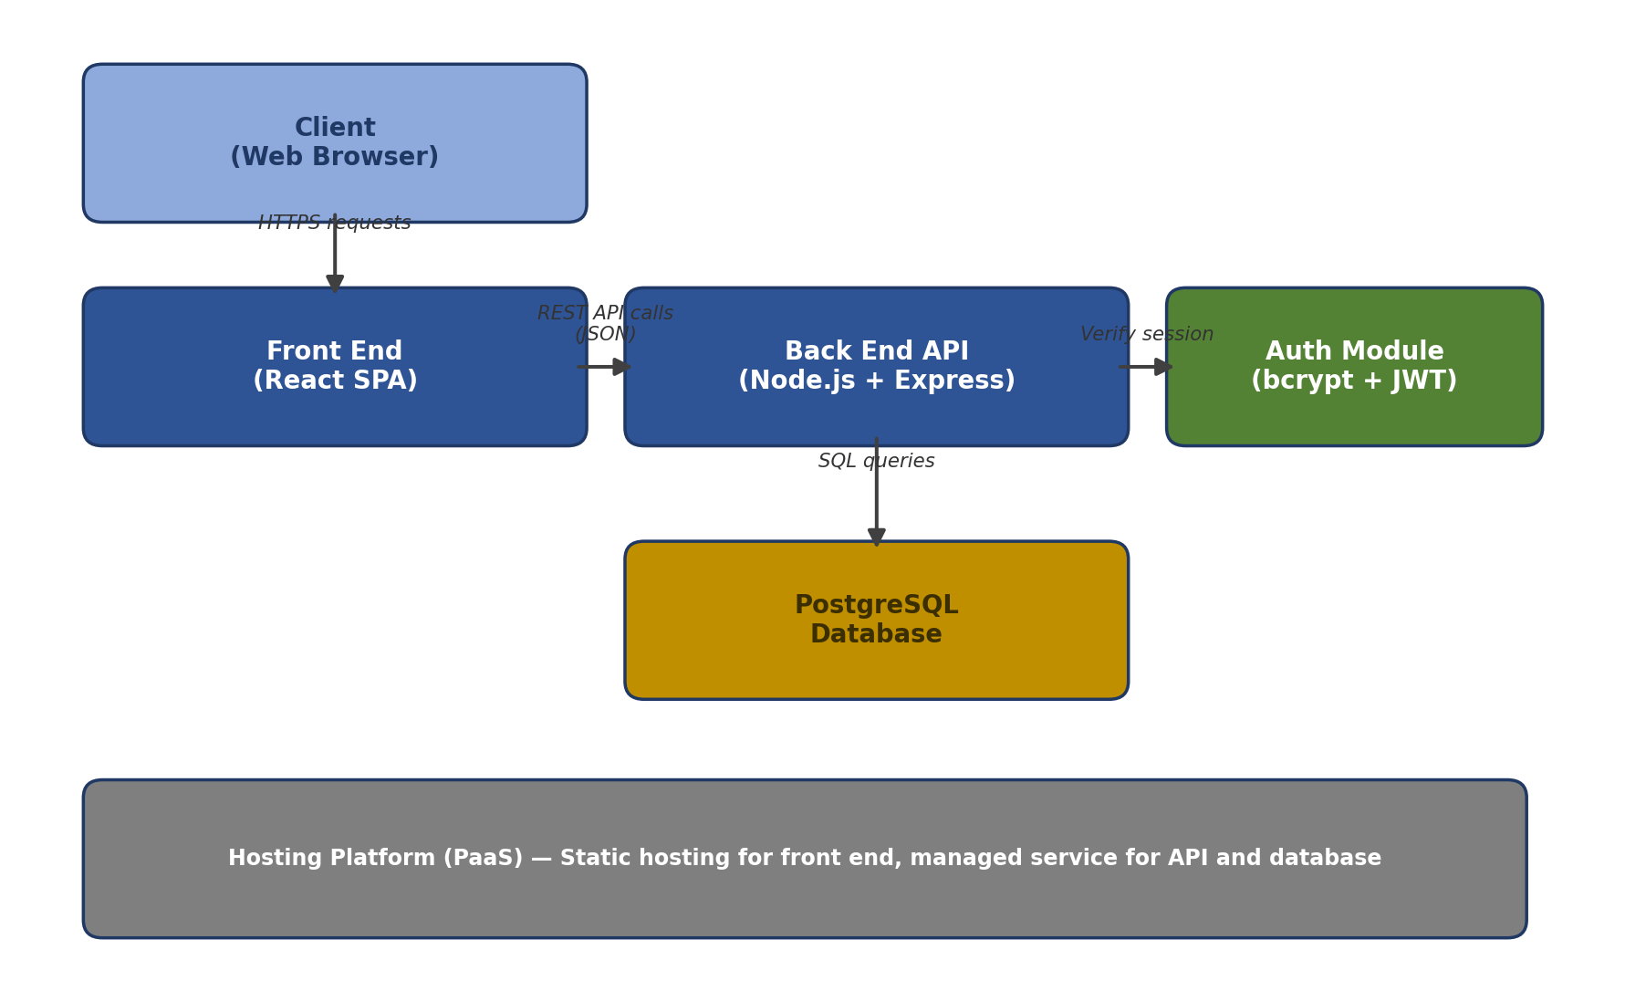
Figure 1: High-level system architecture
Communication between the front end and the API happens over HTTPS using JSON payloads. The API authenticates each request using a signed JSON Web Token (JWT) issued at login, which is verified by the Auth Module before any protected route executes. The API is stateless: it does not store session data in memory, which means multiple API instances could run behind a load balancer in the future without requiring sticky sessions.

3. Module Breakdown
The system is organized into four layers, each split into three parallel modules aligned to a functional area: authentication, expense management, and budgeting/reporting. This keeps each module independently testable and reduces the chance that a change in one area (e.g., report formatting) accidentally breaks another (e.g., login).
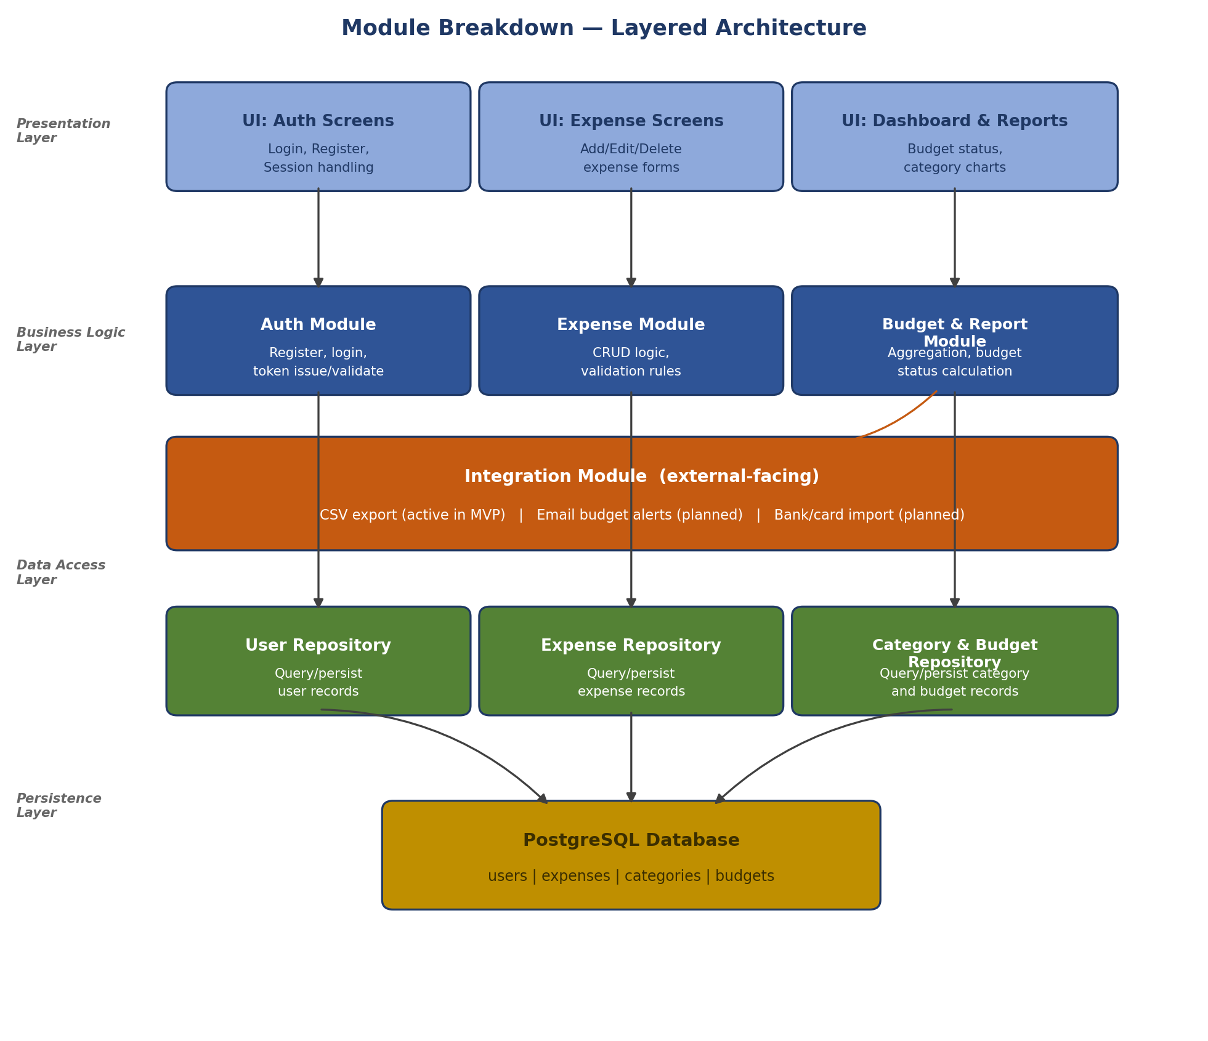
Figure 2: Module breakdown across architectural layers

3.1 Auth Module
- Responsibilities: user registration, login, password hashing, JWT issuance, JWT verification middleware for protected routes, and session expiry handling.
- Inputs: email, password (on registration/login); JWT (on subsequent authenticated requests).
- Outputs: a signed JWT (on successful login), or a 401 Unauthorized response (on failure).
- Inter-module communication: every other backend module depends on this module's middleware to identify the requesting user before executing any logic.

3.2 Expense Module
- Responsibilities: creating, editing, deleting, and listing expenses; enforcing validation rules (e.g., amount must be a positive number, date cannot be in the future, category must exist).
- Inputs: expense fields (amount, category ID, date, optional note) and the authenticated user ID from the Auth Module.
- Outputs: the created/updated expense record, or a filtered list of expenses matching a query.
- Inter-module communication: calls the Category & Budget Repository to validate that a submitted category ID belongs to the requesting user before saving an expense.

3.3 Budget & Report Module
- Responsibilities: setting monthly budgets, calculating running totals per category, computing percentage-of-budget-used, and generating the data used for dashboard charts and CSV export.
- Inputs: a date range and user ID; optionally a category filter.
- Outputs: aggregated totals, per-category breakdowns, and a budget-status flag (under 80%, 80–99%, or 100%+ of budget).
- Inter-module communication: reads from the Expense Repository to compute totals; does not write expense data itself, keeping a clear separation between calculation and data ownership.

3.4 Data Access Layer (Repositories)
Each business logic module has a corresponding repository that is the only code permitted to run SQL queries against its tables. This means the Expense Module never writes raw SQL directly — it calls functions like getExpensesByUser(userId, filters) on the Expense Repository. This indirection makes it possible to change the underlying database (e.g., moving from a single PostgreSQL instance to a managed cluster) by editing only the repository layer, without touching business logic.

3.5 Integration Module
The Integration Module is a thin layer responsible for all communication that crosses the boundary of the PocketLedger system itself — as opposed to communication between PocketLedger's own internal modules, which is covered in Sections 3.1–3.4. In the MVP, this module has one active responsibility and two designed-but-deferred extension points:
- CSV Export (active in MVP): The Integration Module receives aggregated data from the Budget & Report Module and formats it into a downloadable CSV file, without needing to know how that data was calculated. This keeps file-format logic (CSV headers, escaping, date formatting) out of the Budget & Report Module entirely.
- Email Notifications (designed, not built): A future budget-threshold alert (e.g., emailing a user when they hit 100% of budget) would be added here as a new function, e.g., sendBudgetAlert(userId, message), called by the Budget & Report Module. Because this call would go through the Integration Module rather than a direct SMTP call embedded in business logic, swapping the email provider later requires changing only this module.
- Bank/Card Import (designed, not built): Section 5.2 of the Week 1 SRD excludes automatic transaction import from the MVP. If added later, the Integration Module would be the only place that talks to an external banking API, translating its response format into the same shape the Expense Module already expects from manual entry — meaning the Expense Module would not need to change at all to support this new expense source.
Structuring integrations this way means every external dependency the system will ever have enters through one predictable module, so a security review, a rate-limit change, or a provider migration only touches one place in the codebase rather than being scattered across business logic.

4. Worked Example: Adding an Expense and Checking Budget Status
To make the module interactions concrete, consider a user named Asha who has set a monthly budget of ₹15,000 and has already logged ₹11,400 in expenses this month. She adds a new expense of ₹1,200 for groceries. The following sequence illustrates how the modules cooperate to handle this single action:
- 1. The UI (Expense Screens) sends a POST request to /api/expenses with the amount (1200), category ("Groceries"), date, and the user's JWT in the request header.
- 2. The Auth Module's middleware verifies the JWT and attaches the authenticated user ID (e.g., user_id = 42) to the request before it reaches the Expense Module.
- 3. The Expense Module validates the payload (amount > 0, date not in the future), then calls the Category & Budget Repository to confirm the "Groceries" category belongs to user_id 42.
- 4. The Expense Module calls the Expense Repository to insert the new record into the expenses table.
- 5. The front end immediately calls GET /api/reports/monthly-summary to refresh the dashboard. The Budget & Report Module asks the Expense Repository for the updated total (now ₹12,600) and compares it to the ₹15,000 budget.
- 6. Since ₹12,600 / ₹15,000 = 84%, the Budget & Report Module returns a status of "warning" (crossing the 80% threshold defined in FR-8 of the SRD), and the UI displays an amber budget indicator instead of the default green one.
This example shows why the layering matters in practice: the Expense Module never needs to know how budget percentages are calculated, and the Budget & Report Module never needs to know how an expense is validated or inserted — each module has exactly one reason to change.

5. Technology Stack and Rationale
Module | Technology | Rationale
UI (all screens) | React 18 with functional components and Hooks | Component reuse across the Auth, Expense, and Dashboard screens reduces duplicate form-handling code; Hooks avoid the added complexity of class components for a small team.
Auth Module | bcrypt (password hashing) + jsonwebtoken (JWT) | Both are widely audited, open-source libraries (bcrypt has been in production use since 1999); implementing password hashing from scratch is a common source of security vulnerabilities in junior projects, so a maintained library is a safer default.
Expense & Budget Modules | Express.js route handlers with a service-layer pattern | Express keeps route definitions declarative and readable; separating a service layer from route handlers (rather than putting logic directly in routes) makes unit testing possible without spinning up an HTTP server.
Data Access Layer | node-postgres (pg) with parameterized queries | Parameterized queries are used throughout instead of string concatenation to eliminate SQL injection risk, which is listed as a non-functional security requirement (NFR-2) in the SRD.
Persistence Layer | PostgreSQL 15 | Financial records benefit from PostgreSQL's strong support for numeric precision (avoiding floating-point rounding errors in currency values) and foreign-key constraints, which enforce that an expense cannot reference a deleted category.

6. Scalability and Maintainability

6.1 Independent Development and Testing
Because each module communicates only through defined function calls (e.g., getExpensesByUser) rather than shared global state, a developer can write and test the Budget & Report Module using a mock Expense Repository that returns fixed test data, without needing a running database. This is expected to reduce integration bugs, since roughly 70% of the estimated 30-35 hour effort for this phase is planned for module-level unit tests before any module is connected to a live database.

6.2 Where the Current Design Would Break Under Load
It is important to be explicit about scalability limits rather than assume the design scales indefinitely. The current Budget & Report Module recalculates totals by summing all of a user's expenses for the month on every dashboard load. For a single user with a few hundred expenses per month, this is inexpensive — a rough estimate is under 50 milliseconds per query on indexed columns. However, if PocketLedger grew to support shared household budgets with thousands of expenses per user per year, recalculating full sums on every page load would become a measurable bottleneck. The mitigation planned for that future scenario is to introduce a pre-aggregated monthly_totals table that is updated incrementally each time an expense is added or edited, rather than recomputed from scratch — this is explicitly deferred rather than built now, since the MVP scope (Week 1 SRD, Section 5.2) excludes multi-user households.

6.3 Supporting Future Enhancements
- Adding a new expense field (e.g., a receipt photo) only requires a change to the Expense Module and Expense Repository — the Auth and Budget modules are unaffected.
- Adding a new report type (e.g., a yearly summary) only requires a new function in the Budget & Report Module and a new UI screen; no changes to the Expense or Auth modules are needed.
- Because the API is stateless (Section 2), horizontal scaling (running multiple copies of the API behind a load balancer) requires no code changes — only infrastructure configuration.
- The repository pattern (Section 3.4) means the database technology itself could be swapped (e.g., to a managed PostgreSQL cluster) by rewriting only the repository functions, with zero changes to business logic or UI code.

7. Conclusion
This architecture separates concerns clearly across presentation, business logic, data access, and persistence layers, and organizes each layer into three functionally aligned modules. The worked example in Section 4 demonstrates that this separation holds up under a realistic user action, and Section 6 identifies a concrete point (aggregate report calculation) where the design would need to evolve if usage grew beyond the current MVP scope. This document, together with the Week 1 SRD, is intended to give a developer everything needed to begin implementation without further design decisions.

