Development Roadmap and Implementation Strategy
Project: PocketLedger — Personal Expense Tracker
Prepared by: Varsha
Role: Junior Software Developer Intern
Version 1.0 — Week 3 Deliverable

1. Introduction
This document builds on the Week 1 Software Requirements Document and the Week 2 System Architecture Design to define a concrete development roadmap and implementation strategy for PocketLedger. It breaks the project into logical development stages, schedules milestones against a realistic 10-week timeline, selects and justifies a development methodology, estimates effort per stage, identifies risks with mitigation plans, and describes how modules will be integrated and tested. The plan assumes a single junior developer working roughly 15-20 hours per week, consistent with a part-time internship schedule.

2. Stage Planning
The project is divided into five sequential stages, with the coding stage further broken into four sprints aligned to the four modules defined in the Week 2 architecture document (Auth, Expense, Budget & Report, and Integration). Coding is sequenced so that the Auth Module is built first, since every other module depends on it for request authentication.
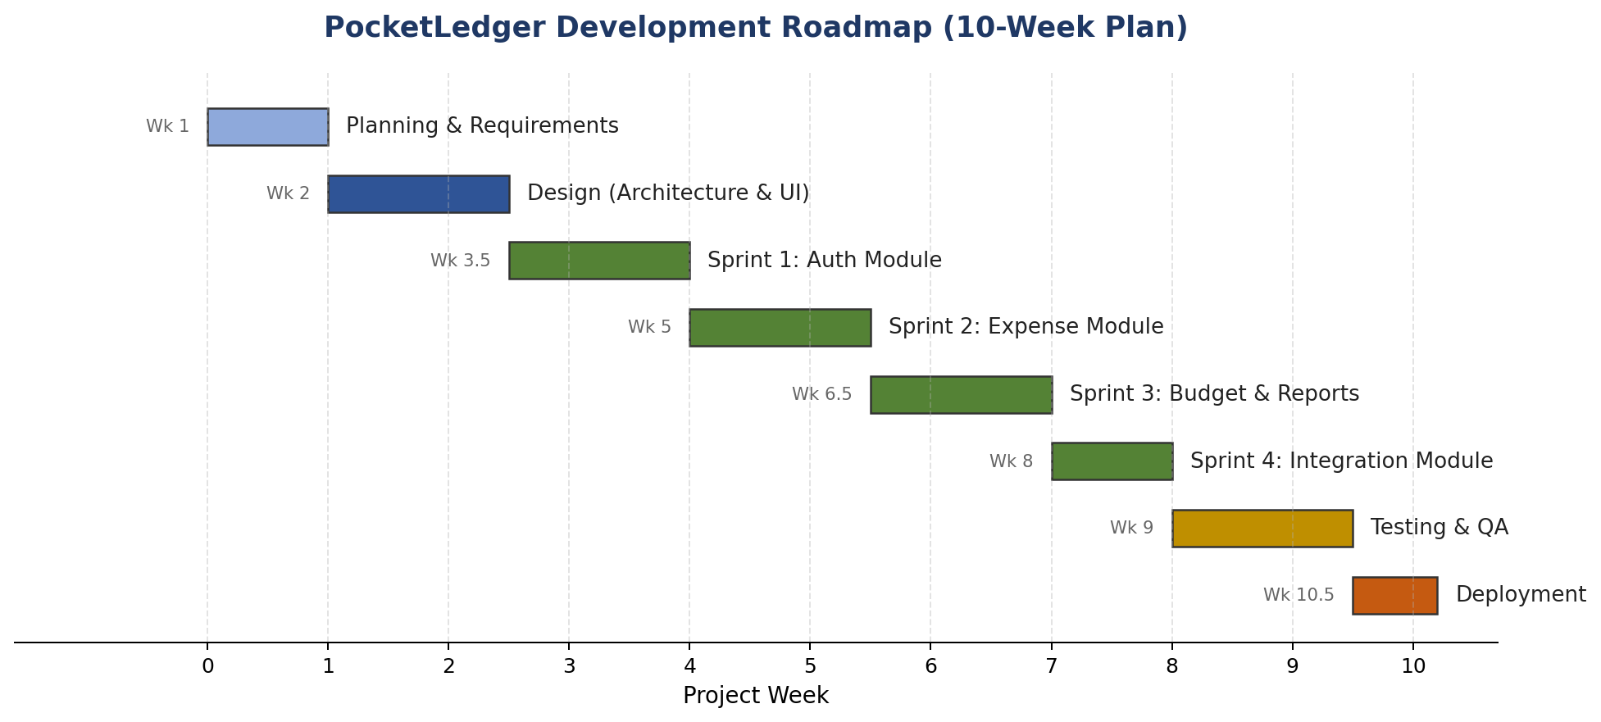
Figure 1: 10-week development roadmap
- Stage 1 — Planning & Requirements (Week 1): Already complete; carried forward from the Week 1 SRD.
- Stage 2 — Design (Weeks 2–2.5): Architecture and module breakdown, carried forward from the Week 2 document; database schema finalized during this stage.
- Stage 3 — Coding, in four sprints (Weeks 2.5–8): Auth Module, then Expense Module, then Budget & Report Module, then Integration Module, each built and unit-tested before the next begins.
- Stage 4 — Testing & QA (Weeks 8–9.5): Integration testing across all modules, cross-browser checks, and bug fixing.
- Stage 5 — Deployment (Weeks 9.5–10): Production deployment and final smoke testing.

3. Milestone Definition
Milestone | Deliverable | Deadline
M1: Requirements sign-off | Week 1 SRD (complete) | End of Week 1
M2: Architecture sign-off | Week 2 architecture document (complete) | End of Week 2.5
M3: Auth Module complete | Working registration/login with JWT issuance; 90%+ unit test coverage on auth logic | End of Week 4
M4: Expense Module complete | Full CRUD for expenses; category validation working | End of Week 5.5
M5: Budget & Report Module complete | Budget-status calculation and dashboard summary working end-to-end | End of Week 7
M6: Integration Module complete | CSV export functional; email-alert and bank-import interfaces stubbed for future use | End of Week 8
M7: QA sign-off | All P1 (blocking) bugs resolved; cross-browser checklist passed | End of Week 9.5
M8: Production deployment | Live, publicly accessible application | End of Week 10

4. Implementation Strategy

4.1 Methodology: Agile (Scrum-inspired, solo adaptation)
This project adopts an Agile approach rather than Waterfall, primarily because the SRD (Week 1) already flagged scope creep as the highest-impact risk, and Agile's short feedback loops make scope drift visible within a week rather than at the end of the project. A pure Waterfall approach — where all coding happens only after design is 100% finalized — was rejected because it would delay discovering integration problems (e.g., a category-validation edge case between the Expense and Budget modules) until Week 8, with little time left to fix them.
Since this is a single-developer project, standard Scrum ceremonies are adapted rather than used literally: there is no daily standup (no team to synchronize with), but each sprint still opens with a 30-minute sprint planning session and closes with a self-review against the sprint's Definition of Done, mirroring the accountability a stand-up would otherwise provide.

4.2 Sprint Breakdown
Sprint | Duration | Goal | Definition of Done
Sprint 1 | 1.5 weeks (Weeks 2.5–4) | Auth Module | User can register, log in, and receive a JWT; invalid credentials are rejected; passwords are hashed, never stored in plaintext
Sprint 2 | 1.5 weeks (Weeks 4–5.5) | Expense Module | User can create, edit, delete, and list expenses; invalid amounts/dates are rejected with clear error messages
Sprint 3 | 1.5 weeks (Weeks 5.5–7) | Budget & Report Module | User can set a budget; dashboard shows correct running total and budget-status flag (matching Week 2, Section 4)
Sprint 4 | 1 week (Weeks 7–8) | Integration Module | CSV export produces a valid, correctly formatted file for a selected date range

5. Resource Estimation
Effort is estimated in developer-hours, assuming roughly 15-20 hours of available time per week. Total estimated effort is 155 hours across 10 weeks, which is within the availability window and leaves a buffer of approximately 15-20% for the challenges listed below.
Stage | Estimated Hours | Key Challenges | Mitigation
Design | 12 hrs | Under-specifying the database schema, leading to rework later | Reuse the schema implied by the Week 2 module breakdown (Section 3.4) rather than redesigning from scratch
Sprint 1: Auth | 20 hrs | Getting JWT expiry and refresh logic wrong, causing users to be logged out unexpectedly | Use a well-documented library default (e.g., a fixed 24-hour token expiry) instead of building custom refresh-token logic for the MVP
Sprint 2: Expense | 22 hrs | Validation edge cases (e.g., negative amounts, future-dated expenses) discovered late | Write validation unit tests before writing the UI form, so edge cases are defined upfront
Sprint 3: Budget & Report | 25 hrs | Aggregation queries becoming slow as test data grows | Add a database index on (user_id, date) early, rather than after a performance problem appears
Sprint 4: Integration | 16 hrs | CSV formatting edge cases (commas inside notes, special characters) | Use a maintained CSV-writing library rather than manually joining strings with commas
Testing & QA | 30 hrs | Limited time to test on multiple real devices | Prioritize the two most common browser/screen-size combinations first (Chrome desktop, and a 375px-wide mobile view), per NFR-5 in the Week 1 SRD
Deployment | 10 hrs | First-time deployment configuration errors (environment variables, database connection strings) | Deploy a minimal "hello world" version of the API in Week 2 to validate the hosting pipeline early, rather than deploying for the first time in Week 10
Buffer / contingency | 20 hrs | Unplanned rework across any stage | Reserved explicitly rather than silently absorbed into other estimates, so schedule slippage is visible rather than hidden

6. Risk Assessment
Risk | Dependency | Likelihood | Mitigation
Sprint 1 (Auth) overruns, delaying all downstream sprints | Sprints 2-4 all depend on a working Auth Module | Medium | Time-box Sprint 1 to 1.5 weeks; if incomplete, ship with a simplified session mechanism and revisit token refresh post-MVP
Free-tier hosting limits cause deployment failures in Week 10 | Deployment stage depends on the hosting provider chosen in Week 2 | Medium | Deploy a minimal test version in Week 2 (see Section 5) instead of discovering limits for the first time at final deployment
Scope creep re-introduces excluded features (e.g., multi-user support) | None — self-imposed risk | Medium | Re-check every new feature idea against the Week 1 SRD's explicit out-of-scope list (Section 5.2) before implementing it
Underestimated testing time due to limited access to multiple devices | Testing & QA stage depends on device/browser access | Low | Use browser developer tools to simulate the 360px mobile viewport (NFR-5) rather than requiring a physical device for every test

7. Integration and Testing Plan
Modules are integrated incrementally rather than all at once at the end, directly reflecting the layered, independently-testable design from the Week 2 architecture document. After each sprint, the newly completed module is integrated with previously completed modules and a short integration test is run before moving to the next sprint — rather than waiting until Week 8 to discover that, for example, the Expense Module and Budget Module disagree about how a deleted category should be handled.

7.1 Unit Testing
- Each repository function (e.g., getExpensesByUser) is tested against a test database with known seed data, verifying correct filtering and correct handling of empty results.
- Each business logic function (e.g., budget percentage calculation) is tested with boundary values: exactly 79%, exactly 80%, and exactly 100% of budget, to confirm the threshold logic in FR-8 (Week 1 SRD) behaves correctly at the edges, not just in the middle of the range.

7.2 Integration Testing
- After Sprint 2: verify that an expense created through the API is correctly retrievable and correctly excluded when its category is deleted.
- After Sprint 3: verify that adding an expense correctly updates the budget-status flag returned by the dashboard endpoint, using the same worked example introduced in the Week 2 document (an ₹1,200 grocery expense pushing total spend to 84% of a ₹15,000 budget).
- After Sprint 4: verify that a CSV export for a given month contains exactly the same totals as the dashboard for that month, confirming the Integration Module and Budget & Report Module agree on the underlying data.

7.3 Manual and Cross-Browser Testing
- Manual click-through testing of the full user journey (register → add three expenses → set a budget → view dashboard → export CSV) is performed once per sprint, not only at the end, to catch UX issues early.
- Cross-browser testing is performed against the two highest-priority targets identified in Section 5 (Chrome desktop and a 375px mobile viewport) before wider browser testing, given the fixed 30-hour testing budget.

8. Conclusion
This roadmap sequences PocketLedger's development into five stages and four sprints across a 10-week, 155-hour plan, with an explicit 20-hour contingency buffer. The Agile methodology was chosen specifically because it surfaces integration problems early, which directly addresses the highest-priority risk (scope creep and late-discovered defects) identified in the Week 1 SRD. Combined with the Week 1 requirements and Week 2 architecture, this document is intended to allow implementation to begin immediately, with clear, testable milestones marking progress at each stage.

