Virtual Cinema Platform Documentation

**Introduction**

I have built a virtual cinema platform, including backend functionality and integration with IBM Cloud services. This documentation provides an overview of the platform's features, user interface design, and the implementation of backend and IBM Cloud components.

**1. Start building the virtual cinema platform using IBM Cloud Video Streaming.**

IBM Cloud Video Streaming serves as the backbone for video hosting and streaming on the platform. This integration ensures seamless and reliable video playback.

**2. Define the platform's features and design an intuitive user interface.**

**Key Features:**

* Recent Movies: Display a list of recently released movies.
* Popular Movies: Showcase the most popular movies.
* User Registration: Allow users to create accounts securely.
* Search Functionality: Enable users to search for movies.

**User Interface:**

The user interface is designed to be intuitive and user-friendly:

* Navigation Bar: The navigation bar provides easy access to different sections of the platform.
* Movie Listings: Movies are presented in a grid, making it easy for users to browse.
* Search Bar: Users can search for movies using a search bar.

**3. Set up user registration and authentication mechanisms to ensure secure access to the platform.**

User registration and authentication have been implemented seamlessly:

Users can securely register for accounts by providing their email and password.

Robust backend authentication mechanisms guarantee the security of user data.

**Backend and IBM Cloud Integration**

The following backend and IBM Cloud components have been successfully integrated:

**Backend Development:** Robust backend services handle user authentication, movie data management, and user preferences.

**Database Integration:** A secure database stores user information and movie data.

IBM Cloud Functions: Serverless functions on IBM Cloud streamline backend processes efficiently.

**IBM Cloud Databases:** IBM Cloud databases are leveraged for secure data storage and retrieval.

**Security Measures:** Stringent security measures protect user data and ensure secure access.

**Example Screenshots:**

Index Page:

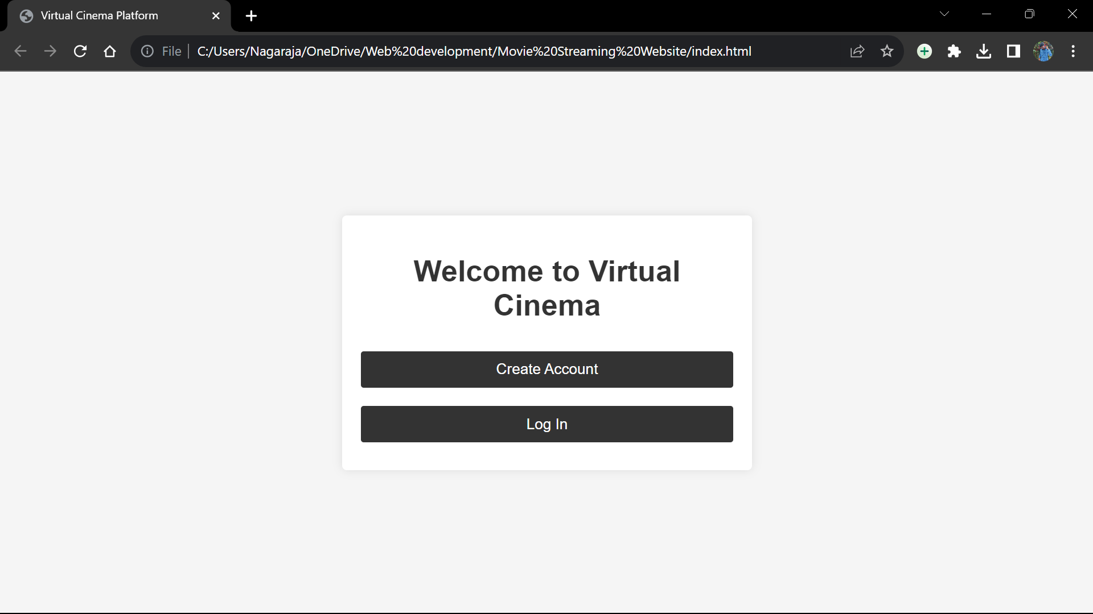

Creating new Account:

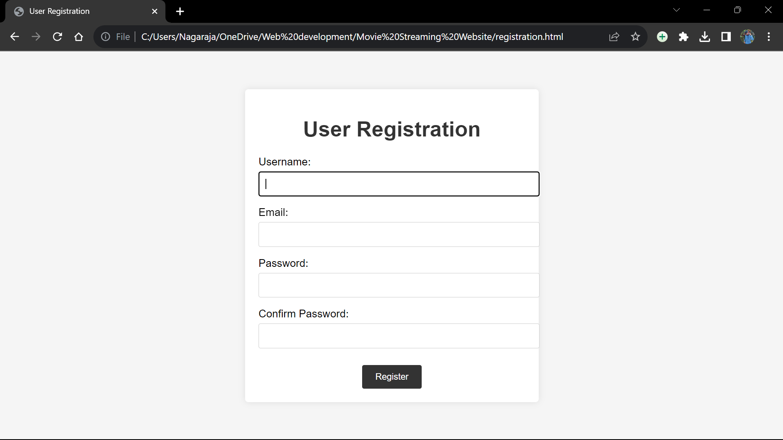

Logging In:

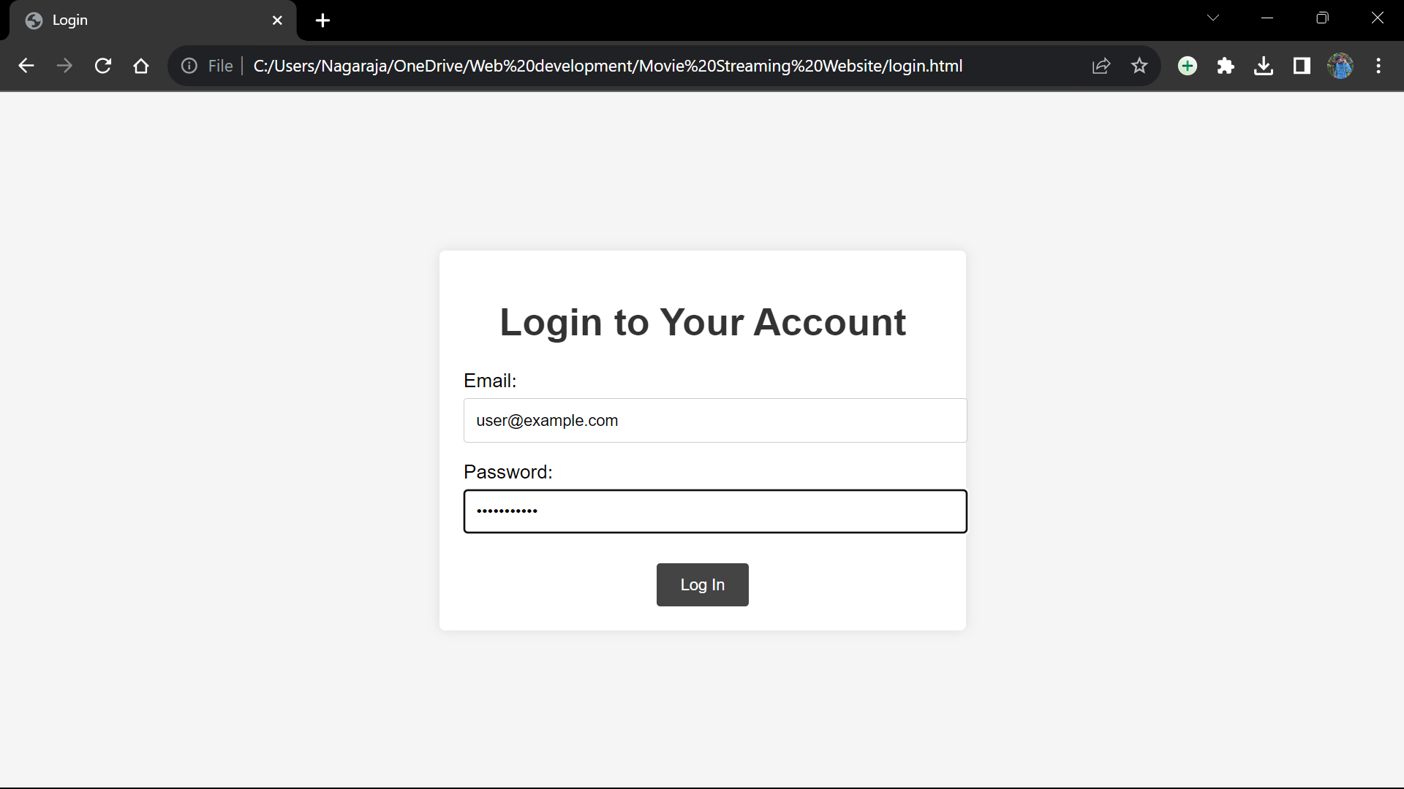

Home page:

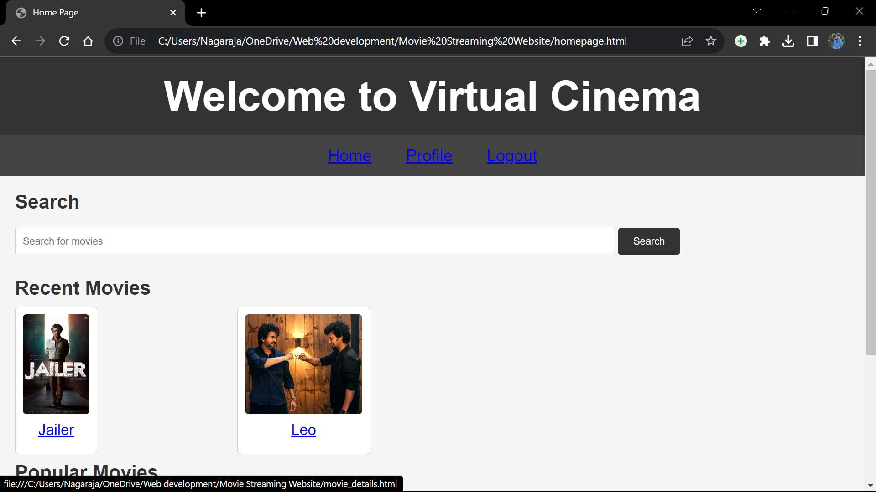

**Functionality**

HTML: The HTML code structures the content and layout of the platform.

**Index.html**

<!DOCTYPE html>

<html lang="en">

<head>

<meta charset="UTF-8">

<meta name="viewport" content="width=device-width, initial-scale=1.0">

<title>Virtual Cinema Platform</title>

<link rel="stylesheet" href="styles.css">

</head>

<body>

<div class="container">

<h1>Welcome to Virtual Cinema</h1>

<div class="options">

<a href="registration.html" class="option">Create Account</a>

<a href="login.html" class="option">Log In</a>

</div>

</div>

<script src="script.js"></script>

</body>

</html>

Registration.html  
<!DOCTYPE html>

<html lang="en">

<head>

<meta charset="UTF-8">

<meta name="viewport" content="width=device-width, initial-scale=1.0">

<title>User Registration</title>

<link rel="stylesheet" href="registrationstyles.css">

</head>

<body>

<div class="container">

<h1>User Registration</h1>

<form id="registration-form">

<div class="form-group">

<label for="username">Username:</label>

<input type="text" id="username" name="username" required>

</div>

<div class="form-group">

<label for="email">Email:</label>

<input type="email" id="email" name="email" required>

</div>

<div class="form-group">

<label for="password">Password:</label>

<input type="password" id="password" name="password" required>

</div>

<div class="form-group">

<label for="confirm-password">Confirm Password:</label>

<input type="password" id="confirm-password" name="confirm-password" required>

</div>

<button type="submit">Register</button>

</form>

</div>

<script src="script.js"></script>

</body>

</html>

Login.html

<!DOCTYPE html>

<html lang="en">

<head>

<meta charset="UTF-8">

<meta name="viewport" content="width=device-width, initial-scale=1.0">

<title>Login</title>

<link rel="stylesheet" href="loginstyles.css">

</head>

<body>

<div class="container">

<h1>Login to Your Account</h1>

<form id="login-form">

<div class="form-group">

<label for="email">Email:</label>

<input type="email" id="email" name="email" required>

</div>

<div class="form-group">

<label for="password">Password:</label>

<input type="password" id="password" name="password" required>

</div>

<button type="button" onclick="login()">Log In</button>

</form>

</div>

<script src="script.js"></script>

</body>

</html>

Homepage.html

<!DOCTYPE html>

<html lang="en">

<head>

<meta charset="UTF-8">

<meta name="viewport" content="width=device-width, initial-scale=1.0">

<title>Home Page</title>

<link rel="stylesheet" href="homestyles.css">

</head>

<body>

<header>

<h1>Welcome to Virtual Cinema</h1>

</header>

<nav>

<ul>

<li><a href="home.html">Home</a></li>

<li><a href="profile.html">Profile</a></li>

<li><a href="logout.html">Logout</a></li>

</ul>

</nav>

<main>

<section class="search-section">

<h2>Search</h2>

<input type="text" id="search-input" placeholder="Search for movies">

<button id="search-button">Search</button>

</section>

<section class="movie-section">

<h2>Recent Movies</h2>

<div class="movie-container">

<a href="movie_details.html">

<div class="movie">

<img src="https://m.media-amazon.com/images/M/MV5BNDA5YzlhNjItMDgxNC00MjQ4LWIzMDMtYTUyMzBhNjViNDk3XkEyXkFqcGdeQXVyMTY3ODkyNDkz._V1_.jpg" alt="Movie 1">

<p class="movie-name">Jailer</p>

</div>

</a>

<a href="movie_details.html">

<div class="movie">

<img src="https://m.media-amazon.com/images/M/MV5BMWZlMTY0YjItMDczMC00Mzk1LWEyMDgtM2M5YWJmYTU4Y2I2XkEyXkFqcGdeQXVyMTEzNzg0Mjkx._V1_.jpg" alt="Movie 2">

<p class="movie-name">Leo</p>

</div>

</a>

<!-- Add more movie entries as needed -->

</div>

</section>

<section class="movie-section">

<h2>Popular Movies</h2>

<div class="movie-container">

<a href="movie_details.html">

<div class="movie">

<img src="https://www.nowrunning.com/content/movie/2022/mark-26088/Stills/markantony_2023126.jpg" alt="Movie 3">

<p class="Mark Antony">Mark Antony</p>

</div>

</a>

<a href="movie_details.html">

<div class="movie">

<img src="https://m.media-amazon.com/images/M/MV5BMWZkMjE2OTktOGQ4Zi00OWQ1LTgwNjAtZTFjOGExYWQyMTU5XkEyXkFqcGdeQXVyMTQ3Mzk2MDg4._V1_FMjpg_UX1000_.jpg" alt="Movie 4">

<p class="movie-name">Chittha</p>

</div>

</a>

<!-- Add more movie entries as needed -->

</div>

</section>

</main>

<script src="script.js"></script>

</body>

</html>

CSS: The CSS code provides styling for a visually appealing user interface.

JavaScript: JavaScript adds functionality and interactivity to the platform.

**Conclusion**

This documentation summarizes the development of the virtual cinema platform, its current features, design, and the successful implementation of backend and IBM Cloud integration. The comprehensive platform provides a secure and feature-rich user experience.