**NAME:** VARSHA CHAMARIA **SAP NO.:** 60004160013

**EXPERIMENT NO. 8**

**CODE:**

#include<graphics.h>

#include<conio.h>

#include<stdio.h>

#include<stdlib.h>

float max1(float max,float ratio)

{

if(max<ratio)

return(ratio);

else

return(max);

}

float min1(float min,float ratio)

{

if(min>ratio)

return(ratio);

else

return(min);

}

void main()

{

int x1,y1,x2,y2,xmin,ymin,xmax,ymax;

float p[4],q[4],t1,t2,min,max,x3,y3,x4,y4;

int gd=DETECT,gm;

initgraph(&gd,&gm,"");

printf("Enter the min and max co-ordinates for the clipping window:");

scanf("%d%d%d%d",&xmin,&ymin,&xmax,&ymax);

printf("Enter the endpoints of the line:");

scanf("%d%d%d%d",&x1,&y1,&x2,&y2);

rectangle(xmin,ymin,xmax,ymax);

line(x1,y1,x2,y2);

p[0]=-(x2-x1);

p[1]=x2-x1;

p[2]=-(y2-y1);

p[3]=y2-y1;

q[0]=x1-xmin;

q[1]=xmax-x1;

q[2]=y1-ymin;

q[3]=ymax-y1;

t1=0;

t2=1;

max=0;

min=1;

for(int i=0;i<4;i++)

{

if(p[i]<0)

max=max1(max,q[i]/p[i]);

else

min=min1(min,q[i]/p[i]);

}

t1=max;

t2=min;

if(t1<t2)

{

x3=x1+t1*p[1];

y3=y1+t1*p[3];

x4=x1+t2*p[1];

y4=y1+t2*p[3];

setcolor(RED);

line(x3,y3,x4,y4);

}

else if(t1>t2)

{

outtextxy(400,240,"Completely outside");

}

getch();

closegraph();

}

**OUTPUT:**

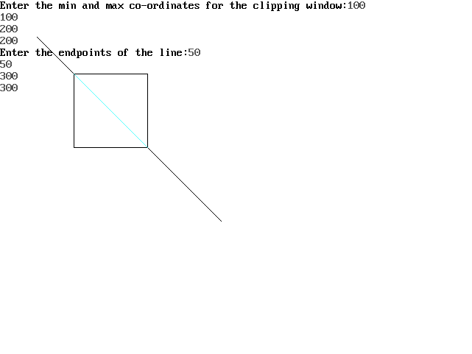

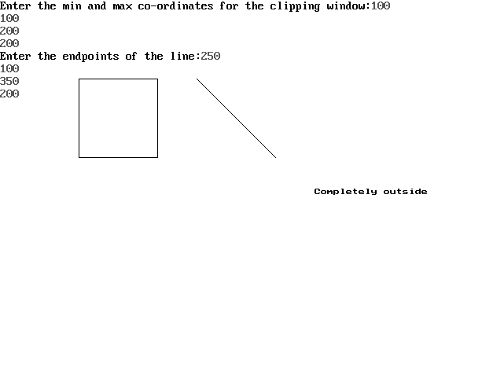

//Outside-Inside

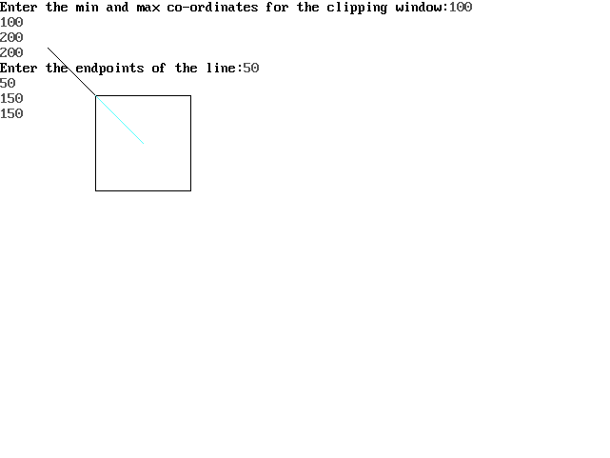

//I*nside-Outside*

