**Source Code:**

import java.util.*;

class pattern

{

public static void main(String args[])

{

int i,j,k,n;

Scanner sc=new Scanner(System.in);

System.out.println("Enter the no. of lines");

n=sc.nextInt();

for(i=n;i>0;i--)

{

for(k=n-i;k>0;k--)

{

System.out.print(" ");

}

for(j=1;j<=i;j++)

{

System.out.print((char)(j+64));

}

for(j=i-1;j>0;j--)

{

System.out.print((char)(j+64));

}

System.out.println();

}

}

}

**Output:**

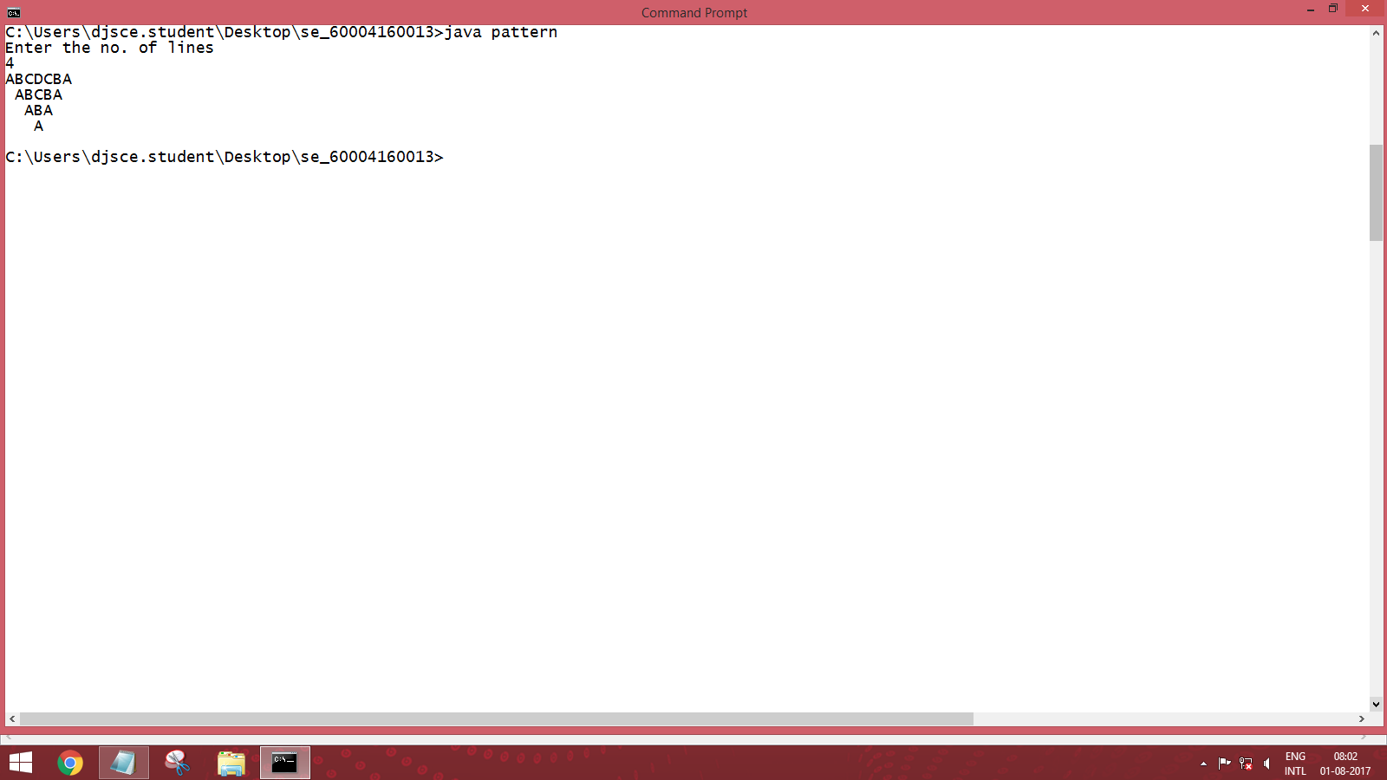

**Source Code:**

import java.util.*;

class series

{

public static void main(String args[])

{

int i,j,n,fact;

float sum=0;

Scanner sc=new Scanner(System.in);

System.out.println("Enter the no. of terms");

n=sc.nextInt();

for(i=1;i<=n;i++)

{

fact =1;

for(j=1;j<=i;j++)

{

fact=fact*j;

}

sum=sum+(float)(i)/fact;

}

System.out.println("The sum of the series is "+sum);

}

}

**Output:**

