Linux Task 03: Process Management, System Monitoring & Basic Shell Scripting

Part A: Process Monitoring:
ps
ps
aux
top
htop
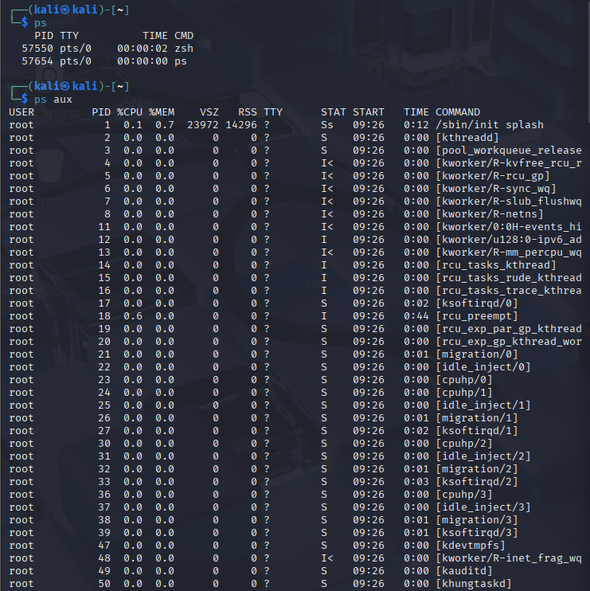
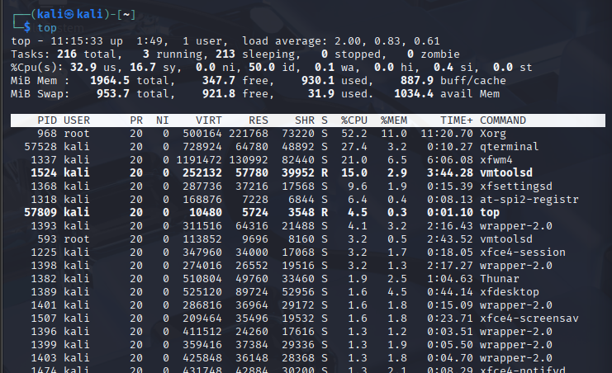

1.What is a Process?
A process is any program that is currently running on the operating system. Every time you open an application, run a command, or start a service, Linux creates a process for it.

2.What is a PID?
A PID (Process ID) is a unique number automatically assigned by Linux to every process when it starts. It is how the operating system tracks, manages, and communicates with each running process.

3.Which process is consuming the most CPU?
htop

4.Which process is consuming the most Memory?
A PID = the unique ID number Linux gives every process
Use ps aux --sort=-%cpu to find the biggest CPU consumer

Part B: Process Management:
free
-h
df
-h
uptime
uname
-a
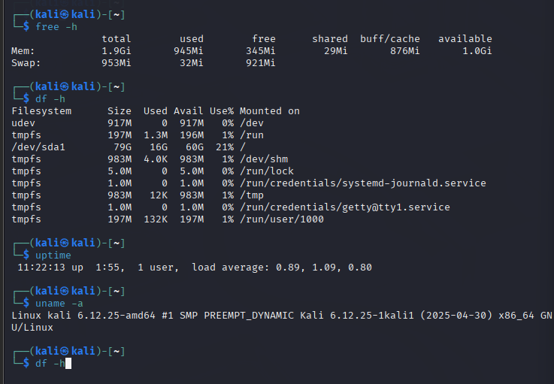

Record:
Total RAM= 1.9gi
Available RAM= 1.0gi
Disk Usage= 16g
System Uptime= 11:22:13
Kernel Version= 6.12.25-amd64

Part D: Service Monitoring:
systemctl status ssh
systemctl status NetworkManager
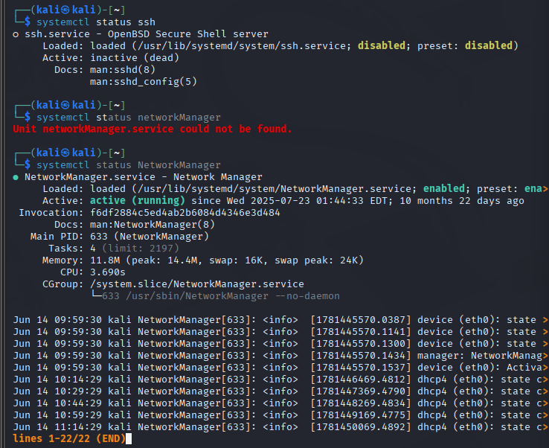

Answer:
1.What is a Service?
A service (also called a daemon) is a program that runs continuously in the background of the operating system without any direct interaction from the user. Services start automatically when the system boots and keep running silently, waiting to perform their specific job whenever needed.

2.Why are services important?
Checks the current status of the NetworkManager service — the daemon responsible for managing all network connections on the system including WiFi, Ethernet, and VPN.

3.How can a stopped service affect a system?
When a service stops whether due to a crash, misconfiguration, update, or attack — the consequences can range from minor inconvenience to complete system failure or security disaster.

Part F: Security Monitoring Challenge:
Research the following commands and explain their purpose:
1.Netstat:
Purpose- netstat stands for Network Statistics. It is a classic command-line tool that displays all active network connections, open ports, routing tables, and network interface statistics on the system. It gives a complete snapshot of everything happening at the network level of a Linux machine at that exact moment.
Security Use Case-
- Discover all open ports on the system
- Hunt for malware or backdoors
- Find active connections — who is connected right now

2.ss:
Purpose-ss stands for Socket Statistics. It is the modern, official replacement for netstat in Linux and is now the recommended tool for all network socket inspection. It communicates directly with the Linux kernel through the netlink interface rather than reading from /proc files, making it significantly faster and more accurate — especially on systems with thousands of connections.
It comes pre-installed on all modern Linux systems including Kali Linux and provides more detailed socket information than netstat ever could.
Security Use Case:
- Find all open ports and their owning processes
- Identify suspicious listening ports
- Count active connections (DDoS detection)

3.who:
Purpose-who is a straightforward command that shows exactly which users are currently logged into the system right now. It reads from the /var/run/utmp file which the system constantly updates as users log in and out. For every active session it shows the username, which terminal they are using, when they logged in, and where they connected from.
Security Use Case:
- Instantly see who is on the system
- Spot unexpected remote connections
- Check for unexpected root sessions

4.w:
Purpose- w is a powerful extension of the who command that shows not only who is currently logged into the system, but also what command each user is running right now, how long they have been idle, and overall system performance metrics. It combines user session information with live process data to give a complete real-time picture of system activity.
Security Use Case:
- See exactly what every user is doing right now
- Identify idle vs active administrators
- Detect suspicious commands being run

5.last:
Purpose- last displays a complete historical record of every user login and logout that has occurred on the system. It reads from the binary log file /var/log/wtmp which Linux automatically maintains, recording every single login event — who logged in, from which IP address, at what time, and for how long.
Security Use Case:
- Full security audit — who has accessed this system
- Detect brute force attacks
- Check for unauthorized root logins

Part G: Mini SOC Activity:
Imagine you are a Security Analyst. A system is running slowly. Using the commands learned today, explain:
1.How would you identify resource-heavy processes?
Tool 1 — htop (First Visual Check)
Tool 2 — ps aux Sorted by CPU
Tool 3 — ps aux Sorted by Memory
Tool 4 — top for Live Monitoring

2.How would you determine whether a process is suspicious?
Finding a resource-heavy process is only the first step. Now I need to determine whether it is legitimate or malicious. I apply a systematic checklist.
Check 1 — Who Owns the Process?
Check 2 — What Exactly is the Process?
Check 3 — What Network Connections is it Making?
Check 4 — How Long Has it Been Running?
Check 5 — Check Login History for the Attack

3.What information would you collect before terminating a process?
This is the most critical phase. Never terminate a suspicious process immediately. Killing it destroys volatile evidence that only exists in memory and running state. As a Security Analyst I must collect everything first.
- Document the Process Details
- Capture Network Connections
- Capture User Session Information
- Preserve the Malicious File
- Capture System State
- Collect Log Files

4.Write your response in your own words.
Only after collecting all evidence do I take action.

As a Security Analyst, a sudden slowdown is never just a technical inconvenience it is a potential security incident until proven otherwise.
Slowdowns can indicate cryptomining malware, DDoS participation, or an active attacker running tools on the system.
My first instinct is not to reboot it is to investigate.
A slow system is a symptom, not the problem. The real question is always why it is slow. By systematically using w, htop, ps aux, ss, netstat, who, last, and lastb together, we can move from noticing a symptom to identifying an active attack, tracing its origin, collecting forensic evidence, and containing the threat.

