Linux Task 01: Linux Environment Setup & Essential Commands

Part A: Linux Installation & Verification:
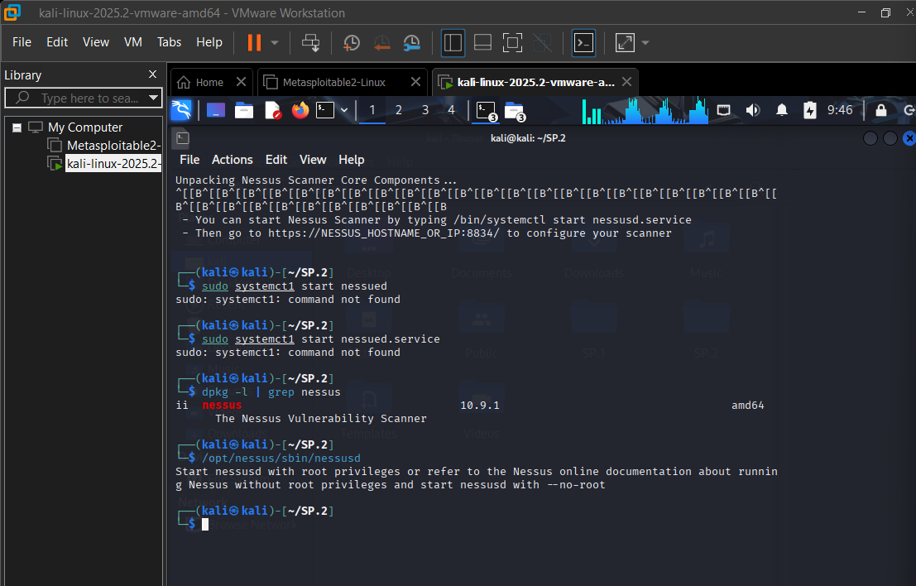

Part B: Basic Navigation Commands:
Open Terminal and perform the following commands:
- Pwd : Print Working Directory
Displays the full path of the current directory you're in.
- Ls : List Directory Contents
Shows files and folders in the current directory (without hidden files).
- Ls -la : List All with Details
Combines -l (long format) and -a (all files including hidden ones).
- Cd : Change Directory
Navigates between directories.
- Clear : Clear the Terminal Screen
Wipes the terminal output to give a clean workspace. Doesn't delete history — just clears the visible screen. Shortcut: Ctrl + L

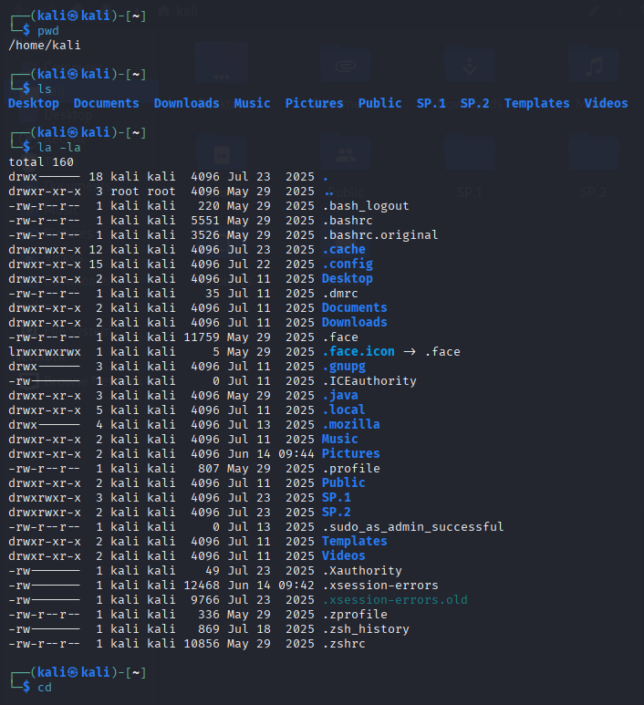

- History : Show Command History
Lists all previously executed commands with line numbers.
- Whoami : Show Current User
Prints the currently logged-in username
- hostname : Show System Hostname
Displays the name of the machine.
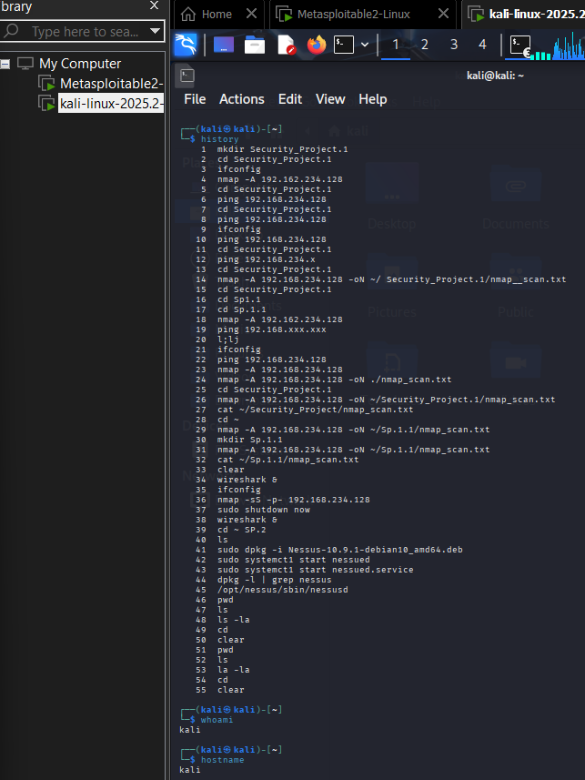

Part C: Directory Management:
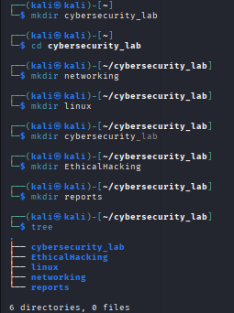
Part D: File Management:

- What touch does:
- Creates a new empty file if it doesn't exist
- Updates the timestamp of an existing file
- Can create multiple files at once

- What cp does:
- Copies a file from source to destination
- Original file remains untouched
- Use -r flag to copy entire folders

- What mv does:
- Moves a file from one location to another
- The original file is removed from its source location
- Works on both files and folders

- What mv does for renaming:
- When source and destination are in the same directory, it renames
- No separate rename command exists in Linux — mv handles it

- What rm does:
- Permanently deletes files (no Recycle Bin!)
- Use -r to delete folders and their contents
- Use -f to force delete without prompting

Part E: System Information Collection:
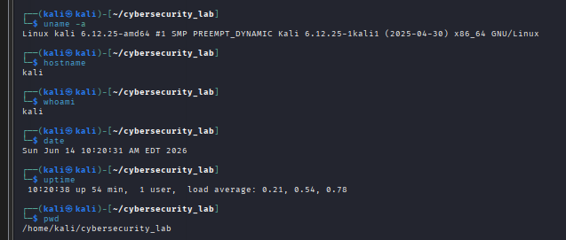
Part F: Linux Research Activity:
Research and explain:

1.What is Linux?
Linux is a free, open-source operating system kernel created by Linus Torvalds in 1991 as a personal project while he was a student in Finland. He wanted to build something similar to UNIX but freely available to everyone.
Linux is the kernel the brain of the operating system that sits between the hardware and the software, managing resources like CPU, memory, and storage.

2.Why is Linux important in Cyber Security?
Linux gives you complete control over every part of the operating system. You can modify system files, configure the kernel, create custom scripts, and automate complex tasks — things that are locked or hidden in Windows.
The Linux terminal (command line) is far more powerful than Windows Command Prompt. Security professionals can:
- Run hundreds of tools with a single line
- Automate attacks and defences with Bash scripts
- Pipe multiple commands together for complex operations
Linux comes with powerful networking utilities built in — such as netstat, ifconfig, tcpdump, nmap, curl, and wget — that are essential for network analysis, traffic monitoring, and vulnerability scanning.
Most professional cybersecurity tools are free and open source on Linux. Wireshark, Metasploit, Nmap, Burp Suite, Aircrack-ng — all run natively and best on Linux.
3.Difference between Linux and Windows.
- Windows: is built for ease of use for everyday users
- Linux: is built for control, performance, and security for power users

4.What is a Linux Distribution?
A Linux Distribution (distro) is a complete operating system built on top of the Linux kernel, packaged together with:
- A desktop environment (GUI)
- Package manager (to install software)
- System utilities and tools
- Pre-installed applications

5.Why do Ethical Hackers prefer Linux-based operating systems?
Ethical hackers (also called penetration testers) overwhelmingly choose Linux over Windows for several strong reasons:
A. Pre-Built Hacking Toolkits
Kali Linux alone comes with 600+ pre-installed tools such as:
- Nmap — Network scanning
- Metasploit — Exploitation framework
- Wireshark — Packet analysis
- Burp Suite — Web app testing
- Aircrack-ng — WiFi cracking
- John the Ripper — Password cracking
- Hydra — Brute force attacks
B. Scripting and Automation
Ethical hackers write Bash, Python, and Perl scripts to automate repetitive tasks like scanning, brute-forcing, or log analysis. Linux's terminal environment is perfect for this.
C. Anonymity and Privacy
Linux doesn't send telemetry data to any company. Tools like Tor, ProxyChains, and MAC address spoofing work seamlessly on Linux, making it easier to work anonymously during authorized tests.
D. Low Footprint
Linux can run on very minimal hardware — even from a USB stick (Live Boot). Ethical hackers can carry their entire hacking environment in their pocket and boot it on any machine without leaving traces.

