Networking Task 02: Network Devices & IP Addressing

Part A: Network Devices Research

Router:
Purpose: A router is a networking device that connects different networks together, usually a home or office network to the internet.
How It Works: The router receives data from devices such as phones or computers and forwards the data to the correct destination using IP addresses. It also assigns private IP addresses to devices in the network.
Real-World Usage
- Home Wi-Fi routers
- Office internet connections
- Connecting multiple devices to the internet

Switch:
Purpose: A switch connects multiple devices within the same local network (LAN) and allows them to communicate efficiently.
How It Works: A switch uses MAC addresses to send data only to the intended device instead of broadcasting to all devices. This improves speed and reduces unnecessary traffic.
Real-World Usage
- Office computer networks
- School or college labs
- Connecting printers, PCs, and servers in a LAN

Hub:
Purpose: A hub is a basic networking device used to connect multiple devices in a network.
How It Works: Unlike a switch, a hub sends incoming data to all connected devices, regardless of the intended recipient. Because of this, hubs are slower and less secure.
Real-World Usage
- Older or small networks
- Basic networking experiments and learning environments

Access Point:
Purpose: An Access Point (AP) provides wireless connectivity to devices in a network.
How It Works: It connects wired networks to wireless devices using Wi-Fi signals. Devices such as smartphones and laptops connect to the access point wirelessly.
Real-World Usage
- Wi-Fi in homes, colleges, malls, and offices
- Extending wireless coverage in large buildings

Firewall
Purpose: A firewall protects a network or computer from unauthorized access and cyber threats.
How It Works: It monitors incoming and outgoing traffic and blocks suspicious or harmful connections based on security rules.
Real-World Usage
- Protecting company networks
- Personal computer security
- Preventing hackers and malware attack
Modem
Purpose: A modem connects a home or office network to the internet service provided by the ISP.
How It Works: The modem converts digital data from computers into signals that can travel through telephone, cable, or fibre lines, and vice versa.
Real-World Usage
- Home broadband internet connections
- Cable and fibre internet setups
- Connecting routers to ISPs

Part B: IP Address Classification

192.168.1.10: Private
This IP belongs to the 192.168.x.x range, which is reserved for private networks and used inside homes, schools, and offices.

10.0.0.5: Private
The 10.x.x.x range is a private IP range reserved for internal network communication.

172.16.5.20: Private
IP addresses from 172.16.0.0 to 172.31.255.255 are private addresses. This IP falls within that range.

8.8.8.8: Public
This is a public IP address used by Google DNS and is accessible over the internet.
1.1.1.1: Public
This is a public IP address provided by Cloudflare DNS and can be accessed globally through the internet.

192.168.100.1: Private
This IP is part of the 192.168.x.x private address range used for local networks

Part C: Understanding Your Network

IPv4 Address: 192.168.1.41
Default Gateway: 192.168.1.200
DNS Server: 218.248.112.1

1. Which IP range does your device belong to?
This belongs to the 192.168.x.x IP range, which is reserved for local/private networks.
2. Is it Public or Private?
Private IP address
3. What role does your router play in your network?
- Sends and receives data between your devices and external networks
- Assigns IP addresses to devices in the network
- Acts as the default gateway for internet communication
Without the router, your devices would not be able to access the internet.
4. What would happen if the DNS server stopped working?
If the DNS server stopped working:
- Websites like google.com would not open using their names
- Internet may still work, but domain names could not be translated into IP addresses

Part D: Network Communication Flow

Step 1: Your Device
When you type www.google.com into your browser, your computer or phone sends a request to access the website.
The device first checks if it already knows the website’s IP address.

Step 2: Router / Wi-Fi
The request is sent to your router (default gateway).
The router forwards the request from your local network to the internet.

Step 3: DNS Server
The DNS server converts www.google.com into an IP address that computers can understand.
This is similar to finding a phone number from a contact name.

Step 4: Google Server
Using the IP address received from DNS, your request reaches Google’s servers.
Google processes the request and prepares the webpage data.

Step 5: Response Back to Device
Google’s server sends the webpage data back through the internet and router to your device.
Your browser receives the data and displays the Google homepage on the screen.

Part E: Practical Command Exercise
ipconfig /all:
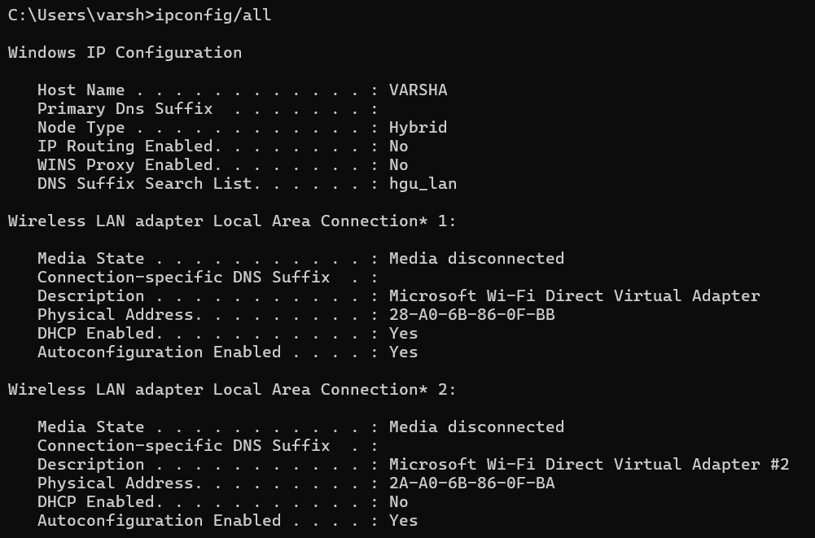
nslookup google.com:
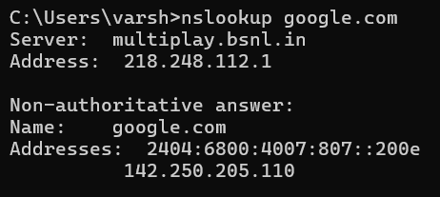
ping google.com:
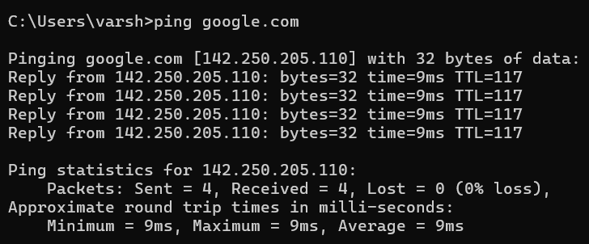

1.What IP address did DNS return for Google?
218.248.112.1

2.Was the ping successful?
Yes

3.Why is DNS important before communication begins?
DNS is vital before communication begins because it acts as the internet's phonebook. Computers can only communicate using numerical IP addresses, but humans rely on easy-to-remember domain names. DNS translates these words into machine-readable IP addresses so your device can locate the correct server.

