Part A: Network Information

1.Hostname (Device Name) : VARSHA
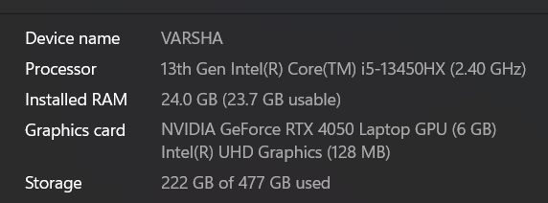

2. IPv4 Address : 192.168.1.41
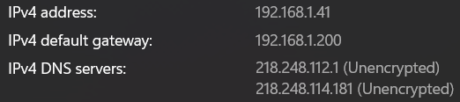
3. MAC Address : 00:1A:2B:3C:4D:5E
4. Default Gateway : 192.168.1.200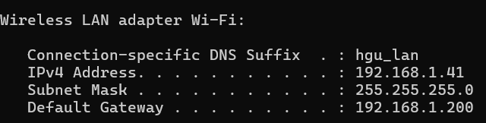

5. DNS Server :218.248.112.1
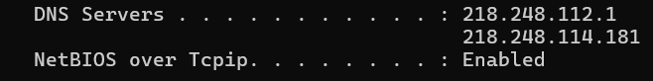

Part B: Basic Networking Concepts

What is an IP Address?
An IP Address (Internet Protocol Address) is a unique number assigned to a device connected to a network or the internet.
It works like a home address for your device so data knows where to go.
When you open a website or send data online, your IP address helps identify your device and allows communication between devices.

What is a MAC Address?
A MAC Address (Media Access Control Address) is a unique physical identifier assigned to a device’s network card by the manufacturer.
It is used mainly for communication inside a local network (LAN).
Unlike an IP address, which can change, a MAC address is usually fixed for the hardware device.

What is a Default Gateway?
A Default Gateway is the device that connects your local network to other networks, usually the internet. If your computer wants to send data outside its own network, it sends the data to the default gateway first, and the gateway forwards it to the destination.
Wi-Fi router is a example of it

What is DNS?
DNS (Domain Name System) is like the internet’s phonebook.
Humans remember names like:
- google.com
But computers communicate using IP addresses like:
- 142.250.183.14
DNS converts website names into IP addresses so your browser can find the correct server.
Without DNS, we would need to remember numeric IP addresses for every website.

Difference Between Public IP and Private IP
Feature | Public IP | Private IP
Definition | IP address used on the internet | IP address used inside local networks
Visibility | Visible to the internet | Not directly visible online
Assigned By | Internet Service Provider (ISP) | Router or local network
Usage | Communication over the internet | Communication within homes, offices, colleges
Example | 8.8.8.8 | 192.168.1.10

Part C: Create a Basic Network Diagram
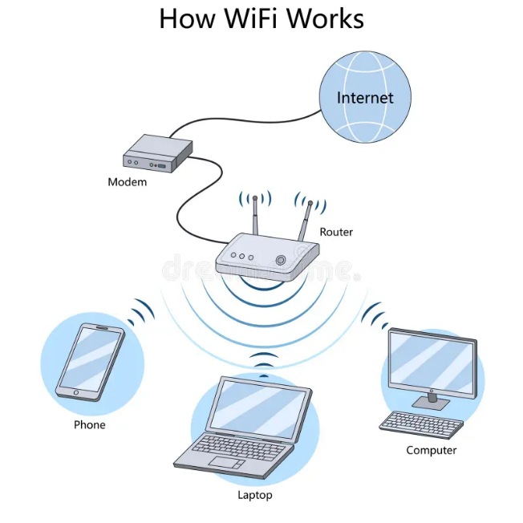
Part D: Network Connectivity Test

Ipconfig:
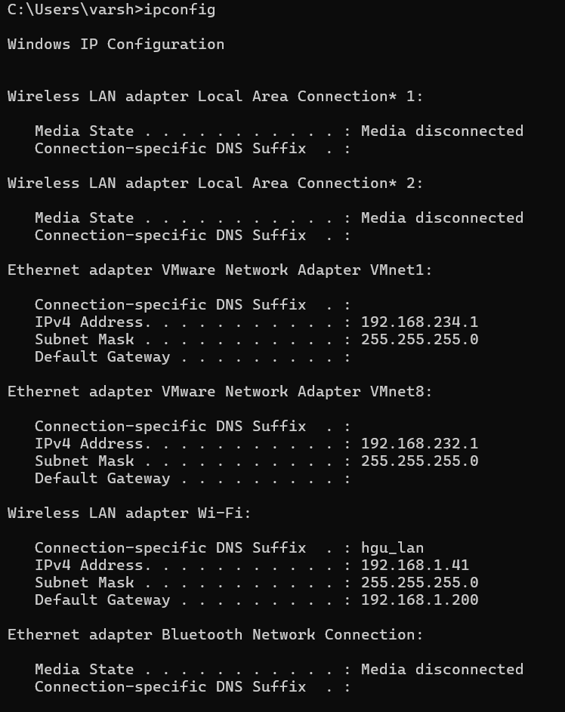

ping google.com:
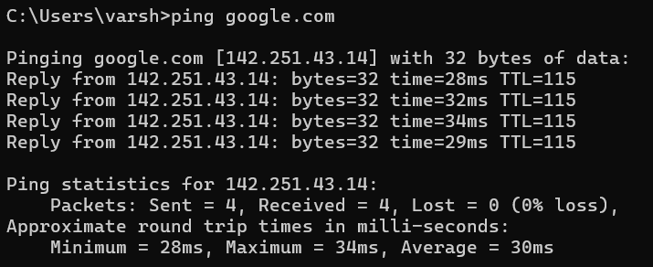
tracert google.com
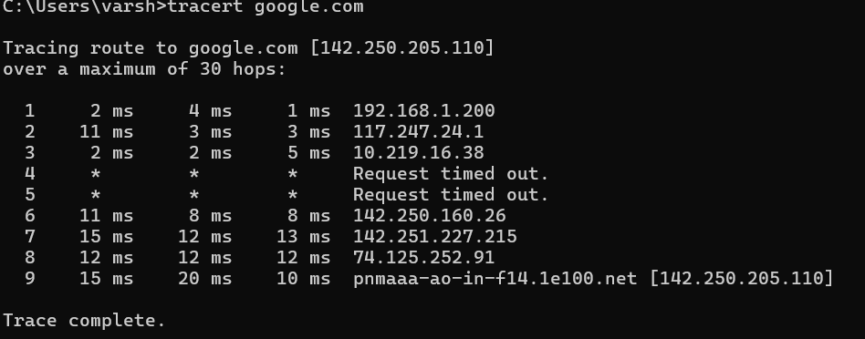
1. Was the ping successful?
Yes, the ping was successful because replies were received from Google’s server.

2. How many hops were shown?
Count the numbered lines in the tracert result.

3. What is the purpose of traceroute?
Traceroute is used to track the path that data packets take from your computer to a destination server on the internet. It helps identify network delays or connection problems.

