Linux Task 02: Users, Groups & File Permissions

Part A: Understanding Users:

Answer the following:
1.What is your current username?
Kali

2.What is UID?
Udi=1000(kali)

3.What is GID?
Gid=1000(kali)

4.What information does /etc/passwd contain?
Is a plain text file that stores essential information about every user account on a Linux system. It is one of the most fundamental files in Linux and has existed since the earliest versions of Unix.
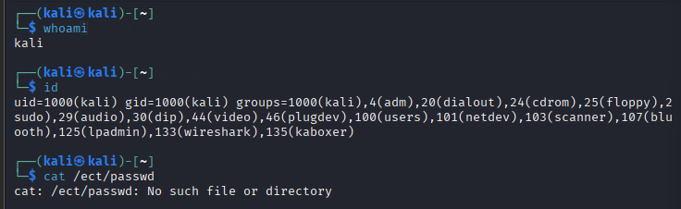

Part B: Create Users & Groups:
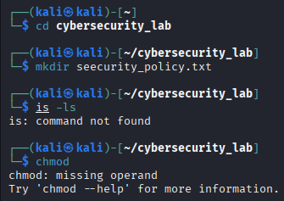

Part E: Permission Analysis:
For the following permissions explain:
755:
rwx r-x r-x 755
The owner has full control — can read, edit, and run the file
Everyone else can read and run it, but cannot modify it

644:
rw- r-- r-- 644
The owner can read and edit the file
Nobody else can edit it
Nobody (including owner) can execute it directly

777:
rwx rwx rwx 7 7 7
Absolutely everyone on the system has full access
Anyone can read, modify, delete, or execute the file
No restrictions whatsoever

600:
rw- --- --- 6 0 0
Only the owner can read or edit this file
Group and others are completely locked out
Even root-group members cannot access it (only actual root)

700:
rwx --- --- 7 0 0
Only the owner has any access — full control
Everyone else is completely blocked
Like a private locked room only you have the key to

For each permission explain:
Owner Rights: The owner has complete and total control over the file. They can open it, change its contents, delete it, rename it, and execute it as a script or program. No restrictions whatsoever for the owner.
Group Rights: Group members can read and run the file but are blocked from making any changes. This is useful when a team needs to use a shared tool or script without being able to accidentally or intentionally alter it.
Other User Rights: Any other user on the system gets the exact same access as the group — they can read and run, but cannot modify. The file is essentially publicly accessible but protected from tampering.
Real-world use case:
System binaries = /usr/bin/ls, /bin/bash
Shared scripts = /usr/local/bin/backup.sh
Web server directories = /var/www/html/
Part G: Linux Security Research:
Research and explain:
1.Why are file permissions important?
File permissions are the first line of defense in Linux security. They act as a gatekeeper that controls exactly who can do what with every single file and folder on the system. Without permissions, Linux would be completely open — any user could read, modify, or delete anything, making the entire system unsafe and unmanageable.

2.What happens if sensitive files are given 777 permissions?
Giving a sensitive file 777 permissions is one of the most dangerous misconfigurations possible in Linux. It means every single user — legitimate or malicious — has full read, write, and execute access. The consequences can be catastrophic.

3.What is the principle of Least Privilege?
The Principle of Least Privilege (PoLP) is a fundamental security concept that states:Every user, program, or system component should have access to only the minimum resources and permissions it absolutely needs to do its job — and nothing more.

4.Why do organizations restrict user access?
Every organization handles data that must not fall into the wrong hands — customer information, financial records, medical data, intellectual property, trade secrets, and employee records. Access restrictions ensure that only authorized personnel can view or handle this data. Many industries are governed by strict legal frameworks that mandate access controls. Organizations that fail to implement proper restrictions face massive fines, lawsuits, and even criminal charges.

