**Cryptoverse**

**Introduction**

A crypto currency dashboard that displays historical price data over the past five years is a

powerful tool for investors seeking a comprehensive understanding of market dynamics.

This feature-rich interface offers users a detailed historical perspective on the performance

of various crypto currencies, enabling insightful analysis and informed decision-making.

Through visually intuitive charts and graphs, the dashboard allows for effective

comparisons of multiple crypto currencies, aiding in the identification of top performers and

overall market trends. Users can customize timeframes for a more granular examination of

price movements, facilitating in-depth volatility analysis and risk assessment. This historical

data not only supports investors in making data-driven decisions but also assists in

recognizing recurring patterns and cycles. Beyond its role in optimizing cryptocurrency

portfolios, the dashboard serves as an educational resource, empowering users to grasp the

evolving nature of crypto currency markets and the nuanced factors shaping price

movements over an extended period.

**Description**

Cryptoverse is a sophisticated cryptocurrency dashboard designed to provide investors with

comprehensive insights into market dynamics through detailed historical price data analysis

spanning five years. Featuring visually intuitive charts, interactive tools, and seamless

navigation, the platform empowers users to identify top-performing assets and make

informed investment decisions. With its robust search functionality, users can easily explore

a wide range of cryptocurrencies and compare their performance over time. Cryptoverse not

only serves as a powerful tool for optimizing investment portfolios but also acts as an

educational resource, helping users understand the evolving nature of cryptocurrency

markets.

**Scenario**

Sarah, a trading enthusiast, wants to analyse the historical price data of various

cryptocurrencies before making investment decisions.

1. Objective: Sarah aims to identify crypto assets that have shown consistent growth over

the past five years to diversify her investment portfolio effectively.

2. Using Cryptoverse: Sarah opens the Cryptoverse application on her computer.

3. Navigation: She finds the navigation within the website to be seamless, facilitated by

react-router-dom. She easily navigates to the "Crypto Currencies" page, where she can

explore different cryptocurrencies.

4. Browsing Cryptocurrencies: Sarah starts browsing through the list of cryptocurrencies

available on the platform. She sees a wide range of options, from popular ones like Bitcoin

and Ethereum to lesser-known altcoins.

5. Visual Currency Browsing: Each cryptocurrency is accompanied by beautiful chart

representations of price fluctuations since its creation. Sarah appreciates the visual

presentation, as it allows her to quickly grasp the historical performance of each asset.

6. Interactive Charts: Sarah clicks on the chart of Bitcoin to view more detailed historical

price data. She interacts with the interactive line chart powered by react-chartjs-2 and

Chart.js, adjusting the time frame to analyze price movements over the past five years.

7. Price Fluctuation Visualization: Sarah examines the historical price changes of Bitcoin

and observes its volatility over the selected time frame. She also compares Bitcoin's

performance with other cryptocurrencies to identify potential investment opportunities.

8. Search Feature: Using the search feature, Sarah easily finds specific cryptocurrencies

she's interested in, such as Bitcoin and Ripple. She explores their historical price data and

compares them with her other findings.

9. Insights and Decision-Making: After thorough analysis and comparison, Sarah gains

valuable insights into the performance of various cryptocurrencies over the past five years.

She identifies several assets that have demonstrated consistent growth and decides to

include them in her investment portfolio.

10. Educational Resource: Throughout her exploration, Sarah finds the Cryptoverse

application to be not only a tool for making data-driven investment decisions but also an

educational resource. She learns more about the evolving nature of cryptocurrency markets

and the factors influencing price movements over time.

11. Further Customization and Development: Impressed by the functionality and user

experience of Cryptoverse, Sarah decides to contribute to the project's development by

providing feedback and suggestions for improvement. She also considers sharing the

application with her fellow trading enthusiasts to help them make informed investment

decisions.

**Pre-requisites:**

Here are the key prerequisites for developing a frontend application using

React.js: ✔ Node.js and npm:

Node.js is a powerful JavaScript runtime environment that allows you

to run JavaScript code on the local environment. It provides a scalable and

efficient platform for building network applications.

Install Node.js and npm on your development machine, as they are required

to run JavaScript on the server-side.

● Download: https://nodejs.org/en/download/

● Installation instructions: https://nodejs.org/en/download/package-manager/

✔ React.js:

React.js is a popular JavaScript library for building user interfaces. It

enables developers to create interactive and reusable UI components,

making it easier to build dynamic and responsive web applications.

Install React.js, a JavaScript library for building user interfaces.

● Create a new React app:

npx create-react-app my-react-app

Replace my-react-app with your preferred project name.

● Navigate to the project directory:

cd my-react-app

● Running the React App:

With the React app created, you can now start the development server

and see your React application in action.

● Start the development server:

npm start

This command launches the development server, and you can

access your React app at http://localhost:3000 in your web

browser.

✔ HTML, CSS, and JavaScript: Basic knowledge of HTML for creating the

structure of your app, CSS for styling, and JavaScript for client-side interactivity

is essential.

✔ Version Control: Use Git for version control, enabling collaboration and

tracking changes throughout the development process. Platforms like GitHub

or Bitbucket can host your repository.

• Git: Download and installation instructions can be found at:

https://git-scm.com/downloads

✔ Development Environment: Choose a code editor or Integrated Development

Environment (IDE) that suits your preferences, such as Visual Studio Code,

Sublime Text, or WebStorm.

• Visual Studio Code: Download from

https://code.visualstudio.com/download • Sublime Text: Download

from https://www.sublimetext.com/download

✔ Start the Development Server:

• To start the development server, execute the following command:

npm run dev (vite) or npm start

Access the App:

• Open your web browser and navigate to http://localhost:3000.

• You should see the Cryptoverse app's homepage, indicating that the

installation and setup were successful.

**Google drive link :**

<https://drive.google.com/drive/folders/1VjRQoprZYn_wIycVvXi14KKreKQS0d7m?usp=drive_link>

**Project Structure:**

**Project Flow:**

● Project setup and configuration:

**1. Setup React Application:**

• Create a React app in the client folder.

• Install required libraries

• Create required pages and components and add routes.

**2.Designed UI components:**

• Created Components.

• Implemented layout and styling.

• Added navigation.

**3.Implement frontend logic:**

• Integration with API endpoints.

• Implement data binding.

Reference Image:

**Project Development:**

**● Create a redux store:**

1. `import { configureStore } from "@reduxjs/toolkit";`: This line imports the

`configureStore` function from Redux Toolkit. Redux Toolkit is a package that provides

utilities to simplify Redux development, making it easier to write Redux logic with less

boilerplate code.

2. `import { cryptoApi } from "../services/cryptoApi";`: This line imports the

`cryptoApi` object from the `cryptoApi.js` file located in the `../services` directory.

This object likely contains configurations and functions related to making API requests

for cryptocurrency data.

3. `export default configureStore({ ... });`: This line exports the Redux store

configuration created by the `configureStore` function as the default export of this

module.

4. `reducer: { [cryptoApi.reducerPath]: cryptoApi.reducer }`: This part of the

configuration specifies the root reducer for the Redux store. In this case, it sets the

`cryptoApi.reducer` as the reducer for the slice of state managed by the `cryptoApi`

API slice. The `cryptoApi.reducerPath` likely refers to the slice's unique identifier,

which is used internally by Redux Toolkit.

5. `middleware: (getDefaultMiddleware) =>

getDefaultMiddleware().concat(cryptoApi.middleware),`: This part of the configuration

specifies middleware for the Redux store. Middleware intercepts actions before they

reach the reducers and can be used for various purposes, such as logging,

asynchronous actions, or handling API requests. Here, it uses the

`getDefaultMiddleware` function provided by Redux Toolkit to get the default

middleware stack and appends the `cryptoApi.middleware`. This middleware likely

handles asynchronous API requests and dispatches corresponding actions based on

the API response.

this configuration sets up a Redux store with a specific reducer and middleware

provided by the `cryptoApi` object, which presumably manages state related to

cryptocurrency data fetched from an external API. This setup allows you to manage and

interact with this data using Redux within your React application.

**● Create a API slice using Redux toolkit’s:**

1. Import Statements:

- `import { createApi, fetchBaseQuery } from "@reduxjs/toolkit/query/react";`: This

line imports the necessary functions from Redux Toolkit's query-related module.

`createApi` is used to create an API slice, while `fetchBaseQuery` is a utility function

provided by Redux Toolkit for making network requests using `fetch`.

2. Header and Base URL Configuration:

- `const cryptoApiHeaders = { ... }`: This object contains headers required for making

requests to the cryptocurrency API. The values for `"X-RapidAPI-Key"` and

`"X-RapidAPI-Host"` are retrieved from environment variables using

`import.meta.env`.

- `const baseUrl = import.meta.env.VITE_BASE_URL;`: This variable holds the base

URL for the cryptocurrency API, which is also retrieved from environment variables.

3. Request Creation Function:

- `const createRequest = (url) => ({ url, headers: cryptoApiHeaders });`: This function

`createRequest` takes a URL and returns an object with the URL and headers required

for making a request. It utilizes `cryptoApiHeaders` to include necessary headers in

the request.

4. Create API Slice:

- `export const cryptoApi = createApi({ ... })`: This part uses the `createApi` function

to create an API slice named `cryptoApi`. It takes an object with several properties:

- `reducerPath`: Specifies the path under which the slice's reducer will be mounted

in the Redux store.

- `baseQuery`: Configures the base query function used by the API slice. In this

case, it uses `fetchBaseQuery` with the base URL specified.

- `endpoints`: Defines the API endpoints available in the slice. It's an object with

keys corresponding to endpoint names and values being endpoint definitions.

5. API Endpoints:

- `getCryptos`, `getCryptoDetails`, `getCryptoHistory`: These are endpoints

defined using the `builder.query` method. Each endpoint is configured with a `query`

function that returns the request configuration object created by `createRequest`.

6. Exporting Hooks:

- `export const { ... }`: This line exports hooks generated by the `createApi` function,

allowing components to easily fetch data from the API slice. Each hook corresponds to

an endpoint defined in the `endpoints` object.

Overall, this code sets up an API slice named `cryptoApi` using Redux Toolkit's query

functionality. It defines endpoints for fetching cryptocurrencies, cryptocurrency details,

and cryptocurrency history. The slice is configured with base URL, headers, and query

functions required for making requests to the cryptocurrency API.

**● Adding Providers in the main function:**

React Router with `BrowserRouter`:

- `<BrowserRouter>`: This component is provided by `react-router-dom` and

enables client-side routing using the HTML5 history API. It wraps the application,

allowing it to use routing features.

Redux Provider:

- `<Provider store={store}>`: This component is provided by `react-redux` and is

used to provide the Redux store to the entire application. It wraps the application,

allowing all components to access the Redux store.

Overall, this code initializes the React application by rendering the root component

(`<App />`) into the DOM, while also providing routing capabilities through

`BrowserRouter` and state management with Redux through `Provider`. Additionally,

it ensures stricter development mode checks with `<React.StrictMode>`.

**● Creating a Line chart component:**

This code defines a React component called `LineChart` which renders a line chart

using the `react-chartjs-2` library.

1. Imports:

- `import React from "react";`: Imports the `React` module.

- `import { Line } from "react-chartjs-2";`: Imports the `Line` component from the

`react-chartjs-2` library, which is used to render line charts.

- `import { Col, Row, Typography } from "antd";`: Imports specific components from

the Ant Design library, including `Col`, `Row`, and `Typography`.

- `const { Title } = Typography;`: Destructures the `Title` component from the

`Typography` module.

2. Component Definition:

- `const LineChart = ({ coinHistory, currentPrice, coinName }) => { ... }`: Defines a

functional component called `LineChart`. It takes three props: `coinHistory`,

`currentPrice`, and `coinName`.

3. Data Preparation:

- Inside the component, it loops through the `coinHistory` data to extract

`coinPrice` and `coinTimestamp` arrays. These arrays will be used as data points for

the line chart.

4. Chart Data:

- `const data = { ... }`: Defines the data object for the line chart. It includes labels

(timestamps) and datasets (coin prices).

5. Rendering:

- Inside the return statement, it renders the chart header, including the coin name,

price change, and current price.

- `Row` and `Col` from Ant Design are used to structure the layout.

- The `Line` component renders the actual line chart using the data object defined

earlier.

6. Export:

- `export default LineChart;`: Exports the `LineChart` component as the default

export.

Overall, this component receives historical data (`coinHistory`), current price

(`currentPrice`), and the name of the cryptocurrency (`coinName`) as props, and

renders a line chart displaying the historical price data. It also includes additional

information such as the price change and current price displayed above the chart.

**● Creating cryptocurrencies component:**

1. Component Definition:

- `const Cryptocurrencies = ({ simplified }) => { ... }`: Defines a functional component

named `Cryptocurrencies`. It accepts a prop named `simplified`, which determines

whether to display a simplified version of the list.

2. Initialization:

- `const count = simplified ? 10 : 100;`: Initializes the `count` variable based on the

value of the `simplified` prop. If `simplified` is true, `count` is set to 10; otherwise,

it's set to 100.

3. Fetching Cryptocurrency Data:

- `const { data: cryptosList, isFetching } = useGetCryptosQuery(count);`: Uses the

`useGetCryptosQuery` hook provided by the `cryptoApi` service to fetch

cryptocurrency data. It retrieves the list of cryptocurrencies (`cryptosList`) and a

boolean flag (`isFetching`) indicating whether the data is being fetched.

4. Filtering Cryptocurrency Data:

- The `useEffect` hook is used to filter the cryptocurrency data based on the

`searchTerm` state variable. It updates the `cryptos` state with filtered data

whenever `cryptosList` or `searchTerm` changes.

5. Rendering Loader:

- `if (isFetching) return <Loader />;`: If data is still being fetched (`isFetching` is

true), it returns a `Loader` component to indicate that the data is loading.

6. Rendering Search Input:

- `!simplified && (...)`: If `simplified` is false, it renders a search input field allowing

users to search for specific cryptocurrencies by name.

7. Rendering Cryptocurrency Cards:

- The `Row` and `Col` components from Ant Design are used to create a grid layout

for displaying cryptocurrency cards.

- For each cryptocurrency in the `cryptos` array, it renders a `Card` component

containing details such as name, price, market cap, and daily change. Each card is

wrapped in a `Link` component, allowing users to navigate to the details page of a

specific cryptocurrency.

8. Return Statement:

- `return (...)`: Returns JSX representing the component's structure and content.

Overall, this component fetches cryptocurrency data, filters it based on a search term,

and renders the data in a visually appealing format with card-based UI. It also provides

a search functionality for users to find specific cryptocurrencies.

**● Create a component to show the details of cryptocurrency:**

This code defines a React functional component called `CryptoDetails` responsible for

displaying detailed information about a specific cryptocurrency. Let's break down the

code:

1. Component Definition:

- `const CryptoDetails = () => { ... }`: Defines a functional component named

`CryptoDetails`. It doesn't accept any props directly but utilizes React Router's

`useParams` hook to get the `coinId` parameter from the URL.

2. State Initialization:

- Initializes state variables `timePeriod` and `coinHistory`. `timePeriod` represents

the selected time period for displaying cryptocurrency history, and `coinHistory`

stores historical data of the selected cryptocurrency.

3. Fetching Data:

- Utilizes `useGetCryptoDetailsQuery` and `useGetCryptoHistoryQuery` hooks

provided by the `cryptoApi` service to fetch details and historical data of the

cryptocurrency specified by `coinId`. It uses `coinId` obtained from `useParams` to

fetch data for the specific cryptocurrency.

4. Setting Coin History:

- Utilizes `useEffect` hook to update the `coinHistory` state when

`coinHistoryData` changes. This ensures that the component re-renders with updated

historical data.

5. Rendering Loader:

- Displays a loading indicator (`<Loader />`) while data is being fetched (`isFetching`

is true).

6. Time Period Selection:

- Renders a `Select` component allowing users to choose the time period for

displaying historical data. It triggers the `setTimePeriod` function when the selection

changes.

7. Rendering Line Chart:

- Utilizes the `LineChart` component to display the historical price trend of the

cryptocurrency over the selected time period.

8. Rendering Statistics:

- Displays various statistics related to the cryptocurrency, such as price, rank, volume,

market cap, etc. These statistics are displayed in two sections: `stats` and

`genericStats`.

9. Rendering Description and Links:

- Parses and displays the description of the cryptocurrency using

`HTMLReactParser`.

- Renders links related to the cryptocurrency, such as official websites, social media,

etc.

10. Return Statement:

- Returns JSX representing the structure and content of the component.

Overall, this component fetches and displays detailed information about a specific

cryptocurrency, including historical price data, key statistics, description, and related

links.

**Reference Image Link :** details.png

**● Create a Homepage:**

This component, named `Home`, is a React functional component responsible for

rendering the home page of the cryptocurrency dashboard. Let's break down the code:

1. Component Definition:

- `const Home = () => { ... }`: Defines a functional component named `Home`.

2. Data Fetching:

- Uses the `useGetCryptosQuery` hook provided by the `cryptoApi` service to fetch

data for the top 10 cryptocurrencies. It retrieves data and a boolean flag indicating

whether data is being fetched.

3. Rendering Loader:

- Displays a loading indicator (`<Loader />`) while data is being fetched (`isFetching`

is true).

4. Global Crypto Stats:

- Renders statistics about the global cryptocurrency market, including total

cryptocurrencies, total exchanges, total market cap, total 24-hour volume, and total

markets. These statistics are displayed using the `Statistic` component from Ant

Design.

5. Top 10 Cryptocurrencies:

- Renders a section displaying the top 10 cryptocurrencies in the world.

- Utilizes the `Cryptocurrencies` component with the `simplified` prop set to true to

display a simplified version of the list.

- Provides a link to view more cryptocurrencies using the `Link` component from

React Router.

6. Return Statement:

- Returns JSX representing the structure and content of the component.

Overall, this component fetches and displays global cryptocurrency statistics and the

top 10 cryptocurrencies on the homepage of the dashboard. It provides links for users

to navigate to the full list of cryptocurrencies.

**User Interface snips:**

⮚ Home page : This pages consists of stats of global crypto like total cryptocurrencies,

total exchanges, market cap etc. Also consist of top 10 cryptocurrencies in the world.

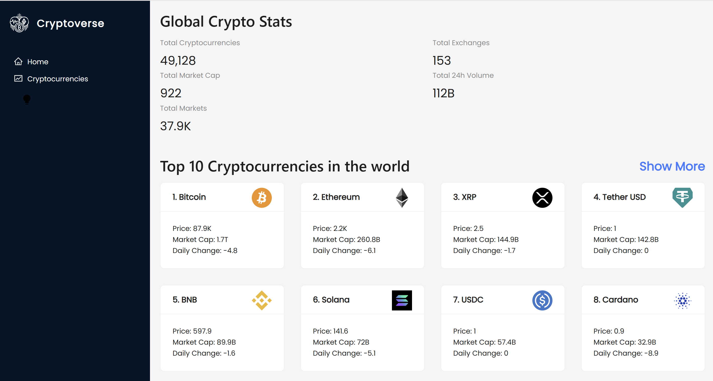

⮚ Crypto currencies page : This pages contains all cryptocurrencies which are

currently in flow in the world. There is also a search feature where users can search

and find out about their desired cryptocurrency.

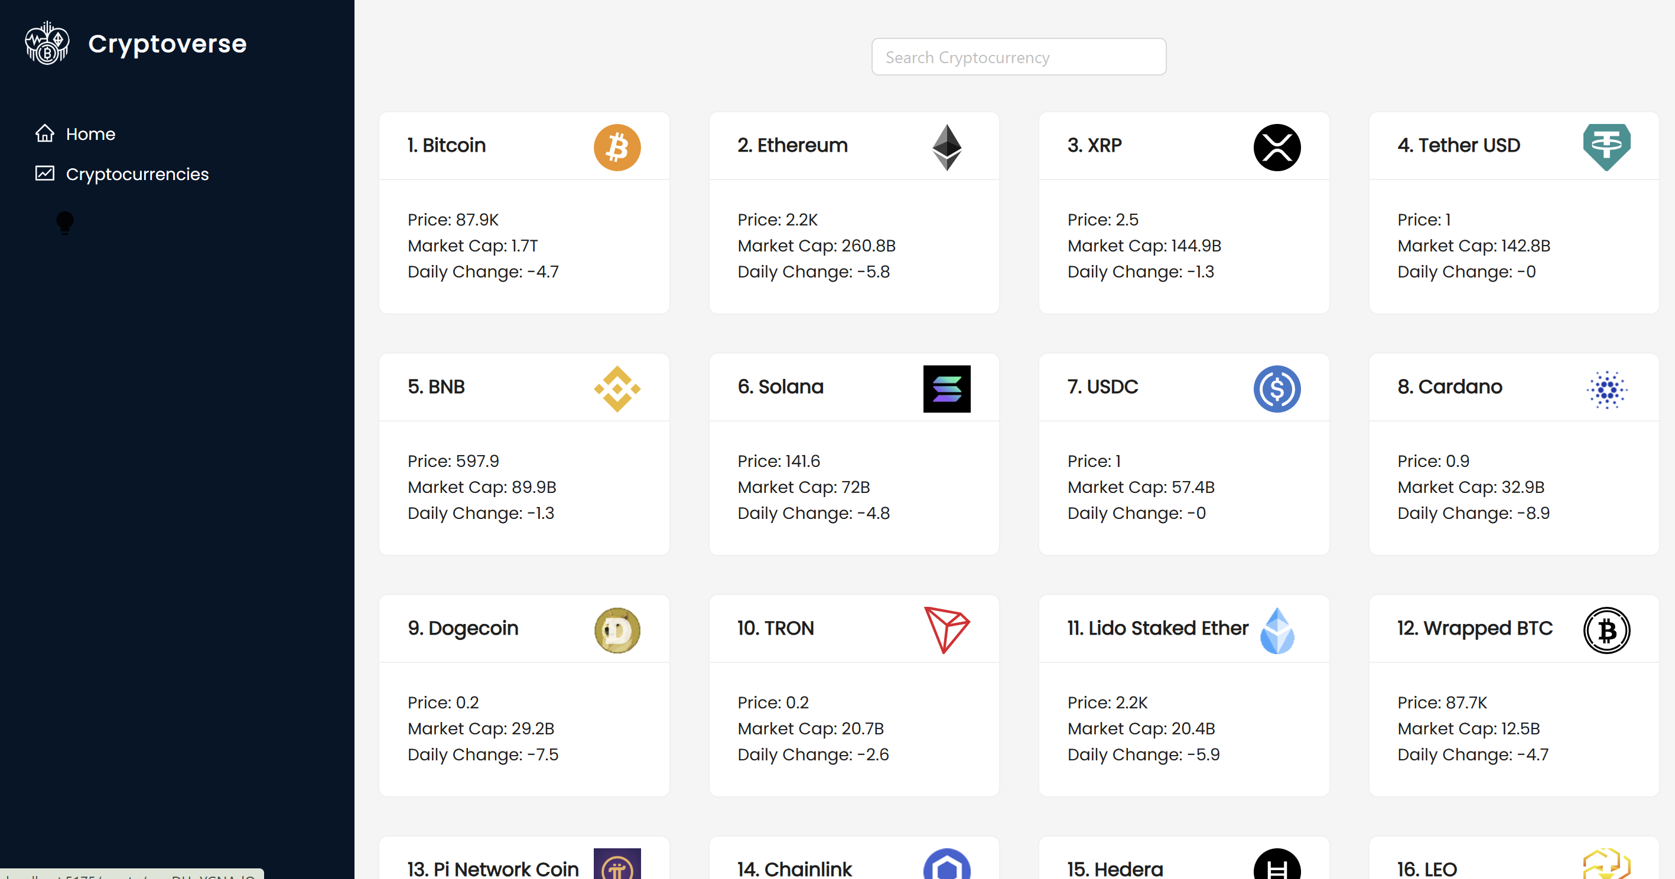

⮚ Crypto currency details page : This page contains the line chart with data

representation of price of cryptocurrencies. Also contains statistics and website links of

cryptocurrencies.

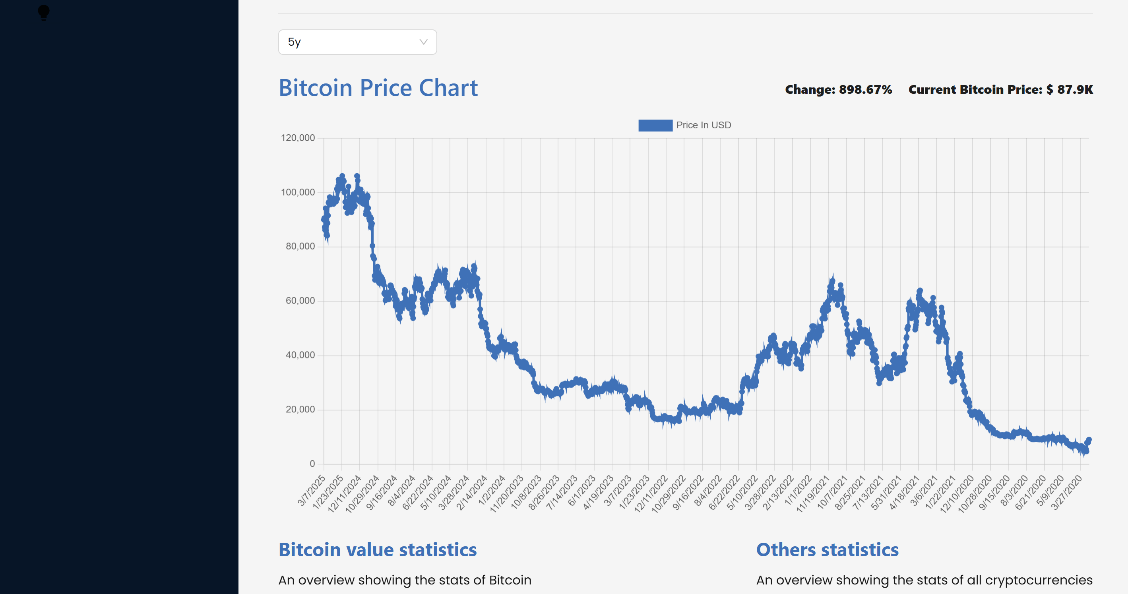

**GitHub Link:**

<https://github.com/varsha365a/Cryptoverse>

**Team Members:**

* **A Varsha (Team Leader)**
* **Christina S**
* **Manisha Dhanprasad Joshi**
* **B Sandhiya**

**Of Dr. MGR Janaki College of Arts and Science for Women**

**THANK YOU**