Design and apply context-aware access
controls based on user identity, device
posture, location, and application risk.

LIST OF TEMATES

S:NO | NAME | COLLEGE | CONTACT
01 | N.SANTHANA VARSHA | CHERRAN COLLEGE FOR WOMEN | santhanavarsha82@gmailcom
02 | K.PRIYA DHARSHINI | CHERRAN COLLEGE FOR WOMEN | kumarpriyadharshini324@gmail.com
03 | M.JOTHIKA | CHERRAN COLLEGE FOR WOMEN | jothisheriya0803@gmail.com
04 | S.JENIFAR | CHERRAN COLLEGE FOR WOMEN | jenifar622@gmail.com
05 | M.UMA MAHESWARI | CHERRAN COLLEGE FOR WOMEN | rameaswari1122@gmail.com

Title Of The Project:
Design and apply context-aware access controls based on user identity,
device posture, location, and application risk.

Introduction:
digital environment, organizations widely use cloud services, mobile devices, and remote working systems. Because of this rapid technological growth, traditional security methods that rely only on usernames and passwords are no longer sufficient to protect sensitive information and systems. Cyberattacks and unauthorized access attempts are increasing, which makes it necessary for organizations to adopt more advanced security mechanisms. One such modern approach is context-aware access control, which improves security by considering multiple contextual factors before granting access to users.
Context-aware access control evaluates different elements such as user identity, device posture, location, and application risk when a user attempts to access a system or application. For instance, the system verifies whether the user is authorized, checks if the device being used is secure and updated, analyzes the geographical location of the login attempt, and determines the sensitivity or risk level of the application being accessed. If the access request appears normal and safe, the system grants access. However, if any unusual behavior is detected, additional verification methods such as multi-factor authentication (MFA) may be required or access may be restricted.
By analyzing these contextual factors in real time, context-aware access control helps organizations strengthen their security framework, reduce the risk of unauthorized access, and ensure that only trusted users with secure devices can access critical applications and sensitive data.

Abstract:
Context-aware access control is an advanced security method used to protect digital systems and sensitive information. Unlike traditional access control systems that only verify a user’s username and password, context-aware systems evaluate multiple factors before granting access. These factors include the user’s identity, the security condition of the device (device posture), the user’s geographic location, and the risk level of the application being accessed. By analyzing these elements together, the system can make smarter and more secure access decisions.
For example, if a user tries to access an application from an unknown device or a suspicious location, the system may request additional verification or block access entirely. This approach helps organizations reduce security risks and prevent unauthorized access to important data. Context-aware access control is widely used in modern cybersecurity frameworks, especially in Zero Trust security models. Overall, it enhances security, improves monitoring, and ensures that only trusted users and secure devices can access critical resources.

Use Case Scenarios:

1. Scenario: Trusted Employee Login
Process:
- User enters username and password.
- System verifies user identity.
- System checks device posture (antivirus, security updates).
- System verifies location (office network).
- System checks application risk level (normal application).
Output:
Access Granted

2. Scenario: Login from New Device
Process:
- User enters login credentials.
- System verifies user identity.
- System detects unknown or unregistered device.
- System checks location and application risk.
- System requests additional authentication (OTP/MFA).
Output:
Access Allowed after OTP verification

3. Scenario: Login from Suspicious Location
Process:
- User attempts login.
- System verifies user identity.
- System checks device posture (secure).
- System detects unusual location (different country).
- System evaluates risk level.
Output:
Access Restricted or additional security verification required

4. Scenario: Unsafe Device
Process:
- User tries to access the system.
- System verifies user identity.
- System checks device posture and finds outdated antivirus.
- System marks device as non-compliant.
- Access request is evaluated as high risk.
Output:
Access Denied until device security is updated

5. Scenario: Access to Sensitive Application
Process:
- User logs into the system.
- System verifies identity and device security.
- System checks location (trusted).
- User tries to open high-risk application (financial data).
- System requires strong authentication (MFA) and monitoring.
Output:
Access Granted with additional security verification

Stage-1

Title:
Design and apply context-aware access controls based on user identity,
device posture, location, and application risk.
Overview:
Context-aware access control is a modern cybersecurity approach that provides system access based on different contextual factors instead of only checking a username and password. It analyzes the situation in which a user is requesting access and makes a smart decision to allow, limit, or deny access.
In this method, the system mainly considers four important factors: user identity, device posture, location, and application risk. First, the system verifies the user identity to ensure that the person requesting access is an authorized user. Next, it checks the device posture, which means verifying whether the device used by the user is secure, updated, and compliant with security policies. Then the system analyzes the location from which the user is trying to access the system, such as office network, home network, or an unknown location. Finally, it evaluates the application risk level, because some applications contain sensitive or confidential information and require stronger security controls.
By combining these factors, context-aware access control can dynamically decide whether to grant access, request additional authentication, or deny access. This approach helps organizations improve security, reduce unauthorized access, and protect sensitive data. It is widely used in modern security frameworks such as Zero Trust security models.

List of Vulnerability:

S.NO | Vulnerability Name | CWE No
1. | Broken Access Control | 285
2. | Information Exposure (HTTP (Multiple Issues)) | 200
3. | Cross-Site Request Forgery | 352
4. | JQuery 1.2 < 3.5.0 Multiple XSS | 79
5. | Cleartext Transmission ofSensitive Information | 319
6. | Information Exposure (Web ServerHTTPHeader Internal IP Disclosure) | 200
7. | webserver allows password auto-completion | 310
8. | Insecure Direct Object Reference | 639
9. | SQL Injection | 89
10. | Security Misconfiguration | 732

Report:
1. Vulnerability Name: Broken access control
CWE: 285
Description: Broken Access Control occurs when an application does not properly enforce authorization checks, allowing a user to access resources or perform actions that should be restricted.
Business Impact: This vulnerability can allow attackers to access sensitive user data such as:
- Personal information
- Email addresses
- Account details
- Other confidential records
If exploited, it could lead to data leakage, privacy violations, and potential regulatory compliance issues, which may harm the organization’s reputation and user trust.
Vulnerability Path: /api/user/profile

Vulnerability Parameter: user_id

Steps to Reproduce:
• Log in to the application using a normal user account.
• Navigate to the user profile section.
• Intercept the request using a proxy tool such as Burp Suite.
• Observe the request sent to the server.

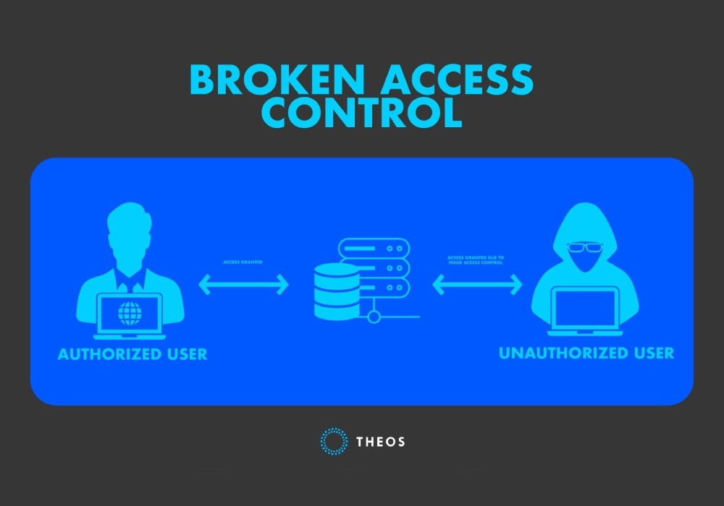

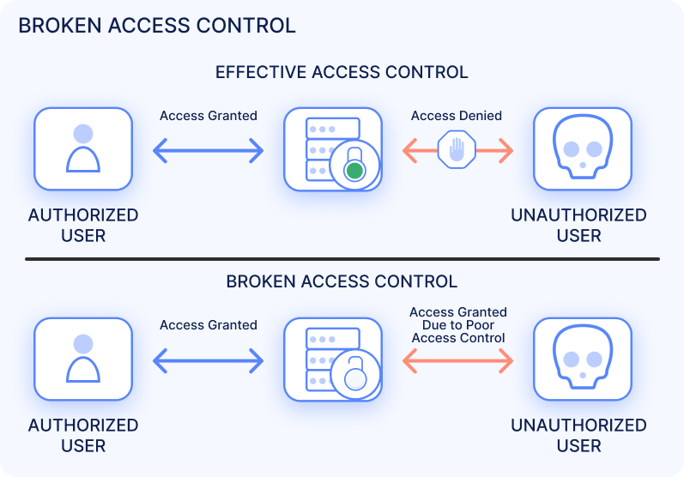

2. Vulnerability Name: Information Exposure (HTTP (Multiple Issues))
CWE: 200
Description: Information Exposure is a vulnerability where sensitive information is unintentionally revealed through HTTP responses, headers, or error messages. This may include server details, internal IP addresses, software versions, framework information, or configuration data. Attackers can use this exposed information to understand the application environment and identify additional vulnerabilities that can be exploited.
Business Impact: If sensitive information is exposed, attackers can collect details about the server configuration and technology stack. This information can help them plan targeted attacks such as exploiting outdated software, gaining unauthorized access, or discovering other vulnerabilities in the system. This may result in data breaches, financial loss, service disruption, and damage to the organization’s reputation.
Vulnerability Path: https://example.com/login
Vulnerability Parameter: https://example.com/login?error=debug
Steps to Reproduce:
• Open the vulnerable URL in a browser or intercept the request using a security testing tool like Burp Suite.
• Send the HTTP request to the server.
• Observe the HTTP response headers and page response.
• The response reveals sensitive information such as server type, framework version, or internal system details.
• This confirms the presence of an Information Exposure (HTTP) vulnerability.
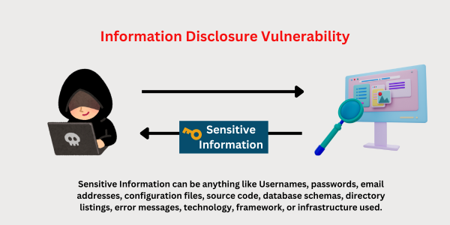



3. . Vulnerability Name: Cross-Site Request Forgery
CWE: 352
Description: Cross-Site Request Forgery (CSRF) is a web security vulnerability where an attacker tricks an authenticated user into performing an unwanted action on a web application without their knowledge. This happens because the application does not properly verify whether the request was intentionally made by the user. When a victim who is already logged in visits a malicious website or clicks a crafted link, the attacker can send unauthorized requests to the application using the victim’s session.
Business Impact: If a CSRF vulnerability exists, attackers can perform actions on behalf of the victim user without their permission. This may include changing account details, updating passwords, making transactions, or modifying sensitive information. Such attacks can lead to unauthorized account activity, financial loss, data manipulation, and damage to the organization’s reputation and user trust.
Vulnerability Path: https://example.com/account/update-profile
Vulnerability Parameter: https://example.com/account/update-profile?email=test@example.com

Steps to Reproduce:
• Log in to the web application with a valid user account.
• Navigate to a sensitive function such as profile update or password change.
• Capture the HTTP request using a testing tool like Burp Suite.
• Observe that the request does not contain a CSRF token or proper validation.
• Create a malicious request or HTML form that automatically sends the same request.
• When the logged-in victim opens the malicious page, the request is executed without the user’s consent, confirming the CSRF vulnerability.

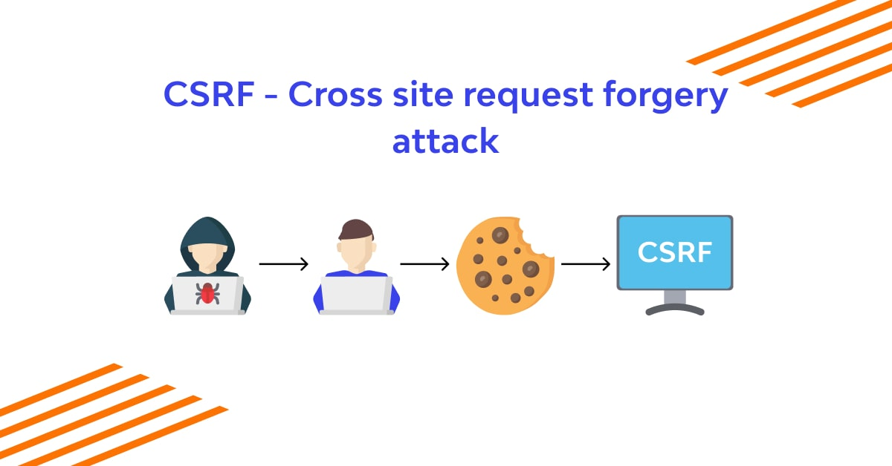

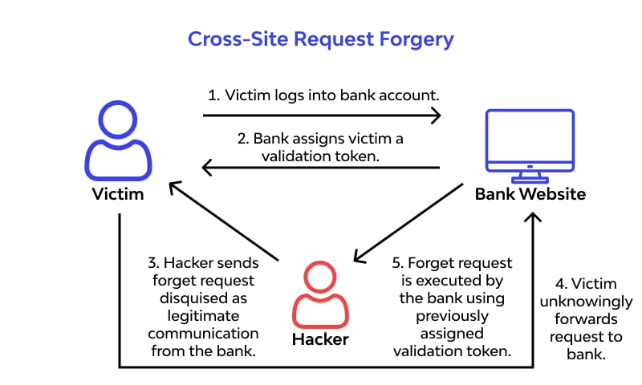

4. Vulnerability Name: JQuery 1.2 < 3.5.0 Multiple XSS
CWE: 79
Description: Cross-Site Request Forgery (CSRF) is a web security vulnerability where an attacker tricks an authenticated user into performing an unwanted action on a web application without their knowledge. This happens because the application does not properly verify whether the request was intentionally made by the user. When a victim who is already logged in visits a malicious website or clicks a crafted link, the attacker can send unauthorized requests to the application using the victim’s session.
Business Impact: If a CSRF vulnerability exists, attackers can perform actions on behalf of the victim user without their permission. This may include changing account details, updating passwords, making transactions, or modifying sensitive information. Such attacks can lead to unauthorized account activity, financial loss, data manipulation, and damage to the organization’s reputation and user trust.
Vulnerability Path: https://example.com/account/update-profile
Vulnerability Parameter: https://example.com/account/update-profile?email=test@example.com
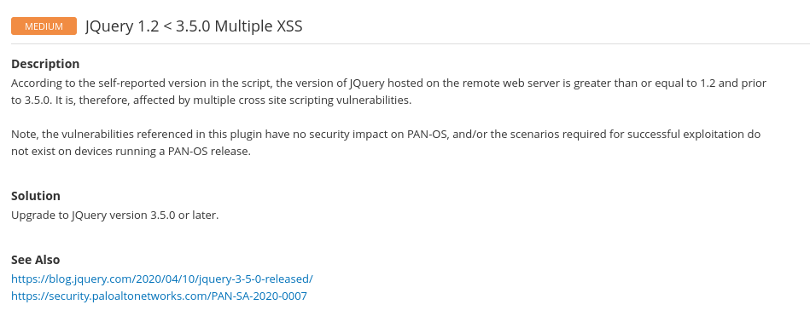

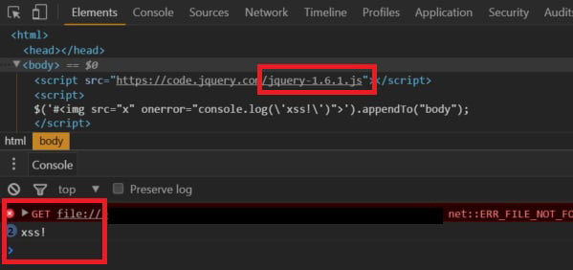

5.Vulnerability Name: Cleartext Transmission of Sensitive Information
CWE: 319
Description: Cleartext Transmission of Sensitive Information occurs when sensitive data such as usernames, passwords, session IDs, credit card details, or personal data is transmitted over the network without encryption.
This usually happens when applications use HTTP instead of HTTPS, allowing attackers to intercept the data through network sniffing or man-in-the-middle attacks
Business Impact:
- Attackers may steal user credentials.
- Sensitive customer data may be exposed or leaked.
- Can lead to account takeover attacks.
- May cause financial loss and legal penalties.
- Damages company reputation and customer trust.
Vulnerability Path: http://example.com/login
Vulnerability Parameter: username=admin password=123456
Step to Reproduce:
• Open the vulnerable application in a browser.
• Navigate to the login page or any form that sends sensitive data.
• Intercept the request using a tool like Burp Suite or Wireshark.
• Submit the login credentials.
• Observe the request in the proxy or packet capture.
• Verify that sensitive information (like username or password) is visible in plain text without encryption.


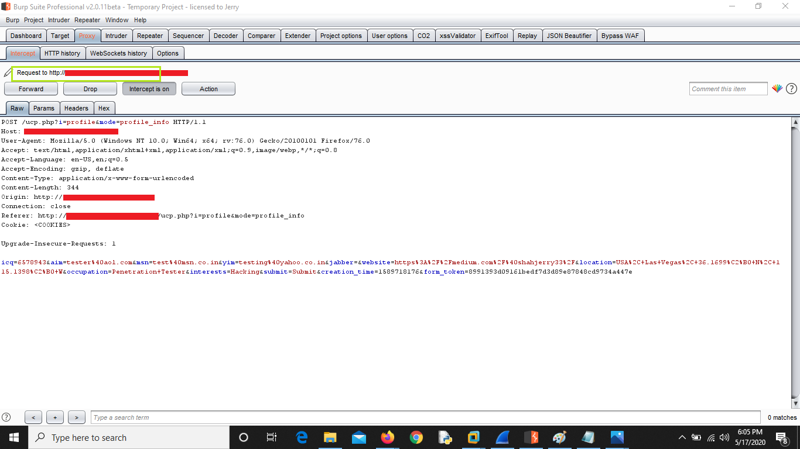

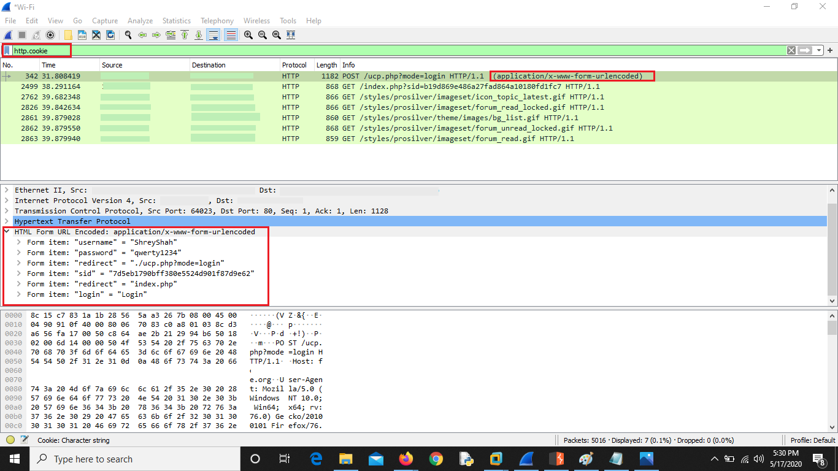

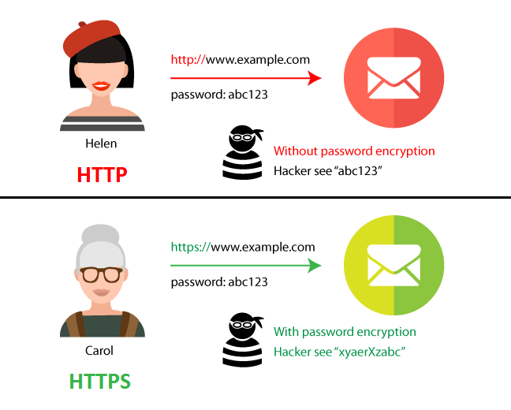
6.Vulnerability Name: Information Exposure Web ServerHTTPHeader Internal IP Disclosure.
CWE: 200
Description: Information Exposure through HTTP Headers occurs when the web server reveals internal IP addresses or infrastructure details in the HTTP response headers.
This usually happens due to server misconfiguration where headers such as X-Forwarded-For, Via, X-Backend-Server, or other debug headers expose internal network information.
Business Impact:
• Attackers may gain internal network information.
• Helps attackers perform targeted attacks on internal servers.
• May assist in network reconnaissance and lateral movement.
• Could lead to further exploitation of internal systems.
• Increases overall security risk of the organization.
Vulnerability Path: https://example.com/
Vulnerability Parameter: No specific parameter required.
Steps to Reproduce:
• Open the target web application in a browser.
• Capture the HTTP request using a tool such as Burp Suite or OWASP ZAP.
• Send the request to the server.
• Inspect the HTTP response headers.
• Check for headers revealing internal IP addresses such as:
- X-Forwarded-For
- X-Backend-Server
- Via
• If an internal IP address (e.g., 10.x.x.x, 192.168.x.x, 172.16.x.x) is visible in the response headers, the vulnerability is confirmed.
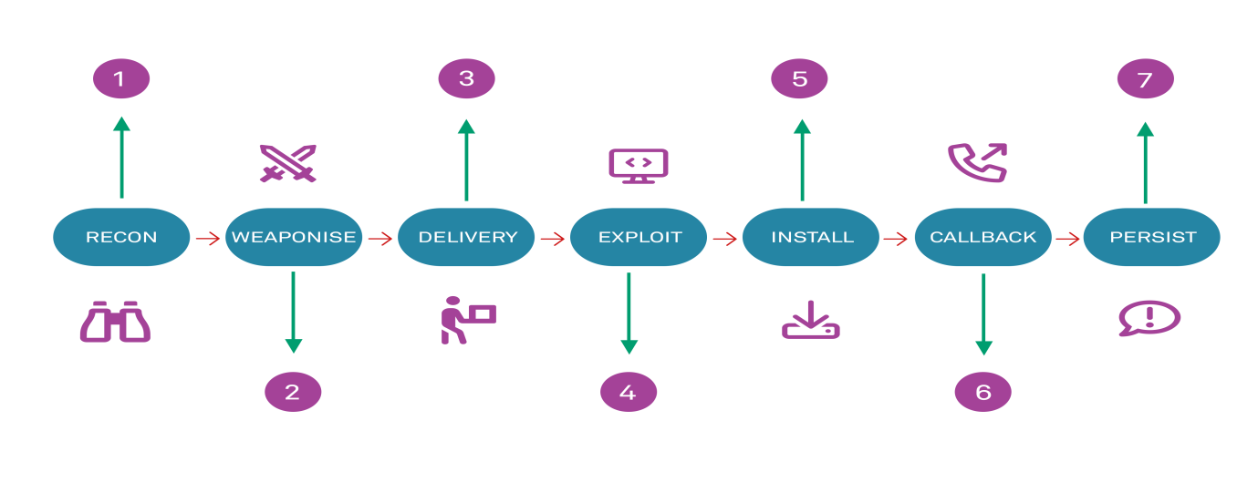
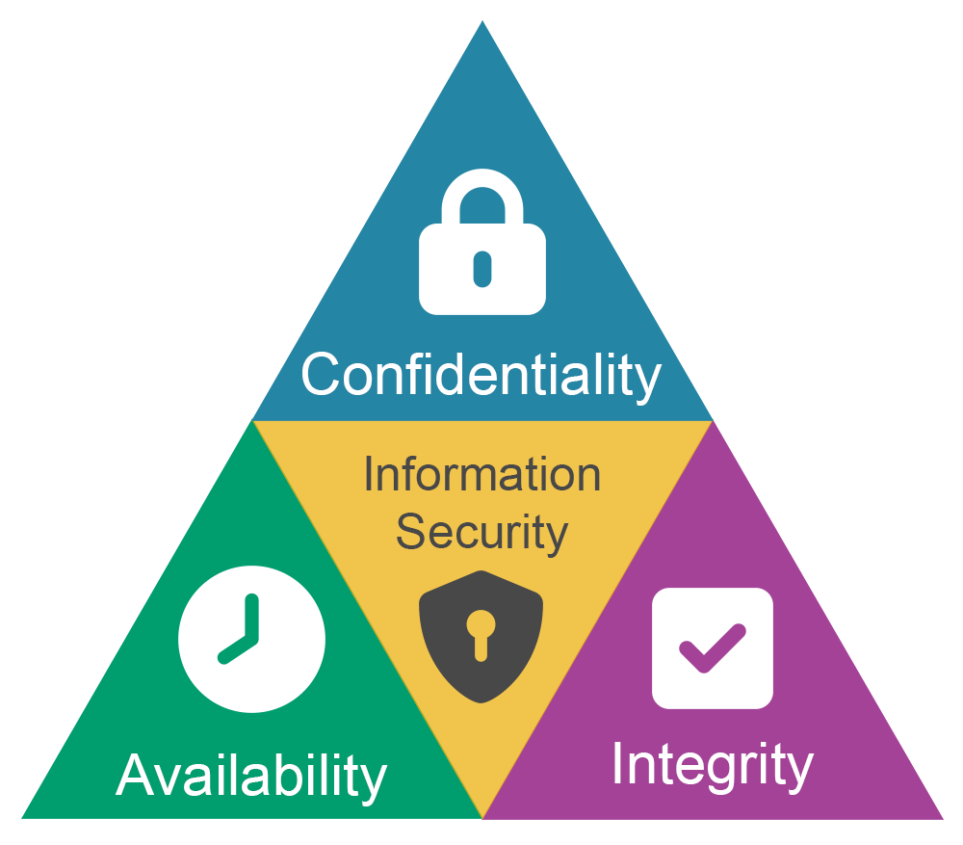
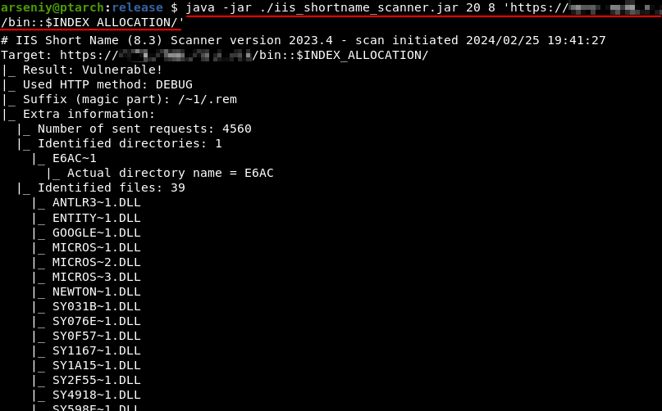.
7.Vulnerability Name: webserver allows password auto-completion.
CWE: 310
Description: The vulnerability occurs when a web application allows browsers to automatically store and fill login credentials in the password field. This happens when the login form does not disable the browser’s autocomplete feature.
Business Impact:
• Unauthorized users may access saved credentials from the browser.
• Can lead to account compromise if the system is shared.
• Increases risk of sensitive data exposure.
• May allow attackers to log in without knowing the password.
• Reduces overall security of the authentication system.
Vulnerability Path: https://example.com/login
Vulnerability Parameter: username password
Steps to Reproduce:
- Open the target web application login page.
- Inspect the login form using browser developer tools.
- Locate the password input field in the HTML source code.
- Check whether the attribute autocomplete="off" is missing.
- Enter login credentials and allow the browser to save them.
- Refresh the page and click on the username or password field.
- If the browser automatically suggests or fills the saved password, the vulnerability is confirmed.

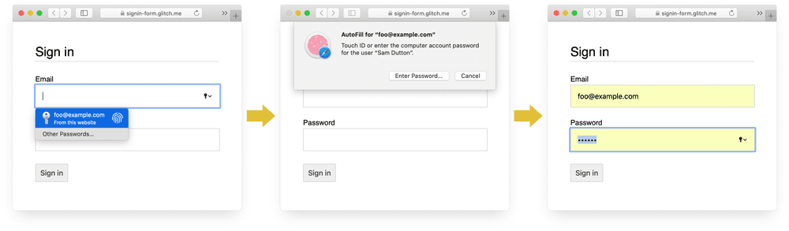

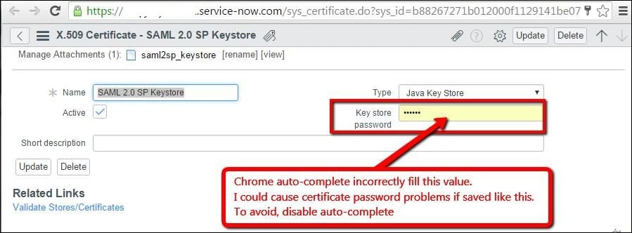

8.Vulnerability Name: Insecure Direct Object Reference.
CWE: 639
Description: Insecure Direct Object Reference (IDOR) occurs when a web application exposes internal object references such as user IDs, file names, or record IDs in the URL or request parameters without proper authorization checks. Attackers can manipulate these values to access other users’ sensitive data.
Business Impact:
• Unauthorized access to sensitive user data.
• Possible data leakage or privacy violation.
• Attackers may modify or delete other users’ data.
• Leads to loss of customer trust and reputational damage.
• May cause legal and compliance issues.
Vulnerability Path: https://example.com/account
Vulnerability Parameter: id=101
Steps to Reproduce:
- Log in to the web application with a valid user account.
- Navigate to a page that displays user-specific information (for example: profile, invoice, or order details).
- Capture the request using a tool like Burp Suite or OWASP ZAP.
- Identify parameters such as id, user_id, account_id, or order_id.
- Modify the parameter value to another number.

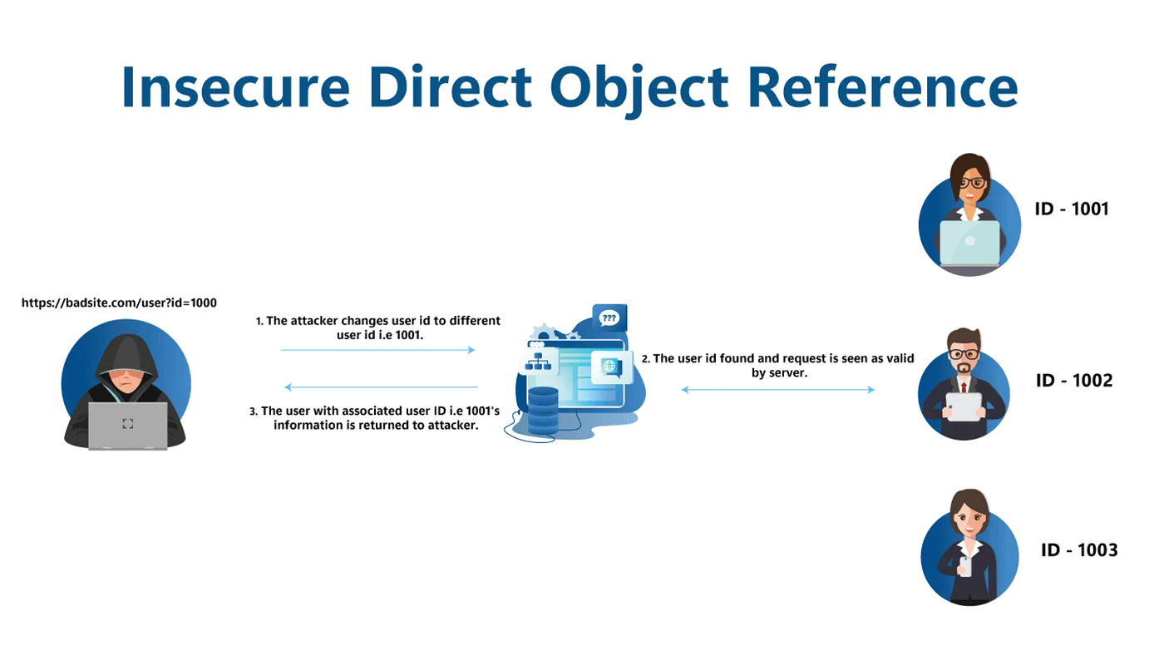
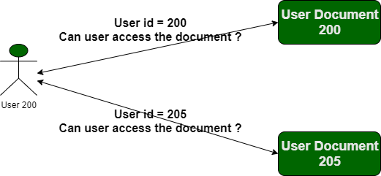
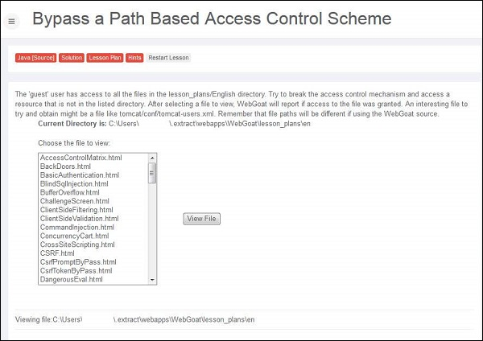
9.Vulnerability Name: SQL Injection
CWE: 89
Description: Insecure Direct Object Reference (IDOR) occurs when a web application exposes internal object references such as user IDs, file names, or record IDs in the URL or request parameters without proper authorization checks.
Business Impact:
- Unauthorized access to sensitive user data.
- Possible data leakage or privacy violation.
- Attackers may modify or delete other users’ data.
- Leads to loss of customer trust and reputational damage.
- May cause legal and compliance issues.
Vulnerability Path: https://example.com/account
Vulnerability Parameter: id=101
Steps to Reproduce:
• Log in to the web application with a valid user account.
• Navigate to a page that displays user-specific information (for example: profile, invoice, or order details).
• Capture the request using a tool like Burp Suite or OWASP ZAP.
• Identify parameters such as id, user_id, account_id, or order_id.
• Modify the parameter value to another number.
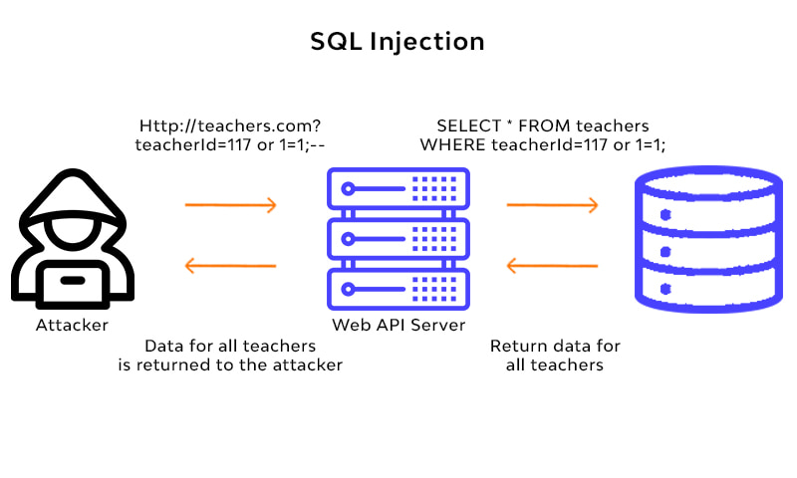
10.Vulnerability Name: Security Misconfiguration.
CWE:732
Description: Security Misconfiguration occurs when a web application, server, or framework is not properly configured, leaving unnecessary features, default settings, or sensitive information exposed.
Common causes include:
- Default credentials enabled
- Unnecessary services running
- Directory listing enabled
- Debug mode enabled
- Missing security headers
These misconfigurations can allow attackers to gain unauthorized access or collect system information.
Business Impact:
• Unauthorized users may access restricted areas.
• Exposure of sensitive system information.
• Attackers may exploit other vulnerabilities more easily.
• Can lead to data breaches or system compromise.
• Causes financial loss and reputation damage.
Vulnerability Path: https://example.com/admin
Vulnerability Parameter: No specific parameter required.
Steps to Reproduce:
• Open the target web application in a browser.
• Use tools such as Burp Suite, Nessus, or Nikto to scan the application.
• Check for common misconfiguration issues such as:
- Directory listing enabled
- Default admin pages accessible
- Debug information displayed
- Server version disclosure
• Try accessing restricted directories manually (e.g., /admin, /backup, /test).
• If sensitive files, directories, or system information are accessible without authorization, the Security Misconfiguration vulnerability is confirmed.

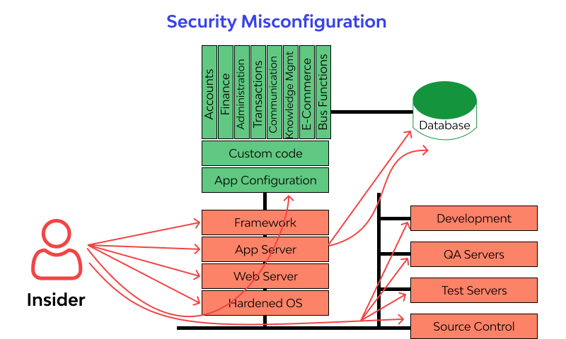

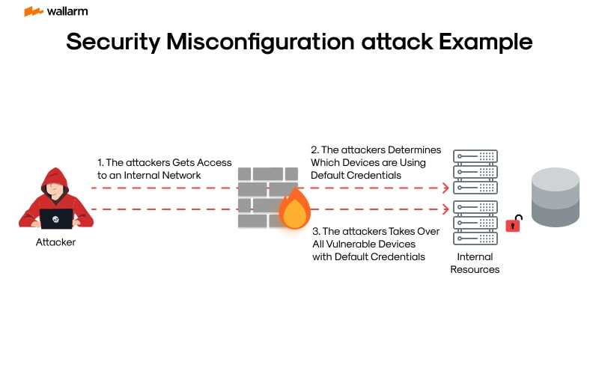

Stage-2

Overview:
Nessus is a widely used vulnerability scanning tool developed by Tenable. It helps organizations identify security vulnerabilities, misconfigurations, and weaknesses in computers, servers, networks, and web applications.
Nessus scans systems and compares them with a large database of known vulnerabilities to detect potential security risks. It is commonly used by cybersecurity professionals, system administrators, and penetration testers to improve system security.
Purpose of Nessus:
The main purpose of Nessus is to detect vulnerabilities before attackers exploit them. It helps organizations identify security weaknesses and fix them to protect their systems and data.
Key Features of Nessus:
• Vulnerability Scanning
Nessus scans systems to find known vulnerabilities such as outdated software, missing patches, and weak configurations.
• Configuration Auditing
It checks system configurations against security best practices and compliance standards.
• Malware Detection
Nessus can detect malware infections and suspicious activity in the system.
• Sensitive Data Discovery
It identifies sensitive information such as passwords or personal data stored in insecure locations.
• Compliance Checks
Nessus helps organizations meet compliance standards like PCI-DSS, HIPAA, and ISO.
Nessus Works:
- The user installs and configures the Nessus scanner.
- The scanner targets specific IP addresses, domains, or networks.
- Nessus performs different tests on the system using thousands of plugins.
- It identifies vulnerabilities and assigns them a severity level.
- A detailed report is generated with risk level, description, and recommended fixes.

Types of Scan In Nessus:
• Basic Network Scan – Scans networks for vulnerabilities.
• Advanced Scan – Allows customized scanning options.
• Web Application Scan – Detects vulnerabilities in web applications.
• Credentialed Scan – Uses login credentials to scan systems deeply.
• Compliance Scan – Checks systems against security standards.
Advantages of Nessus:
- Easy to install and use.
- Large database of vulnerability plugins.
- Accurate vulnerability detection.
- Detailed and easy-to-understand reports.
- Regular updates for new security threat.

S.NO | Vulnerability Name | Severity | Pulgins
1. | Cleartext Transmission of Sensitive Information | Medium | SSL/TLS Cleartext Detection Plugin
2. | Information Exposure – Internal IP Disclosure | Low | Web Server HTTP Header Internal IP Disclosure
3. | Web Server Allows Password Auto-Completion | Low | Web Server Allows Password Auto-Completion Plugin
4. | Insecure Direct Object Reference (IDOR) | Medium | Web Application IDOR Detection Plugin
5. | SQL Injection | Critical | SQL Injection Detection Plugin
6. | Security Misconfiguration | Medium | Web Server Misconfiguration Plugin
7. | Missing Security Headers | Low | HTTP Security Header Not Detected Plugin
8. | Directory Listing Enabled | Medium | Web Directory Listing Plugin
9. | Outdated Web Server Version | High | Web Server Version Detection Plugin
10. | SSL Certificate Cannot Be Trusted | Medium | SSL Certificate Trust Plugin

Target Website: http://testfire.net/
Target IP Address: 65.61.137.117
Report:
1.Vulnerability Name: Cleartext Transmission of Sensitive Information.
Severity: Medium.
Pulgins: SSL/TLS Cleartext Detection Plugin
Port : HTTP
Description: Cleartext Transmission of Sensitive Information is a security vulnerability where sensitive data such as usernames, passwords, session IDs, or personal information is transmitted over the network in plain text without encryption.
Because the data is not encrypted, attackers who intercept the network traffic can easily read or steal the information using packet sniffing tools like Wireshark.
This usually happens when websites use HTTP instead of HTTPS.
Solution:
• Use HTTPS instead of HTTP for all web pages.
• Implement SSL/TLS encryption to protect data in transit.
• Disable insecure protocols like Telnet and FTP.
• Use secure protocols such as SSH, SFTP, and HTTPS.
• Implement HSTS (HTTP Strict Transport Security)
Business Impact:
• Attackers can capture sensitive information like usernames and passwords.
• Leads to unauthorized account access.
• Customer data may be exposed or stolen.
• Causes financial loss and reputational damage to the organization.
• May lead to legal or compliance issues.

2.Vulnerability Name: Information Exposure – Internal IP Disclosure.
Severity: Low
Pulgins: Web Server HTTP Header Internal IP Disclosure.
Port: HTTPS
Description: Information Exposure – Internal IP Disclosure occurs when a web server reveals its internal private IP address in HTTP headers, error messages, or server responses.
Internal IP addresses (for example 192.168.x.x, 10.x.x.x, 172.16.x.x) should normally remain hidden from external users. When they are exposed, attackers can learn about the internal network structure of the organization.
Solution:
• Configure the web server to hide internal IP addresses in HTTP headers.
• Remove unnecessary headers such as X-Powered-By, X-Forwarded-For, Server.
• Use reverse proxy or firewall to filter sensitive information.
• Disable detailed error messages on production servers.
• Regularly scan the server using vulnerability scanners like Nessus.
Business Impact:
• Attackers can gather internal network information.
• Helps attackers plan further attacks on internal systems.
• May assist in network mapping and reconnaissance.
• Increases risk of targeted cyber attacks.
• Can expose sensitive infrastructure details.

3. Vulnerability Name: Web Server Allows Password Auto-Completion.
Severity: Low
Pulgins: Web Application IDOR Detection Plugin
Port: HTTP
Description: Web Server Allows Password Auto-Completion is a vulnerability where the login form allows the browser to store and automatically fill usernames and passwords.
This happens when the login page does not disable the browser’s autocomplete feature in the password field. If a user saves their credentials, anyone with access to the same device can view or use those saved passwords.
Solution:
- Disable browser autocomplete for sensitive fields.
Example:
<input type="password" name="password" autocomplete="off">
- Use multi-factor authentication (MFA).
- Avoid storing sensitive credentials in browsers.
- Implement secure session management.
- Educate users to avoid saving passwords on shared systems.
Business Impact:
• Unauthorized users may access saved credentials.
• Can lead to account compromise.
• Sensitive login information may be exposed.
• Increases risk when shared or public computers are used.
• May lead to unauthorized access to company systems.

4. Vulnerability Name: Insecure Direct Object Reference (IDOR)
Severity: Medium
Pulgins: Web Application IDOR Detection Plugin
Port: HTTPS
Description: Insecure Direct Object Reference (IDOR) is a vulnerability that occurs when a web application exposes internal object references such as user IDs, file names, or account numbers in the URL or request parameters without proper authorization checks.

Solution:
• Implement proper access control and authorization checks.
• Validate whether the user is authorized to access the requested object.
• Avoid exposing direct object references in URLs.
• Use randomized or encrypted identifiers instead of sequential IDs.
• Perform regular security testing and vulnerability scanning.
Business Impact:
- Unauthorized access to sensitive user data.
- Attackers may view, modify, or delete other users' information.
- Leads to data breaches and privacy violations.
- Causes loss of customer trust.
- May result in legal and compliance.
5.Vulnerability Name: SQL Injection.
Severity: Critical
Pulgins: SQL Injection Detection Plugin.
Port: HTTP
Description: SQL Injection is a web security vulnerability where an attacker inserts malicious SQL queries into input fields (like login forms, search boxes).
If the application does not properly validate user input, the attacker can access, modify, or delete data from the database.
Solution:
• Use Prepared Statements / Parameterized Queries
• Implement Input Validation and Sanitization
• Use Web Application Firewall (WAF)
• Apply Least Privilege to database accounts
• Keep software and frameworks updated
• Use ORM frameworks to prevent direct SQL queries

Business Impact:
• Data Breach – Sensitive customer data may be stolen
• Unauthorized Access – Attackers may log in as admin
• Data Loss or Modification – Important records may be deleted or changed
• Financial Loss – Due to fraud or system recovery costs
• Reputation Damage – Customers may lose trust in the company
• Legal Issues – Companies may face legal penalties for data leaks
6.Vulnerability Name: Security Misconfiguration.
Severity: Medium
Pulgins: Web Server Misconfiguration Plugin.
Port: MySql database
Description: Security Misconfiguration is a vulnerability that occurs when a system, server, database, or application is not securely configured.
This may happen due to default settings, unnecessary services, open ports, or improper permissions. Attackers can exploit these weaknesses to gain unauthorized access to the system.
Solution:
• Change default usernames and passwords
• Disable unnecessary services and ports
• Implement proper access control
• Regularly update and patch systems
• Follow secure configuration guidelines
• Perform regular vulnerability scanning and security testing
Business Impact:
• Unauthorized access to systems
• Exposure of sensitive data
• System compromise or hacking
• Service downtime and business disruption
• Financial loss
• Damage to company reputation.
7.Vulnerabiliy Name: Missing Security Headers.
Severity: Low
Pulgins: HTTP Security Header Not Detected Plugin
Port: HTTPS
Description: Missing Security Headers is a vulnerability that occurs when important HTTP security headers are not configured in the web server or application.
Security headers help protect websites from attacks like Cross-Site Scripting (XSS), Clickjacking, and data injection.
If these headers are missing, attackers may exploit the website more easily.
Solution:
• Configure and enable all required HTTP security headers on the web server.
• Implement Content Security Policy (CSP) to prevent script injection.
• Enable X-Frame-Options to protect against clickjacking.
• Use Strict-Transport-Security (HSTS) to enforce HTTPS connections.
• Regularly test the website using security scanning tools.
Business Impact:
- Increased risk of web attacks such as XSS and clickjacking
- User data exposure
- Unauthorized actions performed on behalf of users
- Loss of customer trust
- Reputation damage
- Possible financial and legal consequences.
- Vulnerability Name: Directory Listing Enabled.
Severity:Medium
Pulgin: Web Directory Listing Plugin.
Port: HTTP
Discription: Directory Listing Enabled is a web server misconfiguration where the server automatically displays the contents of a directory when there is no default index file (such as index.html or index.php). This allows anyone to view the list of files and folders stored in that directory through a web browser. Attackers may use this information to access sensitive files such as backup files, configuration files, scripts, or other internal resources.
Solution:
Disable directory listing in the web server configuration.
• Apache: Add Options -Indexes in the configuration or .htaccess file.
• Nginx: Set autoindex off; in the server configuration.
• Ensure that sensitive files (backups, configs, logs) are not stored inside the web root directory.
• Implement proper access controls and permissions.
Business Impact:
• Exposure of sensitive files and internal resources.
• Attackers can understand the website structure and discover hidden files.
• Possible leakage of source code, configuration files, or credentials.
• Increased risk of further attacks such as server compromise or data breaches.
• Potential damage to company reputation and customer trust.
- Vulnerability Name: Outdated Web Server Version.
Severity: High
Pulgin: Web Server Version Detection Plugin.
Port: HTTPS
Description: Outdated Web Server Version refers to a situation where the web server software (such as Apache, Nginx, IIS, etc.) is running an old or unsupported version. Older versions may contain known security vulnerabilities that attackers can exploit. These vulnerabilities are often publicly documented, making it easier for attackers to target systems that have not been updated.
Solution:
Regularly update and patch the web server to the latest stable version.
Apply security updates and patches provided by the vendor.
Enable automatic updates where possible.
Remove or disable unnecessary modules and services.
Use vulnerability scanning tools to regularly check for outdated software.

Business Impact:
Attackers may exploit known vulnerabilities in outdated server versions.
Possibility of remote code execution, server compromise, or data breaches.
Website defacement or service disruption.
Loss of sensitive data and customer information.
Damage to company reputation and potential financial loss.
- Vulnerability Name: SSL Certificate Cannot Be Trusted.
Severity: High
Pulgin: SSL Certificate Trust Plugin.
Port: SSL
Description:

SSL Certificate Cannot Be Trusted occurs when the website uses an SSL/TLS certificate that is not issued by a trusted Certificate Authority (CA), is self-signed, expired, or incorrectly configured. Because of this, the browser cannot verify the authenticity of the server. Users may receive a security warning when accessing the website, indicating that the connection may not be secure. This weakens trust and may allow attackers to perform Man-in-the-Middle (MITM) attacks.
Solution:
Install an SSL/TLS certificate issued by a trusted Certificate Authority (CA).
Ensure the certificate is valid, not expired, and properly configured.
Configure the complete certificate chain (Intermediate + Root certificates).
Regularly monitor and renew SSL certificates before expiration.
Use strong TLS configurations and disable insecure protocols.
Business Impact:
Users may see browser security warnings, reducing trust in the website.
Increased risk of Man-in-the-Middle (MITM) attacks.
Possible interception of sensitive data such as login credentials or personal information.
Loss of customer confidence and potential business reputation damage.
Potential compliance and security policy violations.

Stage-3
Title:
Design and apply context-aware access controls based on user identity, device posture, location, and application risk.
Designing and implementing context-aware access controls is a critical component of a modern Zero Trust security architecture. Instead of relying on traditional perimeter-based security, organizations evaluate every access request dynamically using multiple contextual signals. By analyzing factors such as user identity, device posture, location, and application risk, organizations can make more intelligent security decisions. This approach ensures that only verified and trustworthy users and devices are allowed to access sensitive applications and resources.
User identity forms the foundation of context-aware access control. Integrating with enterprise Identity Providers (IdPs) and enforcing multi-factor authentication (MFA) ensures that users are properly authenticated before accessing any resource. At the same time, device posture verification adds another layer of security by checking whether the device meets required security standards such as updated operating systems, active antivirus protection, and enabled disk encryption. These checks help prevent compromised or insecure devices from becoming entry points for attackers.
Location awareness and application risk assessment further strengthen the security model. By evaluating where a user is connecting from and how sensitive the target application is, organizations can enforce stricter policies for high-risk situations. For example, access from unfamiliar locations, public networks, or high-risk regions may require additional authentication or may be blocked entirely. Similarly, critical applications like financial systems or customer databases can be protected with stronger controls compared to low-risk internal tools.
Overall, context-aware access control enables organizations to create a dynamic, adaptive, and risk-based security environment. Instead of granting broad and permanent access, permissions are continuously evaluated and adjusted based on real-time conditions. This significantly reduces the risk of unauthorized access, data breaches, and lateral movement within the network. By implementing these controls, organizations can effectively strengthen their Zero Trust strategy and ensure that access to critical resources is always verified, monitored, and securely managed.
Implementing context-aware access controls also improves visibility and monitoring across the organization’s digital environment. Security teams gain detailed insights into who is accessing applications, from which device, and under what conditions. This visibility allows organizations to quickly detect unusual behavior, respond to potential threats, and enforce security policies more effectively. As cyber threats continue to evolve, adopting a context-aware access control model helps organizations maintain stronger protection for their critical systems, sensitive data, and business operations while still enabling secure and flexible access for legitimate users.

Conclusion:
Stage1: In conclusion, Furthermore, web application testing plays a vital role in maintaining user trust and ensuring business continuity. By identifying vulnerabilities, performance issues, and functional errors at an early stage, organizations can prevent potential security breaches, system failures, and financial losses. Regular testing also helps developers improve the overall stability and efficiency of applications while ensuring compliance with security standards and best practices. Ultimately, a well-structured web application testing process enables organizations to deliver high-quality, secure, and reliable applications that meet both user expectations and business requirements.
Stage2: In conclusion, the Nessus vulnerability assessment provides a comprehensive overview of the security posture of the tested website. By identifying and categorizing vulnerabilities based on their severity levels, the report helps security teams understand the most critical weaknesses that require immediate attention. Addressing these issues through proper patch management, configuration changes, and security updates can significantly reduce the risk of potential cyberattacks. Overall, the assessment highlights the importance of continuous vulnerability scanning, regular system updates, and proactive security management. Maintaining an ongoing security strategy based on tools like Nessus helps organizations stay prepared against evolving threats and ensures a stronger, more resilient cybersecurity posture.
Stage3: In conclusion, the deployment of Zscaler Private Access (ZPA) represents a significant advancement in adopting a modern Zero Trust security framework. By shifting the focus from traditional network-based security to an identity-driven approach, the organization can ensure that users receive access only to the applications they are authorized to use. This approach greatly reduces the risk of unauthorized access, lateral movement, and exposure of internal resources to external threats. ZPA enhances security by making internal applications invisible to the public internet and establishing secure, direct connections between users and applications. This not only strengthens protection against modern cyber threats but also improves the user experience by providing fast and reliable access for remote and distributed employees. the implementation simplifies network architecture by reducing reliance on traditional VPN solutions and enabling centralized access control. With improved visibility, monitoring capabilities, and policy-based access management, organizations can maintain better control over their digital environment. Overall, adopting Zscaler Private Access helps build a scalable, secure, and future-ready infrastructure that supports modern business operations and ongoing digital transformation.

Future Scope:
Stage1: The future scope of web application testing is expanding rapidly as digital technologies continue to evolve and businesses increasingly rely on web-based platforms. With the growing number of online services such as e-commerce, banking, education, and healthcare systems, the need for reliable and secure web applications is becoming more important than ever. As a result, web application testing will play a crucial role in ensuring that these applications function properly, remain secure, and deliver a smooth user experience.
• Greater Focus on Security
- Cyber threats and data breaches are growing, making security testing, vulnerability assessment, and compliance checks (e.g., GDPR) more critical than ever.
• Mobile and Cross-Browser Testing
- With widespread mobile usage, applications must work seamlessly across different devices, operating systems, and browsers.
• Performance and Scalability Testing
- Testing will emphasize load, stress, and performance testing to ensure applications can handle high traffic, spikes, and latency issues.
• Automation and Continuous Testing
- Use of automated testing tools, AI-driven testing, and CI/CD integration will become standard to improve efficiency and coverage.
• Enhanced Monitoring and Maintenance
- Continuous monitoring, error detection, and updates will be essential to maintain application quality and security in a dynamic environment.
Stage2: Future Scope of the Web Application Testing Process
The future scope of web application testing, especially in terms of identifying vulnerabilities, is highly promising due to the rapid growth of digital platforms, increasing cybersecurity demands, and the constantly evolving threat landscape. As web applications become more complex, testing processes must evolve to address new technologies, deployment models, and attack vectors.
- IoT and Mobile Application Testing
  - With the rise of IoT devices and the widespread use of mobile apps, testing will extend beyond traditional web platforms to ensure the security and functionality of IoT interfaces and mobile applications.
- Blockchain and Cryptocurrency Security
  - As blockchain technology and cryptocurrencies grow, security testing will become essential to protect digital transactions, smart contracts, and blockchain-based applications from exploits.
- Serverless Architecture Testing
  - The adoption of serverless computing introduces new security challenges. Testing processes will need to assess the security of serverless functions, APIs, and cloud-based event-driven workflows to prevent potential vulnerabilities.
- Container and Cloud Security
  - With widespread use of containerization technologies like Docker and orchestration tools like Kubernetes, testing will include verifying container images, configuration security, and deployment pipelines to ensure no vulnerabilities exist in the containerized environment.
- Automated Continuous Testing
  - Automation, CI/CD integration, and continuous security testing will become standard practice, allowing vulnerabilities to be detected early in the development cycle and reducing the time between discovery and remediation.
- Advanced Threat Simulation
  - Future testing will incorporate realistic attack simulations, such as penetration testing using AI-driven threat models, to assess how applications respond to sophisticated, evolving cyber threats.
- Regulatory and Compliance Testing
  - As data privacy regulations like GDPR, CCPA, and industry-specific standards become stricter, testing processes will increasingly include checks for regulatory compliance and secure handling of user data.
Stage3: Future Scope of Context-Aware Access Control (ZPA)
The deployment of Zscaler Private Access (ZPA) establishes a strong foundation for a Zero Trust, identity-centric security model. Looking ahead, several enhancements and innovations can further strengthen organizational security while improving user experience.
Key Future Directions (Stepwise):
- Integration with Zscaler Internet Access (ZIA)
  - Converging ZPA (private access) with ZIA (internet access) to create a unified Secure Access Service Edge (SASE) platform.
  - This allows management of both web and private traffic through a single, centralized policy framework.
- Advanced Device Posture Assessment
  - Moving beyond basic compliance checks to include real-time risk scoring from EDR tools.
  - Access can be blocked automatically if a device shows signs of compromise or unusual behavior.
- Privileged Remote Access
  - Extending secure access to third-party vendors and contractors.
  - Time-bound, audited access can replace traditional jump boxes or bastion hosts, reducing unnecessary exposure.
- IoT and OT Segmentation
  - Applying micro-tunneling principles to Internet of Things (IoT) and Operational Technology (OT) devices.
  - Ensures devices can only communicate with approved management servers, limiting lateral movement.
- AI-Driven Anomaly Detection
  - Using machine learning on access logs to detect unusual behavior, such as logins from unfamiliar locations or unusual times.
  - Triggers automated responses like step-up MFA or temporary access revocation.
- Cloud Workload Protection
  - Securing east-west traffic between containers and microservices in multi-cloud environments (AWS, Azure, GCP).
  - Ensures encrypted and authenticated communication between workloads.
- Automated Provisioning and Deprovisioning
  - Enhancing identity provider integration to automatically revoke access when employees change roles or leave the organization.
  - Ensures near real-time access control and reduces insider risk.
- Digital Experience Monitoring (DEM)
  - Implementing DEM tools to proactively monitor end-user experience, detecting network latency or application performance issues before they impact productivity.

Topic Explored:
1. Zscaler
2. Zero trust
3. ZPA
4. VPN
5. MISP
6. College Network Information
7. Deployment of SOC in the College
8. Threat Intelligence
9. Incident Response

Tools Explored:
▪ Nessus Scanner

