SETTINGUP ENVIRONMNET FOR GIT

GIT is an open source distributed version control system used to track and manage changes within a code repository. It is a Software.

It is a “Command Line” tool and maintained by “LINUX”.

STEPS FOR SETTINGUP GIT ENVIRONMNET

1. Download the GIT usinh”git-scm.com/downloads”

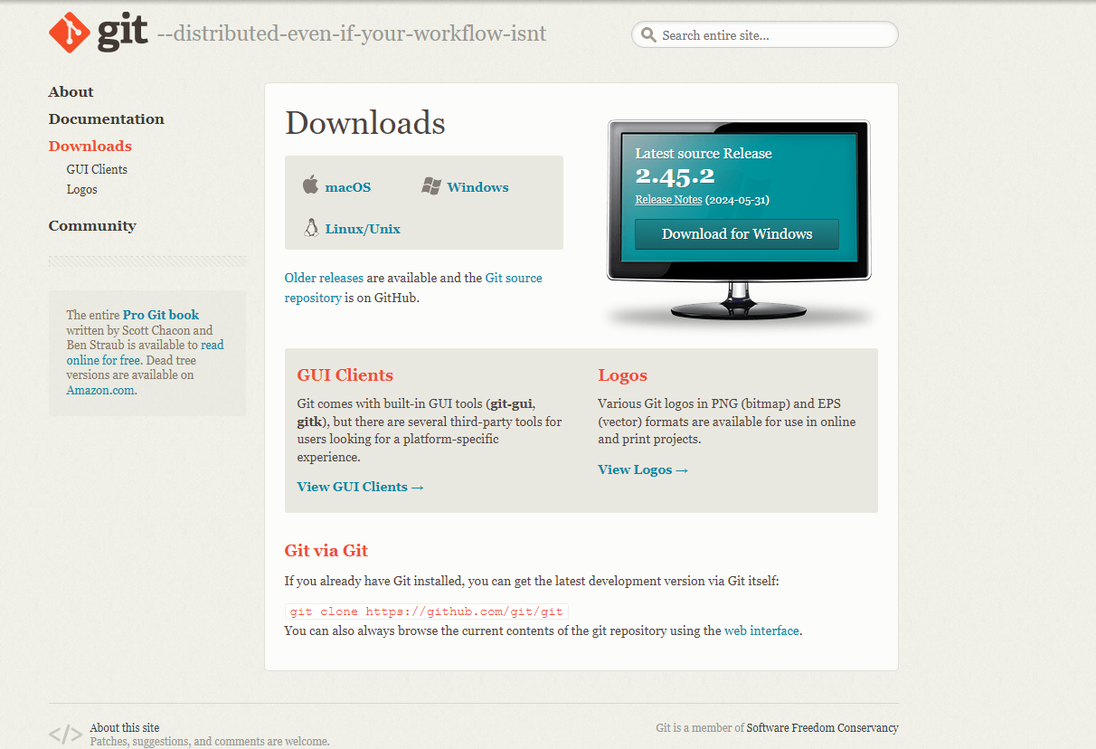

Download the GIT according to your system.

1. Open Command line prompt and type “git –version” to get the version of the GIT

