**SETTINGUP ENVIRONMNET FOR GITHUB**

GitHub is a service. It is hosted on WEB and maintained by Microsoft. It is a hosting service for Git repository. It has a built-in user management feature.

Steps:

Type <https://github.com/> on any web browser.



Click on Signup

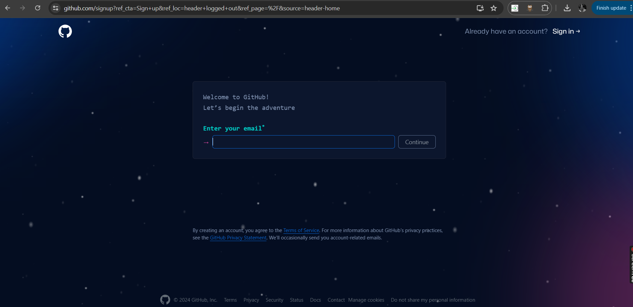

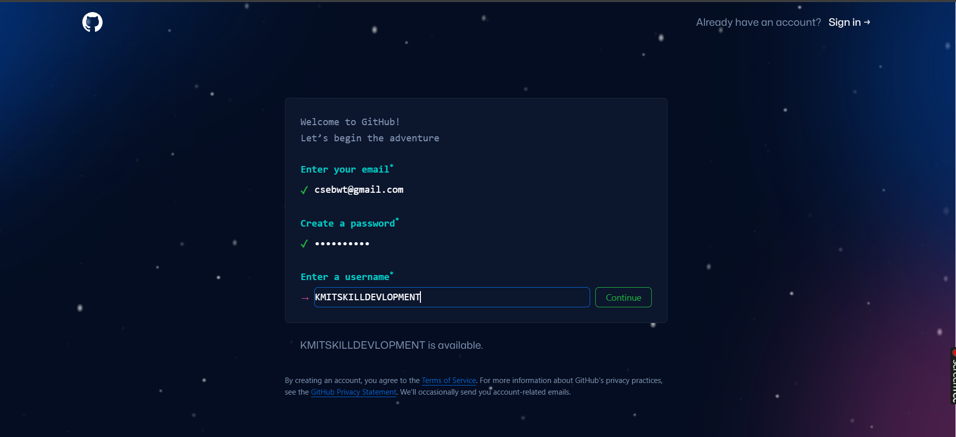

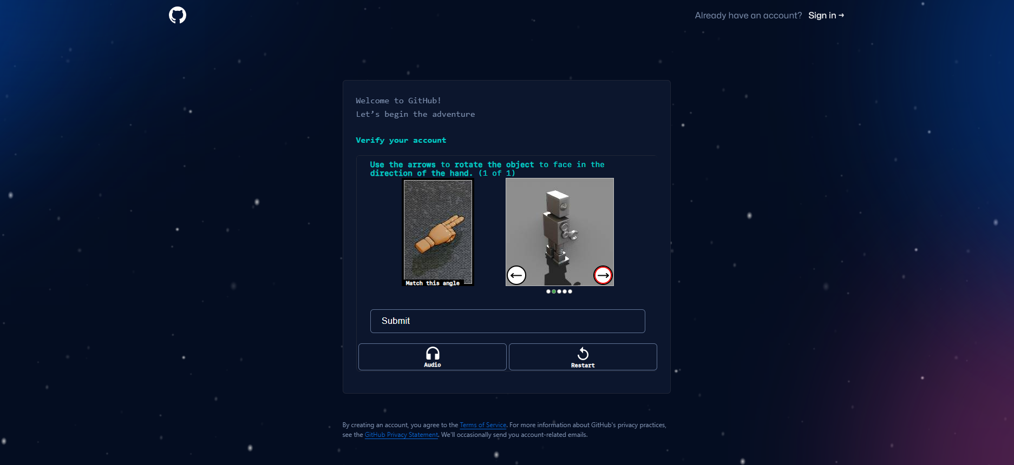

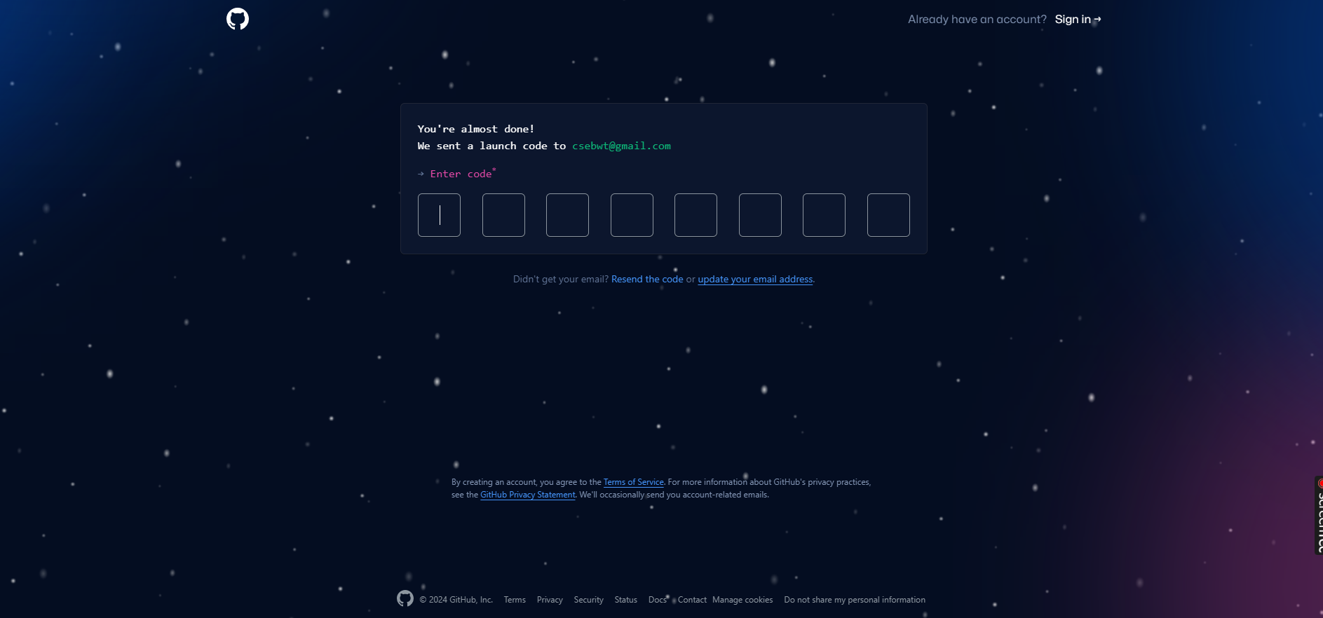

Enter the code in GitHub browser

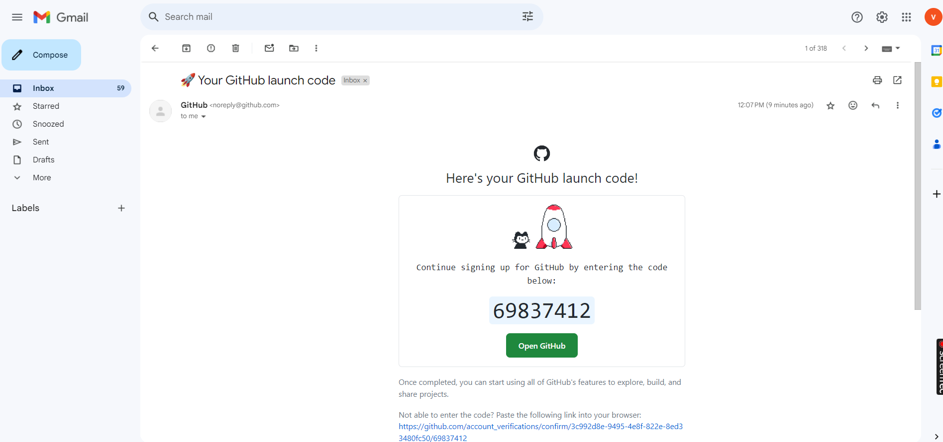

Provide your Credentials and sign into GitHub



Click on Skip Personalization

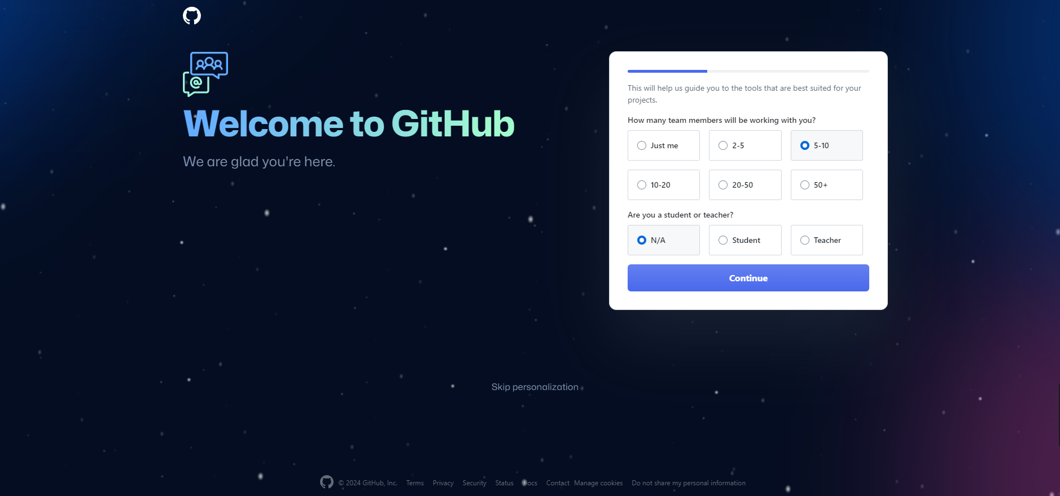

Here we can see the console of the GitHub

Take few seconds to explore it.

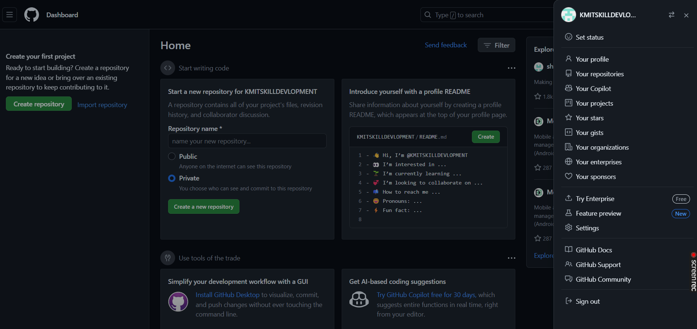

Creation of Repository

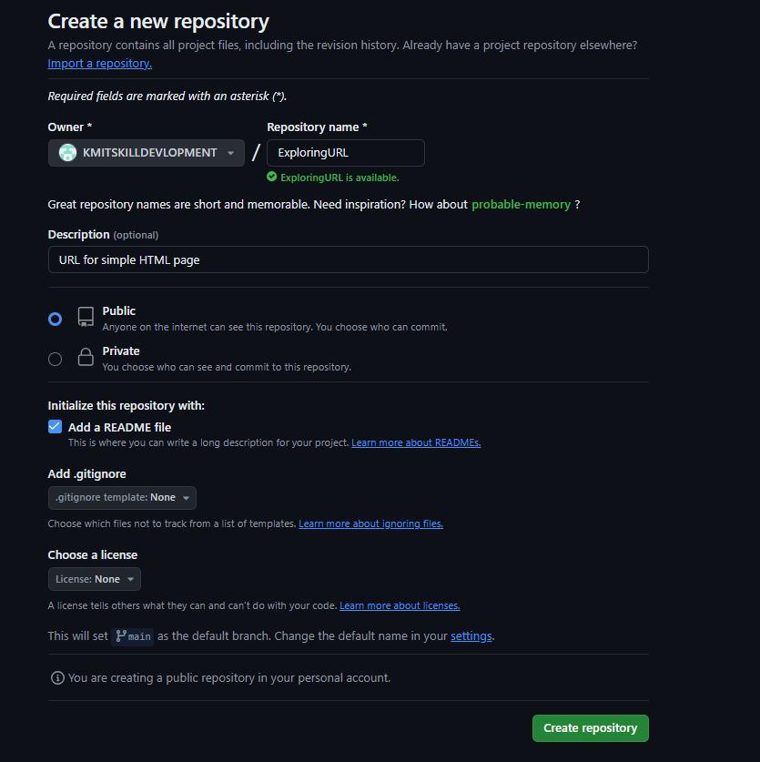

Click on Create repository

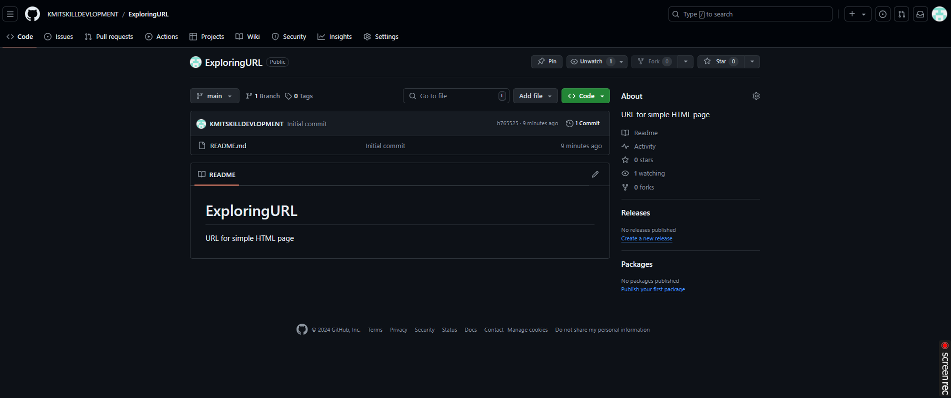

Click on Add files and select upload files

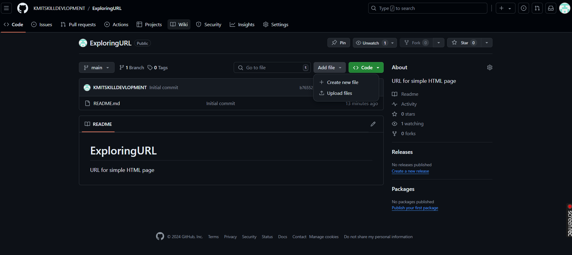

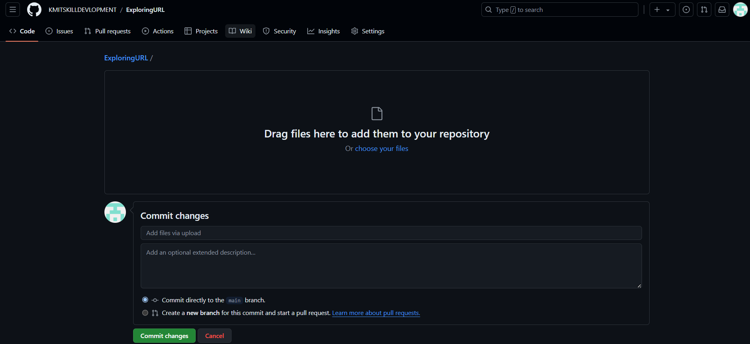

Click on Choose your files and select your file from local system

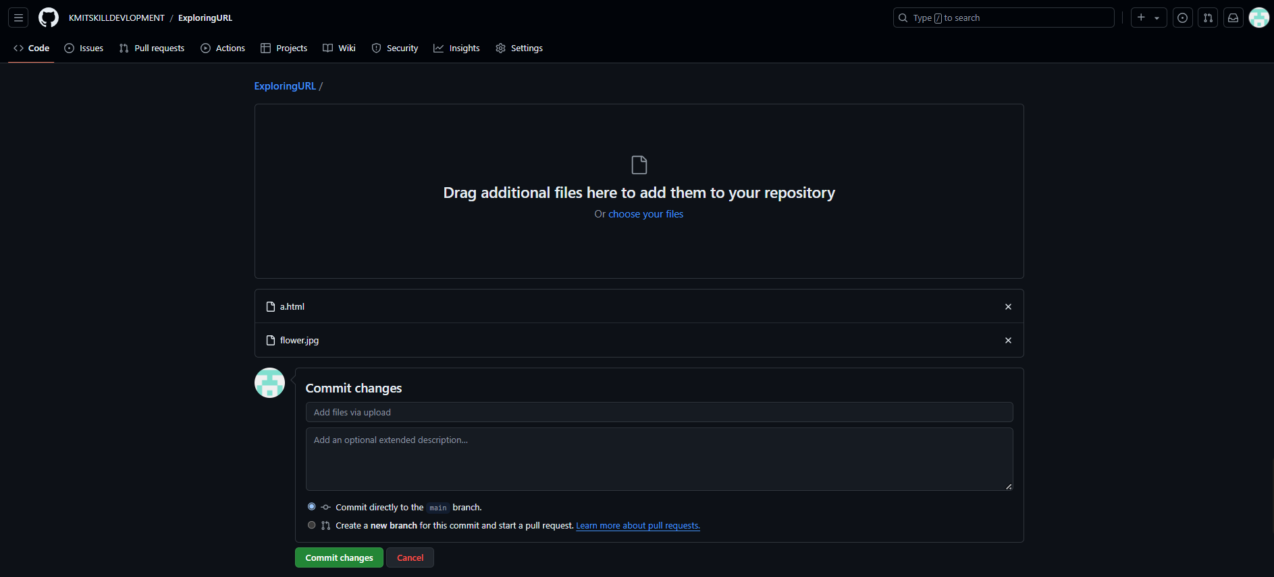

Click on Commit Changes

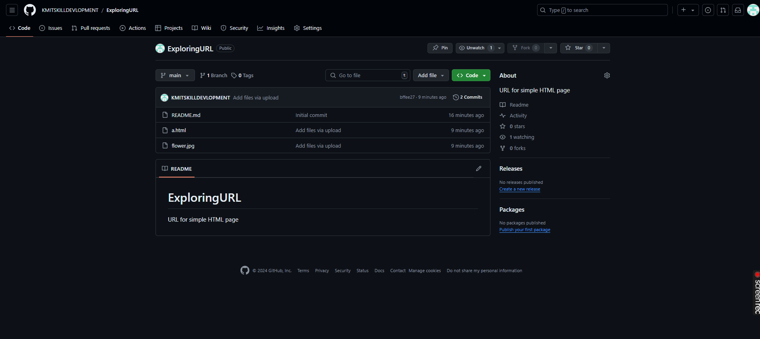

Here we can see our files have been uploaded to the repository.

**To make URL as Public**

Click on Settings

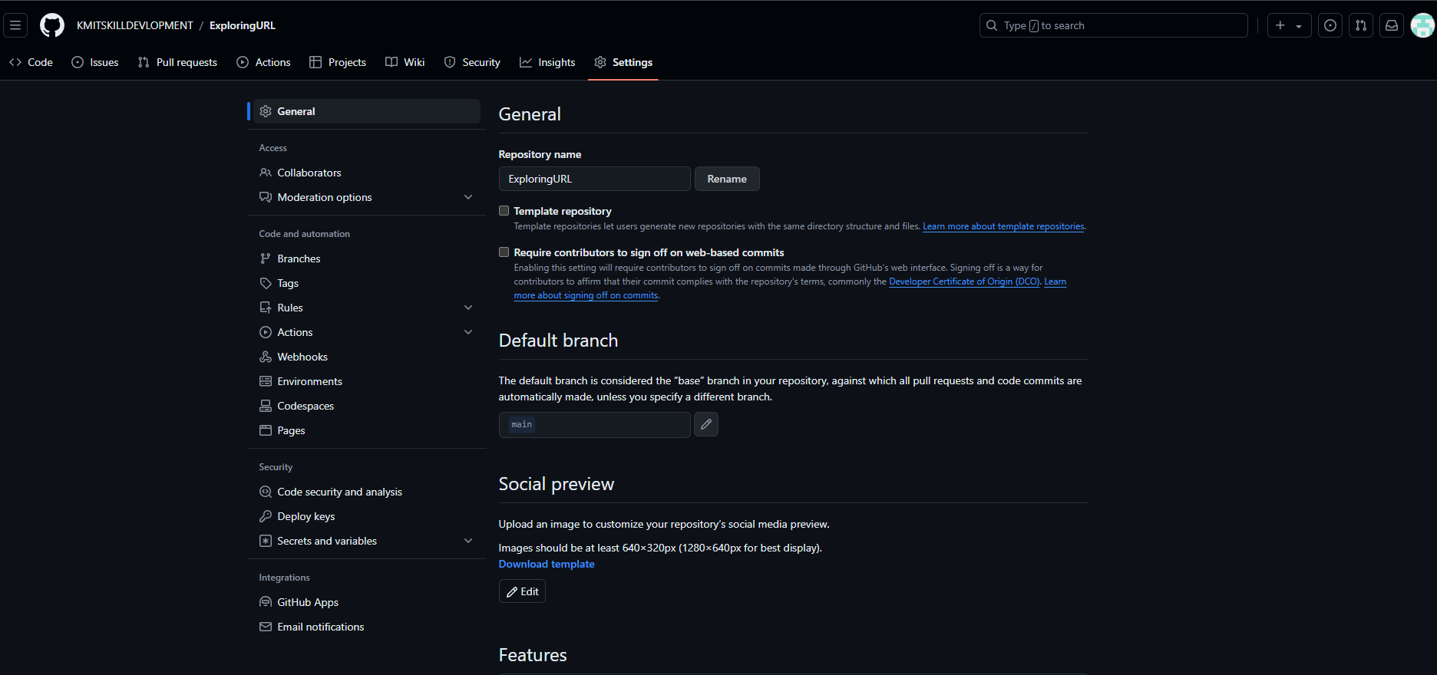

Click on Pages which is on the left side

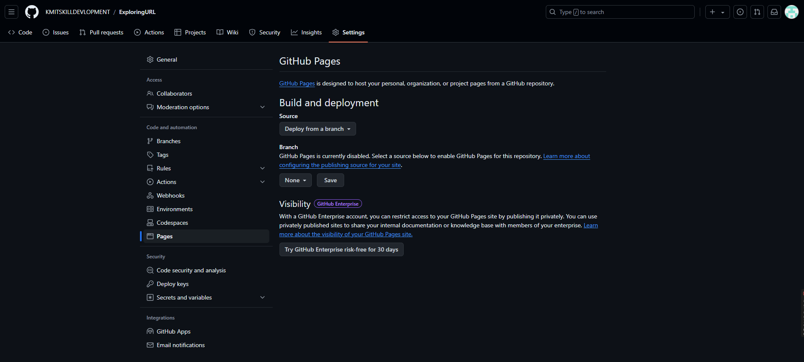

In Branch Section choose the branch i.e., as main

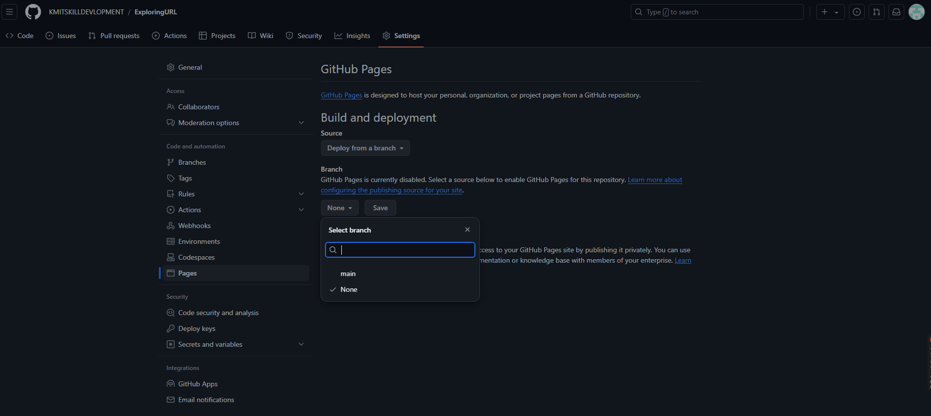

Select /root and click on save

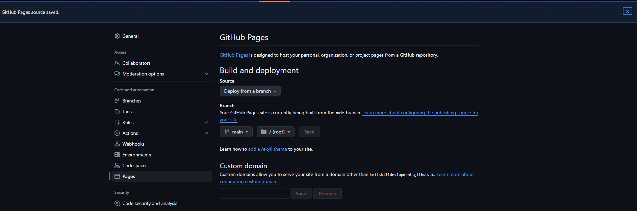

Here we can find our link which can be used as public URL

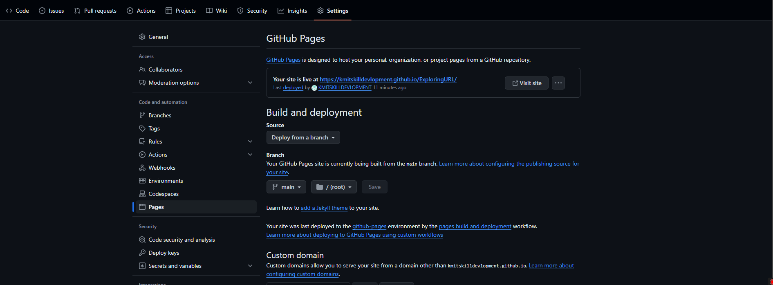

Copy the URL and paste it in browser.

Here we are getting 404 error

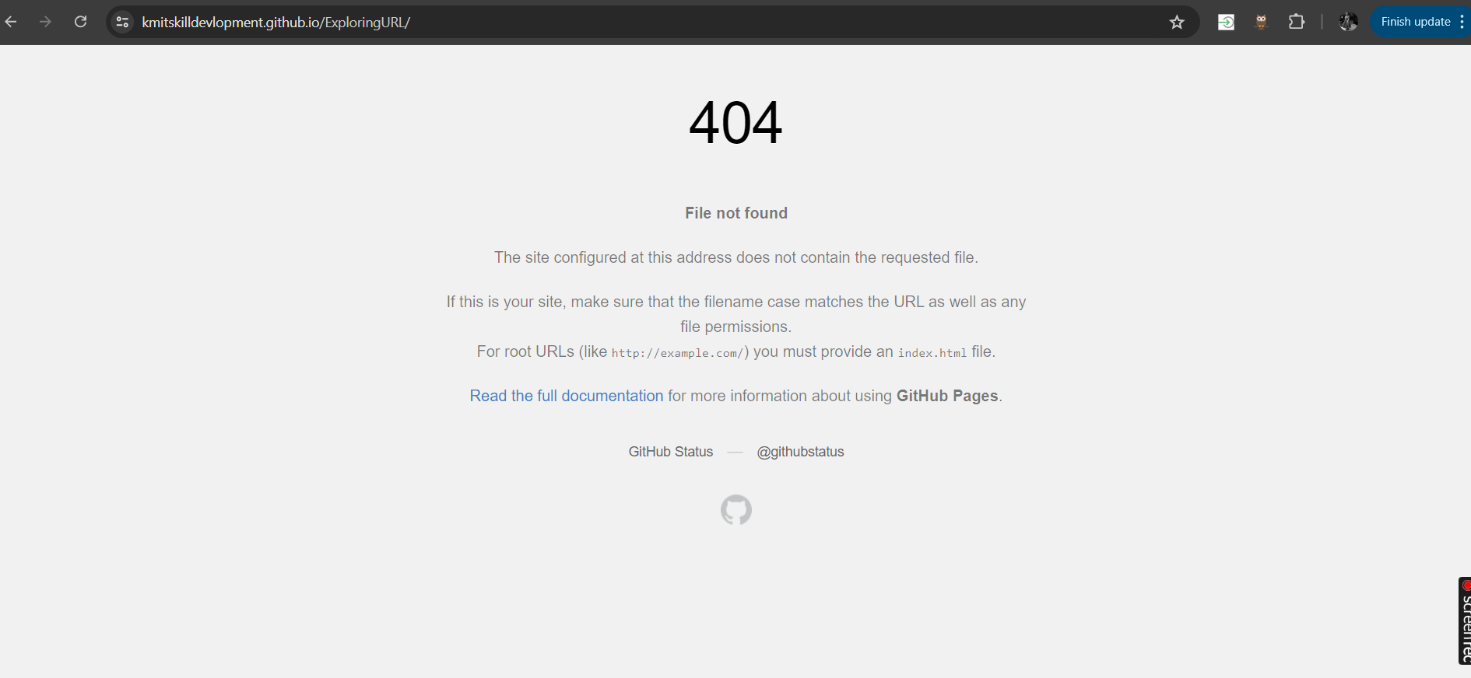

**Troubleshooting**

Let’s check with our files

In the “ExploringURL” Repository we can find a.html which should be renamed as “Index.html”

Note: When we want the URL to be public it is mandatory to have index.html

By renaming “a.html” to “index.html”

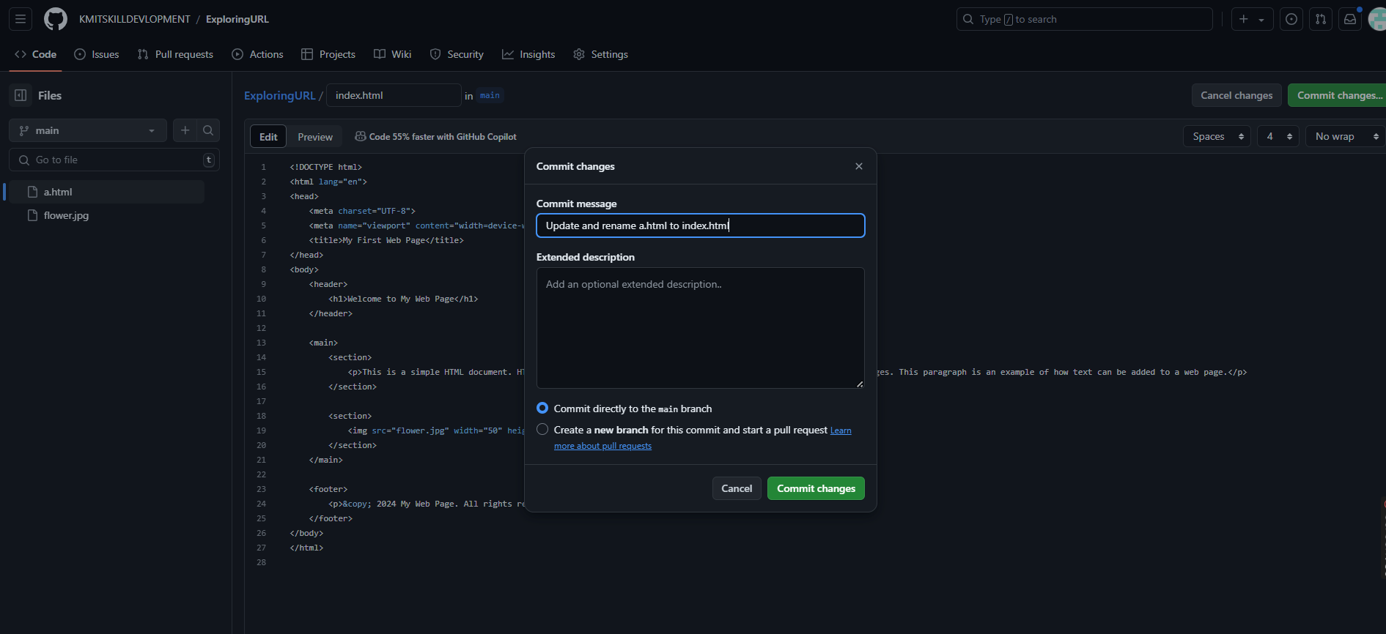

Click on commit changes

Go back to the settings and click on pages and configure the pages so that you get the URL

Final output will be displayed on the screen

This URL can be used by anyone to see your website.

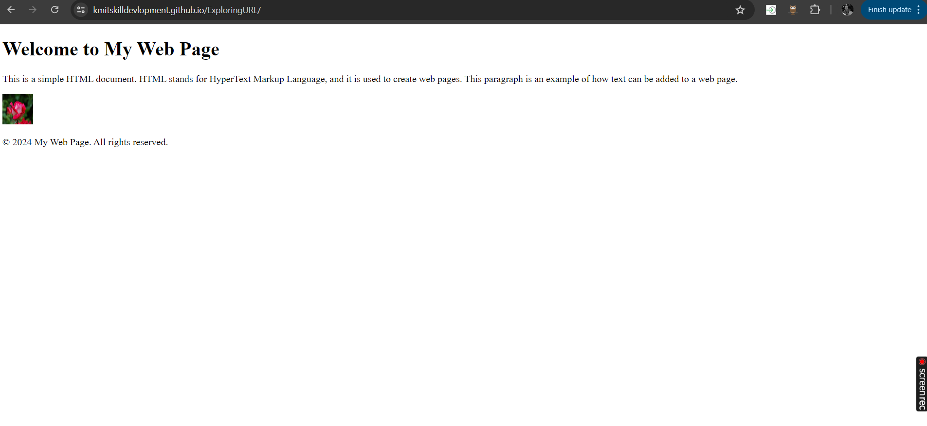

Alternate Method:

In your github URL path by just adding “**box”** beside github gives you the URL as Public.

https://githubbox.com/varsha5592/Sample1