Project Report
Import Data using Transform Maps (ServiceNow)
Team ID | [Team ID]
Project Name | Import Data using Transform Maps (Spreadsheet) – ServiceNow
Team Members | [Member 1], [Member 2], [Member 3], [Member 4]
Platform | ServiceNow (Personal Developer Instance)

1. INTRODUCTION

1.1 Project Overview
This project imports structured employee data from an external spreadsheet into the ServiceNow platform using Import Sets and Transform Maps. It simulates a real-world scenario in which bulk employee data arrives in Excel format and must be migrated into ServiceNow accurately and efficiently.
The spreadsheet (Sample Spreadsheet.xlsx, 15 employee records) is first loaded into an Import Set table (u_employee_import), which acts as a staging area. A Transform Map then maps the source fields to a custom target table, Employee Test (u_employee_test). Coalesce on Employee ID prevents duplicate records on repeated imports, and three reports combined into an Employee Analytics Dashboard give administrators a single view of the data.

1.2 Purpose
- Demonstrate the end-to-end data import process in ServiceNow: data loading, field mapping, transformation execution and result verification.
- Ensure data integrity by using Coalesce so repeated imports update existing records instead of creating duplicates.
- Provide visibility into the imported data through reports (by department, by location, full list) and a dashboard.
- Help beginners understand the staging-table and transform-map concepts through a hands-on micro project.

2. IDEATION PHASE

2.1 Problem Statement
Organizations often receive employee data as Excel files from HR, vendors or external systems. Entering this data manually into ServiceNow is slow and error-prone, and importing the same file twice creates duplicate records. There is a need for a repeatable, validated method to bring spreadsheet data into ServiceNow, update existing records, and monitor the result.
Who has the problem | What is the problem | Why it matters | Impact
HR administrators and ServiceNow admins | Bulk employee data in Excel must be loaded manually; re-imports create duplicates | Manual entry causes typos, delays and inconsistent records | Unreliable employee data and wasted effort

2.2 Empathy Map Canvas
Persona: HR / ServiceNow Administrator responsible for keeping the employee table accurate.
Says | Thinks
"I received another Excel sheet of new joiners."  "Please don't create duplicate employees again." | "Will this import overwrite the right people?"  "There must be a faster way than typing 15 rows."
Does | Feels
Prepares the sheet in Google Sheets and downloads it as .xlsx  Checks records manually after every load  Corrects names and emails when data changes | Frustrated by repetitive data entry  Anxious about duplicates and wrong updates  Confident when the import shows Success and counts match
Pains | Gains
Manual, repetitive data entry  Duplicate records on re-import  No quick overview of the data | Bulk load in seconds  Automatic update of changed records  Dashboard with charts for quick decisions

2.3 Brainstorming
Idea | Description | Decision
Manual record creation | Type each employee into the form | Rejected – slow, error-prone
CSV / Excel import via Import Set | Load file into a staging table and transform | Selected – native, validated, repeatable
REST / Import Set API | Push JSON from an external system | Future scope
Scheduled data source (SFTP/JDBC) | Automatic periodic import | Future scope
Coalesce on Employee ID | Update instead of insert for existing IDs | Selected – prevents duplicates
Reports + dashboard | Visualize department / location distribution | Selected – gives insight

3. REQUIREMENT ANALYSIS

3.1 Customer Journey Map
Stage | Prepare data | Load data | Transform | Verify & report
Actions | Create sheet in Google Sheets, download as .xlsx | Load Data → create import table Employee Import | Create transform map, auto-map fields, run Transform | Open Employee Tests list, build reports and dashboard
Touchpoint | Google Sheets / Excel | System Import Sets → Load Data | Transform Map form, Transform History | Reports, Dashboards
Emotion | Neutral | Hopeful | Anxious → relieved on Success | Satisfied
Pain point | Wrong column headers | Wrong sheet / header row | Unmapped fields, duplicates | Reports need correct group-by field
Opportunity | Template sheet | Reuse existing import table | Coalesce on Employee ID | Share dashboard with roles

3.2 Solution Requirement
Functional requirements
ID | Requirement
FR-1 | Prepare employee data in a spreadsheet and export it as .xlsx
FR-2 | Create a custom table Employee Test (u_employee_test) with fields Employee ID, Employee Name, Email, Department, Location
FR-3 | Load the .xlsx file into an import set table (Employee Import – u_employee_import) with sheet number 1 and header row 1
FR-4 | Create a Transform Map (Sample Spreadsheet Import) mapping source fields to target fields
FR-5 | Run the transform and verify records created in the target table
FR-6 | Enable Coalesce on Employee ID so existing records are updated and duplicates are not inserted
FR-7 | Create three reports: Employees by Department (pie), Employees by Location (bar), Employee List Report (list)
FR-8 | Publish reports on the Employee Analytics Dashboard and control sharing by users, groups and roles

Non-functional requirements
- Accuracy – imported values must match the source sheet exactly.
- Performance – a 15-row import should complete in a couple of seconds.
- Security – dashboard and administrative forms accessible only to authorized roles.
- Repeatability – the same import can be run again without creating duplicates.

3.3 Data Flow Diagram
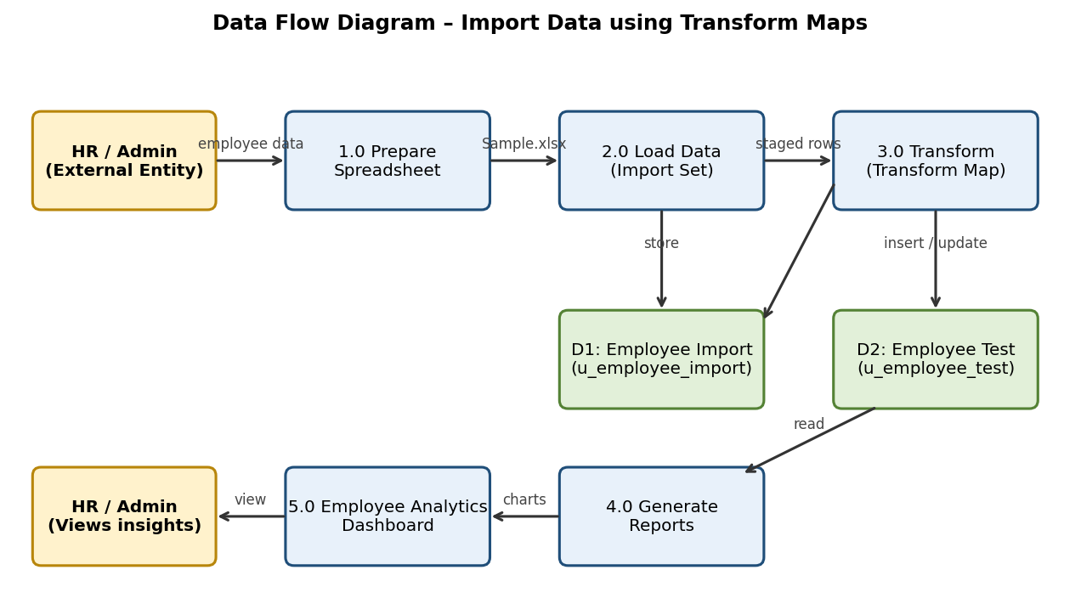
Figure 1: Data Flow Diagram

3.4 Technology Stack
Layer | Technology / Component
Platform | ServiceNow (Global application scope)
Data source | Google Sheets → Microsoft Excel (.xlsx)
Staging | Import Set table u_employee_import (System Import Sets → Load Data)
Transformation | Table Transform Map with Field Maps and Coalesce
Target data store | Custom table u_employee_test (Employee Test)
Reporting | Platform Analytics Reports (Pie, Bar, List)
Visualization | Dashboards (PA_DASHBOARDS.FORM, Employee Analytics Dashboard)
Security | Roles and Access Control (ACL pa_dashboards)

4. PROJECT DESIGN

4.1 Problem Solution Fit
Problem | Solution fit
Manual entry of bulk employee data | Load Data + Import Set loads all rows in one step
Source columns differ from target fields | Transform Map with Auto Map Matching Fields / Mapping Assist
Duplicates on re-import | Coalesce on Employee ID – updates existing rows, ignores unchanged rows
No visibility of results | Transform History, reports and dashboard

4.2 Proposed Solution
- Prepare Sample Spreadsheet.xlsx with Employee ID, Name, Email, Department and Location.
- Create the Employee Test table with five String columns.
- Use Load Data to create the Employee Import staging table and load the file.
- Create a Transform Map (Sample Spreadsheet Import), map the five fields and run Transform.
- Validate the 15 records in Employee Tests and personalise the list columns.
- Enable Coalesce on Employee ID and re-import modified data to confirm inserts, updates and ignored rows.
- Create three reports and add them to the Employee Analytics Dashboard.

4.3 Solution Architecture
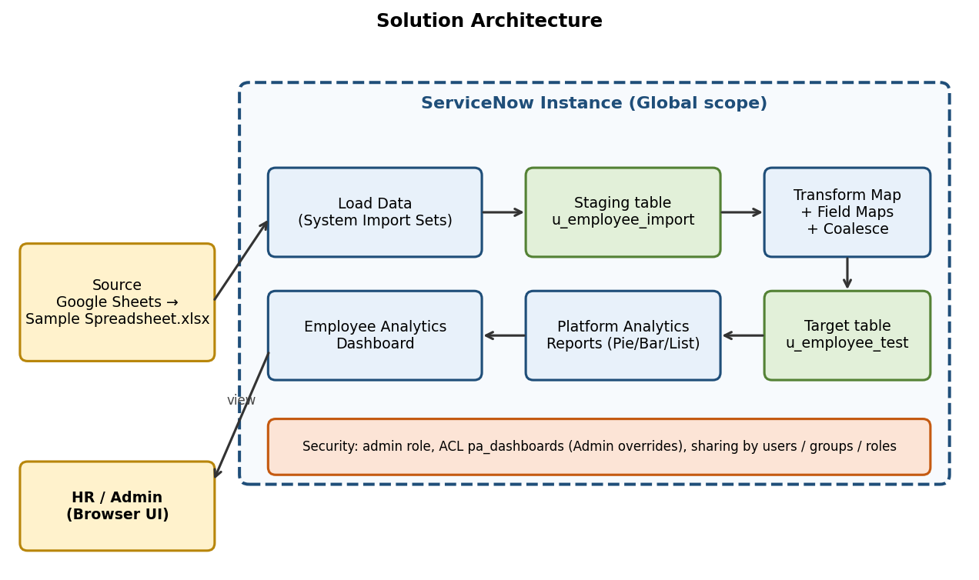
Figure 2: Solution Architecture

5. PROJECT PLANNING & SCHEDULING

5.1 Project Planning
The work was organised in four sprints of 6 days each (20 story points per sprint, 80 in total). Full backlog, tracker, velocity and burndown are provided in the separate Project Planning document.
Sprint | Focus | Story points | Duration
Sprint-1 | Spreadsheet, custom table, import set load, transform map and first transform | 20 | 6 days
Sprint-2 | Coalesce, re-import testing, three reports | 20 | 6 days
Sprint-3 | Dashboard, ACL, functional testing and UAT | 20 | 6 days
Sprint-4 | Documentation, screenshots, review and demo | 20 | 6 days

6. FUNCTIONAL AND PERFORMANCE TESTING

6.1 Performance Testing
Test | Input | Result | Observed outcome
Initial load + transform | 15 rows, new import set | Success | Processed 15, inserts 15, updates 0, errors 0 (load took ~1.4 s)
Re-import with changes (coalesce on) | 4 rows (2 changed, 2 new) | Success | Total 4, inserts 2, updates 2, ignored 0, errors 0 (~1 s)
Re-import identical file | Same 4 rows | Success | Total 4, inserts 0, updates 0, ignored 4, errors 0 (<1 s)
Record count in target table | – | Pass | 17 records (15 + 2 new)
Report: Employees by Department | 17 records | Pass | ServiceNow 11 (64.71%), Salesforce 4 (23.53%), AIML 2 (11.76%)
Report: Employees by Location | 17 records | Pass | Hyderabad 16, Chennai 1
All import runs completed with State = Complete and Completion code = Success and no errors. The detailed UAT results are in the separate UAT Report.

7. RESULTS

7.1 Output Screenshots
[ Paste screenshot here ]
Figure 3: Load Data success – Processed 15, inserts 15, errors 0

[ Paste screenshot here ]
Figure 4: Transform Map field maps (5 fields, Coalesce on u_employee_id = true)

[ Paste screenshot here ]
Figure 5: Transformation complete – State Complete, Completion code Success

[ Paste screenshot here ]
Figure 6: Employee Tests list showing 15 imported records (1 to 15 of 15)

[ Paste screenshot here ]
Figure 7: Transform History after re-import – Total 4, Inserts 2, Updates 2

[ Paste screenshot here ]
Figure 8: Re-import of identical file – Ignored 4

[ Paste screenshot here ]
Figure 9: Employees by Department (pie), Employees by Location (bar), Employee List Report

[ Paste screenshot here ]
Figure 10: Employee Analytics Dashboard with all three reports

8. ADVANTAGES & DISADVANTAGES
Advantages | Disadvantages
Fast bulk loading instead of manual entry  Staging table keeps a copy of the data, using extra storage  Field mapping done once, reused for every import  Coalesce on Employee ID prevents duplicates  Reports/dashboards give instant insight  No code needed (out-of-the-box features) | Manual file upload is required each time  Text values are copied as-is (e.g., "Servicenow" vs "ServiceNow") unless cleaned  Accessing the dashboard form by backend name needs an ACL change (Admin overrides)  Depends on correct sheet number and header row  Unchanged rows are ignored, so no audit of re-submitted data

9. CONCLUSION
The project successfully implemented an employee data management solution using ServiceNow Import Sets and Transform Maps. Data from a spreadsheet was staged, mapped and transformed into the Employee Test table with no errors. Enabling Coalesce on Employee ID ensured that re-imports updated existing records (2 updates), inserted only new employees (2 inserts) and ignored identical rows (4 ignored), keeping the table clean and consistent.
Three reports and the Employee Analytics Dashboard give administrators and HR teams a centralised, visual view of department and location distribution and of the employee list.

10. FUTURE SCOPE
- Automate imports with scheduled Data Sources (SFTP / JDBC / REST) instead of manual uploads.
- Add transform scripts or choice lists to clean data (e.g., standardise department names and email formats).
- Map Department and Location to reference fields and extend to the core User [sys_user] table.
- Add reports on import success/error counts and newly added or updated records, with scheduled email delivery.
- Add notifications and approval workflow for failed imports.

11. APPENDIX
Source Code (if any): No custom code – configuration only (tables, Import Set, Transform Map, reports, dashboard).
Dataset Link: Sample Spreadsheet.xlsx (15 employee records, columns Employee ID, Name, Email, Department, Location) – [add Google Sheet / Drive link]
GitHub & Project Demo Link: [add GitHub repository link] | [add demo video link]

