Project Planning Phase
Project Planning Template (Product Backlog, Sprint Planning, Stories, Story Points)
Date | 03 October 2026
Team ID | [Team ID]
Project Name | Import Data using Transform Maps (Spreadsheet) – ServiceNow
Maximum Marks | 5 Marks

Product Backlog, Sprint Schedule, and Estimation (4 Marks)
Sprint | Functional Requirement (Epic) | User Story Number | User Story / Task | Story Points | Priority | Team Members
Sprint-1 | Data Preparation | USN-1 | As an admin, I can create a spreadsheet with 15 employee records (Employee ID, Name, Email, Department, Location). | 2 | High | [Member]
Sprint-1 |  | USN-2 | As an admin, I can download the spreadsheet as Sample Spreadsheet.xlsx. | 1 | High | [Member]
Sprint-1 | Target Table | USN-3 | As an admin, I can create the custom table Employee Test (u_employee_test). | 3 | High | [Member]
Sprint-1 |  | USN-4 | As an admin, I can add Employee ID, Employee Name, Email, Department and Location (String) using Form Layout. | 3 | High | [Member]
Sprint-1 | Data Load | USN-5 | As an admin, I can load the .xlsx file into a new import set table Employee Import (u_employee_import). | 3 | High | [Member]
Sprint-1 | Transform Map | USN-6 | As an admin, I can create the Transform Map Sample Spreadsheet Import with source Employee Import and target Employee Test. | 3 | High | [Member]
Sprint-1 |  | USN-7 | As an admin, I can map the source fields to target fields using Auto Map / Mapping Assist. | 2 | High | [Member]
Sprint-1 |  | USN-8 | As an admin, I can run the transform and verify that 15 records are created in Employee Tests. | 3 | High | [Member]
Sprint-2 | Duplicate Prevention | USN-9 | As an admin, I can enable Coalesce on the Employee ID field map. | 3 | High | [Member]
Sprint-2 |  | USN-10 | As an admin, I can load a modified spreadsheet into the existing Employee Import table. | 2 | High | [Member]
Sprint-2 |  | USN-11 | As an admin, I can run the transform and verify 2 inserts and 2 updates in Transform History. | 3 | High | [Member]
Sprint-2 |  | USN-12 | As an admin, I can re-import the same file and verify that all 4 rows are ignored. | 2 | Medium | [Member]
Sprint-2 | Reports | USN-13 | As an admin, I can create the pie report Employees by Department (group by Department, count). | 3 | High | [Member]
Sprint-2 |  | USN-14 | As an admin, I can create the bar report Employees by Location (group by Location, count). | 3 | Medium | [Member]
Sprint-2 |  | USN-15 | As an admin, I can create the list report Employee List Report with all five columns. | 2 | Medium | [Member]
Sprint-2 |  | USN-16 | As an admin, I can run and save all reports and validate the counts. | 2 | Medium | [Member]
Sprint-3 | Dashboard | USN-17 | As an admin, I can enable Admin overrides on the pa_dashboards create ACL to open PA_DASHBOARDS.FORM. | 3 | High | [Member]
Sprint-3 |  | USN-18 | As an admin, I can create the Employee Analytics Dashboard. | 3 | High | [Member]
Sprint-3 |  | USN-19 | As an admin, I can add the three reports to the dashboard using Share → Add to Dashboard. | 3 | High | [Member]
Sprint-3 |  | USN-20 | As an admin, I can restrict dashboard access by users, groups and roles from the Share option. | 2 | Medium | [Member]
Sprint-3 | Testing | USN-21 | As a tester, I can execute functional test cases for import, transform, coalesce, reports and dashboard. | 4 | High | [Member]
Sprint-3 |  | USN-22 | As a tester, I can run UAT, log defects and prepare the UAT report. | 3 | High | [Member]
Sprint-3 |  | USN-23 | As a tester, I can record import timings and counts for performance testing. | 2 | Medium | [Member]
Sprint-4 | Documentation | USN-24 | As a team, we can prepare the project report in the prescribed format. | 5 | High | [Member]
Sprint-4 |  | USN-25 | As a team, we can prepare the functional/system documentation (FSD). | 4 | High | [Member]
Sprint-4 |  | USN-26 | As a team, we can prepare the UAT report. | 3 | High | [Member]
Sprint-4 |  | USN-27 | As a team, we can prepare the project planning document. | 2 | Medium | [Member]
Sprint-4 |  | USN-28 | As a team, we can capture output screenshots and the appendix links. | 3 | Medium | [Member]
Sprint-4 |  | USN-29 | As a team, we can review all deliverables and present the project demo. | 3 | Low | [Member]

Total story points: 80 (Sprint-1: 20, Sprint-2: 20, Sprint-3: 20, Sprint-4: 20).

Project Tracker, Velocity & Burndown Chart: (4 Marks)
Sprint dates are working-week sprints of 6 days (Monday to Saturday). Update the dates if your actual schedule differs.
Sprint | Total Story Points | Duration | Sprint Start Date | Sprint End Date (Planned) | Story Points Completed (as on Planned End Date) | Sprint Release Date (Actual)
Sprint-1 | 20 | 6 Days | 19 Jan 2026 | 24 Jan 2026 | 20 | 24 Jan 2026
Sprint-2 | 20 | 6 Days | 26 Jan 2026 | 31 Jan 2026 | 20 | 31 Jan 2026
Sprint-3 | 20 | 6 Days | 02 Feb 2026 | 07 Feb 2026 | 20 | 07 Feb 2026
Sprint-4 | 20 | 6 Days | 09 Feb 2026 | 14 Feb 2026 | 20 | 14 Feb 2026

Velocity
Team velocity is 20 story points per sprint and each sprint lasts 6 days. The average velocity (AV) per iteration unit (story points per day) is:
AV = velocity ÷ sprint duration = 20 ÷ 6 ≈ 3.33 story points per day
Over the four sprints the team completed 80 points in 24 days, which is the same ≈ 3.33 points per day.

Burndown Chart
A burndown chart is a graphical representation of work left to do versus time. The chart below shows the remaining story points after each sprint; actual progress follows the ideal line because every sprint completed its planned 20 points.
Point in time | Start | End of Sprint-1 | End of Sprint-2 | End of Sprint-3 | End of Sprint-4
Ideal remaining | 80 | 60 | 40 | 20 | 0
Actual remaining | 80 | 60 | 40 | 20 | 0

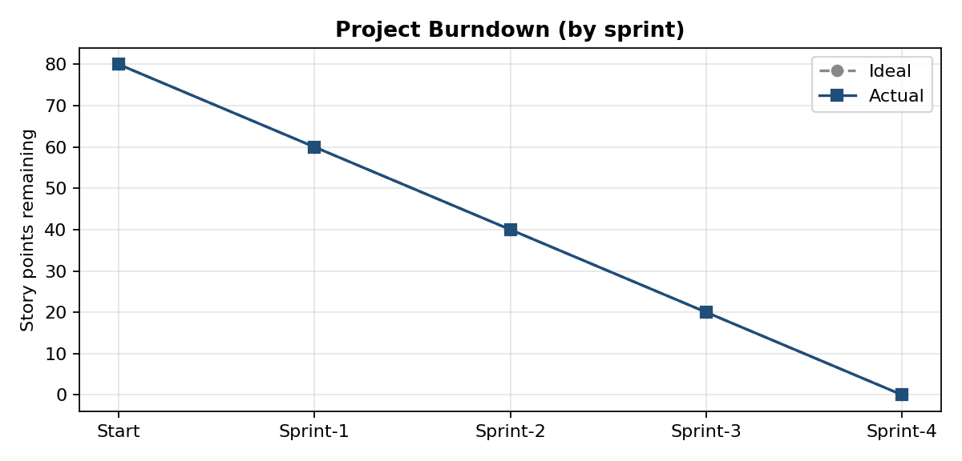
Figure 1: Project burndown chart

Reference
- https://www.atlassian.com/agile/tutorials/burndown-charts
- https://www.atlassian.com/agile/project-management/estimation
- https://www.atlassian.com/agile/tutorials/sprints

