Functional / System Documentation (FSD)
Import Data using Transform Maps – ServiceNow

1. Introduction
- Project Title: Import Data using Transform Maps (Spreadsheet) – ServiceNow
- Team Members:
Name | Role
[Member 1] | Team lead – project coordination, transform map configuration
[Member 2] | Data preparation, custom table and import set configuration
[Member 3] | Reports and dashboard
[Member 4] | Testing, UAT and documentation

2. Project Overview
- Purpose: Import bulk employee data from an Excel spreadsheet into ServiceNow through an Import Set (staging) table and a Transform Map, validate the result, avoid duplicate records using Coalesce, and visualise the data in reports and a dashboard.
- Features:
- Custom table Employee Test (u_employee_test) with Employee ID, Employee Name, Email, Department and Location.
- File-based import with Load Data into the Employee Import staging table (u_employee_import).
- Transform Map "Sample Spreadsheet Import" with five field maps and Auto Map Matching Fields / Mapping Assist.
- Coalesce on Employee ID: existing employees are updated, new ones inserted, unchanged ones ignored.
- Transform History for inserts, updates, ignored rows and errors.
- Three reports (pie, bar, list) and the Employee Analytics Dashboard.

3. Architecture
ServiceNow is a low-code platform, so the three tiers of the template map to platform components instead of separate React / Node.js / MongoDB code.
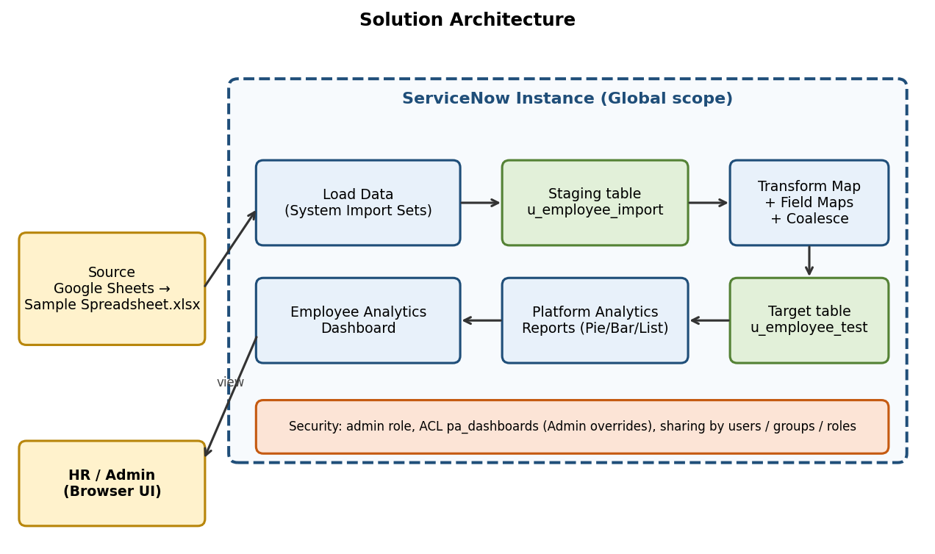
Figure 1: System architecture
- Frontend: ServiceNow web UI (Next Experience / Platform UI) – Load Data form, Table and Form Layout, Transform Map form, list views, Reports and Dashboards. No custom front-end code is written.
- Backend: ServiceNow server-side platform – Import Set processor (ImportProcessor), Transform engine (Transform Map, Field Maps, Coalesce) and Platform Analytics. Processing is configured, not coded.
- Database: ServiceNow relational database accessed through tables. Schema below.
Table | Label | Purpose
u_employee_import | Employee Import | Staging table created by Load Data; holds raw spreadsheet rows plus import set fields
u_employee_test | Employee Test | Target table with final employee records
sys_transform_map / sys_transform_entry | Table Transform Map / Field Maps | Mapping configuration between staging and target

Column label | Column name | Type | Notes
Employee ID | u_employee_id | String | Coalesce field (unique identifier, e.g., SB-0001)
Employee Name | u_employee_name | String | Mapped from source field u_name
Email | u_email | String
Department | u_department | String | ServiceNow / Salesforce / AIML
Location | u_location | String | Hyderabad / Chennai

4. Setup Instructions
- Prerequisites:
- A ServiceNow instance (e.g., Personal Developer Instance) and a user with the admin role.
- A Google account (Google Sheets) or Microsoft Excel to prepare the file.
- A modern web browser.
- Installation (step-by-step):
- Open a new Google Sheet and enter the 15 sample employee rows (columns: Employee ID, Name, Email, Department, Location).
- Download it as Sample Spreadsheet.xlsx (File → Download → Microsoft Excel).
- Log in to the instance. Open Tables → Create New: Label "Employee Test", Name "u_employee_test".
- Show Form → Form Context Menu → Configure → Form Layout; create the five String fields; Save.
- Environment variables are not required – all configuration is stored in the instance.

5. Folder Structure
ServiceNow has no client/server folders. The equivalent application structure is listed below (all artifacts are in the Global scope).
- Client (UI artifacts):
- Employee Test form and list layout (Form Layout, Personalize List Columns).
- Reports: Employees by Department, Employees by Location, Employee List Report.
- Dashboard: Employee Analytics Dashboard.
- Server (platform artifacts):
- Tables: u_employee_test, u_employee_import (staging).
- Transform Map: Sample Spreadsheet Import (5 field maps; Coalesce = true on u_employee_id).
- ACL: pa_dashboards (create operation, Admin overrides = true).
- Source file: Sample Spreadsheet.xlsx (kept outside the instance).

6. Running the Application
There are no npm commands. The solution is run from the ServiceNow Application Navigator:
- Frontend (user interface): log in to the instance, then use the navigator.
- Backend (processing): System Import Sets → Load Data → Submit → Transform (or Run Transform).
Step | Navigator path / action | Expected result
1 | System Import Sets → Load Data (Create table, label Employee Import, File, sheet 1, header row 1) → Submit | State Complete, Success; Processed 15, inserts 15
2 | Create Transform Map (name Sample Spreadsheet Import, target Employee Test) → Auto Map Matching Fields → Save | 5 field maps shown
3 | Transform Map → Transform → Transform button | Transformation complete – Success
4 | Employee Test → Employee Tests | 15 records listed
5 | Transform Map → Field Maps → set Coalesce = true on u_employee_id | Duplicates prevented
6 | Load Data (Existing table: Employee Import) → Run Transform → Transform | Inserts and updates per Transform History

7. API Documentation
The solution is configured through the UI, but the same data is exposed through ServiceNow's standard REST APIs. The endpoints below can be used with the instance URL (https://<instance>.service-now.com).
Method | Endpoint | Description
POST | /api/now/import/u_employee_import | Insert a row into the staging table; the transform map then maps it to u_employee_test
GET | /api/now/table/u_employee_test | List employees (supports sysparm_query, sysparm_limit, sysparm_fields)
GET | /api/now/table/u_employee_test/{sys_id} | Get one employee record
PATCH | /api/now/table/u_employee_test/{sys_id} | Update fields of an employee record
DELETE | /api/now/table/u_employee_test/{sys_id} | Delete an employee record

Example request: GET /api/now/table/u_employee_test?sysparm_query=u_department=Salesforce&sysparm_limit=1
{ "result": [ {
"sys_id": "<32-char id>",
"u_employee_id": "SB-0011",
"u_employee_name": "Abhishek S",
"u_email": "test11@gmail.com",
"u_department": "Salesforce",
"u_location": "Hyderabad" } ] }

Example request: POST /api/now/import/u_employee_import with body {"u_employee_id":"SB-0016","u_name":"Siri","u_email":"test16@gmail.com","u_department":"AIML","u_location":"Chennai"}
Response: 201 Created with import_set, staging_table and a result entry whose transform_map is "Sample Spreadsheet Import" and status "inserted" (or "updated" when the Employee ID already exists).

8. Authentication
- Users log in to the instance with a username and password (or the organisation's SSO). A session cookie is used in the browser.
- REST calls use Basic Authentication or OAuth 2.0 bearer tokens; the calling user needs read/write rights on the tables.
- Authorization is role-based using Access Controls (ACLs). Creating dashboards through PA_DASHBOARDS.FORM requires the ACL pa_dashboards (create operation) to have Admin overrides = true.
- Dashboard visibility is controlled from the Share option by adding users, groups and roles.

9. User Interface
The UI is the standard ServiceNow interface. Insert screenshots of the following screens:
[ Paste screenshot here ]
UI 1: Employee Test form with five fields

[ Paste screenshot here ]
UI 2: Load Data form (Create table, File, sheet 1, header row 1)

[ Paste screenshot here ]
UI 3: Transform Map form and Mapping Assist

[ Paste screenshot here ]
UI 4: Employee Tests list (Employee ID, Employee Name, Email, Department, Location)

[ Paste screenshot here ]
UI 5: Employee Analytics Dashboard

10. Testing
- Strategy: manual functional testing of each phase followed by user acceptance testing (see the UAT Report). No automated test tooling was used.
- Tools: ServiceNow Transform History, Import Log, list views and report preview.
Scenario | Expected | Actual
First import of 15 rows | 15 inserts, 0 errors | 15 inserts, 0 errors – Pass
Modified file (2 changed + 2 new IDs) | 2 updates, 2 inserts | 2 updates, 2 inserts – Pass
Same file imported again | 0 inserts, 0 updates, 4 ignored | 4 ignored – Pass
Report counts | Match table data (17 records) | ServiceNow 11, Salesforce 4, AIML 2; Hyderabad 16, Chennai 1 – Pass

11. Screenshots or Demo
[ Paste screenshot here ]
Screenshot of final Employee Tests list and dashboard
Demo link: [add demo video link]

12. Known Issues
- Department text is copied as typed: after the update import, SB-0004 and SB-0010 show "Servicenow" instead of "ServiceNow". Fix by correcting the source file or adding a transform script.
- PA_DASHBOARDS.FORM cannot be opened by backend name until Admin overrides is enabled on the pa_dashboards create ACL.
- The import is manual; each load requires choosing the file again, and the sheet number and header row must be correct.
- Unchanged rows are ignored on re-import, so repeated uploads leave no update trace.

13. Future Enhancements
- Scheduled imports from SFTP / JDBC / REST data sources.
- Transform scripts to standardise case and validate email format; choice lists or reference fields for Department and Location.
- Reports on import success/error counts and newly added/updated records.
- Notifications to admins when an import fails or is partially processed.

