Project Design Phase-II
Data Flow Diagram & User Stories
Date | 31 January 2025
Team ID
Project Name | Importing & Securing Data in ServiceNow
Maximum Marks | 4 Marks

Data Flow Diagrams:
A Data Flow Diagram (DFD) shows how data enters and leaves the system, what changes it, and where it is stored. Level 0 for this project is below.
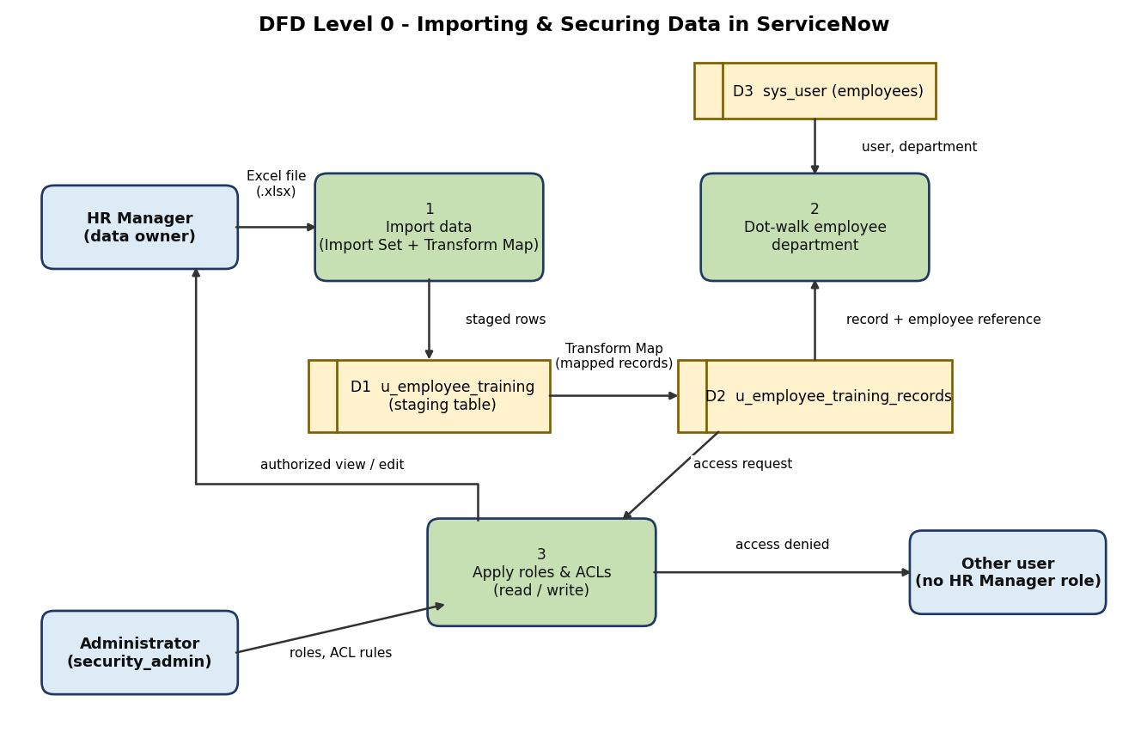

Flow: 1) HR Manager provides the Excel file. 2) Load Data stages it in u_employee_training. 3) The Transform Map writes records to u_employee_training_records. 4) Dot-walking reads sys_user for Department. 5) Roles and ACLs allow the HR Manager to view and edit and deny other users.
User Stories
User stories for the product:
User Type | Functional Requirement (Epic) | User Story Number | User Story / Task | Acceptance criteria | Priority | Release
Administrator | Table setup | USN-1 | As an administrator, I can create the Employee Training Records table with Training Name, Completion Date, Status and Employee (reference to sys_user). | Table appears under the application menu with all four columns | High | Sprint-1
 |  | USN-2 | As an administrator, I can add Status choices (In Progress, Completed). | Choices show in the Status dropdown | Medium | Sprint-1
 | Data import | USN-3 | As an administrator, I can upload the Excel file through Load Data into a staging table. | Import set shows state Complete with inserted rows | High | Sprint-1
 |  | USN-4 | As an administrator, I can create a Transform Map that maps the four fields to the target table and run Transform. | Records appear in Employee Training Records with the employee linked | High | Sprint-1
 | Employee details | USN-5 | As an administrator, I can dot-walk Employee > Department onto the form and list. | Department is shown for each record without extra entry | Medium | Sprint-2
 | Roles & users | USN-6 | As an administrator, I can create the backup user, create the HR Manager role and assign it. | User has the HR Manager role under Roles | High | Sprint-2
 |  | USN-7 | As an administrator, I can add the HR Manager role to the application menu and module. | Menu and module are visible only to that role | High | Sprint-2
 | Access control | USN-8 | As an administrator, I can elevate to security_admin and create read and write ACLs requiring the HR Manager role. | Both ACLs are active on u_employee_training_records | High | Sprint-2
HR Manager | Training records | USN-9 | As an HR Manager, I can view and edit employee training records. | Impersonating the HR Manager shows the table and allows edits | High | Sprint-2
Other user | Access restriction | USN-10 | As a user without the HR Manager role, I cannot see the training table. | Impersonating that user shows no access to the table | High | Sprint-2

