Project Design Phase
Solution Architecture
Date | 15 February 2025
Team ID
Project Name | Importing & Securing Data in ServiceNow
Maximum Marks | 4 Marks

Solution Architecture:
Solution architecture is a complex process – with many sub-processes – that bridges the gap between business problems and technology solutions. Its goals are to:
- Find the best tech solution to solve existing business problems.
- Describe the structure, characteristics, behavior, and other aspects of the software to project stakeholders.
- Define features, development phases, and solution requirements.
- Provide specifications according to which the solution is defined, managed, and delivered.
Solution Architecture Diagram:
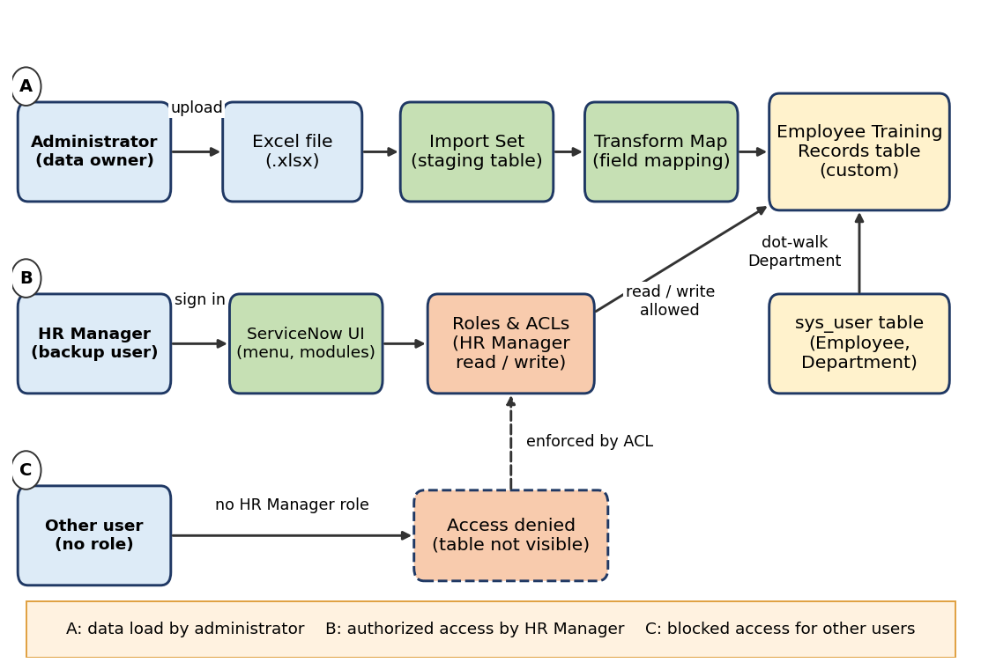
Figure 1: Architecture and data flow of the Employee Training Records solution in ServiceNow
Description:
- Path A (data load): the administrator prepares an Excel file and loads it through an Import Set into a staging table. A Transform Map maps the fields into the Employee Training Records table.
- Employee link: the Employee field references the sys_user table, so Department is shown on the record through dot-walking without storing it again.
- Path B (authorized access): the HR Manager signs in and uses the application menu and modules. Roles and ACLs allow read and write on the table.
- Path C (blocked access): a user without the HR Manager role is denied by the ACLs and the table is not visible.

